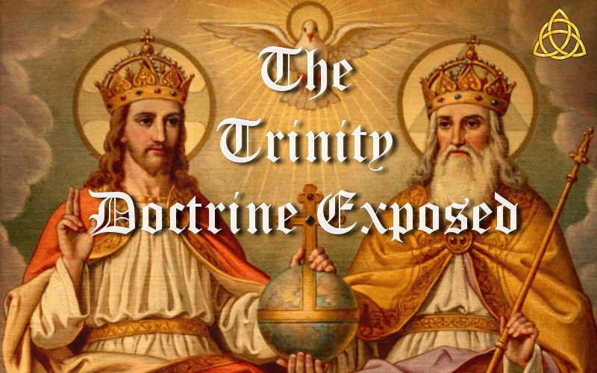

**The Trinity Doctrine Exposed**

This page is designed so that individual parts can be copied and pasted into Facebook as posts, or responses to others. So you will find some duplicated passages in individual parts for this reason. CAPS have also been used in places since FB does not support any form of highlighting. Please feel free to copy and paste individual parts for sharing anywhere you choose or share the entire page. Thank you.

To download images or this document as a PDF. See <http://www.trinitytruth.org/the-trinity-doctrine-exposed.html>

**Index of Parts**

1) What is the Trinity Doctrine?

2) What is the Origin of the Word Trinity?

3) What is the Origin of the Trinity Doctrine?

4) What is Satan's Counterfeit for the Godhead?

5) Most Have No Idea what the Trinity Doctrine is

6) Does the Trinity Doctrine Make Sense or is it Nonsense?

7) The Bible was Written by Non-Trinitarians and so is a Non-Trinitarian Book!

8) What did the People Who Created the Trinity Doctrine Believe?

9) An Attempt to Cover Up History

10) The Idea of the Trinity Predated Christianity

11) Trinity and Sunday Worship Come From Sun and Satan Worship and 666

12) Proof The Trinity Doctrine Is From Satan Via Sun Worship

13) Should Christians use the phrases God the Son and God the Spirit?

14) Did the Apostles Believe in the Trinity Doctrine?

15) Why do most Churches Believe in the Trinity Doctrine?

16) Is the Trinity Doctrine Antichrist?

17) Why Can't Theologians Explain the Trinity Doctrine?

18) Is the Word Trinity Found in the Bible?

19) What is the difference between Godhead and Trinity?

20) Does 1 John 5:7-8 Have Added Text?

21) Does Matthew 28:19 prove a Trinity?

22) What happened to Matthew 28:19?

23) Does Elohim Prove a Trinity?

24) Why is the Trinity a Salvation Issue?

**Introduction**

The word trinity is derived from the Latin word trinitas, which came from the Platonic term *trias* meaning three. Thus it is philosophical in origin.

The word trinity was introduced by Tertullian (160-225 AD) who was a pagan turned Catholic theologian and one of the early Church fathers who wrote in the early third century to define the teaching concerning the Godhead. His conclusion was that the Father, Son and Holy Spirit were *one substance*, but not *one in person*. He also did not see the Son as being co-eternal with the Father.

There are many unanswered questions about the trinity doctrine and the most obvious is where in the Bible is it explained? Scholars throughout history have acknowledged that it is not found in the Bible. Many will respond that the trinity doctrine is found in 1 John 5:7. But the italicized part of this verse that says, “For there are three that bear record in heaven, *the Father, the Word, and the Holy Ghost: and these three are one,*” does not exist in the earliest manuscripts!

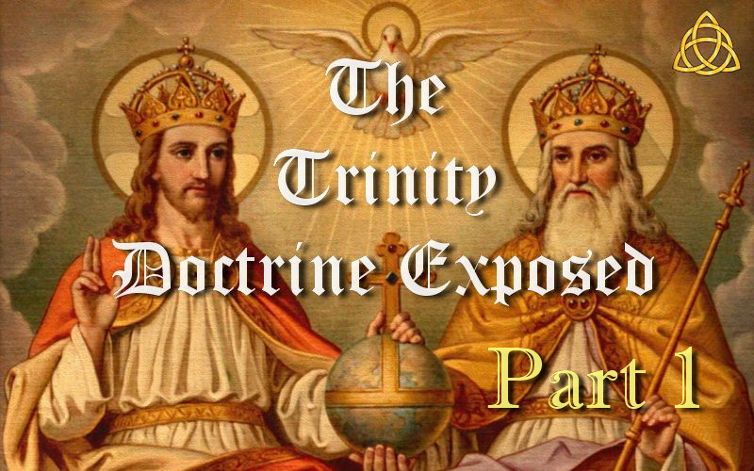

**THE TRINITY DOCTRINE EXPOSED – PART 1**

**What is the Trinity Doctrine?**

The doctrine of the Trinity as taught by most Churches states that there are three co-equal (equal in every respect), co-eternal (the same age), omniscient (all knowing), omnipotent (all powerful) gods, who are not three gods, but one god. By the words of the Athanasian Creed it is, “*the Father is God, the Son is God, and the Holy Spirit is God, and yet there are not three gods but one God.*” The Athanasian Creed (Roman Catholic Creed) says that the *one God* is three divine personalities in one indivisible substance or essence. It is the *one indivisible nature* part which is a problem because it is maintained that this constitutes the *one God* being 1+1+1=One! That is, the Father is God, Jesus is God, the Holy Spirit is God, and yet there are not three gods but one God, and that is the Trinity!

You do not have to be very smart to realize that this makes no sense at all. Therefore, those teaching this doctrine tag it with the word *mystery,* stating that you will never be able to understand it so just accept it. They may also say, just because it is Catholic it does not mean it is wrong. So in one way or another Satan has tricked people into believing this falsehood without checking it out for themselves. There is in fact not one Scripture in the Bible that states the Holy Spirit is God with a “*thus saith the Lord,*” not one! Neither is there any *valid* text that says all three are one.

Some Churches differ on some points from orthodoxy, but regarding the basic premise being the *one God* is three gods in one, it is exactly the same as the Athanasian Creed. This is the creed upon which the Roman Catholic faith is built.

We also find that the word “Trinity” originated from Tertullian around 200 AD who did not even state the immanent trinity as known today, the 3 in 1 god came from Athanasius in 325 AD, and the idea of the Holy Spirit as a third being came from three Cappadocians in 381 AD. Hence the word “Trinity” and this doctrine cannot be found anywhere in the Scriptures. It was patched together by Catholic theologians hundreds of years *after* the death of the apostles and long *after* the completion of the Bible. Instead, Trinitarianism comes from the allegorical ideas of the Alexandrines and is a mixture of Greek and Roman philosophies that are loosely based on a handful of Bible verses snatched out of context or interpolated into the text.

Thus the Trinity is a manmade doctrine that borrows heavily from paganism and Greek philosophy and was developed long after the Scriptures were completed. Therefore, this doctrine could never have come from Scripture anyway and has to be taught alongside the Bible. And so if you had never heard of it, you would never come up with it yourself from just reading the Bible alone. As a result, you will also find that eisegesis has to be used to convince others of this doctrine.

It was after God confused the languages at Babel that the sun began to be worshipped in three stages as three gods. That is, the rising sun was god, the midday sun was god, the setting sun was god, and yet there were not three gods but one god! In other words, 1+1+1=One! This is the absolute origin of the Trinity doctrine. Knowing who we worship is the key to eternal life, so if God truly was a trinity, you can be sure there would be unmistakable Scriptures saying so, but there is none.

Thus the doctrine of the Trinity, or Tritheism is a heresy that proceeds from Romanism and tantamount to Sunday Worship. An Abomination before God. It is a doctrine that emanates straight from the dunghill of Roman decretals. It is philosophy, vain deceit and man's tradition. It denies Jesus, preaches another Jesus, another spirit and another Gospel.

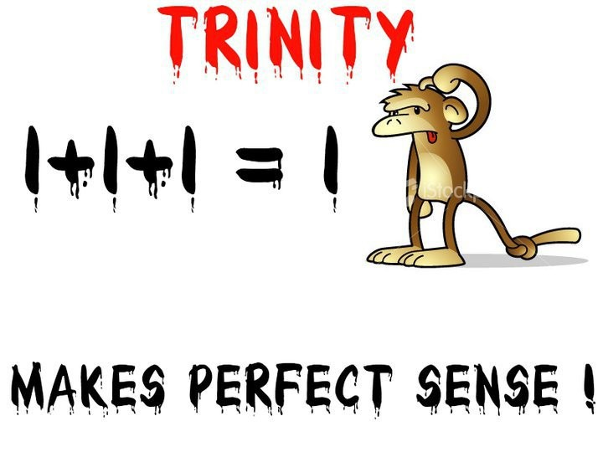

The above is an optional image that can be used if posting this part on the internet.

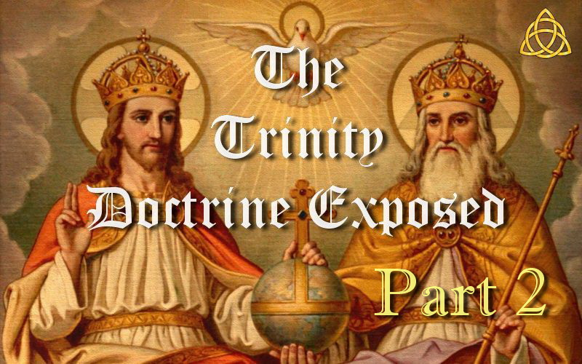

**THE TRINITY DOCTRINE EXPOSED – PART 2**

**What is the Origin of the Word Trinity?**

Most assume that God the Father, Jesus His Son and the Holy Spirit form what is commonly known as the Trinity, which is the belief in 3 co-equal and co-eternal gods that are not 3 gods but 1 god. But did you know that even though it is a common assumption among many sincere Christians, the word “Trinity” does not come from the Bible?

The word “Trinity” did not come into common use as a religious term until *centuries after* the last books of the Bible were completed and long after the apostles of Christ were gone from the scene.

The *New Bible Dictionary* explains, “*The term trinity is not itself found in the Bible. It was first used by Tertullian at the close of the 2nd century, but received wide currency [common use in intellectual discussion] and formal elucidation [clarification] only in the 4th and 5th centuries.*” — (“Trinity,” 1996)

While Tertullian introduced the term “Trinity,” what he taught and believed is different to what the Trinity doctrine is today. And since he introduced this term, that means the Trinity doctrine as taught today did not exist in the time of Tertullian. And if it did not exist in his time, then it could never have existed in the time of Christ and the apostles either.

Tertullian however did introduce pagan ideas into the worship service. He taught oblations for the dead and made the sign of the cross on the forehead of worshipers. He also dipped people three times to baptize them. Tertullian freely admitted that he had adopted these ideas from pagan teachings and could not support them from Scripture, but he thought that if Christians adopted some heathen rituals of the pagans that they would find it easier to join Christianity.

Wikipedia states what Tertullian believed:

Tertullian was just a forerunner of the Nicene doctrine and did not state the immanent Trinity. His use of *trinitas* (Latin: 'Threeness') emphasised the manifold character of God. In his treatise against Praxeas he used the words, “*Trinity and economy, persons and substance.*” The Son is distinct from the Father, and the Spirit from both the Father and the Son. “*These three are one substance, not one person; and it is said, 'I and my Father are one' in respect not of the singularity of number but the unity of the substance.*”

In his book Tertullian against Praxeas, he also states that the Son was *not* co-eternal with the Father and had a beginning as the begotten Son of God. He also did not teach that the Holy Spirit was a literal being.

So the Trinity doctrine as we know it today did not even come from the man who introduced the word “Trinity.” So much for the erroneous argument that the word “Trinity” is not in the Bible but the doctrine is. The Trinity doctrine did not exist for more than 100 years AFTER the word “Trinity” was introduced and is totally different to what Tertullian taught. Hence the Trinity doctrine as we now know it could never have come from the Bible. It is a manmade doctrine.

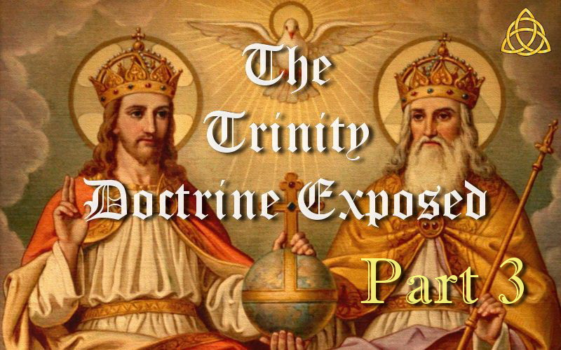

**THE TRINITY DOCTRINE EXPOSED – PART 3**

**What is the Origin of the Trinity Doctrine?**

It was about a century after Tertullian when Arianism began causing so many disputes that Constantine convened the first ecumenical Council in Church history to settle them. Arius was an elder in the Alexandrian Church in the early fourth century that taught Christ truly is the begotten Son of God and why God is called His Father to state the obvious. A real Father and Son in other words. Opposing the teachings of Arius was Athanasius, a deacon also from Alexandria. His view was an early form of Trinitarianism where the Father, Son and Holy Spirit are said to be all the same one god but distinct from each other making it impossible for them to be a real Father and Son. His view was a worsening change to what Tertullian believed with the Holy Spirit not yet claimed to be a literal being. That came later.

Mainstream history says Arius taught Christ was created, but the Church burnt all copies of his book Thalia which contained what Arius believed thus hiding what he really taught. Some historians claim they then altered records and falsely rumoured that he taught Christ was created in order to discredit him. The Catholic Church is known for creating false historical records to their interpretation of events to hide the real truth. Consider the following for instance.

The view of Athanasius was highly influenced by Origen who was a Greek philosopher and theologian who reinterpreted Christian doctrine through the philosophy of Neoplatonism. His work was later condemned as unorthodox. Origen taught the doctrine of Purgatory, transubstantiation, transmigration and reincarnation of the soul, the Holy Spirit was a feminine force, Jesus was only a created being, there would be no physical resurrection, the creation account in Genesis is a fictitious story and is known to have publicly castrated himself based on Matthew 19. Arius on the other hand was a pupil of Lucian of Antioch. Lucian was responsible for the work that gave us what is known as the Textus Receptus which was completed by Erasmus, and is what gave us the trusted New Testament of the KJV Bible. These and other facts reveal that Athanasius was influenced by Greek philosophy and that Arius probably taught Biblical truth despite mainstream history.

Some believe Constantine was the first Christian Roman Emperor, but he was actually a sun worshiper who was baptized on his deathbed. During his reign he had his eldest son and his wife murdered. His belief at best was a blend of paganism and Christianity for political purposes, and so he neither cared nor really understood this dispute, but was just eager to bring the controversy to a close and keep unity in his empire. When the bishops gathered at Nicea on May 20, 325 AD to resolve the crisis, very few shared Athanasius's view of Christ as most held a position midway between Athanasius and Arius. The religious debates lasted two months before the Council rejected the minority view of Arius, but having no alternative, Constantine approved the view of Athanasius, which was also a minority view. And so the Church was left supporting a belief held by only a minority of those attending.

The *Encyclopedia Britannica* states: “*Constantine himself presided, actively guiding the discussions, and personally proposed ... the crucial formula expressing the relation of Christ to God in the creed issued by the council ... Overawed by the emperor, the bishops, with two exceptions only, signed the creed, many of them much against their inclination.*” — (1971 edition, Vol. 6, “Constantine,” p. 386)

Horrific religious persecution followed the decision made by Constantine who was essentially a pagan Emperor who imposed an invented creed never preached by Jesus. Constantine exiled those who refused to accept the creed as well as the bishops who signed the creed but refused to join in condemnation of Arius. But several years later Constantine became lenient toward those he condemned and exiled at the council and allowed them to return. In AD 335, they brought accusations against Athanasius and so now Constantine had Athanasius banished! This was not about Biblical truth.

Many of the Bishops who formulated the doctrine of the Trinity were steeped in Greek and Platonic philosophy, which influenced their religious views. In fact the language they used in defining the Trinity is taken directly from Platonic and Greek philosophy. The Platonic term *trias*, meaning three, was Latinized as *trinitas*, which gave us the English word Trinity which is neither biblical nor Christian. As Bible scholars John McClintock and James Strong (wrote the famous Strong's Concordance) explain, “*Towards the end of the 1st century, and during the 2nd, many learned men came over both from Judaism and paganism to Christianity. These brought with them into the Christian schools of theology their Platonic ideas and phraseology.*” — (*Cyclopaedia of Biblical, Theological, and Ecclesiastical Literature*, 1891, Vol. 10, “Trinity,” p. 553)

So the Trinity was not derived from scripture, but was conceived in philosophy. Greek philosophers were greatly influenced by Plato (427-347 BC) who was considered the greatest of all Greek philosophers. Plato was ingrained with Trinitarian thought and knew that all the ancient religions had triad deities, and so he desired to come up with a better definition to define God above all the deities of Greek mythology.

The Council of Nicea did not end the controversy and the bishops went on teaching as they had before, and the Arian crisis continued for another sixty years. Athanasius was exiled no fewer than five times and it was very difficult to make his creed stick. The ongoing disputes were violent and bloody at times as Christians slaughtered one another over their differing views of God. Noted historian Will Durant writes, “*Probably more Christians were slaughtered by Christians in these two years (342-3) than by all the persecutions of Christians by pagans in the history of Rome.*” — (*The Story of Civilization, Vol. 4: The Age of Faith,* 1950, p. 8)

Disputes eventually became over the nature of the Holy Spirit. So 44 years after Constantine's death in May 381 AD, Emperor Theodosius, baptized only a year earlier, convened the Council of Constantinople to resolve them. Theodosius favoured the Nicene Creed and so after his arrival in Constantinople he expelled the bishop Demophilus, and surrendered the Churches there to Gregory of Nazianzus who was the leader of a small Nicene community there, and one of three men that became known as “the three Cappadocians.” These three men had an agenda at this council which was for the first time to push the idea of the Holy Spirit as a literal being. Gregory was recently appointed as archbishop of Constantinople, but due to illness, Nectarius, an elderly city senator had to take over the role of archbishop and presided over the council. And so Nectarius was baptized for the job and the Trinitarian view on the Holy Spirit was governed by someone with little or no knowledge of theology! What resulted became known as the Nicene-Constantinopolitan Creed where they now decided that the Holy Spirit was a literal being. Any who disagreed were in accordance with the edicts of the emperor and Church authorities branded heretics and dealt with accordingly.

This final teaching on the nature of God is what became the Trinity as it is generally understood today. It was not decided so much from Scripture but from Greek philosophy, much bloodshed and whoever held the most power.

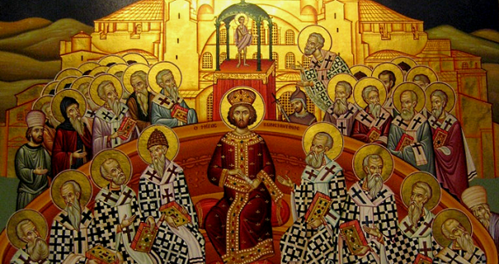

The above is an optional image that can be used if posting this part on the internet.

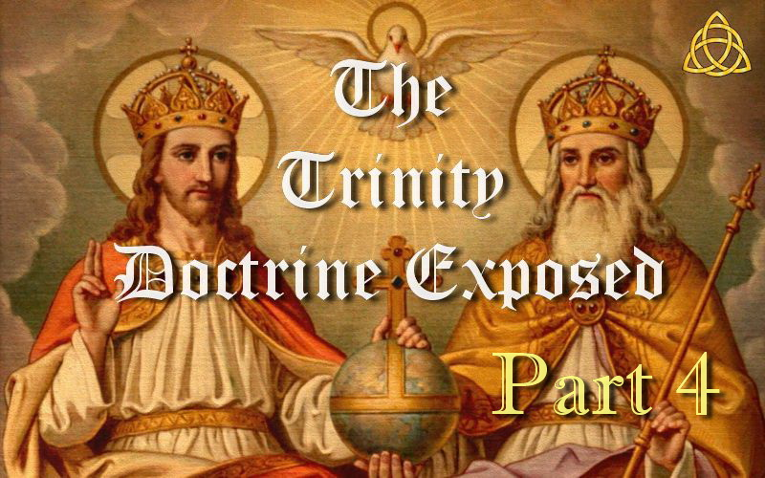

**THE TRINITY DOCTRINE EXPOSED – PART 4**

**What is Satan's Counterfeit for the Godhead?**

Satan is the great deceiver and his greatest tool is deception. So Satan has counterfeited all things of God to take people away from the truth and lead them into false worship thinking it is from God when it is from Satan.

For example. God has true prophets while Satan has false prophets. (2 Peter 2:1, Matthew 24:24, 2 Corinthians 11:13-15) God has true teachers while Satan has false teachers. Jesus is the light of the world and Satan appears as an angel of light. God has true apostles and Satan has false apostles. God gives the true gift of speaking in tongues which is known languages while Satan has false tongues that you do not understand and false interpretations that you have no way of verifying. God has a special day of rest and worship which is a sign that it is God we worship, and Satan instituted a counterfeit day that came from sun and Satan worship. And of course there is the Father, Son and the Holy Spirit. But what is Satan's counterfeit? The Trinity doctrine also came from sun and Satan worship and the number 666!

So which is the counterfeit? The view which acknowledges there is a real Father and Son just as the Bible literally tells us over a hundred times, or the three in one God they call a mystery which says they are not a real Father and Son and are just role playing which the Bible never even hints of.

How many stop to think that Satan would create a doctrine that would destroy the personality of the Father and Son? And would that doctrine make sense or be nonsense coming from our adversary? God is not the author of confusion and mystery doctrines, Satan is. And not forgetting the implications of the Holy Spirit. If you get this wrong you could inadvertently give your adoration to Satan, or even worse, your worship to Satan! This is the worst counterfeit of all that affects the true worship of God and His Son.

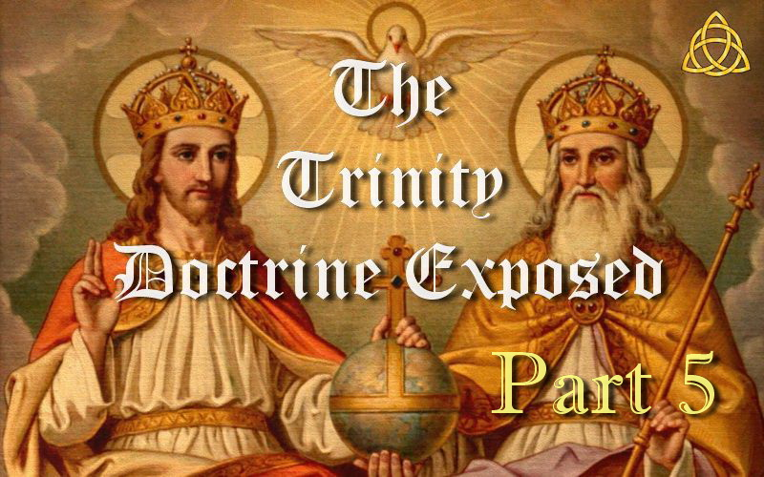

**THE TRINITY DOCTRINE EXPOSED – PART 5**

**Most Have No Idea what the Trinity Doctrine is**

The majority of professed Trinitarians have absolutely no idea what the Trinity doctrine actually is. And when some find out, they are so shocked that they go into denial and say, “That is not what I believe!”

If you do not believe the facts stated below, then you are NOT a Trinitarian! And if what you follow differs from what is explained below, then it is NOT the Trinity doctrine! It does not matter whether it be the SDA Church or any other Church. There is only ONE Trinity doctrine and it does not come in different flavours.

The Trinity doctrine says there are THREE LITERAL GODS that are equal in every way and that all THREE gods have always existed. THREE gods that are co-equal and co-eternal in other words.

But now we have a SERIOUS problem because the Bible says there is only ONE God.

SATAN via the Catholic Church says NO PROBLEM…I have just the answer to keep all deceived. We will teach that all THREE GODS are really only ONE GOD!

**1 + 1 + 1 = 1 !**

THREE LITERAL GODS that are not really 3 GODS but 1 GOD. Make sense? No! Why should it? It was made up by Satan via the Catholic Church so Satan could get worship and have Christians deny the Father and Son and not even know it !

Satan HATES the SON OF GOD and wants us to deny Him. Not only that, but we can only be saved by confessing that Jesus is the Son of God. So how does the Trinity doctrine deny the Father and Son and give worship to Satan?

If they are 3 gods that have ALWAYS existed, Jesus cannot really be a SON and therefore God cannot really be a FATHER.

And so the Bible now has hundreds of lies! More unmistakable Scriptures are denied than any other doctrine EVER ! And yet people just go on blindly believing that it is right. Like lambs to the slaughter as they say.

So God is not the Father of Christ and Christ is not the Son of God says the Trinity doctrine!

Every Scripture that says Jesus is the Son of God is now a lie. Every Scripture that says God is the Father is now a lie. How many Scriptures suddenly become a lie?....“HUNDREDS!”

The Bible says Jesus was God’s Son before He came to Earth. The Trinity doctrine says No!  
The Bible says Jesus is the Son of God. The Trinity doctrine says No! He is just ROLE PLAYING.  
The Bible says God is the Father of Christ. The Trinity doctrine says No! He is just ROLE PLAYING.

Where is there ONE Scripture that even hints they are not really a Father and Son and that they are ROLE PLAYING?

IT DOES NOT EXIST !

The Bible says the Holy Spirit is the “Spirit OF God” or the “Spirit OF the Father.” The Trinity doctrine says No! It claims it is something called “god the spirit” which has a different meaning and does NOT exist in Scripture but came from antichrist !

So instead of the Holy Spirit being the SPIRIT OF THE FATHER, it is now some third god called “god the spirit.”

And if “god the spirit” is Satan’s idea and his creation…what spirit do you have in you? And what spirit do you give your adoration to? And what spirit do you worship or pray to for those who are now doing that also?

It will be SATAN !

The third person in the Trinity is actually Satan, not the real Holy Spirit !

Christians need to wake up before it is too late.

The extract below is from a mainstream SDA book. Adventist Woodrow Whidden says that expressions such as *“Father,” “Son,” “Firstborn,*” “*Only Begotten,*” “*Begotten,*” “*the only true God*” and “*one God the Father*” are just figurative and metaphorical. Now where is there even a hint in Scripture that this is so?

“*Is it not quite apparent that the problem texts become problems only when one assumes an exclusively literalistic interpretation of such expressions as “Father,” “Son,” “Firstborn,” “Only Begotten,” “Begotten,” and so forth? Does not such literalism go against the mainly figurative or metaphorical meaning that the Bible writers use when referring to the persons of the Godhead? Can one really say that the Bible writers meant such expressions as “the only true God” and “one God the Father”…*” — (Woodrow Whidden, *The Trinity*, p. 106, 2002)

A metaphor did not send a metaphor to save us. A Father sent us His Son to save us. (John 3:16)

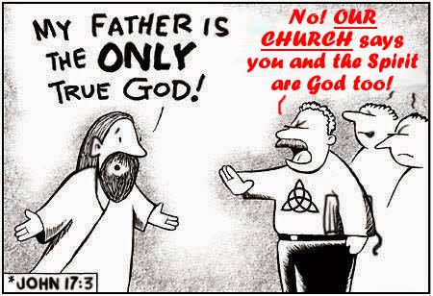

The above is an optional image that can be used if posting this part on the internet.

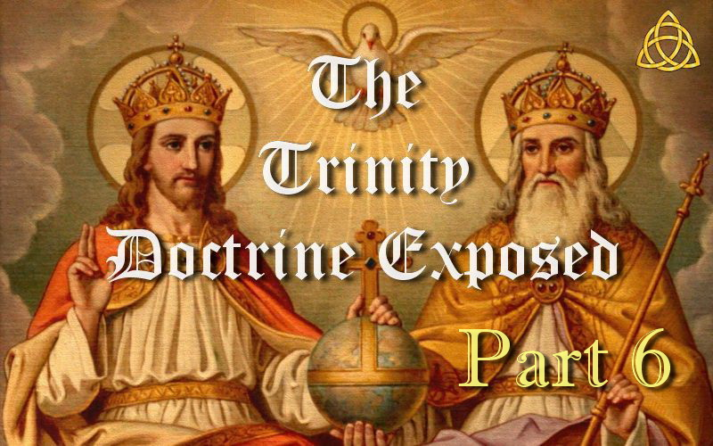

**THE TRINITY DOCTRINE EXPOSED – PART 6**

**Does the Trinity Doctrine Make Sense or is it Nonsense?**

Since the Trinity doctrine claims Jesus is also the one God, an Adventist author from the 1800's wrote,

“*To believe that doctrine, when reading the scripture we must believe that God sent Himself into the world, died to reconcile the world to Himself, raised Himself from the dead, ascended to Himself in heaven, pleads before Himself in heaven to reconcile the world to Himself, and is the only mediator between man and Himself… We must believe also that in the garden God prayed to Himself, if it were possible, to let the cup pass from Himself, and a thousand other such absurdities.*” — (J.N. Loughborough)

Some of those other absurdities it teaches is that Jesus is the immortal God but died,  
is the invisible God but was seen,  
is the omnipotent God but was strengthened by an angel,  
is the omniscient God but did not know the day of his return,  
is as great as His Father but His Father is greater than He,  
is equal with the Father and yet He is the Father,  
is the Son but the same age as the Father,  
is the Son who has a Father and the God who has no Father,  
is the begotten Son and the unbegotten God,  
is very God and very man, came out from Himself,  
prayed to Himself, gave power to Himself,  
thanked Himself, bore witness of Himself,  
went back to Himself,  
sits at the right hand of Himself,  
is His own Father and His own Son,  
left Heaven and yet was there all the time.

There are many things which are hard to understand in the Bible but you can be sure that God never expects us to believe impossibilities.

Over and over again you hear it said that the Gospel is so simple a child can understand it. And I agree. But how can that be the case with the teaching of the Trinity? Not only do children not understand it, but our best theologians cannot even explain it. However, the thought that God sent His Son to this earth to die for you and me is easy to comprehend when we believe the simple Bible statement that Jesus is truly the Son of God! Not one of three mysterious beings making up “one God.”

How can you possibly believe that Jesus is NOT the begotten Son of the eternal Father and share John 3:16 with others in the hope of inviting them to take part in eternal salvation. Doesn't John 3:16 become a lie the moment you deny He is a Son?

A metaphor did not send a metaphor to save us. A Father sent us His Son to save us.

John 3:16 “*For God so loved the world, that he gave his only begotten Son, that whosoever believeth in him should not perish, but have everlasting life.*”

2 John 1:3 “*Grace be with you, mercy, and peace, from God the Father, and from the Lord Jesus Christ, the Son of the Father, in truth and love.*”

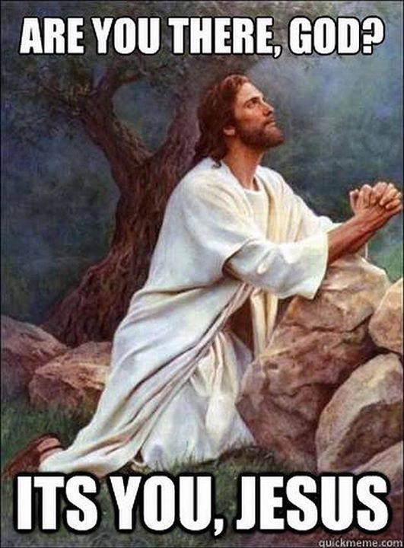

The above is an optional image that can be used if posting this part on the internet.

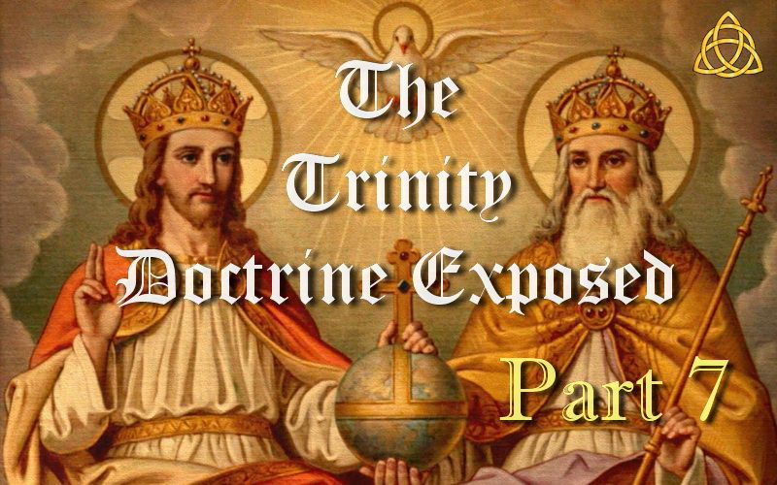

**THE TRINITY DOCTRINE EXPOSED – PART 7**

**The Bible was Written by Non-Trinitarians and So is a Non-Trinitarian Book!**

Have you ever heard it said that the word TRINITY is NOT in the Bible? The deceived often respond by saying, “*The word is NOT in the Bible but the doctrine is.*”

Not only is the word Trinity NOT in the Bible, but neither is the doctrine. And it is in fact IMPOSSIBLE for it to be in the Bible!

Here are the facts…

True Christianity originated from Judaism, not Catholic paganism. You cannot argue the doctrine of the Trinity from the words of the Jews who wrote them when they never believed in it.

Most of the Bible was in fact written by the Jews who never believed or taught the Trinity doctrine and still do not today! And Jesus of course was a Jew as were His disciples. How do you teach a 3 in 1 god from the Bible when it is a non-Trinitarian book? The apostle John for instance could never have been teaching that the Comforter and Spirit of truth is another being as the Jews have never taught or believed that ever!

So the Bible had non-Trinitarian authors in fact.

In a discussion between Summerbell and Flood on Trinity, p. 38, in regards to the Trinity he says, “*it is certain that the Jewish church held to no such doctrine. Says Mr. Summerbell, “A friend of mine who was present in a New York synagogue, asked the Rabbi for an explanation of the word 'Elohim'. A Trinitarian clergyman who stood by, replied, 'Why, that has reference to the three persons in the Trinity,' when a Jew stepped forward and said he must not mention that word again, or they would have to compel him to leave the house; for it was not permitted to mention the name of any strange god in the synagogue.*”

We also know the Bible is a non-Trinitarian book as the word Trinity did not exist until about 200 AD at which point the idea of the Holy Spirit as a third being and the 3 in 1 still did not exist. The fully developed Trinity doctrine did not exist until 381 AD.

The word “Trinity” originated from Tertullian who was a pagan turned Catholic theologian around 200 AD. This word can have no relationship with Scripture as it came from the Platonic term “trias” which is philosophical in origin, and the Bible does not teach Greek philosophy!

“*The term trinity is not itself found in the Bible. It was first used by Tertullian at the close of the 2nd century, but received wide currency and formal elucidation only in the 4th and 5th centuries.*” — (“Trinity,” *New Bible Dictionary*, 1996)

Tertullian did NOT teach the Holy Spirit as a third being and he NEVER taught the 3 in 1 god as the Trinity doctrine does today. So we know this doctrine developed in stages as Tertullian who introduced the word TRINITY did NOT teach it!

So we know that the Trinity doctrine did NOT exist before 200 AD.

It was about 225 years *“after”* the death of the Apostles that the Nicene Council (325 AD) under the pressure of Emperor Constantine ruled in favour of Athanasius who taught a 3 in 1 god.

It was about 280 years *“after”* the death of the Apostles in 381 AD when the Holy Spirit was officially declared as a third being. The Trinity doctrine was now fully established as we know it today.

So the Trinity doctrine is a manmade doctrine from the Catholic Church which was formed in two parts. The first part was made up in 325 AD which states it is a 3 in 1 god. The second and final part was made up in 381 AD. This final part states that the Holy Spirit is a third being.

So it is impossible for any of the Bible authors to have written about something that did not exist in their lifetime, and not forgetting that the Bible authors were non-Trinitarian!

Christians have been indoctrinated with many nice sounding erroneous ideas to make them think the doctrine is in the Bible when in fact it cannot be. It is time to wake up and look at what the real truth is which makes much more sense than the lie.

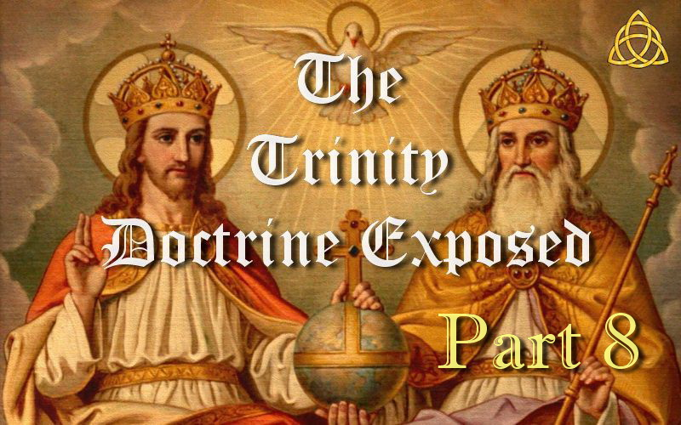

**THE TRINITY DOCTRINE EXPOSED – PART 8**

**What did the People Who Created the Trinity Doctrine Believe?**

Starting with who created the Trinity doctrine…

ATHANASIUS brought in the 3 in 1 idea in 325 AD long after the Bible was written.

And what is now known as the THREE CAPPADOCIANS brought in the idea of the Holy Spirit as a third being in 381 AD also long after the Bible was written.

ATHANASIUS and the THREE CAPPADOCIANS came from the Alexandria catechetical school, which revered ORIGEN who applied the ALLEGORICAL method of explaining Scripture, which was influenced by Plato and its strong point was PAGAN.

“*The Alexandria catechetical school, which revered Clement of Alexandria* and ORIGEN, the *greatest theologian of the Greek Church, as its heads, applied the ALLEGORICAL METHOD to the explanation of Scripture. Its thought was influenced by Plato: its strong point was [PAGAN] theological SPECULATIONS. ATHANASIUS and the THREE CAPPADOCIANS [the men whose Trinitarian views were adopted by the Catholic Church at the Councils of Nicaea and Constantinople] had been included among its members.*” — (Hubert Jedin, *Ecumenical Councils of the Catholic Church: an Historical Outline*, 1960, p. 28)

The pagan idea of the 3 in 1 god from ATHANASIUS resulted from studying the works of ORIGEN.

“*That being said, Athanasius is applying these standard arguments to a more highly developed NEO-PLATONIST PHILOSOPHY and a more cultural diverse society than any previous theologian had faced. Still,* the INFLUENCE OF ORIGEN is *felt throughout the work, particularly in Athanasius' opening statements about the existence (or rather, non-existence) of evil and the refutation of various dualistic cosmologies.*” — (Jonathan Shelley, *Critique of Athanasius Two Books against the Heathens*)

So what did ORIGEN teach and believe whose teachings educated ATHANASIUS?

Origen wrote, “*Could any man of sound judgment suppose that the first, second, and third days (of creation) had an evening and a morning, when there were as yet no sun or moon or stars? Could anyone be so unintelligent as to think that God made a paradise somewhere in the east and planted it with trees, like a farmer, or that in that paradise he put a tree of life, a tree you could see and know with your senses, a tree you could derive life from by eating its fruit with the teeth in your head? When the Bible says that God used to walk in paradise in the evening or that Adam hid behind a tree, no one, I think, will question that these are ONLY FICTITIOUS STORIES of things that NEVER ACTUALLY HAPPENED, and that figuratively they refer to certain mysteries.*” — (Tadros Y. Malaty, *Before Origen*, p. 134)

Origen also “*believed the Holy Spirit was a feminine force, that Jesus was only a created being and Gnosticism taught that Jesus became Christ at his baptism but that he was never God. He was a just a good man with very high morals. He believed in the doctrine of Purgatory, transubstantiation, transmigration of the soul and reincarnation of the soul. He doubted the temptations of Jesus in Scripture and claimed they could have never happened. The Scriptures were not literal. Genesis 1-3 was a myth, not historical or literal, as there was no actual person named “Adam.” Based upon Matthew 19, a TRUE MAN OF GOD SHOULD BE CASTRATED, WHICH HE DID TO HIMSELF. He taught eternal life was not a gift, instead one must grab hold of it and retain it. Christ enters no man until they mentally grasp the understanding of the consummation of the ages. He taught there would be no physical resurrection of the believers.*” — (See Dr. Ken Matto, Origen's Gnostic Belief System)

Origen's beliefs clearly indicate that he was a Gnostic Greek Philosopher and not a true child of God. It is these insane beliefs that brought about the Trinity doctrine!

The above is very brief information to prove a point. There is an abundance of history and evidence that reveals the Doctrine of the Trinity emanates straight from the dunghill of Roman decretals. Its origin is pagan and from Satan so he could achieve worship and have us deny Jesus is the literal Son of God, thus preventing entrance into the kingdom. It is philosophy, vain deceit and man's tradition. It denies Jesus, preaches another Jesus, another spirit and another Gospel.

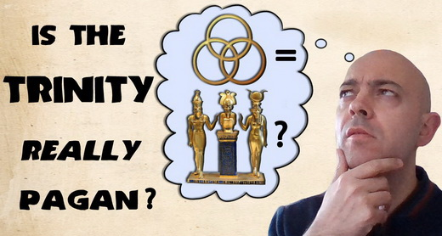

The above is an optional image that can be used if posting this part on the internet.

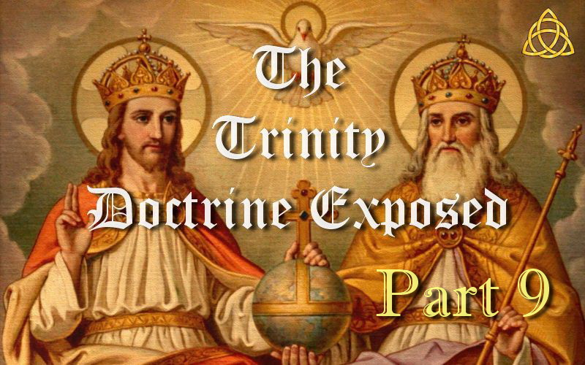

**THE TRINITY DOCTRINE EXPOSED – PART 9**

**An Attempt to Cover Up History**

Those who understand how the Papal Church came to rule for 1260 years known as the dark ages also know they had to uproot three opposing kingdoms. But were you aware that these were Arian tribes? We know Athanasius taught the unbiblical pagan view, and that the Catholic Church is known for casting truth to the ground. So it certainly makes sense that the Arians actually had Biblical truth and why these Arian tribes were all destroyed.

Daniel 8:12 “*Because of transgression, an army was given over to the HORN to oppose the daily sacrifices; and he CAST TRUTH DOWN TO THE GROUND. He did all this and prospered.*”

The HORN here is synonymous with the little horn of Daniel 7 and the first beast of Revelation 13, which is the Roman Catholic Church who have always taught error and cast truth to the ground. And so it was obviously truth that was cast to the ground when the Papacy uprooted the three opposing kingdoms, which gave them uninterrupted rule for 1260 years. These kingdoms were Arian tribes which held the non-Trinitarian view and opposed their Trinitarian view.

“*The three divisions which were plucked up were the Heruli in 493, the Vandals in 534, and the Ostrogoths in 538 A.D. Justinian, the emperor, whose seat was at Constantinople, working through the general Belisarius, was the power which overthrew the three kingdoms represented by the three horns, and THE REASON FOR THEIR OVERTHROW WAS THEIR ADHERENCE TO ARIANISM IN OPPOSITION TO THE ORTHODOX CATHOLIC FAITH. The details of the overthrow, and the religious controversy which was the root of the trouble, are fully given by Gibbon in the “Decline and Fall of the Roman Empire,*” — (S.N. Haskell, *The Story of Daniel the Prophet*, p. 117, 1908)

And further, “*The contest between ARIANISM and the orthodox CATHOLICISM was the means of ENTHRONING THE PAPACY.*” — (lbid, p. 266)

Ever since the inception of the Trinity doctrine into Christianity in the 4th century, in one way or another, Trinitarians have consistently persecuted those who did not hold to the doctrine of the Trinity. They generally regarded them as heretics and the record of Christian history shows this and it is still happening today! Now what spirit is behind persecution?

I have seen non-Trinitarians falsely accused of teaching that Christ was created as a means to discredit them. When the accusers were corrected, they still continued with their false accusations even though they knew it was not true. This of course is dishonest and can only be a deliberate attempt at discrediting non-Trinitarians. Did this same thing happen to Arius? Were rumours started to say that he taught Christ was created when in fact he did not, and was just a means of discrediting him to help the pagan doctrine of the Trinity take hold?

“*'His [Arius'] book, 'Thalia,' was burnt on the spot; and this example was so generally followed, that it became a very rare work.' — Stanley 'History of the Eastern Church,' Lecture iv, par. 39. The decree banishing Arius was shortly so modified as simply to prohibit his returning to Alexandria.*” — (A.T. Jones, *The Two Republics*, p. 351)

The Catholic Church exerted all her power to destroy any records of what Arius believed. The only records we have are those that either fell through the hands of the Catholic power, or those which they have chosen to keep, whether in their original form or altered by them.

“*An erroneous charge was circulated that all who were called Arians believed that Christ was a created being. [Footnote: It is doubtful if many believed Christ to be a created being. Generally, those evangelical bodies who opposed the papacy and who were branded as Arians confessed both the divinity of Christ and that He was begotten, not created, by the Father. They recoiled from other extreme deductions and speculations concerning the Godhead.]*” — (Benjamin G. Wilkinson, *Truth Triumphant*, p. 92)

“*Whether the teachings of Arius were such as are usually represented to us or not, who can say? Phillipus Limborch doubts that Arius himself ever held that Christ was created instead of being begotten [Footnote: Limborch, The History of the Inquisition, page 95].*” — (Benjamin G. Wilkinson, *Truth Triumphant*, p. 142)

In 538 A.D, the Arian believers were completely wiped out by the Catholic Church, leaving the Papacy as the sole “Corrector of heretics.” Anyone opposing the Catholic teaching of the Trinity was exterminated, for “*the Mystery of the Trinity is the central doctrine of the Catholic Faith.*” — (Handbook for Today's Catholic, p. 11)

So how was the Trinity doctrine finally established? Was it through careful study of the Scriptures by all parties to establish what was truth? No! It happened through decades of persecution and bloodshed and by the Papal Church murdering the three Arian tribes that opposed them! The Trinitarian view was won by taking out the opposition.

In this 50 second video, Doug Batchelor explains that the three kingdoms were uprooted because they opposed the Catholic Church and their creation of the Trinity doctrine. He quickly makes the point and changes the topic to their idolatry. His own words revealed the truth but he did not want to see it.

<https://www.youtube.com/watch?v=zDCHwZeKTzA>

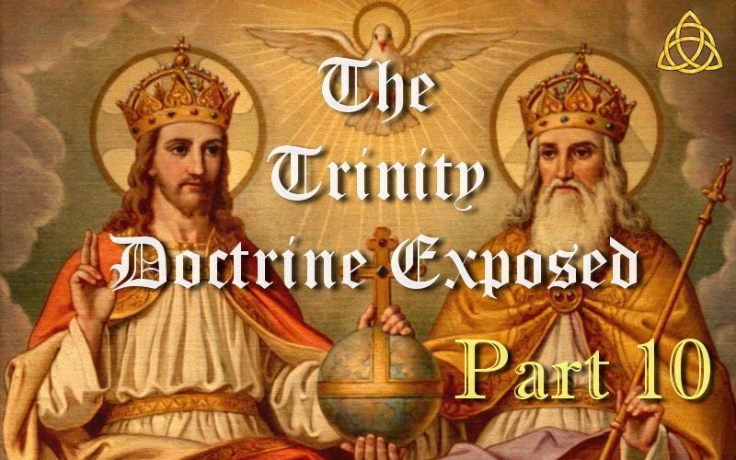

**THE TRINITY DOCTRINE EXPOSED – PART 10**

**The Idea of the Trinity Predated Christianity**

Many who believe in the Trinity are surprised to learn that the idea of divine beings existing as trinities or triads long predated Christianity. Yet the evidence is abundantly documented.

Marie Sinclair, Countess of Caithness, in her 1876 book *Old Truths in a New Light*, states, “*It is generally, although erroneously, supposed that the doctrine of the Trinity is of Christian origin. Nearly every nation of antiquity possessed a similar doctrine. [The early Catholic theologian] St. Jerome testifies unequivocally, 'All the ancient nations believed in the Trinity'.*” — (p. 382)

Notice how the following quotes document belief in a divine Trinity in many regions and religions of the ancient world.

**Sumeria**

“*The universe was divided into three regions each of which became the domain of a god. Anu's share was the sky. The earth was given to Enlil. Ea became the ruler of the waters. Together they constituted the triad of the Great Gods.*” — (*The Larousse Encyclopedia of Mythology*, 1994, pp. 54, 55)

**Babylonia**

“*The ancient Babylonians recognised the doctrine of a trinity, or three persons in one god— as appears from a composite god with three heads forming part of their mythology, and the use of the equilateral triangle, also, as an emblem of such trinity in unity.*” — (Thomas Dennis Rock, *The Mystical Woman and the Cities of the Nations*, 1867, pp. 22, 23)

**India**

“*The Puranas, one of the Hindoo Bibles of more than 3,000 years ago, contain the following passage: 'O ye three Lords! know that I recognize only one God. Inform me, therefore, which of you is the true divinity, that I may address to him alone my adorations.' The three gods, Brahma, Vishnu, and Siva [or Shiva], becoming manifest to him, replied, 'Learn, O devotee, that there is no real distinction between us. What to you appears such is only the semblance. The single being appears under three forms by the acts of creation, preservation, and destruction, but he is one.'*

*Hence the triangle was adopted by all the ancient nations as a symbol of the Deity ... Three was considered among all the pagan nations as the chief of the mystical numbers, because, as Aristotle remarks, it contains within itself a beginning, a middle, and an end. Hence we find it designating some of the attributes of almost all the pagan gods.*” (Sinclair, pp. 382, 383)

**Greece**

“*In the Fourth Century B.C. Aristotle wrote: 'All things are three, and thrice is all: and let us use this number in the worship of the gods; for, as the Pythagoreans say, everything and all things are bounded by threes, for the end, the middle and the beginning have this number in everything, and these compose the number of the Trinity'.*” — (Arthur Weigall, *Paganism in Our Christianity*, 1928, pp. 197, 198)

**Egypt**

“*The Hymn to Amun decreed that 'No god came into being before him (Amun)' and that 'All gods are three: Amun, Re and Ptah, and there is no second to them. Hidden is his name as Amon, he is Re in face, and his body is Ptah.' ... This is a statement of trinity, the three chief gods of Egypt subsumed into one of them, Amon. Clearly, the concept of organic unity within plurality got an extraordinary boost with this formulation. Theologically, in a crude form it came strikingly close to the later Christian form of plural Trinitarian monotheism.*” — (Simson Najovits, *Egypt, Trunk of the Tree*, Vol. 2, 2004, pp. 83, 84)

Egyptologist Arthur Weigall wrote:

“*It must not be forgotten that Jesus Christ never mentioned such a phenomenon [the Trinity], and nowhere in the New Testament does the word 'Trinity' appear. The idea was only adopted by the Church three hundred years after the death of our Lord; and the origin of the conception is entirely pagan ...*

*The ancient Egyptians, whose influence on early religious thought was profound, usually arranged their gods or goddesses in trinities: there was the trinity of Osiris, Isis, and Horus, the trinity of Amen, Mut, and Khonsu, the trinity of Khnum, Satis, and Anukis, and so forth ...*

*The early Christians, however, did not at first think of applying the idea to their own faith. They paid their devotions to God the Father and to Jesus Christ, the Son of God, and they recognized the mysterious and undefined existence of the Holy Spirit; but there was no thought of these three being an actual Trinity, co-equal and united in One ...*

*The application of this old pagan conception of a Trinity to Christian theology was made possible by the recognition of the Holy Spirit as the required third 'Person,' co-equal with the other 'Persons' ...*

*The idea of the Spirit being co-equal with God was not generally recognised until the second half of the Fourth Century A.D... . In the year 381 the Council of Constantinople added to the earlier Nicene Creed a description of the Holy Spirit as 'the Lord, and giver of life, who proceedeth from the Father, who with the Father and Son together is worshipped and glorified.' ...*

*Thus, the Athanasian creed, which is a later composition but reflects the general conceptions of Athanasius [the 4th-century Trinitarian whose view eventually became official doctrine] and his school, formulated the conception of a co-equal Trinity wherein the Holy Spirit was the third 'Person'; and so it was made a dogma of the faith, and belief in the Three in One and One in Three became a paramount doctrine of Christianity, though not without terrible riots and bloodshed ...*

*Today a Christian thinker ... has no wish to be precise about it, more especially since the definition is obviously pagan in origin and was not adopted by the Church until nearly three hundred years after Christ.*” — (Arthur Weigall, *Paganism in Our Christianity*, 1928, pp. 197-203)

James Bonwick summarized the story well on page 396 of his 1878 work Egyptian Belief and Modern Thought:

“*It is an undoubted fact that more or less all over the world the deities are in triads. This rule applies to eastern and western hemispheres, to north and south.*

*Further, it is observed that, in some mystical way, the triad of three persons is one. The first is as the second or third, the second as first or third, the third as first or second; in fact, they are each other, one and the same individual being. The definition of Athanasius, who lived in Egypt, applies to the trinities of all heathen religions.*”

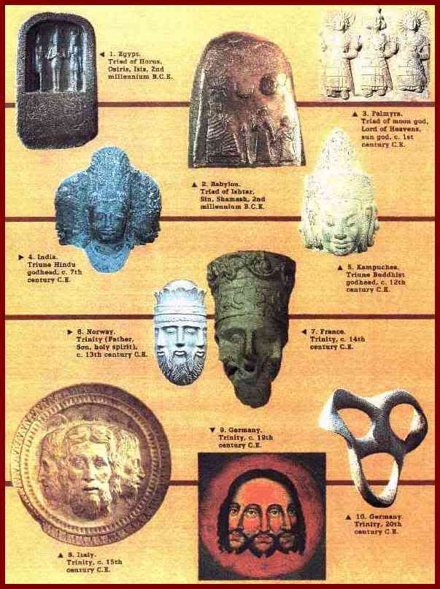

The above is an optional image that can be used if posting this part on the internet.

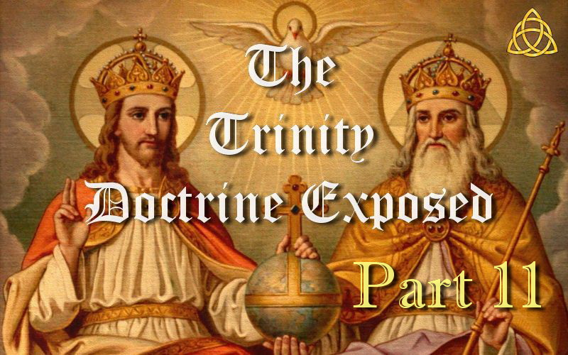

**THE TRINITY DOCTRINE EXPOSED – PART 11**

**Trinity and Sunday Worship Come From Sun and Satan Worship and 666**

Please note the following points…

1. The number 666 originates from SUN and SATAN worship.  
2. The TRIQUETRA comes from the worship of the 3 phases of the SUN  
3. The TRIQUETRA as you would expect then became an occult symbol  
4. The TRIQUETRA then found its way into the Church  
5. The TRIQUETRA is now said to represent the TRINITY  
6. Two doctrines originated from this SUN and SATAN worship and 666  
7. These are SUNDAY worship and the TRINITY as you should expect  
8. Both FALSE doctrines were brought into Christendom by Catholicism  
9. The MARK of the beast is also related to the NUMBER of the beast  
10. The MARK of the beast is about who we WORSHIP  
11. SUNDAY worship and the TRINITY are both about who we WORSHIP  
12. SUNDAY is Satan's counterfeit for the true Seventh day Sabbath  
13. The TRINITY is Satan's counterfeit for the Father, Son and Holy Spirit

James White informs us that SUNDAY worship and the TRINITY are both Satan’s counterfeits from the Catholic Church!

“*As fundamental errors, we might class with this COUNTERFEIT SABBATH other errors which Protestants have brought away from the Catholic church, such as sprinkling for baptism, THE TRINITY,*” — (James White, *RH*, Sept 12, 1854, p. 36)

The question was asked in the Catholic Catechism.

“*Q. What is Sunday, or the Lord's Day in general?*

*A. It is a day dedicated by the Apostles to the HONOUR OF THE MOST HOLY TRINITY, and in memory that Christ our Lord arose from the dead upon Sunday, sent down the holy Ghost on a Sunday, &c. and therefore is called the Lord’s Day. It is also called Sunday from the old Roman denomination of DIES SOLIS, THE DAY OF THE SUN, to which it was sacred.*” — (The Douay Catechism of 1649, p. 143)

An interesting statement considering “Sunday worship” and the “Trinity doctrine” both came from sun and Satan worship in Babylon, and they were both brought into Christendom by the Catholic Church whom God calls Babylon, and both are about who we worship, which is the issue of the mark and the number of the beast!

Note the two quotes below from the Catholic Church.

“*Most Christians assume that Sunday is the biblically approved day of worship. The Catholic Church protests that it transferred Christian worship from the biblical SABBATH (SATURDAY) TO SUNDAY, and that to try to argue that the change was made in the Bible is both dishonest and a denial of Catholic authority. If Protestantism wants to base its teachings only on the Bible, it should worship on Saturday.*” — (Rome's Challenge, immaculateheart . com/maryonline, Dec 2003)

“*Our opponents sometimes claim that no belief should be held dogmatically which is not explicitly stated in scripture ... But the Protestant Churches have themselves accepted such dogmas, AS THE TRINITY, for which there is no such precise authority in the Gospels,*” — (Assumption of Mary, *Life magazine*, Oct 30, 1950, p. 51)

It is not just the MARK OF THE BEAST but also the NUMBER OF THE BEAST which is 666.

Revelation 13:17 “*And that no man might buy or sell, save he that HAD THE MARK, or the name of the beast, or the NUMBER OF HIS NAME.*”

The pagan Babylonian priests had a chief priest who held the title Pontifex Maximus (translated to Latin meant that he was head pagan priest or literally the Greatest Pontiff). So who is Pontifex Maximus and head priest of Babylon now? The “Pontiff” or the Pope in other words!

Revelation 13:18 “*Here is wisdom. Let him that hath understanding count the NUMBER OF THE BEAST: for it is THE NUMBER OF A MAN; and HIS NUMBER IS SIX HUNDRED THREESCORE AND SIX.*”

So where do we find the number of the beast? On the Pope! The head pagan priest who this number has now been given.

Why does 666 belong to the head of the Roman Catholic Church?

Because 666 and the TRIQUETRA came from SUN and SATAN worship in Babylon, which resulted in Satan’s counterfeit Sabbath and counterfeit for the Father, Son and Holy Spirit called the TRINITY.

Considering “SUNDAY worship” and the “TRINITY doctrine” were both brought into Christendom by the beast (Papacy), then consider the following.

“*The third angel's message has been sent forth to the world, warning men against receiving the mark of the beast or of his image in their foreheads or in their hands. To receive this mark means to come to the same decision as the beast has done, and to advocate the SAME IDEAS, in direct opposition to the word of God.*” — (E.G. White, *RH*, July 13, 1897)

Ellen White wrote that there is still more to be revealed.

“*The light that we have upon the third angel's message is the true light. The mark of the beast is exactly what it has been proclaimed to be. NOT ALL IN REGARD TO THIS MATTER IS YET UNDERSTOOD nor will it be understood until the unrolling of the scroll,*” — (E.G. White, 6T 17.1, 1900)

How many are going to perish if Christians do not wake up to what is Satan's biggest and best deception? Adventists think they are fine having the Sabbath truth but are unaware Satan had a backup plan. Most are unaware that a Jesuit was used to slowly bring the Trinity doctrine in to the Adventist Church after the death of Ellen White and the pioneers.

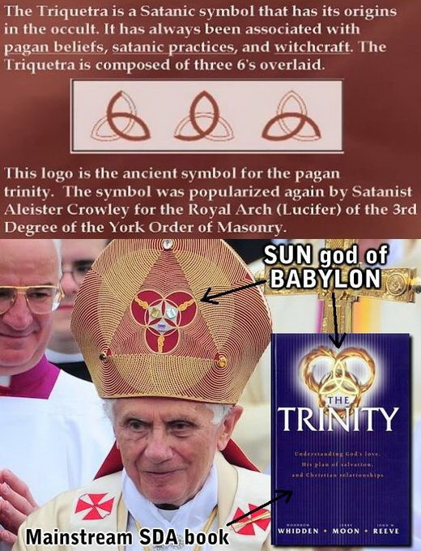

Please use the above image with this part if posting on the internet.

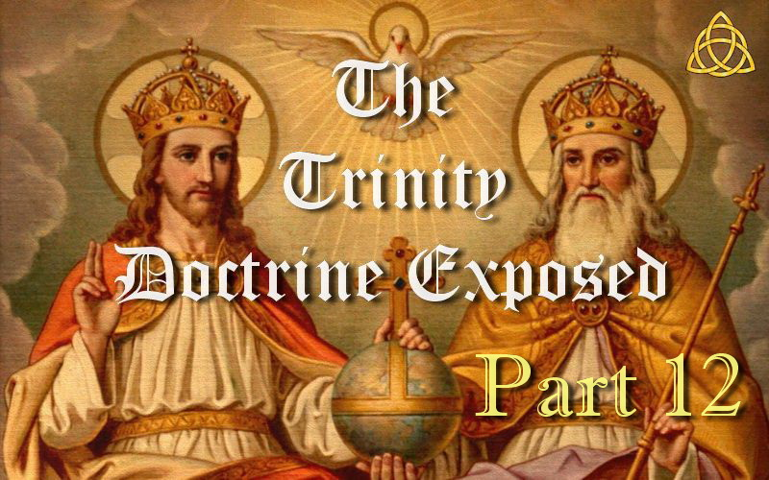

**THE TRINITY DOCTRINE EXPOSED – PART 12**

**Proof The Trinity Doctrine Is From Satan Via Sun Worship**

NOTE the TRIQUETRA on the POPES MITRE and on the book called “THE TRINITY” comes from the worship of the 3 phases of the sun. See the top three pictures on the image provided for how this symbol was made.

The TRINITY DOCTRINE teaches:

The Father is God, Jesus is God, the Holy Spirit is God, and yet there are not three gods but one God, and that's the Trinity! In other words, 1+1+1=One!

This came from SUN WORSHIP:

The rising sun was god, the midday sun was god, the setting sun was god, and yet there were not three gods but one god! In other words, 1+1+1=One!

“*(1. New born at dawn. (2. Mature and full grown at 12 noon. (3. Old and dying at the end of the day.*” — (Jordan Maxwell. BBC of America Quoted in Exposure Vol. 5, No. 6 1999)

The worship of the 3 phases of the SUN (from which we get the TRIQUETRA) was SATAN WORSHIP !

Where else do we find the TRIQUETRA?

Since this symbol comes from SATAN worship, we now find it on the robes of SATAN WORSHIPPERS and on WITCHES BOOKS ! It is a Satanic symbol from Satan worship and the evidence cannot be hidden.

So why is the TRIQUETRA on the SDA book called “THE TRINITY” and on many “BIBLES” as well as the POPES MITRE?!

Because they say it is the symbol for the TRINITY !

And they would be correct, as the TRINITY comes from the worship of the 3 phases of the SUN from which came the idea of a TRINITY being a 3 in 1 god, and more than 200 years AFTER the Bible was written.

Most Christians are totally ignorant of where this symbol came from and so it is even used on BIBLES and TRINITY BOOKS.

It reveals how ignorant Jerry Moon is who co-wrote the book “The Trinity.” He even has 3 fiery rings making up his triquetra on the front cover. Could he be a Jesuit or is he just guided by the wrong spirit?

How Satan must laugh to have this symbol in the face of Christians, on their BIBLES even, and have no idea that it is from sun and Satan worship.

Satan is so bold and so confident that he is blatantly telling Christians with this symbol that the Trinity doctrine is from him. Why would he reveal it? Because Satan knows that most are so indoctrinated with the TRINITY LIE that he can get away with this and Christians will not even know it. How right he is.

The origin of the TRIQUETRA is sun and Satan worship. From there it became an occult symbol, and then it found its way into the Church. There is no counterfeit involved as is the usual excuse from those in denial of the truth.

Christians need to wake up or millions are going to perish in this Satanic doctrine from Satan, and most have no idea why.

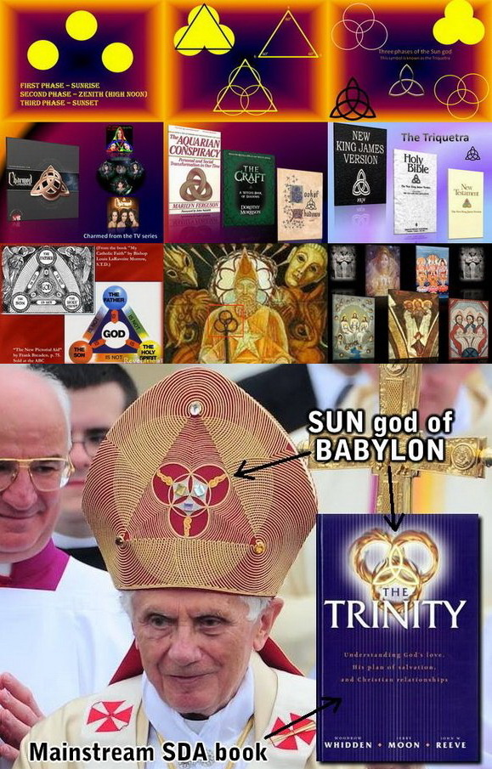

Please use the above image with this part if posting on the internet.

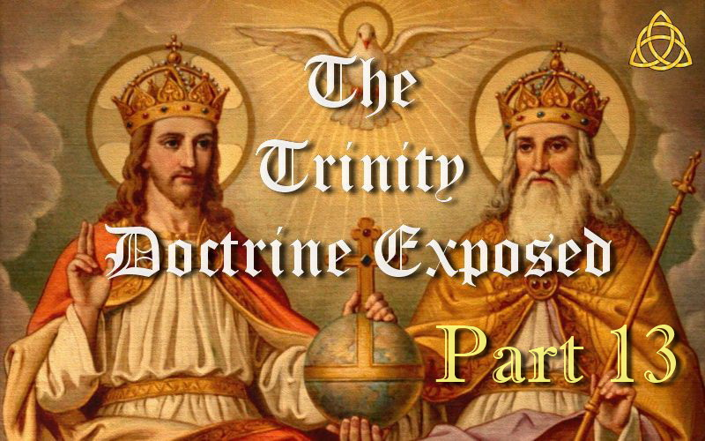

**THE TRINITY DOCTRINE EXPOSED – PART 13**

**Should Christians use the phrases God the Son and God the Spirit?**

Since the Trinity doctrine teaches a three in one God, then Trinitarians use the corresponding phrases “God the Father,” “god the son” and “god the spirit.” They call all three gods. But since the Bible says there is only one God, then Trinitarians have to say that all three are the one God.

If this were true, then indeed the Bible would use these phrases and call them all God. So is it true? Does the Bible say this? No! If there really were three God's then the Bible would use these phrases. But it doesn't because there isn't. The Bible means what it says and says what it means!

It says there is only one God being “God the Father” and so the Father is the only one called God. The phrases “god the son” and “god the spirit” do not exist anywhere in Scripture, not even once! These phrases originated from the Catholic Church and were made up to match the doctrine they created.

The Bible uses the phrase “Son of God” because that is who He is. And it uses “Spirit of God” or “Spirit of the Father” as that is what it is. So why are Trinitarians using made up phrases that have an entirely different meaning and hence are not found in the Bible?

If you are using the Catholic phrases “god the son” or “god the spirit,” that never originated from Scripture, then you are following the Papal Church and antichrist, not the inspired words of God.

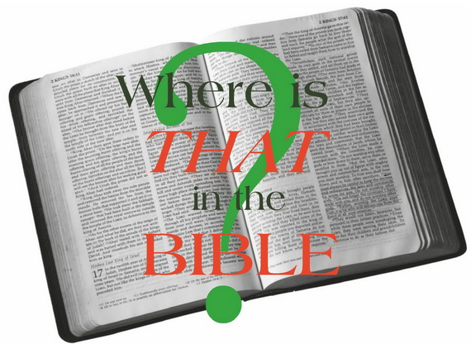

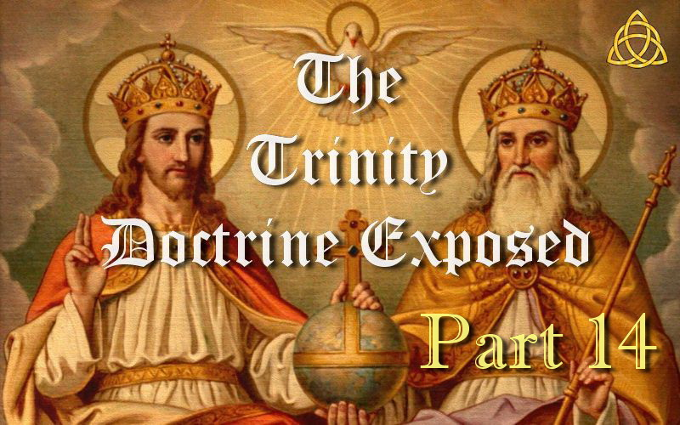

**THE TRINITY DOCTRINE EXPOSED – PART 14**

**Did the Apostles Believe in the Trinity Doctrine?**

The word “Trinity” originated from Tertullian who was a pagan turned Catholic theologian around 200 AD. This word can have no relationship with Scripture as it comes from the Platonic term “trias” which is philosophical in origin, and the Bible does not teach Greek philosophy. It is significant to note that Tertullian did not teach the Holy Spirit as a third being and he never taught the 3 in 1 god as the Trinity doctrine does today. So we know this doctrine developed in stages and could not have existed before 200 AD.

“*The term trinity is not itself found in the Bible. It was first used by Tertullian at the close of the 2nd century, but received wide currency and formal elucidation only in the 4th and 5th centuries.*” — (“Trinity,” *New Bible Dictionary*, 1996)

It was about 225 years *“AFTER”* the death of the Apostles that the Nicene Council (325 AD) under the pressure of Emperor Constantine ruled in favour of Athanasius. The proponents were Arius who believed the Father and Son were two distinct beings, and Athanasius who argued a 3 in 1 god. Most Arians dared not challenge Constantine by refusing to sign the creed but Arius did and was exiled. However, Constantine later changed his mind in favour of Arius and allowed him to return. But Arius was killed on the way which Scholars suspect Athanasius arranged. In any case, it was now Athanasius who was exiled. The chosen view changed back and forth for decades with the governing view being based on who was in power at the time and their preference.

It was about 280 years *“AFTER”* the death of the Apostles in 381 AD when the Holy Spirit was officially declared as a third being. The Trinity doctrine was now fully established as we know it today. The noted Trinitarian historian Adolph Harnack observed that up to 325 AD the majority of Christians insisted the Holy Spirit was not a third being. So neither the Apostles nor their associates who survived them, nor their descendants (the so called early Church Fathers) believed in the Trinity.

The New Bible Dictionary goes on to say, “*the formal doctrine of the Trinity was the result of several inadequate attempts to explain who and what the Christian God really is ... To deal with these problems the Church Fathers met in [A.D.] 325 at the Council of Nicaea to set out an orthodox biblical definition concerning the divine identity.” However, it wasn't until 381, “at the Council of Constantinople, the divinity of the Spirit was affirmed.*” — (lbid)

So the Trinity doctrine is a manmade doctrine from the Catholic Church which was formed in two parts. The first part was made up in 325 AD which states it is a 3 in 1 god. The second and final part was made up in 381 AD. This final part states that the Holy Spirit is a third being. Many people reject the 3 in 1 god part of this manmade doctrine but still accept the Holy Spirit part and yet both parts were made up by the Papacy. If you are going to be silly enough to believe this manmade doctrine, then you either accept both parts or reject both parts. How can you be half Trinitarian and half non-Trinitarian?

The battle over the different views went on for decades according to the politics of the Empire with more than a dozen councils held to try and solve the disputes. Whenever the Arians were dominant, they persecuted the Trinitarians, and when the Trinitarians were dominant, they persecuted the Arians. Blood literally flowed in the streets. By the 8th century, Arianism was almost eradicated. The Trinitarians proved to be more efficient in killing the Arians than the Arians in killing them. Had the Arians been more successful in killing, then the Trinity doctrine would probably not exist today. The final outcome was not the result of rational debate and pious scholarship, but power, politics and the shedding of blood.

So did the Apostles believe in the Trinity? How could they have. It is impossible for the Apostles to have believed or written about this manmade doctrine that did not exist for more than three lifetimes *“AFTER”* their death. So if you think that Scripture shows a 3 in 1 god and the Holy Spirit to be another being, think again. It is just a believable sounding idea you have been indoctrinated with as the Apostles could never have written about something that did not even exist in their time.

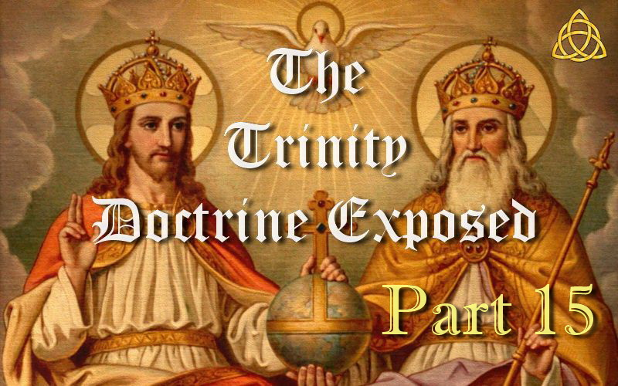

**THE TRINITY DOCTRINE EXPOSED – PART 15**

**Why do most Churches Believe in the Trinity Doctrine?**

It is the same reason that most Churches worship on Sunday instead of the Seventh day Sabbath. Over 550 denominations now know that the Catholic Church changed the Sabbath to Sunday just before the dark ages, which was a 1260 year period where the Papal Church ruled as Church and State and persecuted Christians they called heretics. This included Sabbath keepers who would rather obey God than man. With the arrival of the printing press in the 15th century and the resulting explosion of Bibles it became very apparent that the Catholic Church was a power identified in Scripture.

“*John Wycliffe, William Tyndale (translated the Bible - Tyndale Bible), Martin Luther, John Calvin, Thomas Cranmer; in the seventeenth century, Bunyan, the translators of the King James Bible and the men who published the Westminster and Baptist confessions of Faith; Sir Isaac Newton, John Wesley, Whitfield, Jonathan Edwards; and more recently Spurgeon, Bishop J.C. Ryle and Dr. Martin Lloyd-Jones; these men among countless others, all saw the office of the Papacy as the antichrist.*” — (Michael de Semlyen, *All Roads Lead to Rome*, Dorchestor House Publications, p. 205, 1991)

This knowledge resulted in the Protestant Reformation as many realized the Catholic Church was the antichrist power. The true Sabbath was almost totally persecuted out of existence by this time and so all the new Churches that resulted from the Protestant Reformation continued keeping Sunday in ignorance and why it has such a stronghold today.

But it was not just Sunday keeping that came out of the Protestant Reformation but also the Trinity doctrine. Constantine played a role in both in fact. He instituted the first Sunday law in 321 AD and the Trinity in 325 AD in the council of Nicea. Just four years apart and both from the same sun worshipping Emperor and both originated from sun worship. And so both the Trinity doctrine and Sunday worship originated from sun and Satan worship in Babylon and were brought into Christendom by the Catholic Church whom God calls Babylon.

Sun-day is Satan's counterfeit for the true Sabbath and the Trinity doctrine is Satan's counterfeit for the Godhead.

“*As fundamental errors, we might class with this COUNTERFEIT SABBATH other errors which Protestants have brought away from the Catholic church, such as sprinkling for baptism, THE TRINITY,*” — (J.S. White, *RH*, Sept 12, 1854, p. 36)

We find this question in the Catholic Catechism, “*What is Sunday...*” The answer was that Sunday “*is a day dedicated by the Apostles to the honor of the most holy Trinity.*” — (*RH*, vol. 5, no. 24, p. 86)

Thus both these doctrines are closely related with the exact same origin. So when the Protestant Reformation began, all the new Protestant Churches continued with Sunday worship and the Trinity doctrine in ignorance, and very few have questioned either. As a result most Churches now keep Sunday and believe in the Trinity doctrine, and anyone who tries to share either of these truths is looked upon as a heretic rather than a person who has studied and found the truth.

The Adventist Church was the first mainstream Church to have the truth on both the Sabbath and the Trinity doctrine. But after all the early pioneers had died, a suspected Jesuit infiltrated the Church and slowly brought the Trinity doctrine in by searching for quotes from Ellen White which could be easily misinterpreted unless you looked at what else she wrote. As a result, Adventists today think she became a Trinitarian because of her use of the phrases third person, heavenly trio and calling the Holy Spirit a person. But she was in fact referring to the Holy Spirit of Christ and not a third being. There is a growing count of over 550 Sabbath keeping denominations now but most are still trapped in Trinitarianism.

Note the following two quotes from the Catholic Church who state that neither is based on the Bible.

“*Most Christians assume that Sunday is the biblically approved day of worship. The Catholic Church protests that it transferred Christian worship from the biblical SABBATH (SATURDAY) TO SUNDAY, and that to try to argue that the change was made in the Bible is both dishonest and a denial of Catholic authority. If Protestantism wants to base its teachings only on the Bible, it should worship on Saturday.*” — (Rome's Challenge, immaculateheart . com/maryonline, Dec 2003)

“*Our opponents sometimes claim that no belief should be held dogmatically which is not explicitly stated in scripture ... But the Protestant Churches have themselves accepted such dogmas, AS THE TRINITY, for which there is no such precise authority in the Gospels,*” — (Assumption of Mary, *Life* magazine, Oct 30, 1950, p. 51)

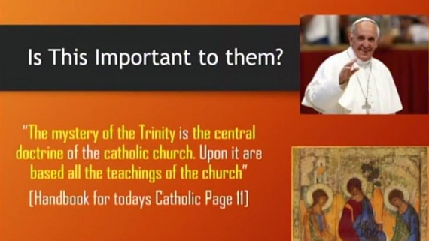

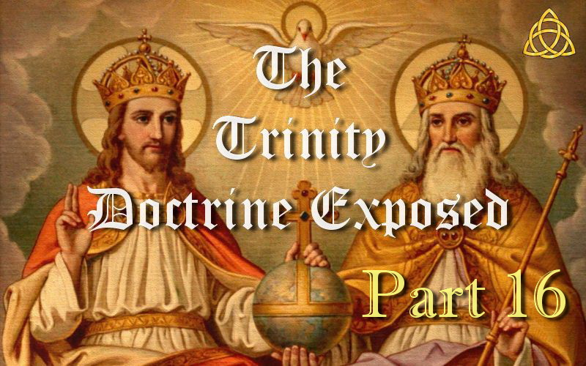

**THE TRINITY DOCTRINE EXPOSED – PART 16**

**Is the Trinity Doctrine Antichrist?**

The four verses below are the only Scriptures in the entire Bible which use the word antichrist. Note that those who John called antichrist were part of his Church but apostatized and went out on their own (see <text>) and hence were in the world in his lifetime (see capitalized TEXT). Thus these people John called antichrist used to be with him as professed Christians but began teaching serious error. So what error did they teach that caused John to call them antichrist? (see **text**)

The Trinity doctrine claims it was the one God playing the role of the Son who died on the cross and hence denies it was the literal Son of God that came in the flesh and died on the cross. Denying Jesus is the literal Son of God also means God cannot be a literal Father and so it denies both the Father and Son. Note carefully 1 John 2:22-23.

1 John 2:18-19 “*it is the last time: and as you have heard that antichrist shall come, EVEN NOW ARE THERE MANY ANTICHRISTS; whereby we know that it is the last time. 19 <They went out from us>, but they were not of <us>; for if they had been of <us>, they would no doubt have continued with <us>: but they went out, that they might be made manifest that they were not all of <us>.*”

1 John 2:22-23 “*Who is a liar but he that denieth that Jesus is the Christ? **He is antichrist, that denieth the Father and the Son**. 23 Whosoever denieth the Son, the same has not the Father: (but) he that acknowledgeth the Son has the Father also.*”

1 John 4:3 “*And every spirit that **confesseth not that Jesus Christ is come in the flesh is not of God**: and THIS IS THAT SPIRIT OF ANTICHRIST, whereof you have heard that it should come; AND EVEN NOW ALREADY IS IT IN THE WORLD.*”

2 John 1:7 “*FOR MANY DECEIVERS ARE ENTERED INTO THE WORLD, **who confess not that Jesus Christ is come in the flesh**. THIS IS A DECEIVER AND AN ANTICHRIST.*”

At the Protestant Reformation the Papacy was first identified as the first beast of Revelation 13 and is synonymous with what John called antichrist. The Catholic Church responded with the Counter Reformation where they commissioned two Jesuits to manufacture false doctrines to take the focus off them being identified as antichrist. This is where the false idea of a one man antichrist originated which Scripture never teaches. Considering what John wrote on antichrist, it becomes obvious that the way the Papacy denies the Father and Son is by their creation of the Trinity doctrine, which has corrupted most of Christendom.

Many believe their faith is well grounded in the doctrine of the Trinity, yet this teaching is the foundational teaching of antichrist which makes it impossible to build on the true rock—Christ the Son of the living God. The Handbook for Today's Catholic, page 11 says, “*The mystery of the trinity is the central doctrine of the Catholic faith.*” The antichrist power has built on the premise that Jesus is not the literal Son of God, thus denying the Father and Son relationship. God's true Church will build on the foundation that Peter declared in Matthew 16:13-18: “*Thou art the Christ, the Son of the living God ... and upon this rock I will build my Church.*” To believe the Trinity teaching is actually to be walking in the footsteps of antichrist.

And since the Trinity doctrine teaches 3 co-equal beings, then why did John fail to include denying the Holy Spirit if it were really a third co-equal being? The answer is simple. Because the Holy Spirit is not a third being but a third entity being their Holy Spirit. As John also said, “*truly our fellowship is with the Father, and with his Son Jesus Christ.*” 1 John 1:3

Only two beings alone as John taught, “*The Father and the Son ALONE are to be exalted.*” — (E.G. White, *YI*, July 7, 1898)

What teaching is antichrist according to Ellen White?

“*Here the apostle has pointed out one of the marked characteristics of spiritualist teachers. They refuse to acknowledge Christ as the Son of God. Concerning such teachers the beloved John declares: “Who is a liar but he that denieth that Jesus is the Christ? He is ANTICHRIST, that denieth the Father and the Son. Whosoever denieth the Son, the same hath not the Father.” 1 John 2:22, 23. Spiritualism, by denying Christ, denies both the Father and the Son, and the Bible pronounces it the manifestation of ANTICHRIST.*” — (E.G. White, *PP*, p. 686.1)

“*Those who become confused in their understanding of the word, who fail to see the meaning of antichrist, will surely place themselves on the side of antichrist.*” — (E.G. White, *7BC*, 949)

Could it be that the way the antichrist denies the Father and Son is by introducing the Trinity doctrine into Christianity, which destroys their true relationship by denying the personality of God and His Son? Remember that the antichrist according to the Scriptures is not a secular power but a religious one that destroys the true essence of the gospel.

Note what else Ellen White wrote on this,

“*Who is a liar but he that denieth that Jesus is the Christ? He is antichrist, that denieth the Father and the Son. Whosoever denieth the Son, the same hath not the Father; [but] he that acknowledgeth the Son hath the Father also. (Par. 17) ... He who denies the personality of God and of his Son Jesus Christ, is denying God and Christ. “If that which ye have heard from the beginning shall remain in you, ye also shall continue in the Son, and in the Father.*” — (E.G. White, *RH*, March 8, 1906, p. 9)

So what wrong belief *denies the personality of God and His Son* which is *denying God and Christ?*

Her husband said, “*Here we might mention the TRINITY, which does away [with] the personality of God, and of his Son Jesus Christ,*” — (James White, *RH*, Dec 11, 1855, p. 85)

So if you believe in the Trinity doctrine then you deny the personality of God and His Son which Ellen White says denies God and Christ, which both the Apostle John and Ellen White said is antichrist. No longer is their personality that of a true Father and Son. To be called antichrist obviously means being excluded from the kingdom.

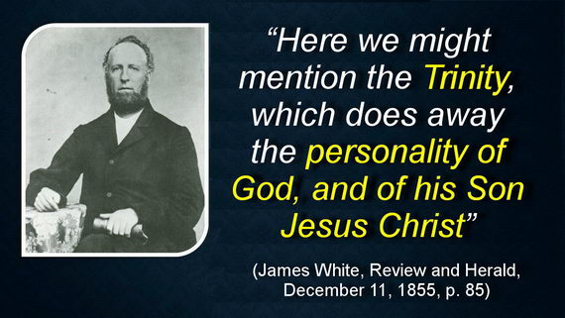

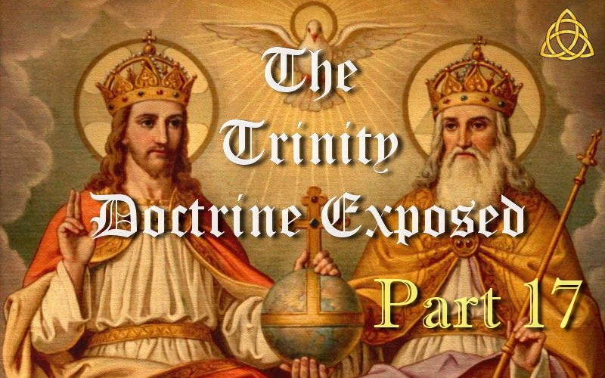

**THE TRINITY DOCTRINE EXPOSED – PART 17**

**Why Can't Theologians Explain the Trinity Doctrine?**

The doctrine of the Trinity states that “*the Father is God, the Son is God, and the Holy Spirit is God, and yet there are not three gods but one God.*” In other words, 1+1+1=One! When it comes to explaining how this can be, our best theologians cannot explain it. It is declared as a mystery that cannot be explained and so we are told to just accept it.

The Trinity doctrine was not formalized until long after the Bible was completed and the apostles were long dead in their graves, and long after the man who introduced the word Trinity was dead and in his grave. It took later theologians centuries to sort out what they believed and to formulate the belief in the Trinity!

The *New Bible Dictionary* says that “*the formal doctrine of the Trinity was the result of several inadequate attempts to explain who and what the Christian God really is ... To deal with these problems the Church Fathers met in [A.D.] 325 at the Council of Nicaea to set out an orthodox biblical definition concerning the divine identity.” However, it wasn't until 381, “at the Council of Constantinople, [that] the divinity of the Spirit was affirmed.*”

By no means are theologians' explanations of the Trinity doctrine clear. Religious writer A.W. Tozer in his book *The Knowledge of the Holy* states that the Trinity is an “*incomprehensible mystery*” and that attempts to understand it “*must remain forever futile.*” He admits that Churches, “*without pretending to understand,*” have nevertheless continued to teach this doctrine (1961, pp. 17, 18) He then remarkably concludes, “*The fact that it cannot be satisfactorily explained, instead of being against it, is in its favor.*” — (p. 23)

*The New Unger's Bible Dictionary* in its article on the Trinity concedes that the Trinitarian concept is humanly incomprehensible, “*It is admitted by all who thoughtfully deal with this subject that the Scripture revelation here leads us into the presence of a deep mystery; and that all human attempts at expression are of necessity imperfect.*” — (1988, p. 1308)

Cyril Richardson, professor of Church history at New York's Union Theological Seminary, though a dedicated Trinitarian himself said this in his book, “*My conclusion, then, about the doctrine of the Trinity is that it is an artificial construct ... It produces confusion rather than clarification; and while the problems with which it deals are real ones, the solutions it offers are not illuminating. It has posed for many Christians dark and mysterious statements, which are ultimately meaningless, because it does not sufficiently discriminate in its use of terms.*” — (*The Doctrine of The Trinity*, 1958, pp. 148-149)

He also admitted, “*Much of the defense of the Trinity as a 'revealed' doctrine, is really an evasion of the objections that can be brought against it.*” — (p. 16)

*A Dictionary of Religious Knowledge* states regarding the Trinity, “*Precisely what that doctrine is, or rather precisely how it is to be explained, Trinitarians are not agreed among themselves.*” — (Lyman Abbott, editor, 1885, “Trinitarians”)

Why do even those who believe in the Trinity doctrine find it so difficult to explain?

The answer is simple yet shocking. It is because the Bible does not teach it! One cannot prove or explain something from the Bible that is not Biblical. The Bible is our only reliable source of divine revelation. And the truth as we will see is that the Trinity concept simply is not part of God's revelation to mankind. It is a doctrine of devils to steal souls from the kingdom.

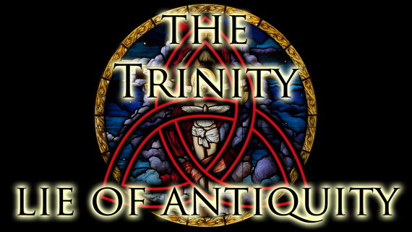

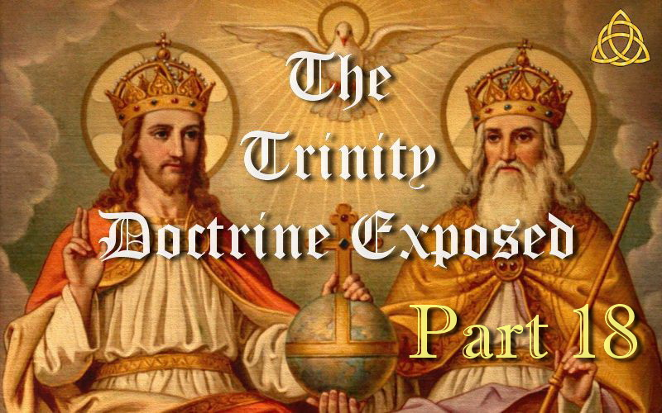

**THE TRINITY DOCTRINE EXPOSED – PART 18**

**Is the Word Trinity Found in the Bible?**

Many people assume that God the Father, Jesus Christ the Son, and the Holy Spirit form a 3 in 1 god which is commonly known as the Trinity. But did you realize that even though it is a common assumption among many sincere Christian people, the word TRINITY does not appear anywhere in the Bible?

The word TRINITY did not come into common use as a religious term until *centuries after* the last books of the Bible were completed and long after the apostles of Christ were gone from the scene.

Notice this admission in the *New Bible Dictionary*, “*The term trinity is not itself found in the Bible. It was first used by Tertullian at the close of the 2nd century, but received wide currency [common use in intellectual discussion] and formal elucidation [clarification] only in the 4th and 5th centuries.*” — (1996, “Trinity”)

These following admissions from a number of reputable sources and authors who, while themselves affirming the Trinity, acknowledge that BOTH the word Trinity AND the doctrine are not found in the Bible.

The International Standard Bible Encyclopedia acknowledges that “*'trinity' is a second-century term found nowhere in the Bible, and the Scriptures present no finished trinitarian statement.*” — (1988, Vol. 4, “Trinity,” p. 914). It further states that “*church fathers crystallized the doctrine in succeeding centuries*”—long after the apostles had passed from the scene.

Martin Luther who was the German priest who initiated the Protestant Reformation said, “*It is indeed true that the name 'Trinity' is nowhere to be found in the Holy Scriptures, but has been conceived and invented by man.*” — (reproduced in The Sermons of Martin Luther, John Lenker, editor, Vol. 3, 1988, p. 406)

Historian and science fiction writer H.G. Wells in his noted work *The Outline of History* stated, “*There is no evidence that the apostles of Jesus ever heard of the trinity—at any rate from him.*” — (1920, Vol. 2, p. 499)

The HarperCollins Encyclopedia of Catholicism says, “*Today, however, scholars generally agree that there is no doctrine of the Trinity as such in either the OT or the NT ... It would go far beyond the intention and thought-forms of the OT to suppose that a late-fourth-century or thirteenth-century Christian doctrine can be found there ... Likewise, the NT does not contain an explicit doctrine of the Trinity.*” — (Richard McBrien, general editor, 1995, “God,” pp. 564, 565)

And the HarperCollins Bible Dictionary states, “*The formal doctrine of the Trinity as it was defined by the great church councils of the fourth and fifth centuries is not to be found in the NT.*” — (Paul Achtemeier, editor, 1996, “Trinity”)

Professor Charles Ryrie wrote, “*Many doctrines are accepted by evangelicals as being clearly taught in the Scripture for which there are no proof texts. The doctrine of the Trinity furnishes the best example of this. It is fair to say that the Bible does not clearly teach the doctrine of the Trinity . . . In fact, there is not even one proof text, if by proof text we mean a verse or passage that 'clearly' states that there is one God who exists in three persons.*” — (Basic Theology, p. 89)

He goes on to say, “*The above illustrations prove the fallacy of concluding that if something is not proof texted in the Bible we cannot clearly teach the results . . . If that were so, I could never teach the doctrine of the Trinity.*” — (lbid, p. 90)

Shirley Guthrie, professor of theology at Columbia Theological Seminary wrote, “*The Bible does not teach the doctrine of the Trinity. Neither the word 'trinity' itself nor such language as 'one-in-three,' 'three-in-one,' one 'essence' (or 'substance'), and three 'persons,' is biblical language. The language of the doctrine is the language of the ancient church taken from classical Greek philosophy.*” — (Christian Doctrine, 1994, pp. 76, 77)

Millard Erickson who is a research professor of theology at Southwestern Baptist Theological Seminary writes that the Trinity “*is not clearly or explicitly taught anywhere in Scripture, yet it is widely regarded as a central doctrine, indispensable to the Christian faith. In this regard, it goes contrary to what is virtually an axiom of biblical doctrine, namely, that there is a direct correlation between the scriptural clarity of a doctrine and its cruciality to the faith and life of the church.*

*In view of the difficulty of the subject and the great amount of effort expended to maintain this doctrine, we may well ask ourselves what might justify all this trouble.*” — (God in Three Persons: A Contemporary Interpretation of the Trinity, p. 12)

He further states that the Trinity teaching “*is not present in biblical thought, but arose when biblical thought was pressed into this foreign mold [of Greek concepts]. Thus, the doctrine of the Trinity goes beyond and even distorts what the Bible says about God.*” — (lbid, p. 20)

He also stated, “*It is claimed that the doctrine of the Trinity is a very important, crucial, and even basic doctrine. If that is indeed the case, should it not be somewhere more clearly, directly, and explicitly stated in the Bible? If this is the doctrine that especially constitutes Christianity's uniqueness ... how can it be only implied in the biblical revelation? ... For here is a seemingly crucial matter where the Scriptures do not speak loudly and clearly.*

*Little direct response can be made to this charge. It is unlikely that any text of Scripture can be shown to teach the doctrine of the Trinity in a clear, direct, and unmistakable fashion.*” — (lbid, pp. 108, 109)

Since the Trinity is not found in the Bible as so many scholars and theologians admit, then how did it come to be viewed as such an important teaching? Theology professors Roger Olson and Christopher Hall explain part of the puzzle in their book:

“*It is understandable that the importance placed on this doctrine is perplexing to many lay Christians and students. Nowhere is it clearly and unequivocally stated in Scripture ... How can it be so important if it is not explicitly stated in Scripture? ...*

*The doctrine of the Trinity developed gradually after the completion of the New Testament in the heat of controversy, but the church fathers who developed it believed they were simply exegeting [explaining] divine revelation and not at all speculating or inventing new ideas. The full-blown doctrine of the Trinity was spelled out in the fourth century at two great ecumenical (universal) councils: Nicea (325 A.D.) and Constantinople (381 A.D.).*” — (*The Trinity*, 2002, pp. 1, 2)

We see from this and other sources quoted above that the idea of a Trinity was foreign to Biblical writers. Instead, as many of these sources openly acknowledge, the Trinity doctrine developed considerably later and over a span of several centuries. To understand the factors that led to the introduction of this belief, you would have to go way back to Babel.

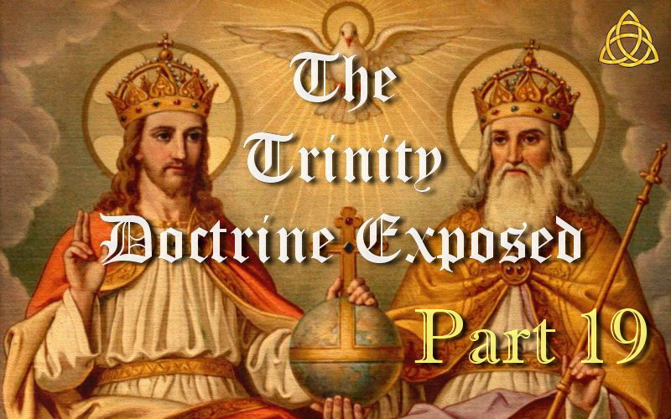

**THE TRINITY DOCTRINE EXPOSED – PART 19**

**What is the difference between Godhead and Trinity?**

So what does the word Godhead mean and can it be used in place of the word Trinity? The fact is there is no relationship with the Trinity and the word Godhead at all as you are about to find out. Godhead refers to God the Father.

And making this issue a little more confusing, Godhead is often a word used by those with the non-Trinitarian truth for lack of a better word to use in opposition to the word Trinity.

More and more Trinitarians are using the word Godhead in place of Trinity thinking that changes what it is. But calling the Trinity by another name will never change what it is. You can call a cat a dog but it will still be a cat. And you can call the Trinity the Godhead but it will still be the Trinity!

The word Godhead is found in 3 verses in the King James Bible which are translated from three different Greek words that have slightly different meanings but all basically mean the same thing.

In Acts 17:29 the Greek word translated Godhead is “theios” (G2304) and means to be godlike and hence divine.

Acts 17:29 KJV “Forasmuch then as we are the offspring of God, we ought not to think that the Godhead is like unto gold, or silver, or stone, graven by art and man's device.”

The same Greek word is used in the verse below but has been translated to the word “divine.”

2 Peter 1:3 KJV “According as his divine power has given unto us all things that pertain unto life and godliness, through the knowledge of him that has called us to glory and virtue:”

In Romans 1:20 the Greek word translated Godhead is “theiotēs” (G2305) and refers to the divine nature.

Romans 1:20 KJV “For the invisible things of him from the creation of the world are clearly seen, being understood by the things that are made, even his eternal power and Godhead; so that they are without excuse:”

And in Colossians 2:9 the Greek word translated Godhead is “theotēs” (G2320) and means deity as in the state of being God.

Colossians 2:9 KJV “For in him dwelleth all the fulness of the Godhead bodily.”

So the word Godhead speaks of the “Divine nature” of the Father which has been given to the Son and hence is in the Son as we find in Colossians 2:9 above. Thus Jesus being the firstborn over all creation (Colossians 1:15), and being brought forth from the Father, He has the same “Divine nature” as His Father. Thus Paul states that the fullness of the “divine nature” of God dwells in His Son.

Colossians 1:19 KJV “For it pleased the Father that in him should all fulness dwell;”

Spirit of Prophecy is also very clear which says. “*The Father is all the fullness of the Godhead bodily, and is invisible to mortal sight.*” — (E.G. White, BTS, March 1, 1906) And so Christ being the Son receives this fullness, “*He [Christ] was not the Father but in him dwelt all the fullness of the Godhead bodily,*” — (E.G. White, Lt8a, July 7, 1890)

John 5:26 also tells us that the Father gave life to His Son. “For as the Father has life in himself; so has he given to the Son to have life in himself.” John 5:26. If Jesus had always existed alongside the Father as the Trinity doctrine claims, then God could not have given life to His Son as He would have always had life. But Scripture reveals this is impossible.

And so neither does the word Godhead explain the non-Trinitarian position in opposition to the word Trinity. It has been the only real option in lack of a better word to use for the non-Trinitarian view.

The Trinity doctrine states that there are three co-equal (equal in every respect), co-eternal (the same age), omniscient (all knowing), omnipotent (all powerful) gods, who are not three gods, but one god.

By the words of the Athanasian Creed it is, “the Father is God, the Son is God, and the Holy Spirit is God, and yet there are not three gods but one God.”

In other words. 1+1+1=1 !

So a 3 in 1 and 1 in 3 god which means the Father cannot really be a Father and the Son cannot really be a Son, which denies the Father and Son which the apostle John called antichrist. And hence the Holy Spirit is supposedly a third god that makes up the one god rather than being the actual Spirit of the Father and Son just as we have a spirit.

So the Divine nature of the Father referring to the ONE true God does not and cannot equal 3 gods yet alone a 3 in 1 god.

Thus Godhead does NOT equal Trinity in any way whatsoever! Godhead refers to God the Father and His Divine nature which dwells in His Son because Jesus Christ is His Son.

See “Does Godhead mean Trinity? - Prove All Things” below for more information.

<https://www.youtube.com/watch?v=n9HxDgBZl-U>

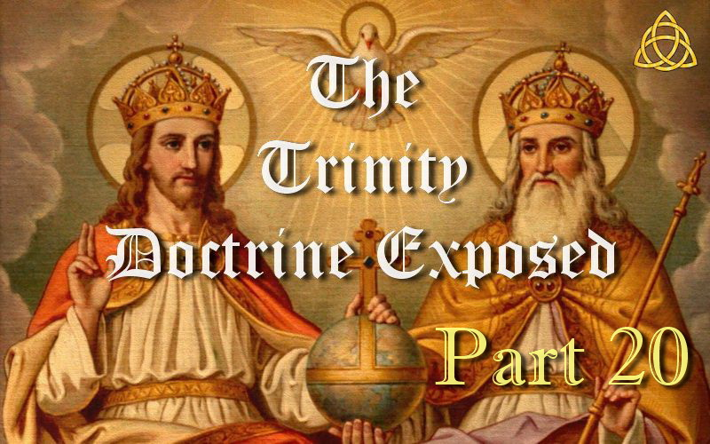

**THE TRINITY DOCTRINE EXPOSED – PART 20**

**Does 1 John 5:7-8 Have Added Text?**

Some person or persons in centuries past were so zealous to find support for their belief in the Trinity that they literally added it. There are numerous Scholars in fact that inform us that this passage has a spurious comment which has been added. The textual Scholar Bart Ehrman described this forgery as follows: “*…this represents the most obvious instance of a theologically motivated corruption in the entire manuscript tradition of the New Testament.*”

Thus the scholarly consensus is that this passage is a Latin corruption that found its way into a Greek manuscript at an early date while being absent from the THOUSANDS of other manuscripts. This addition is so famous and hence so well known that it has even been given its own name and is called the “Comma Johanneum.” Comma means a short clause.

Modern Bible translations come from two manuscripts called the Codex Sinaiticus, which has more edits than any other manuscript in Biblical history (14800 edits), and the Codex Vaticanus which comes from the Vatican. These two manuscripts do NOT contain the Comma Johanneum and why this added text is not found in modern Bible translations other than the NKJV where it was added only to match the KJV.

The King James New Testament on the other hand was compiled from over 5000 copies of copies of the original manuscripts which have long since perished. Now please take careful note that this added text was found in only ONE of the 5000 plus manuscripts. THAT MEANS ADDED! And so there is not one major theologian that does not acknowledge this fact. And yet considering all the irrefutable facts, it is amazing that there are still some who go into denial rather than acknowledge this well-known corruption that is so famous that it has even been given its own name!

The English King James Bible translated in 1611 AD retains this Trinitarian forgery, but none of our modern translations have it except the NKJV where it was added to match the KJV. The King James Version reads as follows, “*For there are three that bear record IN HEAVEN, THE FATHER, THE WORD, AND THE HOLY GHOST: AND THESE THREE ARE ONE. 8 AND THERE ARE THREE THAT BEAR WITNESS IN EARTH, the Spirit, and the water, and the blood: and these three agree in one.*” 1 John 5:7-8

Thus the words in CAPS are found in the KJV, NKJV but are missing from almost every other translation. Thomas Nelson and Sons Catholic Commentary, 1951, page 1186 states, “*It is now generally held that this passage, called the Gomma Johanneum, is a gloss that crept into the text of the Old Latin and Vulgate at an early date, but found its way into the Greek text only in the 15th and 16th centuries.*”

Here is how 1 John 5:7-8 reads from the NIV and most other Bible translations. “*For there are three that testify: 8 the Spirit, the water and the blood; and the three are in agreement.*”

Erasmus did not include the infamous Comma Johanneum of 1 John 5:7-8 in either his 1516 or 1519 editions of his Greek New Testament but made its way into his third edition in 1522 because of pressure from the Catholic Church. After his first edition appeared in 1516, there arose such a furor over the absence of the *Comma* that Erasmus needed to defend himself. He argued that he did not put in the *Comma* Trinitarian formula because he found no Greek manuscripts that included it. Once one was produced called the Codex 61, that was written by one Roy or Froy at Oxford in c. 1520, he reluctantly agreed to include it in his subsequent editions. Erasmus probably altered the text because of politico-theologico-economic concerns. He did not want his reputation ruined, nor his *Novum Instrumentum* to go unsold. Thus it passed into the Stephanus Greek New Testament in 1551 (first New Testament in verses), which came to be called the Textus Receptus, and became the basis for the Geneva Bible New Testament in 1557 and the Authorized King James Version in 1611. Note the image of the Codex 61 with the added words underlined in red.

“*The passage as given in the KJV is in no Greek MS earlier than the 15th and 16th centuries. The disputed words found their way into the KJV by way of the Greek text of Erasmus (see Vol. V, p. 141). It is said that Erasmus offered to include the disputed words in his Greek Testament if he were shown even one Greek MS that contained them. A library in Dublin produced such a MS (known as 34), and Erasmus included the passage in his text. It is now believed that the later editions of the Vulgate acquired the passage by the mistake of a scribe who included an exegetical marginal comment in the Bible text that he was copying. The disputed words have been widely used in support of the doctrine of the Trinity, but, in view of such overwhelming evidence against their authenticity, their support is valueless and should not be used. In spite of their appearance in the Vulgate A Catholic Commentary on Holy Scripture freely admits regarding these words: “It is now generally held that this passage, called the Comma Johanneum, is a gloss that crept into the text of the Old Latin and Vulgate at an early date, but found its way into the Greek text only in the 15th and 16th centuries” (Thomas Nelson and Sons, 1951, p. 1186).*” — (*The Seventh-day Adventist Bible Commentary*, vol. 7, p. 675)

The Seventh day Adventist Biblical Research Institute also admits this text in 1 John 5:7 is added. So their final conclusion and advice to Seventh day Adventists was “*...you should NOT use this text.*” So the SDA BRI and the SDA Bible Commentary both acknowledge this text is added and say it should *not* be used, and yet you constantly see Adventists and their key organizations using this verse anyway. So Seventh day Adventists are not following their own advice.

“*I saw that God had especially guarded the Bible; yet when copies of it were few, learned men had in some instances changed the words, thinking that they were making it more plain, when in reality they were mystifying that which was plain, by causing it to lean to their established views, which were governed by tradition.*” — (E.G. White, *EW*, 220.2)

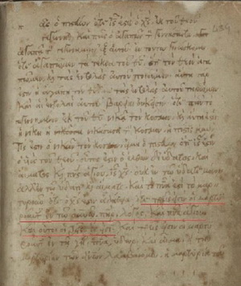

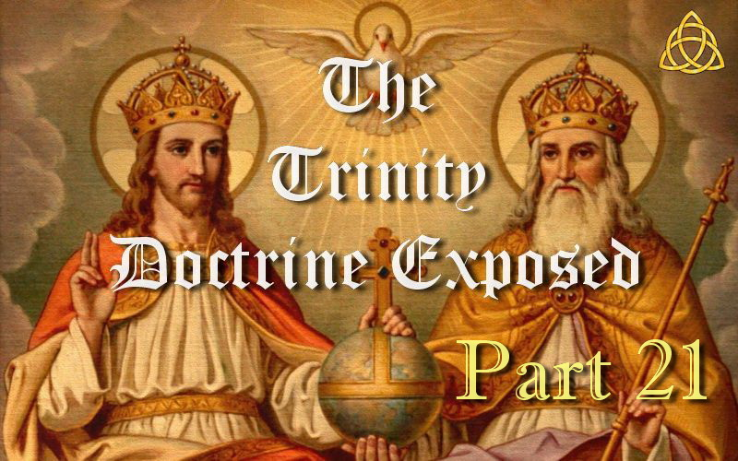

**THE TRINITY DOCTRINE EXPOSED – PART 21**

**Does Matthew 28:19 prove a Trinity?**

Trinitarians often claim Matthew 28:19 supports their belief in a Trinity. But this verse in no way affirms the Trinity doctrine which states that the Father, Son and Holy Spirit are three co-equal, co-eternal beings that make up one God.

Nobody denies there is the Father, Son and the Holy Spirit.

This verse refers to three entities but never says they are one and says nothing about their personality.

It does not say they are three beings,  
it does not say they are three in one or one in three,  
it does not say these three are the Godhead,  
it does not say these three are a Trinity,  
it does not say these three are co-equal or co-eternal beings,  
it does not say that these three are all God.

And yet some wrongly draw the conclusion that this supports their belief in the Trinity or that the Holy Spirit is another being which is clearly not so.

It is just a very bad assumption and a lie that we are so often told.

**PLEASE NOTE:** Some who know the truth on the false doctrine of the Trinity have criticized me for attributing the words of Matthew 28:19 to Christ. Why? Because there are literally dozens of well-known theologians that claim this verse is corrupted by the Catholic Church at a very early stage, and hence it cannot be proven. Their conclusion is based on the following facts.

1. Baptism is symbolic of a believer’s faith in a crucified, buried, and risen Saviour. Hence baptism is about Christ ONLY!
2. Other Scriptures say we are baptized and saved by calling on the name of the Lord ONLY.
3. No one in Scripture was ever baptized in the name of the Father, Son and Holy Spirit. Every example given in Scripture reveals all were baptized in the name of Christ ONLY as you would therefore expect. See Acts 2:38; Acts 8:12; Acts 8:16; Acts 10:48; Acts 19:5; Acts 22:16; Romans 6:3; 1 Corinthians 1:13 and Galatians 3:27.
4. Eusebius who was present at the council of Nicea and is known as “the Father of Church History” quotes Matthew 28:19 several times and would have seen the original manuscripts. But he never quotes it as it appears in Bibles today. He always finishes the verse with the words “in my name.”
5. The Catholic Church confess they changed it as part of their baptismal formula to match the Trinity doctrine, which is their creation. For example: “*The baptismal formula was changed from the name of Jesus Christ to the words Father, Son, and Holy Spirit by the Catholic Church in the second century.*” — (The Catholic Encyclopedia, II, p. 263)

Whatever the truth, Matthew 28:19 does not support the doctrine of the Trinity as written. You will have to decide for yourself if the weight of evidence proves this verse to be an early Catholic corruption.

See “Matthew 28:19 & The Trinity - Prove All Things” below for more information.

<https://www.youtube.com/watch?v=gOcY72ZFO8A>

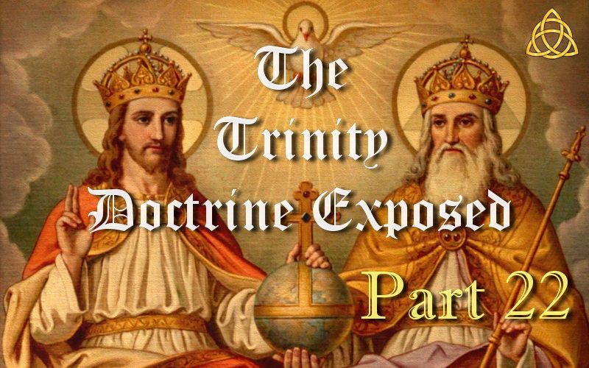

**THE TRINITY DOCTRINE EXPOSED – PART 22**

**What happened to Matthew 28:19?**

When it comes to Matthew 28:19, one might also ask why the apparent disobedience of the Apostles as there is not one who obeyed these supposed words of Jesus Christ in this verse. Here are all the scriptures relating to baptism in the New Testament. New converts were all baptized into the name of Jesus Christ only.

Acts 2:38 “*Then Peter said unto them, Repent, and be baptized every one of you in the name of Jesus Christ for the remission of sins, and you shall receive the gift of the Holy Ghost.*”

Acts 8:12 “*But when they believed Philip preaching the things concerning the kingdom of God, and the name of Jesus Christ, they were baptized, both men and women.*”

Acts 8:16 “*For as yet he was fallen upon none of them: only they were baptized in the name of the Lord Jesus.*”

Acts 10:48 “*And he commanded them to be baptized in the name of the Lord. Then prayed they him to tarry certain days.*”

Acts 19:5 “*When they heard this, they were baptized in the name of the Lord Jesus.*”

Acts 22:16 “*And now why tarriest you? arise, and be baptized, and wash away your sins, calling on the name of the Lord.*”

Romans 6:3 “*Know you not, that so many of us as were baptized into Jesus Christ were baptized into his death?*”

1 Corinthians 1:13 “*Is Christ divided? was Paul crucified for you? or were you baptized in the name of Paul?*” [Implied]

Galatians 3:27 “*For as many of you as have been baptized into Christ have put on Christ.*”

So why the apparent disobedience of the Apostles? The following dictionary explains,

“*The historical riddle is not solved by Matthew 28:19, since, according to a wide scholarly consensus, it is not an authentic saying of Jesus, not even an elaboration of a Jesus-saying on baptism.*” — (Anchor Bible Dictionary, Vol. 1, 1992, p. 585)

Further research revealed all Bible commentaries and dictionaries quoting on this issue claimed that it was added by the Church of Rome to support their Trinitarian formula. The quote below states the origin of this baptismal formula.

“*The baptismal formula was changed from the name of Jesus Christ to the words Father, Son, and Holy Spirit by the Catholic Church in the second century.*” — (The Catholic Encyclopedia, II, p. 263)

So how did this happen and what did the original text say if this is true? It must be remembered that we have no known manuscripts that were written in the first, second or third centuries. There is a gap of over three hundred years between when Matthew wrote his epistle and our earliest manuscript copies. (It also took over three hundred years for the Catholic Church to evolve into what the “early church fathers” wanted it to become.) This is what my research revealed.

Eusebius (c. 260—c. 340) was the Bishop of Caesarea and is known as “the Father of Church History.” He wrote prolifically and his most celebrated work is his Ecclesiastical History, a history of the Church from the Apostolic period until his own time. Eusebius quotes many verses in his writings including Matthew 28:19 several times. But he never quotes it as it appears in modern Bibles. He always finishes the verse with the words “in my name.”

The following example comes from an unaltered book of Matthew that could have been the original or the first copy of the original. Thus Eusebius informs us of the actual words Jesus spoke to his disciples in Matthew 28:19 which were,

“*With one word and voice He said to His disciples: “Go, and make disciples of all nations in My Name, teaching them to observe all things whatsoever I have commanded you,*” — (Proof of the Gospel by Eusebius, Book III, Ch. 6, 132 (a), p. 152)

Eusebius was present at the council of Nicea and was involved in the debates over the Godhead. If the manuscripts he had in front of him read “*in the name of the Father, and of the Son and of the Holy Spirit,*” he would never have quoted instead, “*in my name.*” So it appears that the earliest manuscripts read “*in my name,*” and the phrase was enlarged to reflect the orthodox position as Trinitarian influence spread.

So should Matthew 28:19 read “*baptizing them in the name of the Father, and of the Son, and of the Holy Ghost.” or “baptizing them in My name.*” And based on your conclusion, which of the following is correct?

Colossians 2:12 “*Buried with the Father, Son and Holy Spirit in baptism, wherein also you are risen with them through the faith of the operation of God, who has raised them from the dead.*”

or  
Colossians 2:12 “*Buried with him in baptism, wherein also you are risen with him through the faith of the operation of God, who has raised him from the dead.*”

The reason we are baptized in the name of Christ is because we are baptized “into” Jesus Christ. Baptism is a symbol of His death, burial and resurrection. Even if the Trinity doctrine was true, only Jesus Christ died, was buried and rose again. When we are baptized in the name of Christ we become Christians. Paul argued this point in 1 Corinthians 1:13 when he said, “*Is Christ divided? Was Paul crucified for you? Or were you baptized in the name of Paul?*” The obvious answer to this rhetorical question is, “*No. You were baptized in the name of Christ because He was crucified for you.*”

Consider also “*He that believeth and is baptized shall be saved;*” Mark 16:16

And whose name do we call on to be saved when we are baptized?

“*arise, and be baptized, and wash away your sins, calling on the NAME of the LORD.*” Acts 22:16

It does not say “*calling on the name of the Father, Son and Holy Spirit*” now does it? And what is the ONLY name under heaven whereby we can be saved? We do NOT call on the name of the Father or Holy Spirit to be saved in baptism. These verses also reveal Matthew 28:19 as it appears to be incorrect and that it should have said in the name of the Lord only.

“*for there is NONE other NAME under heaven given among men, whereby we must be saved.*” Acts 4:12

Whose name did Peter say we were to be baptized in?

“*Peter said unto them, Repent and be baptized every one of you in the NAME of JESUS CHRIST*” Acts 2:38

We cannot prove this verse has been tampered with by the Catholic Church but what we do know is:

1) The Catholic Church confess to changing it  
2) Most theologians also agree that they did change it  
3) No one followed this supposed instruction and all were baptized in the name of Christ ONLY!  
4) Other Scriptures say we are baptized and saved by calling on the name of the Lord ONLY  
5) Eusebius who saw the earliest manuscripts when he quoted this verse wrote that it said, “In His name”

I think most will agree that the weight of evidence is overwhelming that Matthew 28:19 should have read “*in My name.*”

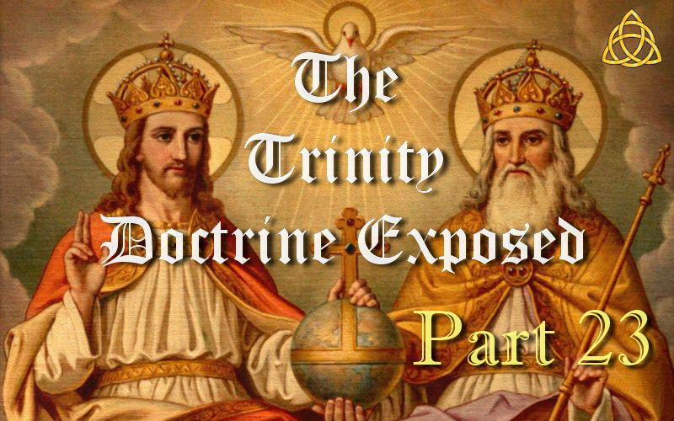

**THE TRINITY DOCTRINE EXPOSED – PART 23**

**Does Elohim Prove a Trinity?**

Some claim that because the word most often used for God in the Hebrew Bible is Elohim (plural for El), then the one true God must be a Trinity. But this is just another deception from those who have been deceived. The fact is that the word Elohim is used for the true God, false gods, supernatural spirits (angels) and even human leaders such as kings and judges. Thus the word Elohim can and is used to refer to a single person, and when it does, linguists call it a “plural intensive” or “plural of majesty” which denotes greatness. The Hebrew people pluralized nouns when they desired to express greatness or majesty as they did with God. So when Elohim is used of the one true God, it is called a “plural of majesty” which denotes the greatness of God, not number.

This was “only” done by the Hebrew people so in the Greek translation of the Hebrew Bible (the Septuagint, which Jesus and the apostles quoted) where Elohim refers to the true God, the word Theos is used which is not plural but singular. The same applies to the New Testament where Theos is the Greek equivalent to Elohim and once again it is not plural but singular. For example. Jesus quotes Deuteronomy 6:4 in Mark 12:29. The word Theos for God in this verse is singular, not plural. If Elohim was really a plurality of the one true God, then the New Testament writers would have used the plural of Theos also when referring to God. Instead they used the singular form every single time. And yet the plural form is used eight times in the New Testament referring to men or false gods. (John 10:34-35; Acts 7:40, 14:11, 19:26; 1 Corinthians 8:5; Galatians 4:8). I trust that no one will say that God is a Trinity in the Hebrew language while being one God in the Greek language.

Note the examples below. The Hebrew morphology codes [ncmpa] used with Elohim below are Noun Common, Masculine, Plural and Absolute, while the Greek morphology codes [N-NSM] used with Theos are Noun, Nominative, Singular and Masculine. Every occurrence of the word Theos for God is always singular in the Greek Old and New Testaments.

Genesis 1:1 Hebrew — “In the beginning, God [**אלהים** ĕlôhîym 430 [ncmpa] p=Plural] created the heavens and the earth.”

Genesis 1:1 Greek — “In the beginning, God [**θεος** theos 2316 [N-NSM] s=Singular] made the heavens and the earth.”

And what about Moses, was he a Trinity to Pharaoh? Obviously not. “And the LORD said unto Moses, See, I have made you a god [Elohim] to Pharaoh.” Exodus 7:1. Here Elohim refers to one person and so it is a “Plural of Majesty” and therefore denotes greatness. So this verse simply means that God would make Moses appear great in the eyes of Pharaoh. For example. “And the LORD gave the people favour in the sight of the Egyptians. Moreover the man Moses was very great in the land of Egypt, in the sight of Pharaoh's servants, and in the sight of the people.” Exodus 11:3. The word Elohim in the KJV Bible has also been translated to the words “great” and “mighty” due to its meaning.

Below are some dictionary definitions from scholars concerning the usage of Elohim as a “plural intensive,” or as many prefer, “plural of majesty” (a pluralis excellentice) or “plentitude of might.”

“Elohim is a plural form which is often used in Hebrew to denote plentitude of might.” — (Hertz, The Pentateuch & Haftorahs)

“The form of the word, Elohim, is plural. The Hebrews pluralized nouns to express greatness or majesty.” — (Flanders, Cresson; Introduction to the Bible)

“The Hebrew noun Elohim is plural but the verb is singular, a normal usage in the OT when reference is to the one true God. This use of the plural expresses intensification rather than number and has been called the plural of majesty, or of potentiality.” — (New International Version Study Bible, Grand Rapids: Zondervan, 1985, p. 6)

“This word [elohim], which is generally viewed as the plural of eloah [Strong's #433], is found far more frequently in Scripture than either el or eloah for the true God. The plural ending is usually described as a plural of majesty and not intended as a true plural when used of God. This is seen in the fact that the noun elohim is consistently used with singular verb forms and with adjectives and pronouns in the singular.” — (Theological Wordbook of the Old Testament, Vol. 1, 1980, p. 44)

“The plural form of Elohim has given rise to much discussion. The fanciful idea that it referred to the trinity of persons in the Godhead hardly finds now a supporter among scholars. It is either what grammarians call the plural of majesty, or it denotes the fullness of divine strength, the sum of the powers displayed by God. Jehovah denotes specifically the one true God, whose people the Jews were, and who made them the guardians of his truth.” — (Smith's Bible Dictionary)

So why does the fanciful idea that Elohim refers to a Trinity hardly find a supporter among scholars now? Because the truth is impossible to avoid and you would only end up looking very foolish and deceived if you use this to try and prove a lie.

So when you hear the argument that Elohim means God must be a Trinity, then understand that there is either deliberate deception or total ignorance and such a person cannot be trusted.

See “Elohim & The Trinity - Prove All Things” below for more information.

<https://www.youtube.com/watch?v=_VZw6Dqczs8>

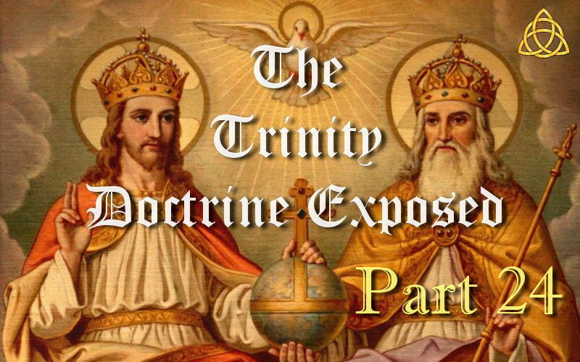

**THE TRINITY DOCTRINE EXPOSED – PART 24**

**Why is the Trinity a Salvation Issue?**

Those who have not studied the doctrine of the Trinity never see it as a salvation issue because they do not understand exactly what it entails and the many implications. And so most Christians typically have no idea that this doctrine is actually the biggest and worst deception of all that is also related to the mark of the beast and the Sabbath.

The Trinity doctrine claims that the Father, Son and Holy Spirit are three co-equal, co-eternal gods that are not three gods but one god. But how can Jesus be the literal Son of God if He has always existed alongside the Father? And how can the Father be a Father if Jesus is not really His Son? Hence the Trinity doctrine and other similar beliefs like Unitarians deny that Jesus is the literal Son of God in one way or another.

If you do not confess Jesus is the Son of God then you are separated from God. And if you do not believe Jesus is the Son of God and that God gave His literal Son then you make God a liar and you do not have eternal life.

“Whosoever shall CONFESS THAT JESUS IS THE SON OF GOD, God dwelleth in him, and he in God.” 1 John 4:15

“Who is he that overcometh the world, but he that BELIEVETH THAT JESUS IS THE SON OF GOD?” 1 John 5:5

“He that believeth on the Son of God has the witness in himself: he that believeth not God has made him a liar; because he believeth not the record that God gave of his Son. And this is the record, that God has given to us eternal life, and this life is in his Son. He that has the Son has life; and he that has not the Son of God has not life.” 1 John 5:10-12

“But these are written, that you might believe THAT JESUS IS THE CHRIST, THE SON OF GOD; and that believing YOU MIGHT HAVE LIFE THROUGH HIS NAME.” John 20:31

Thus it is only by acknowledging that Jesus is the Son of God that we can be saved and have access to the Father. And if you deny Jesus is the literal Son of God then it is also impossible for God to be a literal Father. So it denies both the Father and the Son which is what John called antichrist as it opposes Christ being the true and literal Son of God. It denies that it was the literal Son of God that came in the flesh and died on the cross. (1 John 2:18-19, 22-23; 4:3; 2 John 1:7)

The Bible reveals over and over again that they are a real Father and Son. But the Trinity doctrine says no. Some today including Adventist Pastors when asked is Jesus the Son of God reply, No! They say He is just the one God playing the role of the Son. Yet nowhere is there even so much as a hint in Scripture that they are just role playing or are not really a Father and Son. God brought forth a Son whom He loves very much and Satan is working very hard to hide this fact.

And if the Trinity doctrine is wrong, the Holy Spirit is really a creation of Satan rather than the Spirit of the Father and Son. Scripture says Satan wants to be worshipped like the most high God. Does it matter if we choose a non–existent god that is a creation of Satan to be the Holy Spirit so he can get worship and have us deny the real Holy Spirit? In other words, does it matter if we have the Spirit of the Father and Son or a creation of Satan and hence reject the real Holy Spirit? Of course it does! The third person in the Trinity is actually Satan! It should be obvious that if you get this wrong you will not be in the kingdom.

So has Satan succeeded in accomplishing his goal of being included as deity? More and more today are praying and worshipping the Holy Spirit which the Bible never tells us to do. If the Holy Spirit is not a third being then what spirit would we have as per our belief? And if we believe the Holy Spirit can be worshipped and prayed to just like the Father and the Son, who receives our worship? It goes to Satan!

Revelation 13:17 states, “And that no man might buy or sell, save he that had the Mark, ***OR*** the Name of the Beast, ***OR*** the Number of his Name.”

Did you notice that it is three things? It is not just the mark of the beast, but also the name and the number of his name which is 666. The [pagan origins of the trinity](http://www.trinitytruth.org/paganoriginsofthetrinity.html) reveals that 666 comes from the Trinity doctrine and sun and Satan worship!

The question was asked in the Catholic Catechism, “What is Sunday...” The answer was that Sunday “is a day dedicated by the Apostles to the honor of the most holy Trinity.” — (RH, vol. 5, no. 24, p. 86)

An interesting statement considering “Sunday worship” and the “Trinity doctrine” both came from sun and Satan worship in Babylon, and they were both brought into Christendom by the Catholic Church whom God calls Babylon! They are also both about who we worship which Revelation 13 and 14 reveals is exactly what the mark of the beast issue is all about. So do we worship the one true God on His Holy day or the pagan Catholic 3 in 1 god? And what about the Seal of God. Which God do we need to be sealed by? The one true God the Father or the pagan Catholic 3 in 1 god. This would certainly explain why Revelation reveals so many will still be deceived and perish in the end.

Considering “Sunday worship” and the “Trinity doctrine” were both brought into Christendom by the beast (Papacy), then consider the following.

“The third angel's message has been sent forth to the world, warning men against receiving the mark of the beast or of his image in their foreheads or in their hands. To receive this mark means to come to the same decision as the beast has done, and to advocate the same ideas, in direct opposition to the word of God.” — (E.G. White, RH, July 13, 1897)

E.G. White says there is still more to be revealed.

“The light that we have upon the third angel's message is the true light. The mark of the beast is exactly what it has been proclaimed to be. Not all in regard to this matter is yet understood nor will it be understood until the unrolling of the scroll,” — (E.G. White, 6T 17.1, 1900)

Christ was the Son of God before coming to earth. “Christ was the only begotten Son of God, and Lucifer, that glorious angel, got up a warfare over the matter, until he had to be thrust down to the earth.” — (E.G. White, Ms86, Aug 21, 1910)

Satan hates the Son of God and wants us to deny Him, but not just for his own gratification. When this topic is fully understood, it becomes blatantly obvious that the Trinity doctrine is the work of Satan via the Catholic Church to steal souls. And sadly, our adversary has no shortage of workers to keep Christians trapped in this satanic doctrine. It is not only the worst possible deception, but is also his greatest end time deception that is also related to the mark of the beast.