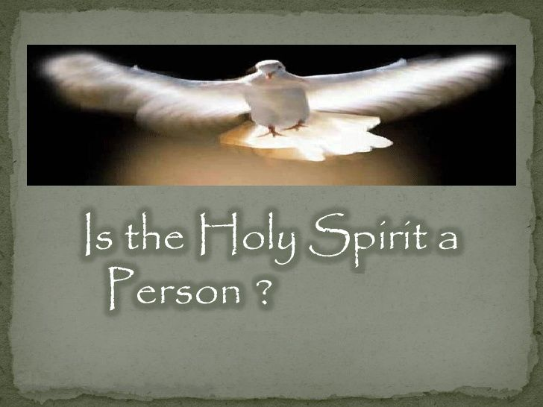

Please note: This document is designed so that individual parts can be printed and handed out, or copied and posted into Facebook as posts, or responses to others. So you will find some duplicated passages in individual parts for this reason. CAPS have also been used in places since FB does not support any form of highlighting. Please feel free to copy and paste individual parts for sharing anywhere you choose or share the entire file. Thank you.

To download images or this document as a PDF.

See <http://www.trinitytruth.org/istheholyspiritaperson.html>

[**Is the Holy Spirit a Person?**](http://www.trinitytruth.org/istheholyspiritaperson.html)

1) Is the Holy Spirit a “He” or “It”?

2) Does Matthew 28:19 say the Holy Spirit is a Third Being?

3) Why is the Holy Spirit Left Out of Every Greeting?

4) Is God's Spirit Another Being Because it has Mind, Will and Emotions?

5) Does the Baptism of Christ Reveal Three beings?

6) Is the Holy Spirit the Third Highest Being in Heaven?

7) Is the Holy Spirit a Third CO-EQUAL Being?

8) Is the Holy Spirit the Father of Christ?

9) Is the Holy Spirit a God?

10) What is Blasphemy against the Holy Spirit?

11) Who is the Holy Spirit According to SOP?

12) How Many Beings According to SOP?

13) How Many Beings According to the Bible?

14) Who is the Comforter According to SOP?

15) Who is the Comforter According to the Bible?

16) Who is the Spirit of Truth According to SOP?

17) Who is the Spirit of Truth According to the Bible?

18) Whose Spirit was given at Pentecost?

19) How Many Beings Involved in Creation?

20) Who is the Holy Spirit According to the Bible?

21) Did Satan Counterfeit the Holy Spirit?

22) Do non-Trinitarians Believe in the Holy Spirit?

23) Whose Spirit Represents Christ?

24) How was the SDA Church Changed to Think the Holy Spirit is a Person?

25) Did Ellen White Write “Three Holiest Beings?”

26) Who is the Third Person of the Heavenly Trio?

27) How many Holy Spirits are there?

28) Did the Apostles Believe the Holy Spirit was a Literal Being?

29) What is the Nature of the Holy Spirit?

30) Who is the Holy Spirit that Comforts and Guides your life?

**Introduction**

Have you ever noticed when reading your Bible that the Holy Spirit seems to be left out of some pretty important verses? Like, why does John only mention God and the Word when talking about creation? In all the letters of Paul, why does he always state that grace and peace come from the Father and Son alone? Why did Jesus leave out the Holy Spirit completely when he stated that eternal life hinges on knowing God and Himself? Many people believe that the Holy Spirit is the third God of the Trinitarian Godhead. Yet, is this true? What do we do with statements in the Bible that say things like, “*God hath sent forth the Spirit of his Son into your hearts,*” and that “*if any man have not the Spirit of Christ, he is none of his?*”

Some say the Bible calls the Holy Spirit a “He” or “Him” so therefore it must be a third being, but this is jumping to conclusions. Interestingly enough, Jesus often talked about Himself in the third person. For instance, Jesus said, “*For God so loved the world that he gave his only begotten Son, that whosoever believeth in HIM should not perish, but have everlasting life,*” John 3:16. Here Jesus called Himself “the Son” and “Him.” It gets even more interesting when you consider the only verses that refer to the Holy Spirit as “He” or “Him” are actually referring to Christ by His Spirit. In this series you are going to learn the real truth on the Holy Spirit.

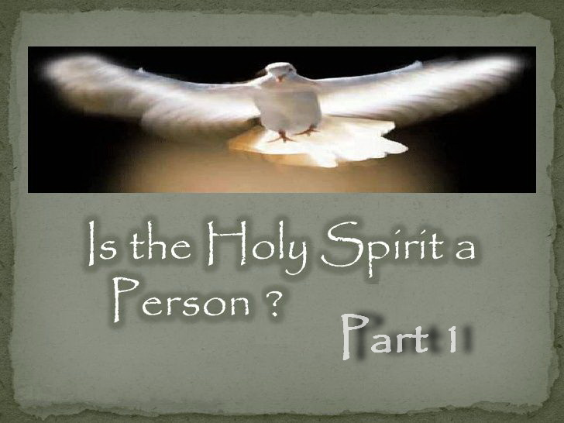

**IS THE HOLY SPIRIT A PERSON – PART 1**

**Is the Holy Spirit a “He” or “It”?**

Some say the Bible calls the Holy Spirit “He” or “Him” so therefore it must be a third being, but this is incorrect.

Here are the ONLY verses that refer to the Holy Spirit as a “He” or “Him.” Verses are abbreviated.

John 14:16-17 “*he shall give you another [allos] COMFORTER [****parakletos****], that he may abide with you forever; 17 Even the SPIRIT OF TRUTH;*”

John 14:26 “*But the COMFORTER [****parakletos****], which is the Holy Ghost,*”

John 15:26 “*when the COMFORTER [****parakletos****] is come, whom I will send unto you from the Father, even the SPIRIT OF TRUTH,*”

John 16:7 “*if I go not away, the COMFORTER [****parakletos****] will not come unto you;*”

John 16:13 “*when he, the SPIRIT OF TRUTH, is come, he will guide you into all truth:*”

Note that EVERY verse is referring to the COMFORTER [Greek=**parakletos**] and SPIRIT OF TRUTH.

So who is the COMFORTER and SPIRIT OF TRUTH?

In John 14:6 Jesus says, “*I am the truth*” and by His Spirit He is the “*Spirit of truth.*” (John 14:17)  
And in John 14:18 Jesus said, “*I will not leave you comfortless: I will come to you.*”

It is Christ by “HIS” Spirit!

Many get confused because Jesus said he will send “another” Comforter not realizing that the “another” is HIS SPIRIT. The Greek word “allos” for “another” in John 14:16 means another of the exact same kind. Jesus was present with His disciples in physical form, but after His ascension He comes back in another form, that is, by His Spirit. Hence the “another” is His Spirit. Because Christ's Spirit can function independently of Himself, it is like His Spirit is “another.” And because it is His Spirit, it is “another” of the same kind. If it was someone different, John would have used the Greek word “heteros” which means another of a different kind.

1 John 2:1 also reveals that Jesus is our “**parakletos**” (Comforter). John 14:16, 26; 15:26; 16:7 above and 1 John 2:1 below are the only verses that use this Greek word which means “ADVOCATE and COMFORTER.” So the Greek text also reveals that our COMFORTER and Advocate is JESUS CHRIST the righteous!

“*If any man sin, we have an advocate* [**parakletos**] (Comforter) *with the Father, Jesus Christ the righteous:*” 1 John 2:1

And here is further proof from Ellen White who of course confirms that the COMFORTER and SPIRIT OF TRUTH is the HOLY SPIRIT OF CHRIST.

“This refers to the omnipresence of the SPIRIT of CHRIST, called the COMFORTER.” — (E.G. White, 14MR 179.2)

“Let them study the seventeenth of John, and learn how to pray and how to live the *prayer of CHRIST. HE is THE COMFORTER.* He will abide in their hearts, making their joy full.” — (Ellen G. White, Review and Herald, January 27, 1903)

“*JESUS comes to you as the SPIRIT of TRUTH; study the mind of the Spirit, consult your Lord, follow His way.*” — (E.G. White, 2MR 337.1)

“*We cannot be with CHRIST in person, as were His first disciples, but HE has sent HIS Holy Spirit to guide us into all truth, and through this power we too can bear witness for the Saviour.* [John 16:13 quoted]” — (E.G. White, Ms30, June 18, 1900)

Now for the BIG question.

Is Jesus Christ a “He” and a “Him” even if it is by “HIS” Spirit? – Of Course!

Therefore, the Holy Spirit is NOT another being, which is a manmade doctrine from Satan via the Catholic Church in 381 AD long after the Bible was written so Satan could achieve worship. How easily so many have been deceived and indoctrinated with Satan’s lie.

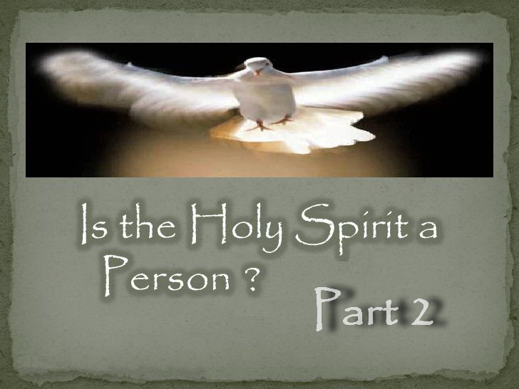

**IS THE HOLY SPIRIT A PERSON – PART 2**

**Does Matthew 28:19 say the Holy Spirit is a Third Being?**

Trinitarians often claim Matthew 28:19 supports their belief in a Trinity and the Holy Spirit as a third being. But this verse in no way affirms the Trinity doctrine which states that the Father, Son and Holy Spirit are three co-equal, co-eternal beings that make up one God.

Nobody denies there is the Father, Son and the Holy Spirit.

But does this verse actually say the HOLY SPIRIT is a THIRD CO-EQUAL BEING? No!

This verse refers to three powers, but says nothing about their personality.

It does not say they are three beings,

it does not say they are three in one or one in three,

it does not say these three are the Godhead,

it does not say these three are a Trinity,

it does not say these three are co-equal or co-eternal beings,

it does not say that these three are all God.

And yet, Trinitarians wrongly draw the conclusion that this supports their belief in the Trinity or that the Holy Spirit is another being which is clearly not so.

It is just a very bad assumption and a lie we are often told.

**PLEASE NOTE:** Some who know the truth on the false doctrine of the Trinity have criticized me for attributing the words of Matthew 28:19 to Christ. Why? Because there are literally dozens of well-known theologians that claim this verse is corrupted by the Catholic Church at a very early stage, and hence it cannot be proven. Their conclusion is based on the following facts.

1. Baptism is symbolic of a believer’s faith in a crucified, buried, and risen Saviour. Hence baptism is about Christ ONLY!
2. Other Scriptures say we are baptized and saved by calling on the name of the Lord ONLY.
3. No one in Scripture was ever baptized in the name of the Father, Son and Holy Spirit. Every example given in Scripture reveals all were baptized in the name of Christ ONLY as you would therefore expect. See Acts 2:38; Acts 8:12; Acts 8:16; Acts 10:48; Acts 19:5; Acts 22:16; Romans 6:3; 1 Corinthians 1:13 and Galatians 3:27.
4. Eusebius who was present at the council of Nicea and is known as “the Father of Church History” quotes Matthew 28:19 several times and would have seen the original manuscripts. But he never quotes it as it appears in Bibles today. He always finishes the verse with the words “in my name.”
5. The Catholic Church confess they changed it as part of their baptismal formula to match the Trinity doctrine, which is their creation. For example: “*The baptismal formula was changed from the name of Jesus Christ to the words Father, Son, and Holy Spirit by the Catholic Church in the second century.*” — (The Catholic Encyclopedia, II, p. 263)

Whatever the truth, Matthew 28:19 does not support the doctrine of the Trinity as written. You will have to decide for yourself if the weight of evidence proves this verse to be an early Catholic corruption.

See also <https://youtu.be/gOcY72ZFO8A>

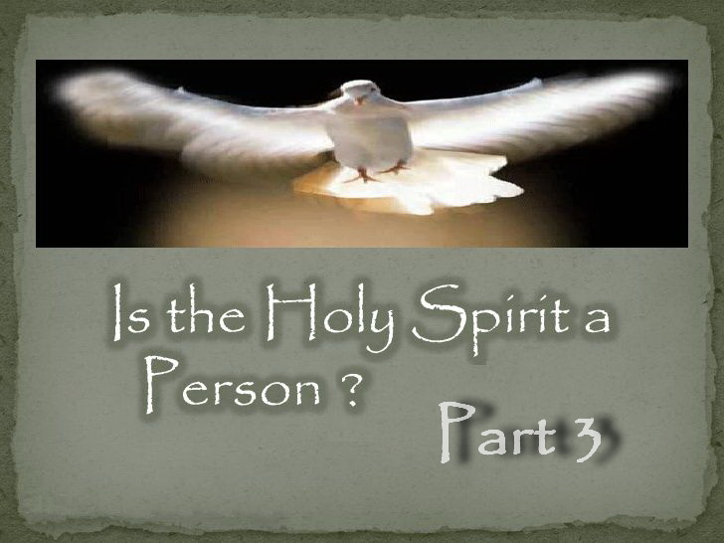

**IS THE HOLY SPIRIT A PERSON – PART 3**

**Why is the Holy Spirit Left Out of Every Greeting?**

The Trinity doctrine teaches that the Holy Spirit is a literal being that is CO-EQUAL with the Father and Son. CO-EQUAL means equal in every single way possible.

So what an inexplicable oversight for Paul if the Spirit were indeed a literal being CO-EQUAL with the Father and Son, because Paul excluded the Holy Spirit in EVERY SINGLE ONE of his greetings in EVERY SINGLE LETTER he wrote! And Peter and John did the same.

“*Grace to you and peace from God our Father, and the Lord Jesus Christ.*” Romans 1:7

“*Grace be unto you, and peace, from God our Father, and from the Lord Jesus Christ.*” 1 Corinthians 1:3

“*Grace be to you and peace from God our Father, and from the Lord Jesus Christ.*” 2 Corinthians 1:2

“*Grace be to you and peace from God the Father, and from our Lord Jesus Christ,*” Galatians 1:3

“*Grace be to you, and peace, from God our Father, and from the Lord Jesus Christ.*” Ephesians 1:2

“*Grace be unto you, and peace, from God our Father, and from the Lord Jesus Christ.*” Philippians 1:2

“*Grace be unto you, and peace, from God our Father and the Lord Jesus Christ.*” Colossians 1:2

“*Grace be unto you, and peace, from God our Father, and the Lord Jesus Christ.*” 1 Thessalonians 1:1

“*Grace unto you, and peace, from God our Father and the Lord Jesus Christ.*” 2 Thessalonians 1:2

“*Grace, mercy, and peace, from God our Father and Jesus Christ our Lord.*” 1 Timothy 1:2

“*Grace, mercy, and peace, from God the Father and Christ Jesus our Lord.*” 2 Timothy 1:2

“*Grace, mercy, and peace, from God the Father and the Lord Jesus Christ our Saviour.*” Titus 1:4

“*Grace to you, and peace, from God our Father and the Lord Jesus Christ.*” Philemon 1:3

“*Grace and peace be multiplied unto you through the knowledge of God, and of Jesus our Lord,*” 2 Peter 1:2

“*Grace, mercy and peace will be with us, from God the Father and from Jesus Christ, the Son of the Father,*” 2 John 1:3

How can the Holy Spirit be a literal co-equal being when it is consistently left out of every greeting?

If the Spirit was an individual being co-equal with the Father and Son, then this consistent omission is incomprehensible. It would have been effrontery and insubordination by the apostles at the highest level. This would be like having a country with three presidents but only ever acknowledging two of them. In fact, not once is the Holy Spirit ever uplifted or praised in the Scriptures. It is always just God the Father and His Son Jesus Christ. And why is that?

Because “*there is but ONE God, the Father, of whom are all things, and we in him; and ONE Lord Jesus Christ, by whom are all things, and we by him.*” 1 Corinthians 8:6. That's why!

The Holy Spirit is the “Spirit of God,” not something called “god the spirit” which is a phrase that does not exist in the Bible and came from the Catholic Church to match the Trinity doctrine they created over 200 years AFTER the Bible was written.

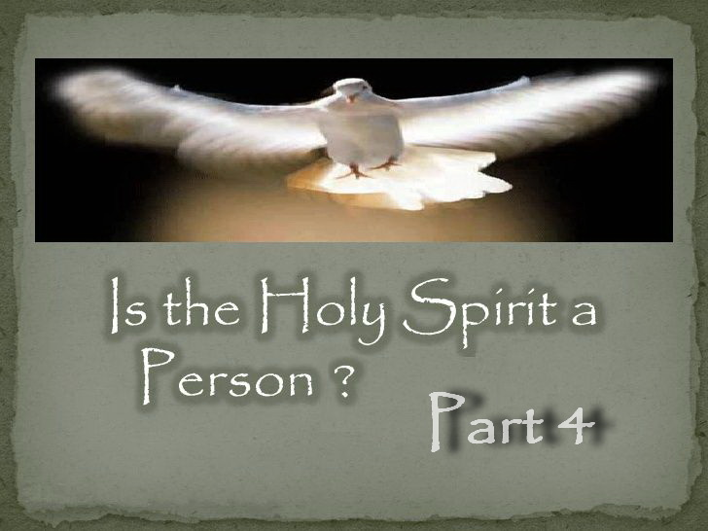

**IS THE HOLY SPIRIT A PERSON – PART 4**

**Is God's Spirit Another Being Because it has Mind, Will and Emotions?**

Would you believe me if I said that a person's spirit is another literal being?

After all, a person's spirit can be troubled, Daniel 2:3 “*...my spirit was troubled...*”  
And a person's spirit can be grieved, Daniel 7:15 “*I Daniel was grieved in my spirit...*”  
And a person's spirit can speak and pray, 1 Corinthians 14:14 “*...my spirit prayeth...*”  
And a person's spirit can rejoice, Luke 1:47 “*my spirit has rejoiced...*”  
And a person's spirit can be received by the Lord, Acts 7:59 “*...Lord Jesus, receive my spirit.*”  
A person's spirit can also serve, Romans 1:9 “*...I serve with my spirit...*”  
And a person's spirit can also rest, 2 Corinthians 2:13 “*I had no rest in my spirit...*”

So we find that a person's spirit has a mind, will and emotions just like God. Therefore, a person's spirit must be another literal being, right?

You are probably thinking I have lost the plot, and yet this is exactly the SAME LOGIC that is used to imply that the Holy Spirit is another literal being!

And Paul said it is no different with God's Spirit in that respect. But note Paul states man’s spirit is within him while God can send His Spirit anywhere.

“*For who among men knows the thoughts of a man except the man's spirit WITHIN HIM? In the SAME WAY NO ONE knows the thoughts of God EXCEPT the Spirit of God.*” 1 Corinthians 2:11

Since your Spirit is your mind, will and emotions, the Greek and Hebrew word for “Spirit” also means “mind” as you would expect. Strong's concordance says, breath, figuratively life, spirit, (including its expression and functions), mind.

Note below that Paul in Romans 11:34 is quoting Isaiah 40:13. So we know that Paul understood the Spirit of the Lord to also mean the mind of the Lord. And of course the mind of someone is not a different person to them any more than their spirit is and this also includes God as Paul reveals below.

“*Who has directed the SPIRIT of the LORD, or being his counsellor has taught him?*” Isaiah 40:13 KJV

“*For who has known the MIND of the LORD? Or who has been his counsellor?*” Romans 11:34 KJV

How can the mind of the Lord be another being? Clearly it cannot!

The spirit of every living being has a personality because our spirit is in fact our personality. So the Holy Spirit has a personality because God has a personality. In giving us His Spirit God gives us Himself. It is not another being and it is not some impersonal force. It is the presence and power of God Himself. It is God's own Spirit having God's own personality.

“*In giving us HIS SPIRIT, God gives us HIMSELF,*” — (E.G. White, 7T 273.1, 1902)

“*The DIVINE SPIRIT that the world's Redeemer promised to send, is the PRESENCE and POWER of GOD.*” — (E.G. White, *ST*, Nov 23, 1891)

If I could give you my spirit, whose personality would you have? Mine! Thus God's Spirit has God's personality. God and His Son have a Spirit and that is how “They” represent “Themselves” where they are not personally present. This is the nature of the Holy Spirit that we cannot understand.

So the Holy Spirit is not some force or another being, but the presence and power of God Himself.

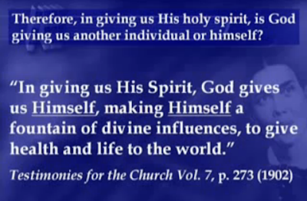

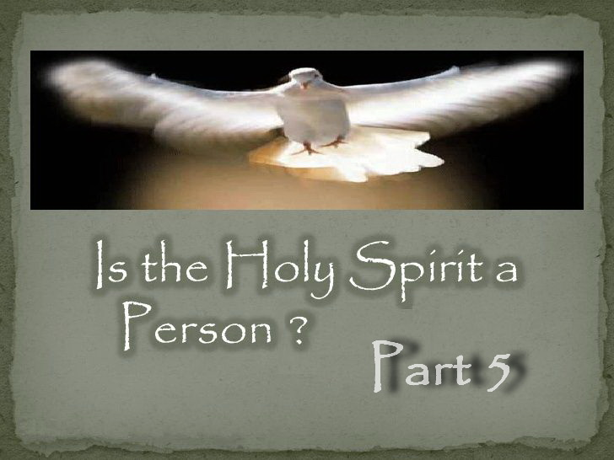

**IS THE HOLY SPIRIT A PERSON – PART 5**

**Does the Baptism of Christ Reveal Three beings?**

One of the latest reasons being perpetuated to claim that the Holy Spirit is a literal being, is by claiming that there were three beings present at Christ’s baptism.

They say God the Father in the voice from heaven, Jesus coming up out of the water, and the Spirit of God descending in the form of a dove.

The dove to the Jews was a symbol of purity of heart, harmlessness and gentleness. Thus the form chosen was an emblem of the innocence, meekness and tenderness of the Saviour.

Now, how does one conclude the Holy Spirit is another being from the beams of glory that came from the Father and rested on His Son in the form of a dove?

“*Never before had angels listened to such a prayer as Christ offered at his baptism, and they were solicitous to be the bearers of the message from the Father to his Son. But, no! direct FROM THE FATHER ISSUES THE LIGHT OF HIS GLORY. The heavens were opened, and BEAMS OF GLORY RESTED UPON THE SON OF GOD AND ASSUMED THE FORM OF A DOVE, in appearance like burnished gold. The dove-like form was EMBLEMATICAL OF THE MEEKNESS AND GENTLENESS OF CHRIST. While the people stood spell-bound with amazement, their eyes fastened upon Christ, from the opening heavens came these words: “This is my beloved Son, in whom I am well pleased.” The WORDS OF CONFIRMATION THAT CHRIST IS THE SON OF GOD were given to inspire faith in those who witnessed the scene, and to sustain the Son of God in his arduous work. Notwithstanding the Son of God was clothed with humanity, yet Jehovah, with his own voice, assures him of his sonship with the Eternal.*” — (E.G. White, *RH*, Jan 21, 1873)

Thus we find there was no third being, but God’s presence and power by His Holy Spirit, represented symbolically in the form of a dove.

God’s presence by His Spirit, shown visibly at Christ’s baptism by beams of glory in the form of a dove, was a sign to John the Baptist that Jesus was indeed the Son of God. See John 1:33-34.

“*The heavenly angels were looking with intense interest upon the scene of the Saviour’s baptism, and could the eyes of those who were looking on, have been opened, they would have seen the heavenly host surrounding the Son of God as he bowed on the banks of the Jordan. The Lord had promised to give John a sign whereby he might know who was the Messiah, and now as Jesus went up out of the water, the promised sign was given;*” — (E.G. White, *YI*, June 23, 1892)

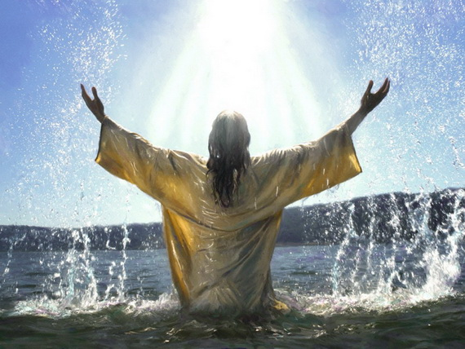

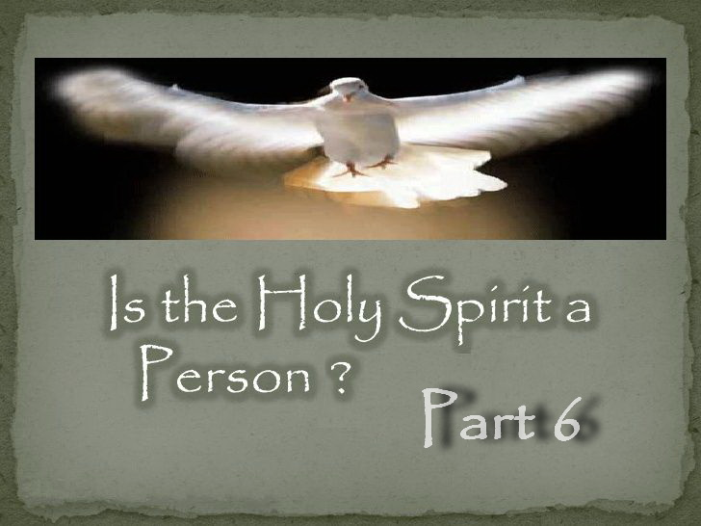

**IS THE HOLY SPIRIT A PERSON – PART 6**

**Is the Holy Spirit the Third Highest Being in Heaven?**

The Trinity doctrine teaches 3 CO-EQUAL beings and hence it claims the 3 highest BEINGS in Heaven are therefore the Father, Son and Holy Spirit.

Thus the Trinity doctrine declares the Holy Spirit is the third highest being in heaven.

But according to Ellen White in the first chapter of Patriarchs and Prophets (p. 35), the third highest being in Heaven before the entrance of sin was Lucifer. And after the fall, Ellen White says Gabriel was the next in line. “It was Gabriel, the angel next in rank to the Son of God, who came with the divine message to Daniel.” — (E.G. White, *DA*, p. 234)

Now consider the following.

Who wants to be like the most High and be worshipped and prayed to as God? Isaiah 14:12-14 informs us that this is Satan’s desire. Has Satan devised a clever scheme to regain his lost third position and the worship he craves? By Satan creating the Trinity doctrine, it creates a non-existent third being. Satan can then step into that position he has created and not only receives the worship he desires, but he would also effectively regain the position he lost as the third highest being in heaven. This is known as worship by representation and is what Satan has also done with Sunday worship.

Has Satan succeeded in accomplishing his goal of being included as deity? If we now believe the Holy Spirit can be worshipped and prayed to just like the Father and the Son, who actually receives our worship? If the Holy Spirit is not a third being then what spirit would we have according to our belief and who would we be giving our adoration to? It would be Satan himself!

Below is even a clearer quote from Ellen White that reveals the Holy Spirit is NOT a being let alone the third highest being as the Trinity doctrine claims. She wrote that Satan was second to Christ making Satan the third highest being in heaven. Hence the Holy Spirit is not some third being called “god the holy spirit” as the Trinity doctrine claims but the Spirit of the Father and Son.

Below we find that Satan wanted to be next to God and have Christ second to Him. In other words, for the three highest beings in Heaven to be the Father, Satan and Christ. This also proves Ellen White was not a Trinitarian and never saw the Holy Spirit as a third being as some have misunderstood due to her use of the word person in regards to the Holy Spirit.

“*Satan, who was once a beautiful angel in the heavenly courts, became a fallen angel because HE DID NOT WANT TO OCCUPY A SECONDARY PLACE, BUT TO BE NEXT TO GOD. HE WOULD HAVE THE LORD JESUS BECOME SECOND TO HIM, for his own glory was very precious in his own sight. He was jealous of Christ, the Saviour. Study the Word of God, and see what this jealousy led to in the end. There is nothing to be gained by jealousies. Although in the beginning Satan was an exalted angel of great glory in the heavenly courts, THAT GLORY BECAME EXTINGUISHED THROUGH HIS CRAVING TO BE THE HIGHEST ONE NEXT TO GOD.*” — (E.G. White, *Ms74*, March 20, 1910)

This quote from Ellen White proves inarguably that the Holy Spirit is NOT and CANNOT be a third highest CO-EQUAL being in Heaven, and hence is NOT and CANNOT be a being at all.

By Satan creating the Trinity doctrine and the idea of the Holy Spirit as a third being, Satan effectively gets his third highest position back, but more importantly, he obtains worship as a god by representation just as he always wanted. Thus the third person in the Trinity is actually Satan! It should be obvious that if you get this wrong you will not be in the kingdom.

Note the table for clarity. The Holy Spirit is not included in the Biblical view as it is not a literal being but the Spirit of the Father and Son. Satan used to hold the third highest position in Heaven until he was thrown out and Gabriel took his place.

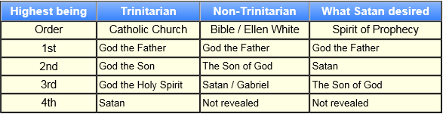

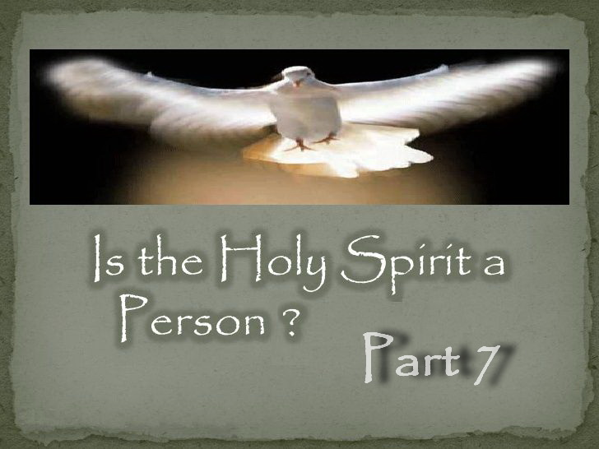

**IS THE HOLY SPIRIT A PERSON – PART 7**

**Is the Holy Spirit a Third CO-EQUAL Being?**

The Trinity doctrine teaches that the Holy Spirit is a being that is CO-EQUAL with the Father and Son, and that means equal in EVERY SINGLE WAY. No exceptions!

So if the Holy Spirit is a separate being equal to the Father and the Son as the Trinity doctrine claims, then why are we “never” told the Holy Spirit loves us? And why does the Bible “never” teach we are to love, worship, or pray to the Holy Spirit?

Because it cannot be a third CO-EQUAL being with that being the case.

If the Holy Spirit was a CO-EQUAL being then it would have also seen the Father. “Not that ANYONE has seen the Father, EXCEPT He [Jesus] who is from God; He has seen the Father.” John 6:46. How can the Holy Spirit be a literal being and yet never have seen the Father?

Luke wrote that no one knows who the Father and Son are except each other. This makes it impossible for the Holy Spirit to be a literal being who would have to be able to reveal the Father and Son if it was. “All things have been committed to me by my Father. NO ONE KNOWS who the Son is except the Father, and NO ONE KNOWS who the Father is except the Son and those to whom the Son chooses to reveal him.” Luke 10:22

If the Trinity doctrine was true, 1 John 1:3 would say, “truly our fellowship is with the Father, and with his Son Jesus Christ and the Holy Spirit,” but it ONLY says the Father and Son. Why? Because the Holy Spirit is not a literal being but the Spirit of God. So our fellowship is only with the Father and Son. The same applies to 1 John 2:22-23. John says nothing about denying the Holy Spirit for the same reason.

Ellen White said, “*The Father and the Son ALONE are to be exalted.*” — (E.G. White, *YI*, July 7, 1898). She did not say “The Father, Son and Holy Spirit are to be exalted.” She specified ALONE.

The thrones of God and His Son are spoken of, but a throne for the Holy Spirit is “never” mentioned. If the Holy Spirit is equal to the Father and Son, why is a throne for the Holy Spirit “never” mentioned?

Ask yourself these simple questions.

Why did the Father never speak to the Holy Spirit?  
Why did Jesus never speak to the Holy Spirit?  
Why did the Holy Spirit never speak to Jesus?

Why did the Holy Spirit never speak to the Father?

Yet the Father spoke to His Son over and over again all throughout the Bible, and Jesus spoke to His Father over and over again all throughout the Bible.

So how can the Holy Spirit be a CO-EQUAL being when it never speaks to the Father and Son?

The answer is simple. Because the “Spirit of God” is just that. It is NOT some third being called “god the holy spirit.” This phrase occurs nowhere in Scripture, but originated from the creators of the Trinity doctrine being the Roman Catholic Church more than 200 years AFTER the Bible was written.

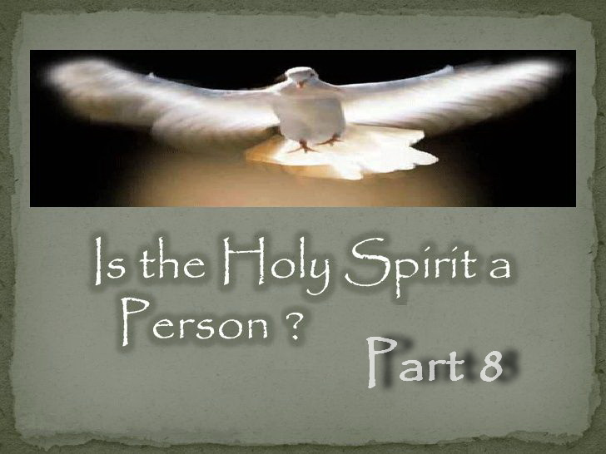

**IS THE HOLY SPIRIT A PERSON – PART 8**

**Is the Holy Spirit the Father of Christ?**

Trinitarians claim that Jesus became the Son of God by His birth in Bethlehem. If this were true, then consider the following. Matthew 1:18 says that “*Mary was found with child of the Holy Ghost.*”

So if the Holy Spirit impregnated Mary, and the Holy Spirit was an individual being as the Trinity doctrine claims, then the Holy Spirit must be the father of Christ.

Yet my Bible tells me that God the Father is the father of Christ. So how can this be? Because the Holy Spirit is not another god called “god the spirit” but is the “Spirit OF God” or the “Spirit OF the Father” as the Bible tells us.

The phrase “god the holy spirit” occurs nowhere in Scripture, but originated from the creators of the Trinity doctrine being the Roman Catholic Church in 381 AD, more than 200 years AFTER the Bible was written.

Note below that SOP informs us that Jesus was already the literal SON OF GOD before He came to earth and so He became the Son of God in a NEW SENSE.

“*Christ brought men and women power to overcome. He came to this world in human form, to live a man amongst men. He assumed the liabilities of human nature, to be proved and tried. In His humanity He was a partaker of the divine nature. In His INCARNATION He gained in a NEW SENSE THE TITLE OF THE SON OF GOD. Said the angel to Mary, “The power of the Highest shall overshadow thee: therefore also that holy thing which shall be born of thee shall be called the Son of God” (Luke 1:35). While the Son of a human being, He became the SON OF GOD IN A NEW SENSE. Thus He stood in our world--the SON OF GOD, yet allied by birth to the human race.*” — (E.G. White, *ST*, Aug 2, 1905)

“*O what a gift God has made to our world! The Word was made flesh and dwelt among us. GOD SENT HIS OWN SON in the likeness of sinful flesh, liable to physical infirmities, tempted in all points like as we are. HE WAS THE SON OF THE LIVING GOD. His PERSONALITY did NOT begin with His INCARNATION in the flesh.*” — (E.G. White, *Lt77*, Aug 3, 1894)

“*The more we think about Christ's becoming a babe here on earth, the more wonderful it appears. How can it be that the helpless babe in Bethlehem's manger is still the DIVINE SON OF GOD?*” — (E.G. White, *YI*, Nov 21, 1895)

“*The dedication of the FIRST-BORN had its origin in the earliest times. God had promised to give the FIRST-BORN OF HEAVEN to save the SINNER.*” — (E.G. White, *DA*, p. 51)

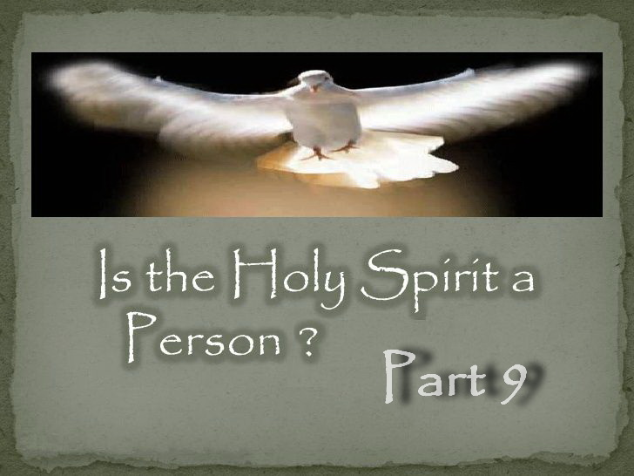

**IS THE HOLY SPIRIT A PERSON – PART 9**

**Is the Holy Spirit a God?**

The Trinity doctrine teaches the Father is God, Jesus is God and the Holy Spirit is God and yet there are not three gods but one God. So when the challenge first arose to prove the Holy Spirit is God, Trinitarians had to find something in Scripture to support their erroneous belief. Acts 5:3-4 is the ONLY passage that could be found to make such a false argument.

Acts 5:3-4 “*But Peter said, Ananias, why has Satan filled thine heart to lie to the Holy Spirit, and to keep back part of the price of the land? Whiles it remained, was it not thine own? and after it was sold, was it not in thine own power? why have you conceived this thing in thine heart? you have not lied unto men, but unto God.*”

Since verse three says Ananias lied to the Holy Spirit and verse four says he had not lied to man but to God, it is claimed that the Holy Spirit is God. But this is eisegesis and what I call red fire engine logic. That is, fire engines are red, my car is red, therefore my car is a fire engine! Eisegesis is the process of misinterpreting a text or portion of text in such a way that it introduces one's own presuppositions, agendas, and or biases into and onto the text.

Peter said to lie to the Spirit of God is to lie to God Himself because it is His Spirit. My Spirit belongs to me in the same way as Paul reveals below. So if you lie to my spirit you have lied to me, not someone else! God's Spirit revealed to Peter that Ananias had lied and so he had not lied to man but to God as it was God Himself through His spirit that revealed the lie.

As Paul said, “*no one knows the thoughts of God except the Spirit of God.*” 1 Corinthians 2:11

Ananias lied to God's Spirit which was within Peter which is the same as lying to the Almighty God Himself as it is His Spirit.

What does Ellen White say? Does she say this passage is calling the Holy Spirit a god or that lying to the Holy Spirit is the same as lying to the “almighty God” as it is His Spirit?

“*Peter asked, “Was it not thine own?” thus showing that no undue influence had been brought to bear upon Ananias and Sapphira to compel them to sacrifice their possessions to the general good. They had acted from choice. But in pretending to be wrought upon by the Holy Ghost, and attempting to deceive the apostles, they had lied to the ALMIGHTY.*” — (E.G. White, 3SP 285.1)

“*In giving us HIS SPIRIT, God gives us HIMSELF,*” — (E.G. White, 7T 273.1 1902)

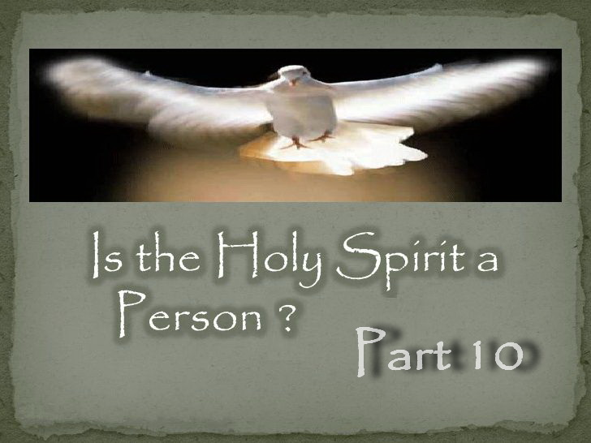

**IS THE HOLY SPIRIT A PERSON – PART 10**

**What is Blasphemy against the Holy Spirit?**

Since Jesus said blasphemy against the Holy Spirit will not be forgiven, some conclude this means the Holy Spirit must be a person. But this wrong conclusion comes about from a lack of understanding of what blasphemy against the Holy Spirit is.

In Matthew 12:22-32 we find Jesus casting out a demon. The Pharisees claimed He did it by the power of the devil. But Jesus being FULLY MAN said He did it by the SPIRIT OF GOD.

He then informs them that they can speak against the SON OF MAN and be forgiven, but blasphemy against the Holy Spirit will not be forgiven. Why?

Because verse 28 says Jesus did this by the power of the SPIRIT OF GOD. Remember that Jesus was the Word made flesh and was fully man. The Pharisees were not insulting the SON OF MAN but the SPIRIT OF GOD by whose power the demon was cast out and hence were blaspheming the Spirit of God by attributing the work of the Holy Spirit to Satan.

Thus Matthew 12:22-32 reveals that the unpardonable sin and blasphemy against the Holy Spirit to be attributing the work of the Holy Spirit to Satan.

Some Trinitarians who do not understand this conclude that blasphemy against the Holy Spirit could be sharing truth on this topic which is clearly not so. But what about Trinitarians? Could they in fact be guilty of blasphemy against the Holy Spirit?

What if the “Spirit of God” is the “Spirit OF God” just as the Bible states, and not something called “god the holy spirit” which the Bible never says?

If the Trinity doctrine is wrong, the Holy Spirit is really a creation of Satan rather than the Spirit of the Father. And if it is a creation of Satan, who would Trinitarians be attributing the work of the Holy Spirit to? They would inadvertently be attributing the work of the Spirit of God to Satan which is in fact the unpardonable sin! You cannot afford to get this wrong.

“*What constitutes the sin against the Holy Ghost? It is willfully attributing to Satan the work of the Holy Spirit.*” — (E.G. White, 5T 634.1, 1889

Ellen White gives another definition for blasphemy against the Holy Spirit.

“*The sin of blasphemy against the Holy Spirit does not lie in any sudden word or deed; it is the firm, determined resistance of truth and evidence.*” — (E.G. White, *Manuscript 30*, 1890)

It is not rejecting someone called “god the holy spirit.” It is resisting *Truth* and *Evidence!*

If the Holy Spirit is speaking to you and giving you truth and evidence which you choose to ignore, then you are resisting the Holy Spirit. This cannot be forgiven because they have become deaf to the voice of the Spirit of God.

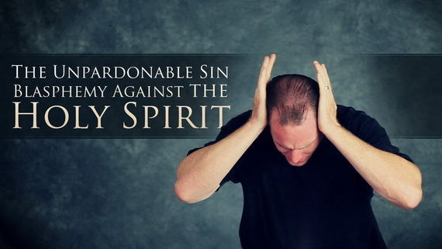

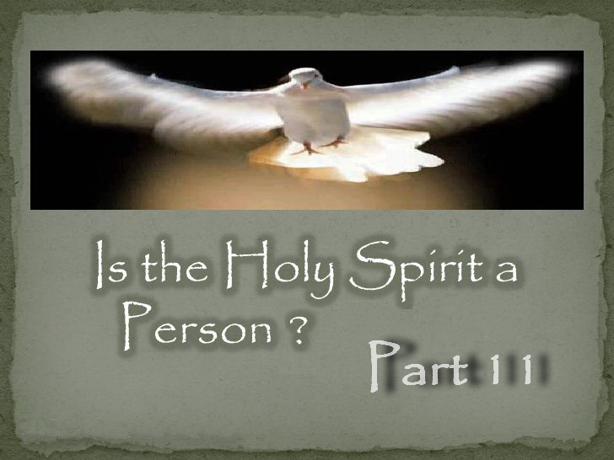

**IS THE HOLY SPIRIT A PERSON – PART 11**

**Who is the Holy Spirit According to SOP?**

Below is the truth about the Holy Spirit that God gave to our pioneers, which is a pillar of our faith.

“The terms “Holy Ghost”, are a harsh and repulsive translation. It should be “Holy Spirit” (hagion pneuma) in every instance. This Spirit is the Spirit of God, and the Spirit of Christ; the Spirit being the same whether it is spoken of as pertaining to God or Christ. But respecting this Spirit, the Bible uses expressions which cannot be harmonized with the idea that it is a person like the Father and the Son. Rather it is shown to be a divine influence from them ***both***, the medium which represents their presence and by which they have knowledge and power through all the universe, when not personally present.” — (Uriah Smith, RH, Oct 28, 1890)

Ellen White wrote it this way. “They were two, yet little short of being identical; two in individuality, yet ONE IN SPIRIT,” — (E.G. White, YI, Dec 16, 1897)

ONE in Spirit because God gave HIS Spirit to HIS Son. “The Father GAVE HIS SPIRIT without measure to HIS SON,” — (E.G. White, RH, Nov 5, 1908)

So when we are given the Holy Spirit, are we given another being or God Himself? “*In giving us HIS SPIRIT, God gives us HIMSELF,*” — (E.G. White, 7T 273.1 1902)

Thus the Holy Spirit is God’s presence and power in you, “*The DIVINE SPIRIT that the world's Redeemer promised to send, is the PRESENCE and POWER of GOD.*” — (E.G. White, *ST*, Nov 23, 1891)

And so the Holy Spirit is the mind, power, character and personal presence of the very life of God that the Father sends through His Son to us. Or to put it another way to make sure this is clear; the Holy Spirit is the presence and power of the Father manifested through Jesus Christ, His only begotten son. This is not a separate person of the Godhead who is being sent, it is the very life of God coming to us through His Son.

And so the SPIRIT OF GOD comes to us through His only begotten Son.

“The HOLY SPIRIT, which PROCEEDS FROM the only begotten SON OF GOD,” — (E.G. White, RH, April 5, 1906)

Thus the HOLY SPIRIT is also the SPIRIT OF CHRIST.

“*The HOLY SPIRIT is the SPIRIT of CHRIST,*” — (E.G. White, 14MR 84.3)

“*We want the HOLY SPIRIT, which is JESUS CHRIST.*” — (E.G. White, *Lt66*, April 10, 1894)

“*but it is the leaven of the SPIRIT of JESUS CHRIST, which is sent down from heaven, called the HOLY GHOST, and that Spirit affects the heart and the character.*” — (E.G. White, Ms36-1891)

“*When God's people take the position that they are the temple of the HOLY GHOST, CHRIST HIMSELF abiding within, they will so clearly reveal Him in spirit, words and actions,*” — (E.G. White, Ms100-1902)

Did you ever wonder how we can have the Father and Son live in us? Because the HOLY SPIRIT is the Spirit of the FATHER AND SON. So who do we have in us when we have the HOLY SPIRIT? The FATHER AND SON!

“By the SPIRIT the FATHER AND THE SON will come and MAKE THEIR ABODE WITH YOU. [John 14:23 quoted]” — (E.G. White, BEcho, Jan 15, 1893)

This is the truth God gave His remnant Church. It is not another being which is a creation of Satan via the Catholic Church so he could achieve worship and steal souls!

Some reject this truth because Ellen White called the Holy Spirit a person. But those who rejected the truth God gave through His prophet failed to look at what else she wrote, which reveals she did not and could not mean a literal person, but was referring to the person of Jesus Christ by His Holy Spirit.

If she meant a literal person then the quotes from her here would be a contradiction making her a false prophet. Think about it. One has to line up all SOP in the same way we must line up all Scripture.

Here is the Heavenly trio from Ellen White and who she called the third person. Is this consistent with her calling the Holy Spirit the Spirit of Christ? It most certainly is!

“They have ***ONE*** God and ***ONE*** Saviour; and ***ONE*** Spirit--***the Spirit of Christ***--” — (E.G. White, 9T 189.3, 1909)

ONE + ONE + ONE = “the SPIRIT OF CHRIST”

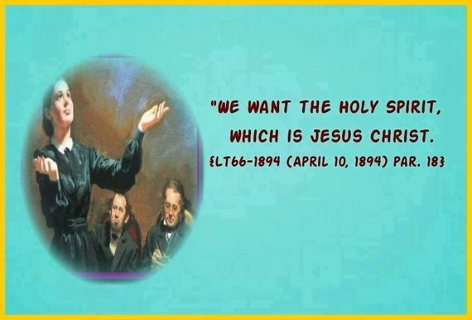

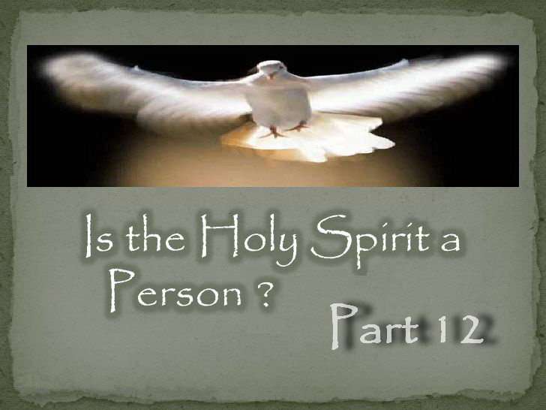

**IS THE HOLY SPIRIT A PERSON – PART 12**

**How Many Beings According to SOP?**

Note that Ellen White demonstrated a distinction between the words “PERSON” and “BEING.” While she speaks of three persons or personalities and powers, she consistently identifies “ONLY” two beings -- the Father and His Son. Thus the words “PERSON” and “BEING” have different meanings to Ellen White.

She called Jesus Christ by HIS Spirit a “PERSON,” but she obviously did not mean a literal person which has confused some. “*When trials overshadow the soul, remember the words of CHRIST, remember that HE is an unseen presence in the PERSON of the Holy Spirit,*” — (E.G. White, DG 185.2, 1897)

Thus when Ellen White calls the Holy Spirit a “PERSON,” she is NOT referring to another “BEING.” She is referring to Christ by HIS Holy Spirit. We also know this because she only ever identifies two beings -- the Father and His Son. And if Ellen White meant a literal person, then that would contradict all the quotes below making her a false prophet.

The Trinity doctrine claims three CO-EQUAL beings, but notice that the quotes below from Ellen White state there are “ONLY” two beings and that there is the Father and Son “ALONE” and hence there cannot be a third being.

Note that Ellen White wrote “ALONE” and “ONLY.”

“*The Father and the Son ALONE are to be exalted.*” — (E.G. White, *YI*, July 7, 1898) **-- TWO BEINGS ALONE**

“*God and Christ ALONE know what the souls of men have cost.*” — (E.G. White, *ST*, Jan 13, 1909) **-- TWO BEINGS ALONE**

“*God informed Satan that to his Son ALONE he would reveal his secret purposes, and he required all the family in heaven, even Satan, to yield him implicit, unquestioned obedience;*” — (E.G. White, *ST*, Jan 9, 1879) **-- TWO BEINGS ALONE**

“*Can anyone consider the condescension of God in preparing the gospel feast, and its great cost, and treat the invitation slightingly? No man, nor even the highest angel, can estimate the great cost; it is known ONLY to the Father and the Son.*” — (E.G. White, *BEcho*, Oct 28, 1895) **-- ONLY TWO BEINGS**

“*The ONLY Being who was one with God lived the law in humanity, descended to the lowly life of a common laborer, and toiled at the carpenter's bench with His earthly parent.*” — (E.G. White, *ST*, Oct 14, 1897) **-- ONLY TWO BEINGS**

“*And truly our fellowship is with the Father, and with his Son Jesus Christ.*” — (E.G. White, *RH*, July 13, 1905) **-- TWO BEINGS**

“*CHRIST the Word, the only-begotten of God, was one with the eternal Father,-one in nature, in character, and in purpose,-the ONLY being in all the universe that could enter into all the counsels and purposes of God. By Christ, the Father wrought in the creation of all heavenly beings.*” — (E.G. White, *GC*, p. 493) **-- ONLY TWO BEINGS**

This is the truth God gave His remnant. “*The HOLY SPIRIT is the SPIRIT OF GOD; it is also the SPIRIT OF CHRIST. It is that divine, mysterious emanation through which they carry forward their great and infinite work.*” — (Uriah Smith, *GC Bulletin*, March 18, 1891, pp. 146, 147)

Thus, “*The DIVINE SPIRIT that the world's Redeemer promised to send, is the PRESENCE and POWER of GOD.*” — (E.G. White, ST, Nov 23, 1891)

So while there are three powers, there are only TWO LITERAL BEINGS. The Holy Spirit is the mind, power and personal presence of God coming to us through His Son and why Ellen White calls the Holy Spirit the Spirit of Christ. It is not and cannot be a third being.

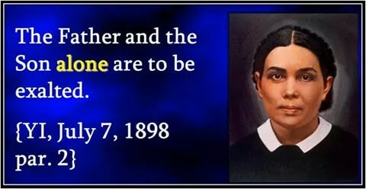

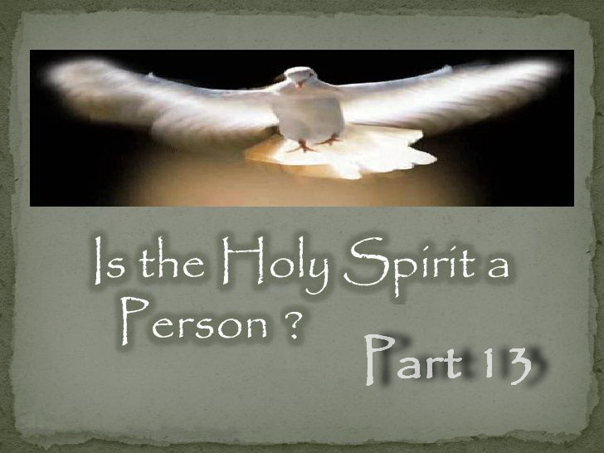

**IS THE HOLY SPIRIT A PERSON – PART 13**

**How Many Beings According to the Bible?**

The “Holy Spirit” is the power and presence of God and of Christ which can function independently of themselves like a third (but not a literal third) and is how “They” represent “Themselves” where they are not personally present. Since the Holy Spirit is the Spirit of the Father and Son, then how many literal beings are there?

Remember that the Trinity doctrine teaches three “co-equal” beings that are supposedly three gods that are one god which does not make sense I know, but nothing from Satan does.

In the following verse we find every possible being is mentioned to clarify that only the Father knows the day and the hour. If the Holy Spirit was a third being it would have also been mentioned which would be more relevant than the angels! “But of that day and that hour KNOWS NO MAN, no, NOT THE ANGELS which are in heaven, NEITHER THE SON, but THE FATHER.” Mark 13:32

How many beings is our fellowship with? “truly our fellowship is with the Father, AND with his Son Jesus Christ.” 1 John 1:3 — **Answer:2**

How many beings does one deny to be called antichrist? Why is the Holy Spirit excluded? “He is antichrist, that denieth the Father AND the Son. Whosoever denieth the Son, the same hath not the Father: but he that acknowledgeth the Son hath the Father also.” 1 John 2:22-23 — **Answer:2**

How many beings were being denied by ungodly men and is this consistent with what John said above? “For there are certain men crept in unawares, who were before of old ordained to this condemnation, ungodly men, turning the grace of our God into lasciviousness, and denying the only Lord God, AND our Lord Jesus Christ.” Jude 1:4 — **Answer:2**

How many beings does John say we need to know to have eternal life? “And THIS IS LIFE ETERNAL, that they might know you the only true God, AND Jesus Christ, whom you have sent.” John 17:3 — **Answer:2**

How many beings can see the Father including Himself? “Not that anyone has seen the Father, except He [Jesus] who is from God; He has seen the Father.” John 6:46 — **Answer:2**

How many beings can reveal the Father and Son? “NO ONE knows who the Son is EXCEPT THE FATHER, and NO ONE knows who the Father is EXCEPT THE SON and those to whom the Son chooses to reveal him.” Luke 10:22 — **Answer:2**

How many beings can be hated? “HE THAT HATETH ME HATETH MY FATHER ALSO. If I had not done among them the works which none other man did, they had not had sin: but now have they both seen and HATED BOTH ME AND MY FATHER.” John 15:23-24 — **Answer:2**

How many beings are involved in our mediation? The trinity doctrine makes the Holy Spirit a mediator but Scripture says no! “For there is one God, AND one mediator between God and men, the man Christ Jesus.” 1 Timothy 2:5 — **Answer:2**

How many beings are on and by the throne all throughout Revelation? “And cried with a loud voice, saying, Salvation to our God which sitteth upon the throne, AND unto the Lamb.” Revelation 7:10 — **Answer:2**

How many beings are in Heaven? “Behold, I see the heavens opened, and the SON OF MAN standing on the right hand of GOD.” Acts 7:56 — **Answer:2**

How many beings are we heirs with? “And if children, then heirs; heirs of God, AND joint-heirs with Christ; if so be that we suffer with him, that we may be also glorified together.” Romans 8:17 — **Answer:2**

How many divine beings bear witness of Christ? “I am one that bear witness of myself, AND the Father that sent me beareth witness of me.” John 8:18 — **Answer:2**

How many divine beings do we believe in? “Let not your heart be troubled: you believe in God, believe also in me.” John 14:1 — **Answer:2**

How many beings are involved in creation? “And to make all men see what is the fellowship of the mystery, which from the beginning of the world has been hid in GOD, who created all things by JESUS CHRIST:” Ephesians 3:9 — **Answer:2**

How many divine beings are in the kingdom of heaven? “*For this you know, that no whoremonger, nor unclean person, nor covetous man, who is an idolater, has any inheritance in the kingdom of Christ AND of God.*” Ephesians 5:5 — **Answer:2**

How many beings do we honour? “That all men should HONOUR THE SON, even as they HONOUR THE FATHER. He that honoureth not the Son honoureth not the Father which has sent him.” John 5:23 — **Answer:2**

How many beings do we serve? “James, a servant of God AND of the Lord Jesus Christ, to the twelve tribes which are scattered abroad, greeting.” James 1:1 — **Answer:2**

How many beings does Paul send greetings from in every letter he wrote? Peter has done the same. “Grace to you and peace from God our Father, AND the Lord Jesus Christ.” Romans 1:7, 1 Corinthians 1:3, 2 Corinthians 1:2, Galatians 1:3, Ephesians 1:2, Philippians 1:2, Colossians 1:2, 1 Thessalonians 1:1, 2 Thessalonians 1:2, 1 Timothy 1:2, 2 Timothy 1:2, Titus 1:4, Philemon 1:3, 2 Peter 1:2 — **Answer:2**

And finally, how many beings are in the Godhead? “But to us there is but one God, the Father, of whom are all things, and we in him; AND one Lord Jesus Christ, by whom are all things, and we by him.” 1 Corinthians 8:6 — **Answer:2**

The following two verses are used by Trinitarians to try and prove that the Father, Son and Holy Spirit are one God. But how many beings are described in both verses? Two! According to the trinity teaching, the first verse should have said, “he who has seen me has seen the Father and the Holy Spirit.” And the second should have said, “I and my Father and the Holy Spirit are one.” But no, there are always only two beings revealed all throughout Scripture.

How many beings? “Jesus saith unto him, Have I been so long time with you, and yet have you not known me, Philip? HE THAT HAS SEEN ME HAS SEEN THE FATHER; and how sayest you then, Show us the Father?” John 14:9 — **Answer:2**

How many beings? “I AND MY FATHER are one.” John 10:30 — **Answer:2**

The answer is two every time and yet according to the Trinity doctrine it should have been three “CO-EQUAL BEINGS” and yet the Holy Spirit is EXCLUDED every time. And if the Holy Spirit was a god then it would have been called “god the spirit,” not the “Spirit OF God.”

Scripture speaks only of honouring and worshiping the Father and Son. Nowhere does it even hint that we are to worship the Holy Spirit. All these verses and more reveal the Holy Spirit is not a literal being.

In fact some of these Scriptures prove that it is an impossibility for the Holy Spirit to be a literal third being which is a belief that originated and was enforced by death by Emperor Theodosius 348 years after the cross.

Hence the idea of the Holy Spirit as a third being could never have come from Scripture as this was a manmade idea more than 250 years AFTER the Bible was written. So while there are three powers, there are only two literal beings. The Holy Spirit is the mind, power and personal presence of God coming to us through His Son.

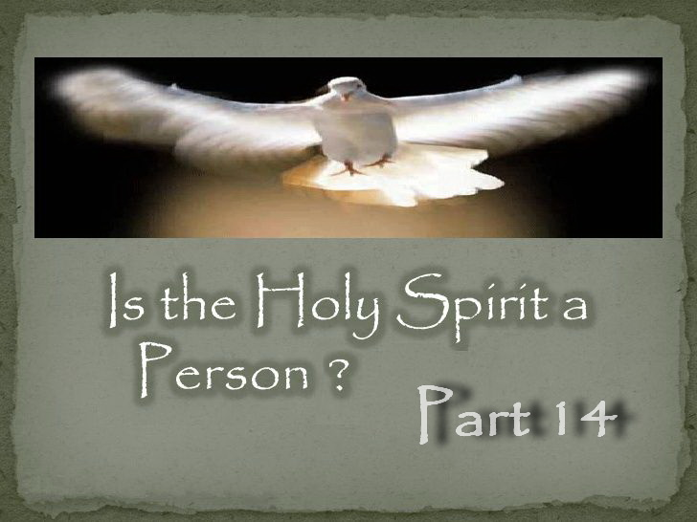

**IS THE HOLY SPIRIT A PERSON – PART 14**

**Who is the Comforter According to SOP?**

John tells us that the Comforter is the Holy Spirit. John 14:26 “*But the Comforter, which is the Holy Ghost,*”

And Jesus tells us He is going to be our Comforter. John 14:18 “*I will not leave you comfortless: I will come to you.*”

Therefore, Christ is the Comforter by His own words. How? He comes back by the Holy Spirit, which is His and His Father’s Spirit. “*By the SPIRIT the FATHER AND THE SON will come and make their abode with you.* [John 14:23 quoted]” — (E.G. White, *BEcho*, Jan 15, 1893)

Judas, not Iscariot, asks Christ how is He going to MANIFEST Himself to them as the Comforter and not unto the world. John 14:22 “*Judas saith unto him, not Iscariot, Lord, how is it that YOU will MANIFEST THYSELF unto us, and not unto the world?*”

Notice that his question is not “WHO” but “HOW?” They were wondering “HOW” Christ was going to manifest HIMSELF to them as their Comforter. The answer is: By His Spirit which is something the apostles did not yet understand. “*That CHRIST should MANIFEST HIMSELF to them, and yet be invisible to the world, was a mystery to the disciples. They could not understand the words of Christ in their SPIRITUAL sense. They were thinking of the outward, visible manifestation. They could not take in the fact that they could have the PRESENCE OF CHRIST WITH THEM, and yet He be unseen by the world. They did not understand the meaning of a SPIRITUAL MANIFESTATION.*” — (E.G. White, *SW*, Sept 13, 1898)

So the “ANOTHER” in John 14:16 is the SPIRIT OF CHRIST. Not Christ physically but HIS Spirit, which is like “ANOTHER.” “*This refers to the omnipresence of the SPIRIT OF CHRIST, called the COMFORTER.*” — (E.G. White, 14MR 179.2)

John said, “*But the Comforter, which is the Holy Ghost, whom the FATHER WILL SEND in my name, he shall TEACH YOU ALL THINGS,*” John 14:26. Whose Spirit was sent to teach us all things and hence guide us into all truth? “*We cannot be with CHRIST in person, as were His first disciples, but HE has SENT HIS HOLY SPIRIT to GUIDE US INTO ALL TRUTH,*” — (E.G. White, *Ms30*, June 18, 1900)

Below are some quotes stating in unmistakable words that Christ is THE COMFORTER by HIS SPIRIT, which God has revealed to us through His prophet.

“To the poor and oppressed and downtrodden of earth, Christ says, “*If ye love me, keep my commandments. And I will pray the Father, and he shall give you another Comforter, even the Spirit of truth, (WHICH IS CHRIST formed within the hope of glory,) whom the world cannot receive, because it seeth him not: but ye know him, for he dwelleth with you, and shall be in you. I will not leave you comfortless.* [John 14:15-18 quoted]” — (E.G. White, *Ms24*, Feb 22, 1898)

“*CHRIST is to be known by the blessed name of Comforter. “The Comforter,” said Christ to His disciples, “which is the Holy Ghost, whom the Father will send in My name, He shall teach you all things, and bring all things to your remembrance, whatsoever I have said unto you,* [John 14:26 quoted]” — (E.G. White, *Ms7*, Jan 26, 1902)

“*Let them study the seventeenth of John, and learn how to pray and how to live the prayer of CHRIST. HE IS THE COMFORTER. He will abide in their hearts, making their joy full.*” — (E.G. White, *RH*, Jan 27, 1903)

“*When He should come forth from the tomb, their sorrow would be turned to joy. After His ascension He was to be absent in person; but through THE COMFORTER He would still be with them, and they were not to spend their time in mourning.*” — (E.G. White, *DA*, p. 278)

“*We are ready to receive THE COMFORTER; we open the door of the heart, and invite the Saviour in.*” — (E.G. White, *GCB*, April 2, 1903)

“*If you are looking to Jesus, and drawing from him knowledge and strength and grace, you can impart his consolation to others, because THE COMFORTER IS WITH YOU.*” — (E.G. White, *RH*, Dec 17, 1914)

“*Christ is everything to those who receive Him. HE IS THEIR COMFORTER, their safety, their healthfulness. Apart from Christ there is no light at all.*” — (E.G. White, 21MR 372.1)

“*The Saviour is our Comforter. This I have proved Him to be.*” — (E.G. White, 8MR 49.3)

“*As by faith we look to Jesus, our faith pierces the shadow, and we adore God for His wondrous love in giving JESUS THE COMFORTER.*” — (E.G. White, 19MR 297.3)

“*The reasons why the churches are weak and sickly and ready to die is that the enemy has brought influences of a discouraging nature to bear upon trembling souls. He has sought to shut JESUS from their view as THE COMFORTER.*” — (E.G. White, *RH*, Aug 26, 1890)

Thus the Holy Spirit is NOT a third being but the Spirit of God coming to us through His Son. Who but someone who has been tempted and suffered as us, and lived as one of us is more qualified to Comfort us? What a blessing it is to have our Lord and Saviour make His abode in us as our Comforter!

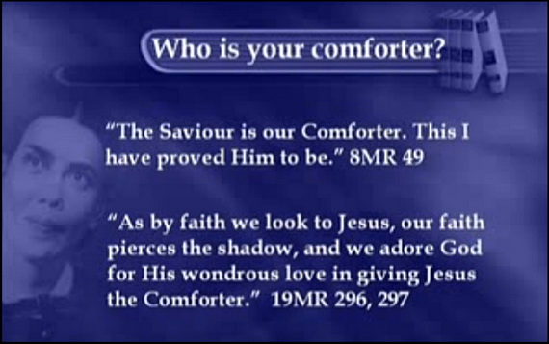

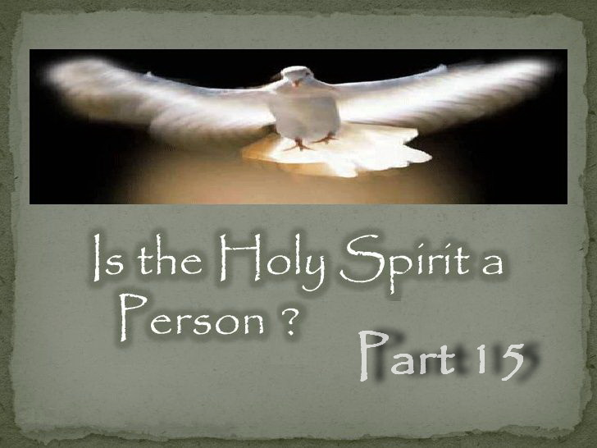

**IS THE HOLY SPIRIT A PERSON – PART 15**

**Who is the Comforter According to the Bible?**

John 14:16-28 tells us many times that the Comforter is Christ by His Spirit, but the moment Jesus says “another Comforter,” most become blind to the fact He is referring to Himself by His Spirit despite His clear words that follow.

The Greek word for another is “allos,” which means another of the exact same kind and hence means another as the same kind as Christ. Jesus was present with His disciples in physical form but after His ascension He comes back in another form, that is, by His Spirit. Hence the “another” is His Spirit. Because Christ's Spirit can function independently of Himself, it is like His Spirit is “another.” And because it is His Spirit, it is “another” of the same kind.

If the Comforter was someone different, then John would have used the word “heteros,” meaning another of a different kind. Easy to understand once you know. Most also fail to notice that Jesus often speaks of Himself in the third person as He has in this passage. See John 17:1-3 for one such example.

Compare “heteros” with “allos”

HELPS Word-studies © 1987, 2011 by Helps Ministries, Inc.

G2087 héteros – another (of a different kind). 2087 /héteros (“another but distinct in kind”) stands in contrast to 243 /állos (“another of the same kind”). 2087 /héteros (“another of a different quality”) emphasizes it is qualitatively different from its counterpart (comparison). [2087 (héteros) sometimes refers to “another” of a different class group or type (as in Plato; Oxy. papyri).]

G243 állos (a primitive word) – another of the same kind; another of a similar type.

In v. 16 Jesus says He will send “another” Comforter but leaves no doubt as to who He meant in v. 18. In unmistakable words Jesus says “I will not leave you comfortless: I will come to you.”

This “other Comforter” is none other than Christ Himself in another form (Spirit form). He is not seen (physically) as He was when He was here on earth. He is removed from the eye of sense, but He is still with us in Spirit.

The Comforter is referred to as the Spirit of truth in v. 17, which is Christ. Ten verses earlier Jesus says, “I am the truth” (v. 6) and by His Spirit, He is the “Spirit of truth.” In v. 17 we also see that the Comforter is someone whom the world cannot receive because it does not know Him. But Christ tells His disciples that they know the Comforter for He is dwelling with them. The only one with them is Christ!

In verse 19 Christ says that in a while the world seeth me no more referring to His death and resurrection, so in v. 18 and 19 Christ is saying that though He is leaving, He will not leave them Comfortless and is going to come back to them. So the disciples knew it was Christ who was going to return to them as their Comforter, but did not understand how. So Judas, not Iscariot, asks Christ how is He going to manifest Himself to them as the Comforter and not unto the world? (v. 22)

How did the disciples understand “another Comforter?” Did they understand that Christ was talking about someone else? No! This Judas understood perfectly that it was Christ who was coming back to them and not someone else. Notice that his question is not “WHO” but “HOW?” So he was not wondering “who” but “how” Christ was going to manifest Himself to them as their Comforter. The answer is: by His Spirit, which is something they did not yet understand.

In John 16:7 Jesus says, “*Nevertheless I tell you the truth; It is expedient for you that I go away: for if I go not away, the Comforter will not come unto you; but if I depart, I will send him unto you.*” So how is it that the Comforter who was yet to be sent to them was dwelling with them in John 14? In John 7:39 we find “*But this spoke he of the Spirit, which they that believe on him should receive: for the Holy Ghost was not yet given; because that Jesus was not yet glorified.*”

If the Holy Spirit was another being as per the trinity doctrine, it would not be dependent on Christ returning to the Father and being glorified before it could be given. The Holy Spirit could not be given until Christ was glorified as this is how Christ returns as another, that is, by His Holy Spirit.

John 14:23 above says “*we will come unto him and make our abode with him.*” That is, both the Father and the Son through the Holy Spirit. This is not a separate person of the Godhead who is being sent, it is the very life of God coming to us through His Son Jesus Christ. Who is more qualified to comfort us other than someone who has lived and suffered as one of us and knows what it is like to be tempted? How precious is it to have both the Father and Son?

How many times did Jesus say that He will be our Comforter in John 14? [Parentheses are added]

1. John 14:17 “*Even the Spirit of truth [Jesus is the truth and by His Spirit He is the Spirit of truth]; whom the world cannot receive, because it seeth him not, neither knows him: but you know him; for he dwelleth with you [Christ is the only one with them], and shall be in you [by His Spirit as the Comforter].*”
2. John 14:18 “*I [Jesus] will not leave you comfortless: I will come to you.*”
3. John 14:20 “*At that day you shall know that I am in my Father, and you in me, and I in you [by His Spirit as the Comforter].*”
4. John 14:21 “*He that has my commandments, and keepeth them, he it is that loveth me: and he that loveth me shall be loved of my Father, and I will love him, and will manifest myself to him [by His Spirit as the Comforter].*”
5. John 14:22 “*Judas saith unto him, not Iscariot, Lord, how is it that you [Jesus] will manifest thyself unto us [as the Comforter], and not unto the world?*”
6. John 14:23 “*If a man love me, he will keep my words: and my Father will love him, and we [Jesus and His Father] will come unto him, and make our abode with him.*”
7. John 14:28 “*You heard me say, I [Jesus] am going away and I am coming back to you [by His Spirit as the Comforter].*”

Note also that the Greek word “paraklētos” is used 5 times in Scripture and refers to Christ. It is used four times in John 14:16, 26; 15:26; 16:7 and is translated as “Comforter,” and it is used once in 1 John 2:1 where it is translated as “advocate.”

1 John 2:1 “*if any man sin, we have an advocate* [**paraklētos**] (Comforter) *with the Father, Jesus Christ the righteous:*” [Parentheses are added]

Thus Jesus Christ is both our “Comforter” and “advocate.” The Comforter is not another being but Christ Himself by His Spirit. Who but Christ who has been tempted and suffered as us, and lived as one of us is more qualified to Comfort us? How blessed we are to have our Saviour in us as our Comforter!

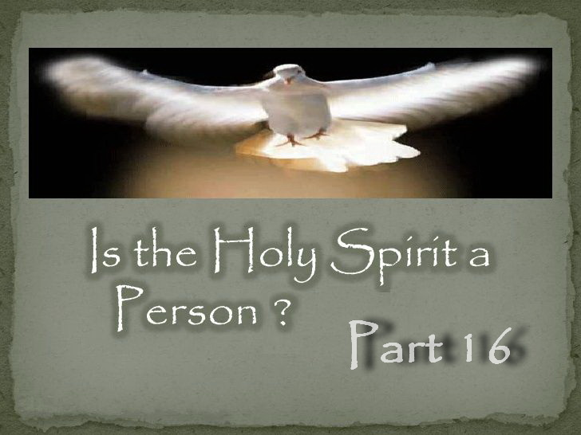

**IS THE HOLY SPIRIT A PERSON – PART 16**

**Who is the Spirit of Truth According to SOP?**

Ellen White states the HOLY SPIRIT is both the COMFORTER and the SPIRIT OF TRUTH, while also telling us that Comforter is the SPIRIT OF CHRIST. And so the “Comforter” and the “Spirit of truth” are both Christ by His Holy Spirit.”

Don’t forget that, “*The HOLY SPIRIT is the SPIRIT OF GOD; it is also the SPIRIT OF CHRIST. It is that divine, mysterious emanation through which they carry forward their great and infinite work.*” — (Uriah Smith, *GC Bulletin*, March 18, 1891, pp. 146, 147)

“*Christ tells us that the HOLY SPIRIT IS THE COMFORTER, and the Comforter is the Holy Ghost, “the Spirit of truth, which the Father shall send in My name.” “I will pray the Father, and He shall give you another Comforter, that He may abide with you for ever; EVEN THE SPIRIT OF TRUTH; whom the world cannot receive, because it seeth Him not, neither knoweth Him: but ye know Him, for He dwelleth with you, and shall be in you” This refers to the omnipresence of the SPIRIT OF CHRIST, called the COMFORTER.*” — (E.G. White, 14MR 179.2)

“*The HOLY SPIRIT is called both the COMFORTER AND THE SPIRIT OF TRUTH, because there is comfort and hope in the truth.*” — (E.G. White, *GW92*, 310.2, 1892)

“*JESUS comes to you as the SPIRIT of TRUTH; study the mind of the Spirit, consult your Lord, follow His way.*” — (E.G. White, 2MR 337.1)

“*The SPIRIT of TRUTH is the only effectual teacher of divine truth; those who are taught of Him have entered the school of CHRIST. How must God esteem the race, that He gave HIS SON to die for them, and appoints HIS SPIRIT to be man's teacher and continual guide.*” — (E.G. White, *ST*, Oct 24, 1906)

“*CHRIST was about to depart to His home in the heavenly courts. But He assured His disciples that He would send them another Comforter, who would abide with them forever. To the guidance of this Comforter all who believe in CHRIST may implicitly trust. HE IS THE SPIRIT OF TRUTH, but this truth the world can neither discern nor receive.*” — (E.G. White, 12MR 260.1)

“*The HOLY SPIRIT is constantly at work, teaching, reminding, testifying, coming to the soul as a divine COMFORTER, convincing of sin as an appointed judge and guide. CHRIST WAS THE SPIRIT OF TRUTH.*” — (E.G. White, *SW*, Oct 25, 1898)

“*How shall I bear impressively the commission CHRIST has given to His people—the privilege of being workers with the SPIRIT OF ALL TRUTH manifest in the flesh—the DIVINE SON OF GOD, clothed with humanity, a channel devised and prepared to be continually receiving and imparting the heavenly current?*” — (E.G. White, *Ms125*, July 25, 1906)

Whose Spirit was sent to guide us into all truth?

“*We cannot be with CHRIST in person, as were His first disciples, but HE has sent HIS HOLY SPIRIT to guide us into all truth, and through this power we too can bear witness for the Saviour.* [John 16:13 quoted]” — (E.G. White, *Ms30*, June 18, 1900)

The Spirit of truth is the Spirit of Christ. Thus the Holy Spirit is NOT a third being but the Spirit of God coming to us through His Son.

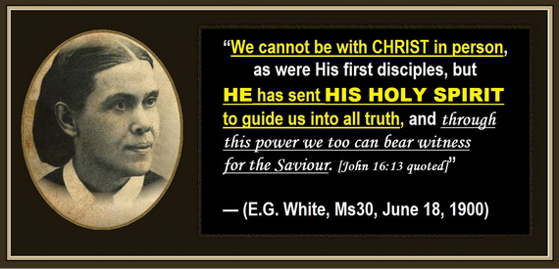

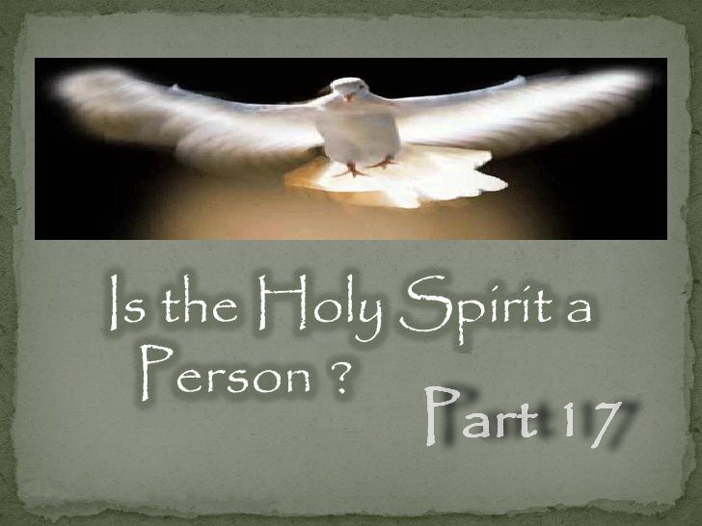

**IS THE HOLY SPIRIT A PERSON – PART 17**

**Who is the Spirit of Truth According to the Bible?**

The Spirit of truth is the Spirit of Christ, and below are four ways Scripture reveals this.

1) John 14:16-17, 26; 15:26 reveals the Comforter is the Spirit of truth and the Comforter is Christ. Jesus said, “I will not leave you comfortless: I will come to you.” John 14:18

2) John 14:6 says Jesus is the truth and by His Spirit He is the Spirit of truth. “*JESUS saith unto him, I am the way, THE TRUTH, and the life:*” John 14:6

3) The Spirit of truth does not speak of Himself; it is the Father that tells “Him” what to speak and that “Him” is Christ. See John 8:28; 12:49; 14:10, 24 and 16:13 below.

4) The Spirit of truth is also to *show us things to come* which Revelation 1:1 tells us it is Jesus Christ which is once again revealed to Him by His Father.

John 16:13 “*Howbeit when HE, the SPIRIT OF TRUTH, is come, he will guide you into all truth: FOR HE SHALL NOT SPEAK OF HIMSELF; but whatsoever he shall hear, that shall he speak: and HE WILL SHOW YOU THINGS TO COME.*”

Note that the above verse says the Spirit of truth is a “HE” and that “HE” is “Christ” Himself by His Holy Spirit. Christ is a “HE” even if it is by HIS Spirit!

Note also in John 16:13 above that the Spirit of truth (Christ) does not SPEAK OF HIMSELF but speaks what He hears from someone else. In the verses below we find that someone else is His FATHER.

*JESUS DOES NOT SPEAK OF HIMSELF* but *WHAT THE FATHER INSTRUCTS HIM TO SAY*. And that remains the same when Christ returns as our Comforter and Spirit of truth. Even by His Spirit, *HE DOES NOT SPEAK OF HIMSELF* but speaks *WHAT HE HEARS FROM HIS FATHER*. That is what He shall speak.

John 12:49 “*FOR I HAVE NOT SPOKEN OF MYSELF; but the FATHER which sent me, he gave me a commandment, what I should say, and what I should speak.*”

John 14:10 “*The words that I speak unto you I SPEAK NOT OF MYSELF: but the FATHER that dwelleth in me,*”

John 14:24 “*He that loveth me not keepeth not my sayings: and THE WORD WHICH YOU HEAR IS NOT MINE, but the FATHER'S which sent me.*”

John 8:28 “*When you have lifted up the Son of man, then shall you know that I am he, and that I DO NOTHING OF MYSELF; but as my FATHER has taught me, I speak these things.*”

So when Jesus was on Earth, He did not SPEAK OF HIMSELF but what the Father told Him to speak. And when Jesus returned by His Spirit as the Spirit of truth, nothing changed. Jesus by His Spirit does not SPEAK OF HIMSELF but what the Father has shown Him.

The Spirit of truth is also to *SHOW US WHAT THINGS ARE TO COME* which we find in Revelation 1:1 is also Christ. Just as the words He speaks are from His Father, so are the things to come that He is to show us. And hence we find all Scripture lines up without any contradiction or inconsistencies as truth always does.

Revelation 1:1 “*The Revelation of JESUS CHRIST, WHICH GOD GAVE UNTO HIM, to show unto his servants things which must shortly come to pass;*”

The Spirit of truth is the Spirit of Christ. Thus the Holy Spirit is NOT a third being but the Spirit of God coming to us through His Son.

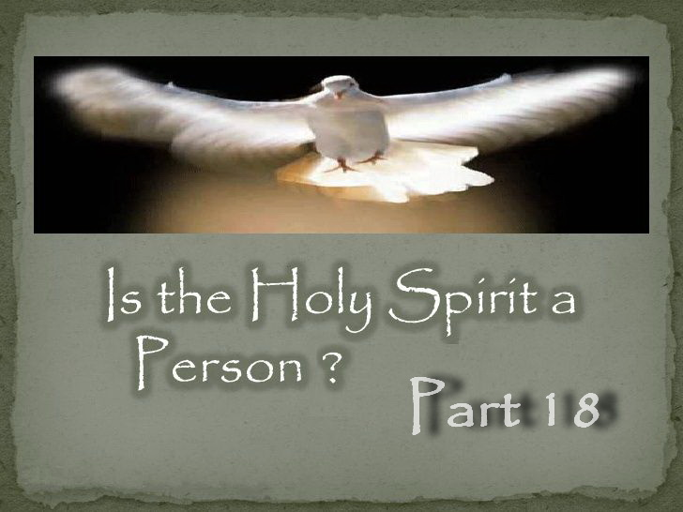

**IS THE HOLY SPIRIT A PERSON – PART 18**

**Whose Spirit was given at Pentecost?**

Did you ever wonder why Jesus said, “*Nevertheless I tell you the truth; It is expedient for you that I go away: for if I go not away, the Comforter will not come unto you; but if I depart, I will send him unto you.*” John 16:7. Why did Jesus have to go away before the Comforter could be sent?

Jesus also said, “*You heard me say, I am going away and I am coming back to you.*” John 14:28 NIV

So “How,” “Why” and “When” was Jesus coming back?

WHY?

Because Jesus promised that He would not leave us comfortless and that He would stay with us until the end of the world.

“*I will not leave you comfortless: I will come to you.*” John 14:18

“*lo, I am with you alway, even unto the end of the world.*” Matthew 28:20

WHEN?

On the day of Pentecost when the promise of the Father was to be given. “*And, being assembled together with them, commanded them that they should not depart from Jerusalem, but wait for the PROMISE OF THE FATHER, which, saith he, you have heard of me.*” Acts 1:4

“*And when the day of PENTECOST was fully come, they were all with one accord in one place.*” Acts 2:1

HOW?

By the PROMISE OF THE FATHER which was the outpouring of the Holy Spirit on the day of Pentecost. “*And, behold, I send the PROMISE OF MY FATHER upon you: but tarry you in the city of Jerusalem, until you be ENDUED WITH POWER FROM ON HIGH.*” Luke 24:49

So why couldn’t this be done until Jesus had returned to the Father and been glorified? “*But this spoke he of the Spirit, which they that believe on him should receive: for the HOLY GHOST WAS NOT YET GIVEN; because that JESUS WAS NOT YET GLORIFIED.*” John 7:39

It could not be done until Jesus had been glorified because Jesus was returning to us on the day of Pentecost by the outpouring of the HOLY SPIRIT.

Jesus had to be anointed WITH THE HOLY SPIRIT of His Father before this could happen. Jesus gave up a lot when He came as the Son of man and He now receives back the power of His Father’s Spirit.

In other words, God the Father GAVE HIS SPIRIT to Jesus in full measure at this glorification event. This is why the Holy Spirit could not be poured out until Jesus was glorified, because it is God's OWN Spirit which He was going to anoint Jesus fully with, not “another being.”

Jesus did not receive “another person.” He received the Father’s own Divine Spirit and power, which Jesus then “poured out” upon His followers.

“*During the patriarchal age the influence of the Holy Spirit had often been revealed in a marked manner, but never in its fullness. Now, in obedience to the word of the Saviour, the disciples offered their supplications for this gift, and in heaven Christ added His intercession. HE CLAIMED THE GIFT OF THE SPIRIT, that He might POUR IT upon His people.*” — (E.G. White, *AA*, p.37)

“*God has raised this Jesus to life, and we are all witnesses of the fact. Exalted to the right hand of God, he [Christ] has received from the FATHER THE PROMISED HOLY SPIRIT and has poured out what you now see and hear.*” Acts 2:32-33 NIV

Jesus had gained the victory over Satan. He had been raised and ascended back to heaven. If the Holy Spirit was a person separate from the Father and Son, then why did He need to wait for Jesus to be glorified to come down to earth? The job was done, the Holy Spirit could have come right away if it was a separate person. But what was part of this glorification event for Jesus? *“…having received from the Father the promise of the Holy Spirit…*” -- “*He claimed the gift of the Spirit, that He might pour it upon His people.*”

“*Outpouring of the Holy Spirit at Pentecost—Christ ascended on high, to take His position as our Advocate in the heavenly courts. Having reached His throne, HE SENT HIS HOLY SPIRIT, as He had promised, in response to the prayers of His disciples.*” — (E.G. White, 10MR 98.1, 1899)

“*And when He had said this, HE [Christ] breathed on them, and saith unto them, Receive ye the Holy Ghost: Whosesoever sins ye remit, they are remitted unto them; and whosesoever sins ye retain, they are retained. The Holy Spirit was not yet fully manifested; for Christ had not yet been glorified. The more abundant impartation of the Spirit did not take place till after Christ's ascension. Not until this was received could the disciples fulfill the commission to preach the gospel to the world. But the Spirit was now given for a special purpose. Before the disciples could fulfill their official duties in connection with the church, CHRIST BREATHED HIS SPIRIT upon them.*” — (E.G. White, *DA*, p. 805)

“*When the HOLY SPIRIT was poured out upon the early church, 'The whole multitude of them that believed were of one heart and of one soul.' The SPIRIT of CHRIST made them one. This is the fruit of abiding in Christ.*” — (E.G. White, *GCDB*, Feb 6, 1893)

“*The promise of the Holy Spirit is not limited to any age or to any race. CHRIST declared that the divine influence of HIS SPIRIT was to be with His followers unto the end. From the Day of Pentecost to the present time, the Comforter has been sent to all who have yielded themselves fully to the Lord and to His service.*” — (E.G. White, *AA*, 49.2)

So how is Jesus going to be with us as our Comforter and Spirit of truth if He has returned to the Father? By coming back as “another” of the same kind. That is, through His Holy Spirit.

“While JESUS ministers in the sanctuary above, HE is still by HIS SPIRIT the minister of the church on earth. HE is withdrawn from the eye of sense, but HIS parting promise is fulfilled, “Lo, I am with you alway, even unto the end of the world.” Matthew 28:20. While HE delegates HIS power to inferior ministers, HIS energizing presence is still with HIS church.” — (E.G. White, *DA*, p. 166)

Thus the Holy Spirit is not another being but the Spirit of God coming to us through His Son.

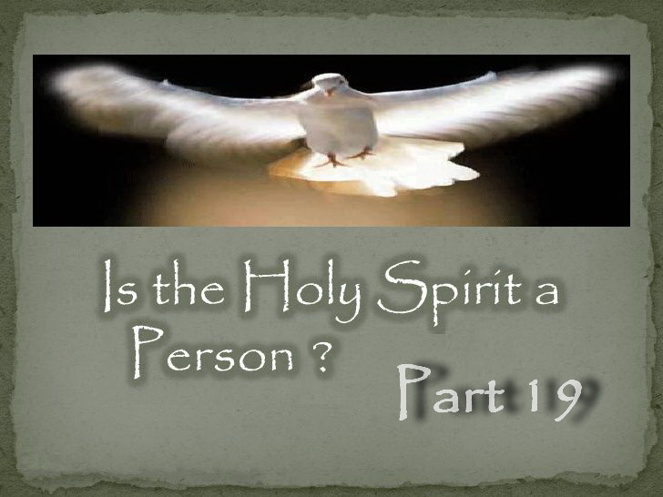

**IS THE HOLY SPIRIT A PERSON – PART 19**

**How Many Beings Involved in Creation?**

Trinitarians claim three beings were involved in the literal work of creation. Genesis 1:2 and Genesis 1:26 are used as the so-called evidence.

Genesis 1:2 says, “*And the Spirit of God moved upon the face of the waters.*”

The Trinitarian mindset thinks this means a literal being is moving across the waters. But the real and simple truth is that God can send His Spirit anywhere and can be anywhere He pleases. It does not say something called “god the spirit” moved upon the face of the waters. It says the “Spirit of God.” If one chooses to claim Genesis 1:2 means God’s Spirit was a literal being moving across the waters, then the verse below says a literal being is in Job’s nostrils. Clearly that is not so!

“*All the while my breath is in me, and the SPIRIT OF GOD IS IN MY NOSTRILS;*” Job 27:3

The “Spirit OF God” is God’s Spirit, not another being. It is His personal presence and power.

David wrote, “*Whither shall I go from thy spirit? Or whither shall I flee from thy presence?*” Psalm 139:7. Here David uses Hebrew parallelism to express himself. This expresses a thought one way, and then uses a complementary thought to express it another way. His first thought is, “*Whither shall I go from thy spirit?*” And the second which is equivalent to the first says, “*whither shall I flee from thy presence?*” So David is saying that God's Spirit is equivalent to God's presence. Thus the Holy Spirit is God's presence and power.

“*In giving us HIS SPIRIT, God gives us HIMSELF,*” — (E.G. White, 7T 273.1, 1902)

“*The divine Spirit that the world's Redeemer promised to send, is the presence and power of God.*” — (E.G. White, *ST*, Nov 23, 1891)

Thus it was not some being called “god the holy spirit” but the “Spirit OF God” being His personal presence that was moving across the waters.

Genesis 1:26 says, “*And God said, Let us make man in our image, after our likeness:*”

The argument with Genesis 1:26 is that the Hebrew word “Elohim” for God is plural and so this must mean that God is 3 beings. It is further argued that since the pronoun “us” is used in Genesis 1:26 that this also confirms that God must be 3 and that 3 beings did the creating.

Did anyone ever stop to think that “us” is just the Father and Son?

The Greek word for God is “Theos” while the Hebrew word is “Elohim.” Note that the Greek word “Theos” is singular and “only” the Hebrew word for God is plural. This is because the Hebrew people pluralized nouns to denote greatness and this is called a “Plural of majesty.” They did this to express that God is great, not that God is more than one.

Below is one dictionary that not only explains the truth but also informs us that no intelligent scholar uses this false argument anymore because the truth is so easily seen and the deception exposed. Hence no one uses this argument anymore unless they are ignorant and deceived.

“*Elohim is the plural of Eloah ... The fanciful idea that it referred to the trinity of persons in the Godhead hardly finds now a supporter among scholars. It is either what grammarians call the plural of majesty, or it denotes the fullness of divine strength, the sum of the powers displayed by God. Jehovah denotes specifically the one true God, whose people the Jews were, and who made them the guardians of his truth.*” — (Smith's Bible Dictionary)

How many beings does the Bible say were involved in creation?

Ephesians 3:9 “*And to make all men see what is the fellowship of the mystery, which from the beginning of the world has been hid in GOD, WHO CREATED ALL THINGS BY JESUS CHRIST:*”

Hebrews 1:1-2 “*God, who at sundry times and in divers manners spoke in time past unto the fathers by the prophets, 2 Has in these last days spoken unto us by his Son, whom he has appointed heir of all things, BY WHOM ALSO HE MADE THE WORLDS;*”

1 Corinthians 8:6 “*But to us there is but ONE GOD, the Father, of WHOM ARE ALL THINGS, and we in him; and ONE LORD JESUS CHRIST, BY WHOM ARE ALL THINGS, and we by him.*”

God in Ephesians 3:9 is obviously someone other than Jesus Christ, and Hebrews 1:2 and John 1:3 also say God created all things by His Son. So who is speaking in Genesis 1:26 and who is He speaking to according to these verses?

God said to His Son, “*let us make man in our image.*” Christ is “the express image” of the Father, so anyone created in the Father's image is also created in His Son's image.

How many beings does SOP say were involved in creation?

“*The Father and the Son engaged in the mighty, wondrous work they had contemplated, of creating the world. ... After the earth was created, and the beasts upon it, the Father and Son carried out their purpose, which was designed before the fall of Satan, to make man in their own image. They had wrought together in the creation of the earth and every living thing upon it. And now GOD said to His SON, “Let us make man in our image.* [GENESIS 1:26 QUOTED]” — (E.G. White, *1SP*, 24.1,2)

Note also that SOP says that the president of the SDA Church Ted Wilson is in ERROR. This is what happens when you teach a lie from Satan. You get caught out!

<https://www.youtube.com/watch?v=8NO95n1jdho>

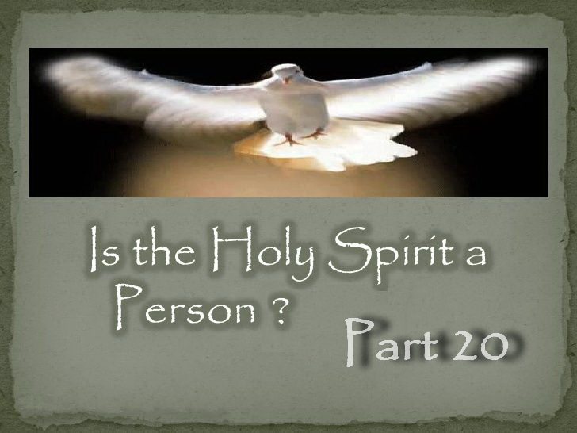

**IS THE HOLY SPIRIT A PERSON – PART 20**

**Who is the Holy Spirit According to the Bible?**

Paul says in Ephesians 4:4 that there is “one Spirit.” But the Bible speaks of the “Spirit of God” and the “Spirit of Christ” which involves two DIVINE beings. If the Father has a Holy Spirit, the Son must too. So how then is there only one Spirit? The answer is something the majority miss because most have been indoctrinated with the Catholic idea of the Holy Spirit as another being rather than God's own Spirit. God and His Son have a shared Spirit and that is how “They” represent “Themselves” where they are not personally present.

So the Holy Spirit is the mind, power, character and personal presence of the very life of God that the Father sends through His Son to us. Or to put it another way to make sure this is clear; the Holy Spirit is the presence and power of the Father manifested through Jesus Christ, His only begotten son. This is not a separate person of the Godhead who is being sent, it is the very life of God coming to us through His Son.

“*But unto them which are called, both Jews and Greeks, Christ the power of God, and the wisdom of God.*” 1 Corinthians 1:24

Everything Christ received He inherited from His Father including His very own life which is self-existent as it came from the Father. “*For as the Father has life in himself; so has he given to the Son to have life in himself.*” John 5:26

But not only His life but Christ also received of His Father’s Spirit. Thus the Father and Son are one in Spirit, and that one Spirit proceeds from the Father and comes to us through His Son. This is why Paul equates the “Spirit of God” with the “Spirit of Christ” as it is the same one Spirit of God the Father and His Son Jesus Christ. And so we find that the Holy Spirit is the same Spirit whether it is spoken of as pertaining to God or Christ.

“*But you are not in the flesh, but in the Spirit, if so be that the Spirit of God dwell in you. Now if any man have not the Spirit of Christ, he is none of his.*” Romans 8:9

Referring to the Holy Spirit, Paul says that Christ is that Spirit. “*Now the Lord [Jesus] is that Spirit: and where the Spirit of the Lord is, there is liberty.*” 2 Corinthians 3:17

And further, while Paul wrote in Ephesians 4:4 that there is only one Spirit, he again tells us in Galatians 4:6 that this Spirit is the Spirit of our Lord Jesus Christ, which He received from His Father. So when you receive the Spirit of God, you receive the Spirit of His Son into your heart also. The Father did not send another individual. He sent the Spirit of His Son. “*God has sent forth the Spirit of his Son into your hearts, crying, Abba, Father.*” Galatians 4:6

How do both the Father and Son live in us? Since they are one in Spirit, it is by the Holy Spirit. “*If a man love me, he will keep my words: and my Father will love him, and WE will come unto him, and make our abode with him.*” John 14:23

And being one in Spirit gives us access to the Father through Christ our mediator. “*For through him [Christ] we both have access by one Spirit unto the Father.*” Ephesians 2:18

As Jesus said, “*No one comes to the Father except through Me.*” John 14:6

And so it is by the Holy Spirit that Christ lives in us which also gives us access to the Father. “*I am crucified with Christ: nevertheless I live; yet not I, but Christ liveth in me:*” Galatians 2:20

The Spirit of Christ is our Comforter (parakletos) which also means “helper” and is translated as such in the NKJV, “*For I know that through your prayers and the help given by the Spirit of Jesus Christ, what has happened to me will turn out for my deliverance.*” Philippians 1:19

And since the Holy Spirit is the Comforter and Spirit of truth, if the Father and Son were not one in Spirit, then Christ by His Spirit could not be the Comforter and Spirit of truth. It is only by sharing the same Spirit that this is possible.

Christ had also spoken through all the prophets. “*Searching what, or what manner of time the Spirit of Christ which was in them did signify, when it testified beforehand the sufferings of Christ, and the glory that should follow.*” 1 Peter 1:11

Christ has always partaken of the Spirit of God since He was begotten of the Father before they created anything. When Jesus was incarnated on earth 2000 years ago, He was full of that same Holy Spirit of God from His conception, and throughout His earthy sojourn as the Son of Man. After His resurrection and ascension to Heaven, He sent “*another Comforter*” to earth to empower His people till the end of time, which was Himself in Spirit form. Only the Father and the Son can be present outside of their bodies throughout the Universe. Their Holy Spirit is the way in which they are omnipresent while also being physically present in the Heavenly Sanctuary as we speak. This is where the nascent Catholics made their mistakes when coming up with the incomprehensible doctrine of the trinity versus the plain word of God. In creating the trinity they philosophized when they should have left it alone as it is totally un-Scriptural.

“*And so it is written, The first man Adam was made a living soul; the last Adam was made a quickening spirit. Howbeit that was not first which is spiritual, but that which is natural; and afterward that which is spiritual. The first man is of the earth, earthy: the second man is the Lord from heaven.*” 1 Corinthians 15:45-47

Here the Apostle Paul is talking about the two Adams. The first Adam was the first created man on earth who sinned by eating the forbidden fruit. The second (last) Adam is Christ who came to redeem us. Notice that Paul says that this One was made “*a quickening spirit.*” This is the other important thing about Christ. Not just His earthly human life, but also what happened after. In verse 46 Paul clarifies that the natural comes first and then the spiritual. This is exactly what happened with Jesus. He came to earth first as a man, ministered, ascended to Heaven, and then at Pentecost He came back in Spirit with mighty power! Both times was to instruct and sanctify His people, and that is the same purpose today. So the Holy Spirit of God the Father is now also the Spirit of Christ which point Paul confirms in verse 47. So “*the Lord from Heaven*” in verse 47 is the “*quickening Spirit*” of verse 45. It cannot be any clearer. The Spirit of God and of Christ is the third entity of the Godhead, but it is not another being any more than our Spirit is another being.

However, the Spirit of the Father and Son as divine beings can do something we cannot. They can leave their bodies in one place, and also be omnipresent anyplace throughout the universe at the same time by their Holy Spirit. In this way they can also enter the hearts of a repentant believer. The teachings of the Catholic trinity (three persons in one god) are now rampant in most Churches which destroys this wonderful truth of who the Holy Spirit really is by the introduction of a totally different third being which does not actually exist! And as if that were not bad enough, Satan receives the unwitting worship of millions upon millions of people through this serious deception that he has inspired man to create.

In conclusion, the Holy Spirit is the very life of God coming from the Father and shared by the Son. It is the personal presence of the Father and the Son given to us. Those who partake of this divine presence and power within, the life of God, and allow Him to transform their characters into the likeness of His Son will someday personally meet this wondrous God of love.

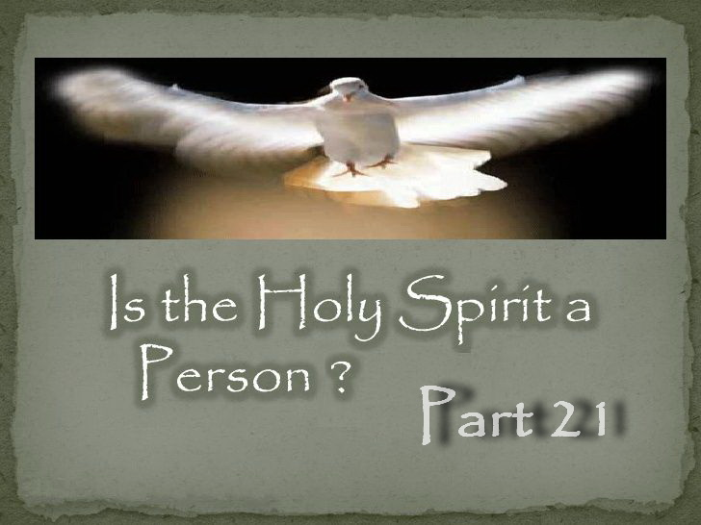

**IS THE HOLY SPIRIT A PERSON – PART 21**

**Did Satan Counterfeit the Holy Spirit?**

In Revelation 13 and 14, we find that the mark of the beast is about who we worship. Isaiah 14:12-14 says that Satan desires to be worshipped as God. But if Satan asked you to worship him, would you do it? Of course not. And Satan of course knows this. So Satan gets himself a front man and props him up so when they are worshipped, he receives worship by proxy. This is called worship by representation. There are two ways Satan does this with Christians and both come from sun worship.

The first way is through Sunday worship. Scripture informs us that the Lord's Sabbath is a sign that it is God we worship and God who sanctifies us when we keep His Seventh day Holy. Revelation 13:2 says Satan gave his power, throne and great authority to the beast which is the Papal Church system. So when this beast power is being worshipped, who is really being worshipped? Satan himself! So where does worship come into this? By Satan through the Catholic Church implementing his own day of worship being Sunday. That is, Sunday worship that evolved from sun worship.

The second way is by worship of the Holy Spirit as a non-existent literal being, and so Satan steps in to receive this worship by representation once again. This was something he put in place a long time ago in 381 A.D. The Bible never teaches that the Holy Spirit is God or that the Holy Spirit should be prayed to or worshipped, and yet the Catholic Church does this. Today there are more and more from other denominations now doing the same. Just recently some Adventists are now teaching we should pray to the Holy Spirit.

If the Trinity doctrine is wrong, then the idea of “God the Holy Spirit” is really a creation of Satan rather than the Spirit of the Father and Son, which would be the real Holy Spirit. And if this third being is a creation of Satan, who would we be giving our adoration to? Whose Spirit would we have? Knowing exactly who the Father and Son are is the key to eternal life. But understanding the identity of the Holy Spirit is also something you cannot afford to get wrong.

One might ask why the Bible never tells us to “pray to” or “worship” the Holy Spirit if it is a third co-equal being as the Trinity doctrine claims. We are told to pray “for” the Spirit, but never “to” the Spirit. Yet as the trinity doctrine takes a stronger hold on the Church, some are beginning to do just that contrary to the teachings of Scripture.

Who would be the four highest beings in Heaven before the fall of man if the Holy Spirit was a third co-equal being as per the Trinity doctrine? It would be the Father, Son, Holy Spirit and Lucifer. Who is it that wants to be like the most High and be worshipped and prayed to as God? (Isaiah 14:12-14) What if the Holy Spirit was not a third literal being. Who would then be the third highest being? Lucifer!

So if the Holy Spirit is not a third literal being, a separate god, then who would be answering our prayers if we prayed to the “Spirit”? Who would be setting himself up as a third “god” worthy of praise and worship? Has Satan succeeded in accomplishing his goal of being included as a deity? If we now believe the Holy Spirit can be worshipped and prayed to just like the Father and the Son, who receives our worship? If the Holy Spirit is not a third being then what spirit would we have according to our belief and who would we be giving our adoration to?

Thus the third person in the Trinity is actually Satan! It should be obvious that if you get this wrong you will not be in the kingdom.

So regardless of whether you “pray” or “worship” to a counterfeit Holy Spirit from Satan or not, you still need to acknowledge the real Holy Spirit or clearly you are still in grave danger.

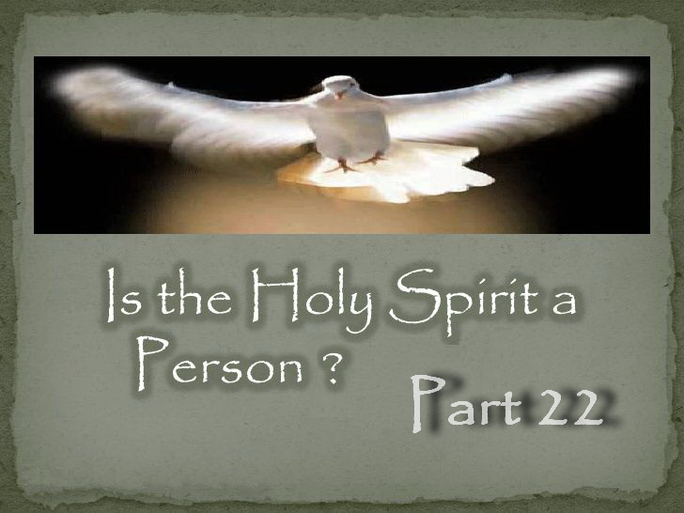

**IS THE HOLY SPIRIT A PERSON – PART 22**

**Do non-Trinitarians Believe in the Holy Spirit?**

The answer is of course! So why am I asking the question?

Please allow me to explain.

The idea of the Holy Spirit as a third being comes from Satan via the Roman Catholic Church more than 250 years AFTER the Bible was written so Satan could achieve worship, and steal souls from the kingdom. So how do you think Satan feels about people exposing his lie? I and others have found that he will resort to any tactic no matter how dirty to keep his lie from being exposed!

Sadly, Satan has even managed to find Christians to spread false rumours about those who have discovered Satan’s masterful deception to achieve worship.

Typical false rumours that are spread is that non-Trinitarians teach the Holy Spirit is just a force. It saddens me deeply that even Adventist Pastor Doug Batchelor has preached this fallacy.

To the contrary, the Holy Spirit is the mind, power and personal presence of the very life of God that the Father sends through His Son to us, which is exactly what God taught through His prophet. “*The divine Spirit that the world's Redeemer promised to send, is the PRESENCE and POWER of God.*” — (E.G. White, *ST*, Nov 23, 1891)

And the second most common false rumour is that non-Trinitarians do not believe in the Holy Spirit. What a shocking outright lie!

If anyone is found spreading false rumours such as these, they need to be informed that bearing false testimony breaks the ninth Commandment and that there is no sacrifice that covers wilful sin!

“*For if we sin wilfully after that we have received the knowledge of the truth, there remaineth no more sacrifice for sins,*” Hebrews 10:26

So who is following the Bible, and who is following the Papal Church and Satan’s lie?

Non-Trinitarians believe exactly what the Bible says. Scripture says the Holy Spirit is the “Spirit OF God” and the “Spirit OF the Father” and the “Spirit OF Christ” and that is exactly what is believed.

Trinitarians on the other hand believe in something called “god the spirit” or “god the holy spirit.” I cannot capitalize these words as they are not Biblical and DO NOT exist in Scripture anywhere!

Thus it is Trinitarians who DO NOT believe in the real Holy Spirit as Scriptures states, but something called “god the holy spirit” which does not exist in Scripture.

So since the Trinity doctrine teaches a three in one God, then Trinitarians use the corresponding phrases “God the Father,” “god the son” and “god the spirit.” They call all three god's. But since the Bible says there is only one God, then Trinitarians have to say that all three are one God.

If this were true, then indeed the Bible would use these phrases and call them all God. So is it true? Does the Bible say this? No! If there really were three gods then the Bible would use these phrases. But it doesn't because there isn't. The Bible means what it says and says what it means!

It says there is only one God being “God the Father” and so the Father is the only one called God. The phrases “god the son” and “god the spirit” do not exist anywhere in Scripture, not even once! These phrases originated from the Catholic Church and were made up to match the doctrine they created.

The Bible uses the phrase “Son of God” because that is who He is. And it uses “Spirit of God” or “Spirit of the Father” as that is what it is. So why are Trinitarians using made up phrases that have an entirely different meaning and hence are not found in the Bible?

If you are using the Catholic phrases “god the son” or “god the spirit,” that never originated from Scripture, then you are following the Papal Church and antichrist, not the inspired words of God.

So why are Trinitarians spreading false rumours about non-Trinitarians when it is they themselves who are not following the Bible but a doctrine from antichrist?

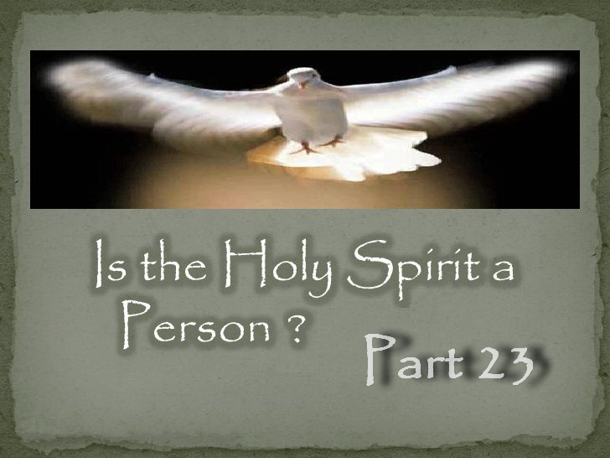

**IS THE HOLY SPIRIT A PERSON – PART 23**

**Whose Spirit Represents Christ?**

Some assume that since Ellen White said the Holy Spirit represents Christ that it must be another being. And others believe that if the Holy Spirit is not a literal third being then there cannot be three.

But this wrong mindset comes from a lack of understanding of the power and capabilities of the Holy Spirit, and that the Holy Spirit is the ONE Spirit of the Father and Son.

“*The HOLY SPIRIT is the SPIRIT OF GOD; it is also the SPIRIT OF CHRIST. It is that divine, mysterious emanation through which they carry forward their great and infinite work.*” — (Uriah Smith, *GC Bulletin*, March 18, 1891, pp. 146, 147)

Thus the Holy Spirit is the mind, power and personal presence of the very life of God that the Father sends through His Son to us. This is not a separate person of the Godhead who is being sent, it is the very life of God coming to us through His beloved Son.

So whose Spirit represents Christ? Below Ellen White states that Christ has left HIS SPIRIT in the world to represent Himself.

Most respond, “How can His own Spirit represent Himself?”

Quite easily in fact, as Christ’s Spirit can function independently of Himself like it is another. Many fail to realize that the Spirit of Christ can function like a person separate to Himself, so it is like it is “another” person.

This is the nature of the Holy Spirit that Ellen White said we cannot understand. So the Holy Spirit is indeed like a third person, though not a literal person.

“*CHRIST has left HIS Holy Spirit to be HIS representative in the world, to give celestial aid to every hungering, thirsting soul.*” — (E.G. White, *Lt84*, Oct 22, 1895)

Ellen White understood that “representative” does not make a third being, but that Christ represents Himself in a different form. God and His Son have a Spirit and that is how “They” represent “Themselves” where they are not personally present.

She made this very clear several times as we find from the following quotes.

“*Cumbered with humanity, CHRIST could not be in every place personally; therefore it was altogether for their advantage that He should leave them, go to His father, and send the Holy Spirit to be His successor on earth. The Holy Spirit is [Christ] HIMSELF, divested of the personality of humanity, and independent thereof. HE would represent Himself as present in all places by HIS Holy Spirit, as the Omnipresent.*” — (E.G. White, *Lt119*, Feb 18, 1895)

“*The Holy Spirit is the SPIRIT of CHRIST; it is HIS representative. Here is the divine agency that carries conviction to hearts. When the power of His Spirit is revealed through the servants of God, we behold divinity flashing through humanity.*” — (E.G. White, 13MR 313.3, 1895)

“*CHRIST came to our world, but the world could not endure His purity. He has gone to His Father, but HE has sent HIS Holy Spirit to represent HIM in the world till he shall come again.*” — (E.G. White, *Ms1*, Jan 11, 1897)

Thus we find that the Holy Spirit is the Spirit of God coming to us through His Son, and that Christ sent His Spirit to represent Himself. It is not another being as the Trinity doctrine claims.

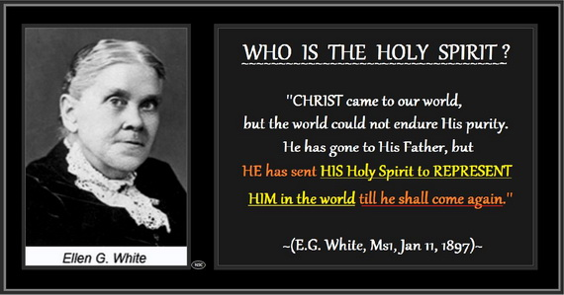

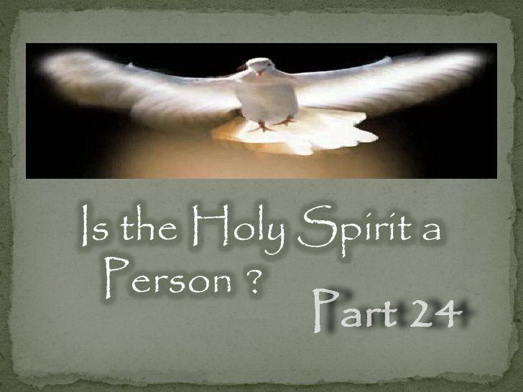

**IS THE HOLY SPIRIT A PERSON – PART 24**

**How was the SDA Church Changed to Think the Holy Spirit is a Person?**

It is claimed that Ellen White became a Trinitarian 20 years before her passing. This erroneous claim is based on a handful of quotes that LeRoy Froom set out to search for that he rightly figured would be misunderstood. He searched over 100,000 pages of her writings (25,000,000 words) and found a few quotes that on the surface appeared to fit the Trinitarian concept on the Holy Spirit. But only if you choose to read them as such, and at the expense of the “tens of thousands” of non-Trinitarian statements she wrote.

Note that Froom was labelled as being the most dangerous man in the SDA Church and is now suspected of being a Jesuit. On the 14 December 1955, Leroy Froom in a letter to Reuben Figuhr wrote, “*I was publicly denounced in the chapel at the Washington Missionary College by Dr. B. G. Wilkinson as the most dangerous man in this denomination.*”

The claim that Ellen White was given light which resulted in her becoming a Trinitarian means God would have been lying to her for many decades. This claim is obviously false! New light CANNOT contradict old light or the old light was a LIE from God. A change from non-Trinitarian to Trinitarian is a total backflip and can NEVER be called progressive truth.

Sadly, Froom eventually managed to convince the SDA Church with these misunderstood quotes that he cherry picked that Ellen White had become a Trinitarian. But he had to wait until the death of Ellen White and all the pioneers as he could never have achieved this change while they were still alive.

The deception of Froom was so successful that many believe that the quotes called “EV” or “Evangelism” are from a book written by Ellen White. But they were compiled by Froom in 1946 which was 30 years after the death of Ellen White. While this book contains the writings of Ellen White, the headings, subheadings and bolded texts before the quotes in this book are NOT her words, and some included the word “Trinity” which she never wrote and were added to aid the deception!

These quotes are typically called EV 615-EV 617 or Evangelism 615-617.

Ellen White actually taught that the “Holy Spirit” is the “Spirit of God” coming to us through His Son, and hence she frequently wrote the Holy Spirit is the “SPIRIT OF CHRIST.” For example, “*We want the HOLY SPIRIT, which is JESUS CHRIST.*” — (EGW, *Lt66*, April 10, 1894)

But many today are so indoctrinated with a Trinitarian mindset, that they mistakenly believe that the quotes Froom compiled and put in one place imply the Holy Spirit is a third being. But Ellen White was referring to the “SPIRIT OF CHRIST,” not a third being.

She was 100% consistent in all that she wrote. And since she wrote, “The Holy Spirit is the Spirit of Christ,” she also wrote:

The Comforter is the SPIRIT OF CHRIST,  
the Spirit of truth is the SPIRIT OF CHRIST,  
the third person is the SPIRIT OF CHRIST,  
the third great power is the SPIRIT OF CHRIST,  
the Holy Spirit given at Pentecost was the SPIRIT OF CHRIST,  
the Holy Spirit Jesus breathed on His disciples was HIS own SPIRIT,  
the Holy Spirit Christ sent to represent Himself was HIS own SPIRIT,

the heavenly dignitaries are the Father, Son and SPIRIT OF CHRIST,

the Heavenly trio is the Father, Son and SPIRIT OF CHRIST,  
and she reveals over and over again that there are only two beings.

There are literally thousands of quotes from Ellen White that confirm the above facts. But since size is an issue, just one quote will be provided that confirm all of the above. The first covers almost all of the above points.

For instance: “**THIRD PERSON**,” “**THIRD GREAT POWER**,” “**HEAVENLY DIGNITARIES**” and “**HEAVENLY TRIO**.” —<>— “They have ***ONE*** God and ***ONE*** Saviour; and ***ONE*** Spirit--***the Spirit of Christ***--is to bring unity into their ranks.” — (EGW, 9T 189.3, 1909)

The third person, power and dignitary of the trio = ONE + ONE + ONE = “the SPIRIT OF CHRIST”

**THIRD GREAT POWER** —<>— “*CHRIST has given HIS SPIRIT as a divine POWER.*” — (EGW, *RH*, Nov 19, 1908)

**COMFORTER** —<>— “*This refers to the omnipresence of the SPIRIT OF CHRIST, called the COMFORTER.*” (EGW, 14MR 179.2)

**SPIRIT OF TRUTH** —<>— “*JESUS comes to you as the SPIRIT of TRUTH; study the mind of the Spirit, consult your Lord, follow His way.*” (EGW, 2MR 337.1)

**SPIRIT JESUS BREATHED ON HIS DISCIPLES** —<>— “*And when He had said this, He [Christ] breathed on them, and saith unto them, Receive ye the Holy Ghost: ... Before the disciples could fulfill their official duties in connection with the church, CHRIST breathed HIS Spirit upon them.*” (EGW, *DA*, p. 805)

**SPIRIT GIVEN AT PENTECOST** —<>— “*The promise of the HOLY SPIRIT is not limited to any age or to any race. CHRIST declared that the divine influence of HIS SPIRIT was to be with His followers unto the end. From the Day of PENTECOST to the present time, the COMFORTER has been sent to all who have yielded themselves fully to the Lord and to His service.*” (EGW, *AA*, 49.2)

**SPIRIT THAT REPRESENTS CHRIST** —<>— “*CHRIST came to our world, but the world could not endure His purity. He has gone to His Father, but HE has sent HIS Holy Spirit to represent HIM in the world till he shall come again.*” — (EGW, *Ms1*, Jan 11, 1897)

**TWO BEINGS ALONE** —<>— “*The Father and the Son ALONE are to be exalted.*” — (EGW, *YI*, July 7, 1898)

And since Ellen White wrote that the Holy Spirit is the SPIRIT OF CHRIST, for any quote Froom used regarding the Holy Spirit that has been misunderstood, replace the words “HOLY SPIRIT” with “SPIRIT OF CHRIST” or “CHRIST BY HIS SPIRIT” and read it again. I quite assure you that it can no longer be mistaken as a Trinitarian quote!

For example: “*We need to realize that the holy spirit [CHRIST BY HIS SPIRIT], who is as much a person as God is a person, is WALKING through these grounds, UNSEEN by human eyes.*” — (EGW, 2SAT 136.6, [Evangelism p. 616.5], 1899)

And for further clarity on this quote, “*How few realize that JESUS, UNSEEN, is WALKING by their side!*” — (EGW, 14MR 125.3)

And, “*He [CHRIST] is an UNSEEN presence in the PERSON of the HOLY SPIRIT,*” — (EGW, DG 185.2, 1897)

Who is UNSEEN? Christ! And why is Christ UNSEEN? Because it is by HIS HOLY SPIRIT.

The early pioneers had no problem with the few quotes that Froom searched for because they knew who the Holy Spirit is and would never read them the wrong way. But if your belief is that the Holy Spirit is another being, then that is what you will see when you read them.

Cherry picking statements from Ellen White’s writings that would fit into a Trinitarian concept of God while ignoring her statements that do not fit the Trinitarian concept of God is a dishonest way to use her writings. To understand correctly what God has revealed through Ellen White, and find out what her beliefs were on this topic, it is necessary to quote all that she wrote on this subject, not just be selective in what we quote to suit our own agenda. That would be tantamount to deception.

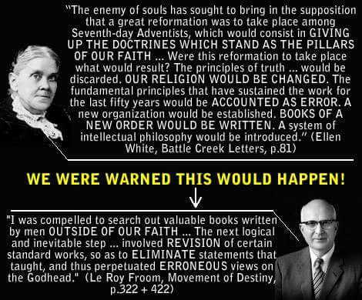

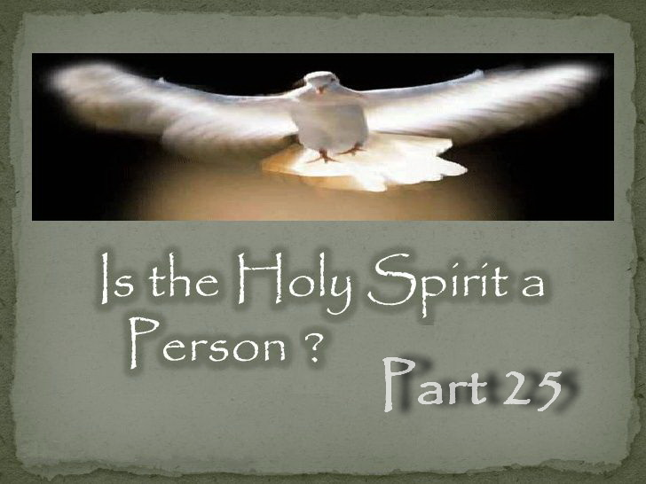

**IS THE HOLY SPIRIT A PERSON – PART 25**

**Did Ellen White Write “Three Holiest Beings?”**

The answer is a definite “No.”

Ellen White DID NOT pen these words by her own hand. They were written by a stenographer trying to keep up with a sermon she was preaching.

So while some claim that Ellen White wrote “three holiest beings,” the “Ellen White Estate” clearly informs us on their web site that “Sermons and Talks, Book 1” containing the phrase “three holiest beings” comes from an edited stenographer's report of a sermon she preached on October 20, 1906 at the Congregational Church of Oakland, California. It was also taken in shorthand.

The date of release by the White Estate is “March 16, 1976.” So this was not her handwriting but a typed report from a stenographers shorthand that was first published 70 years after her sermon and can never be authenticated.

This is what Ellen White wrote about unauthenticated reports,

“*And now to all who have a desire for truth I would say: Do not give credence to unauthenticated reports as to what Sister White has done or said or written. If you desire to know what the Lord has revealed through her, read her published works.*” — (E.G. White, 5T 696.1).

The statement appears in the book Sermons and Talks, Book 1.

In the forward of the book we are told,

“*All the messages reproduced in this volume were delivered in public and stenographically reported, or were prepared with that purpose in view. Many of Ellen White's sermons may be found in the Review and Herald and Signs of the Times, but nearly all of those included in this series have been drawn from previously unpublished manuscripts, as they appear in our files. So, although there were no tape recorders in Ellen White's day, a person may get the true “feel” of Ellen White as a speaker by reading this book.*” — (Forward, Sermons and Talks, Vol. 1)

Ellen White taught that the Holy Spirit is the Spirit of God coming to us through His Son and so she wrote.

“*The HOLY SPIRIT is the SPIRIT of CHRIST,*” — (E.G. White, 14MR 84.3)

“*We want the HOLY SPIRIT, which is JESUS CHRIST.*” — (E.G. White, *Lt66*, April 10, 1894)

Not only did she identify the “Holy Spirit” as the “Spirit of Christ,” but she always identified ONLY two beings ALONE, not three. So if Ellen White had said or written “three holiest beings” then she would have contradicted herself making herself a false prophet.

“*The Father and the Son ALONE are to be exalted.*” — (E.G. White, *YI*, July 7, 1898) **-- TWO BEINGS ALONE**

“*God and Christ ALONE know what the souls of men have cost.*” — (E.G. White, *ST*, Jan 13, 1909) **-- TWO BEINGS ALONE**

“*Can anyone consider the condescension of God in preparing the gospel feast, and its great cost, and treat the invitation slightingly? No man, nor even the highest angel, can estimate the great cost; it is known ONLY to the Father and the Son.*” — (E.G. White, *BEcho*, Oct 28, 1895) **-- ONLY TWO BEINGS**

In more than one quote Ellen White identified the three highest beings in heaven before the fall as the Father, Son and Satan. Not the Father, Son and Holy Spirit since the Holy Spirit is not a being. “*Satan, next to Christ, was at one time most honored of God, and highest in power and glory.*” — (E.G. White, *ST*, July 23, 1902)

So that facts are:

1. Ellen White DID NOT pen the words “three holiest beings.”

2. The words of the stenographer ARE NOT inspired or error free.

3. The sermon was not transcribed for another 70 years.

4. The stenographer's report was edited.

5. The stenographer's report can never be authenticated.

6. The words “three holiest beings” contradicts a multitude of things she did write.

7. Sermon and Talks was only intended to get the “feel” of Ellen White as a speaker.

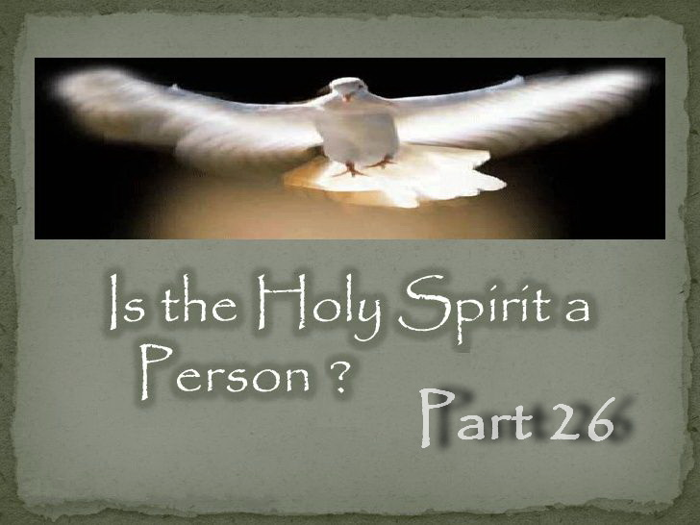

**IS THE HOLY SPIRIT A PERSON – PART 26**

## **Who is the Third Person of the Heavenly Trio?**

Most Adventists today have no idea what the real truth is that God gave His remnant regarding the Holy Spirit. And when shown, many reject the truth because they have been indoctrinated with the Catholic idea of the Holy Spirit being a third god. And even worse, the origin of this idea is from Satan so he could achieve worship.

These quotes from Waggoner and Smith state what Ellen White and the pioneers always taught regarding the Holy Spirit very clearly. Note that Ellen White endorsed this book by Waggoner.

“Finally, we know the Divine unity of the Father and the Son from the fact that both have the same Spirit. Paul, after saying that they that are in the flesh cannot please God, continues: “But ye are not in the flesh, but in the Spirit, if so be that the Spirit of God dwell in you. Now if any man have not the Spirit of Christ, he is none of his.” Rom. 8:9. Here we find that the Holy Spirit is both the Spirit of God and the Spirit of Christ.” — (E.J. Waggoner, CAHR, p. 23, 1890)

“This Spirit is the Spirit of God, and the Spirit of Christ; the Spirit being the same whether it is spoken of as pertaining to God or Christ. But respecting this Spirit, the Bible uses expressions which cannot be harmonized with the idea that it is a person like the Father and the Son. Rather it is shown to be a divine influence from them ***both***, the medium which represents their presence and by which they have knowledge and power through all the universe, when not personally present.” — (Uriah Smith, RH, Oct 28, 1890)

Ellen White wrote it this way.

“They were two, yet little short of being identical; two in individuality, yet ONE IN SPIRIT,” — (EGW, YI, Dec 16, 1897)

The reason they are ONE in Spirit is because God gave not only His life but also HIS Spirit to HIS Son.

“The Father GAVE HIS SPIRIT without measure to HIS SON,” — (EGW, RH, Nov 5, 1908)

And so the Holy Spirit is the mind, power, character and personal presence of the very life of God that the Father sends through His Son to us. Or to put it another way to make sure this is clear; the Holy Spirit is the presence and power of the Father manifested through Jesus Christ, His only begotten son. This is not a separate person of the Godhead who is being sent, it is the very life of God coming to us through His Son.

Thus it is through the Spirit that we have access to the Father through Christ as they are ONE IN SPIRIT.

“For through him [Christ] we both have access by ONE SPIRIT unto the Father.” Ephesians 2:18

Hence Ellen White said, the SPIRIT OF GOD comes to us through His only begotten Son and why the HOLY SPIRIT can rightfully be called the SPIRIT OF CHRIST.

“The HOLY SPIRIT, which PROCEEDS FROM the only begotten SON OF GOD,” — (EGW, RH, April 5, 1906)

Did you ever wonder how we can have the Father and Son live in us? It is because the Holy Spirit is the Spirit of the FATHER AND SON. So who do we have in us when we have the Holy Spirit? The FATHER AND SON!

“By the Spirit the Father and the Son will come and make their abode with you. [John 14:23 quoted]” — (EGW, BEcho, Jan 15, 1893)

Now you know why Ellen White wrote the following.

“*The HOLY SPIRIT is the SPIRIT of CHRIST,*” — (EGW, 14MR 84.3)

“*We want the HOLY SPIRIT, which is JESUS CHRIST.*” — (EGW, *Lt66*, April 10, 1894)

“but it is the leaven of ***the SPIRIT of JESUS CHRIST, which is sent down from heaven, called the HOLY GHOST***,” — (EGW, *Ms36*, 1891)

While the above information is unmistakably clear, out of the 25,000,000 words and the tens of thousands of non-Trinitarian statements that Ellen White wrote, she also wrote, “third person of the Godhead” 4 times (duplicated 4 times), “living three personalities of the heavenly trio” 1 time, “the Holy Spirit is as much a person as God is a person” 1 time and that “the Holy Spirit is a divine person” 1 time.

These statements have caused much confusion because most Adventists failed to let SOP explain SOP. And so many have wrongly assumed that Ellen White was supporting the Catholic Trinitarian idea that the Holy Spirit is a third god. But that could not be further from the truth. You will note that this already contradicts what is written above, so there has to be an answer where there are no contradictions in all that she wrote on this topic.

As seen above, it is through the Holy Spirit that we have access to the Father. Or should I say, it is through Christ and His Spirit, also being His Fathers Spirit that we have access to the Father.

Consider the following quote, “*We want the HOLY SPIRIT, which is JESUS CHRIST.*” — (EGW, *Lt66*, April 10, 1894)

Did Ellen White literally mean the physical PERSON of Jesus Christ? Of course not. If you took her literally in this case we would have a serious problem as the Holy Spirit cannot be the physical person of Jesus Christ. She obviously meant Christ by His Spirit. So let me ask you. When she called the Holy Spirit a person, did she mean that the SPIRIT OF CHRIST was a literal person? Again, of course not. That is not possible.

Many also erroneously believe that if the Holy Spirit is not a literal third being, then there cannot be three. But this wrong mindset comes from visualizing their Holy Spirit with the human limitations of our own. Their Spirit is Divine and can do what our spirit cannot.

Below Ellen White states that Christ has left HIS SPIRIT in the world to represent Him. Most respond, “how can His own Spirit represent Himself?” Quite easily in fact as Christ’s Spirit can function independently of Himself like it is another. Many fail to realize that the Spirit of Christ can function like a person separate to Himself so it is like it is “another” person. This is the nature of the Holy Spirit that Ellen White said we cannot understand. So the Holy Spirit is indeed like a third person.

“***CHRIST*** has left ***HIS Holy Spirit*** to be ***HIS representative*** in the world,” — (EGW, *Lt84*, Oct 22, 1895)

Ellen White understood that “representative” does not make a third being, but that Christ represents Himself in a different form. God and His Son have a Spirit and that is how “They” represent “Themselves” where they are not personally present.

And yet some still respond, “How can Jesus be the Holy Spirit? Jesus is in the heavenly sanctuary!” Some have a lot of trouble grasping this for some reason. Below Ellen White explains that while Christ ministers in the sanctuary above, He is still by HIS Spirit ministering on earth. So again we find that the Spirit of Christ can function like a separate person.

“While JESUS ministers in the sanctuary above, HE is still by HIS SPIRIT the minister of the church on earth. HE is withdrawn from the eye of sense, but HIS parting promise is fulfilled, “Lo, I am with you alway, even unto the end of the world.” Matthew 28:20. While HE delegates HIS power to inferior ministers, HIS energizing presence is still with HIS church.” — (EGW, DA, p. 166)

Did you get that? Christ is physically MINISTERING in the Heavenly Sanctuary and by HIS Spirit HE is also MINISTERING on earth.

And so whose Spirit did Christ send to represent Him and guide us into all truth? It was HIS very own Spirit! Hence yet again we find His Spirit can function like a separate person even though it is His own Spirit.

“We cannot be with ***Christ*** in person, as were His first disciples, but ***HE*** has sent ***HIS Holy Spirit*** to guide us into all truth, [John 16:13 quoted]” — (EGW, *Ms30*, June 18, 1900)

Thus Ellen White taught that there is the one true God the Father, Jesus Christ His Son, and the Holy Spirit which is Christ’s very own Spirit that proceeds from the Father, which was given to Him by His Father, and can function like a third person, though not a literal third person. So why not call the Holy Spirit the third person which Ellen White did four times? But is it a literal person and a third god as per the Trinity doctrine? Of course not! She made it very clear that it is the Spirit of Christ.

Those who conclude that Ellen White meant a literal person have failed to let SOP explain SOP and did NOT look at what else she wrote. For instance, note below who Ellen White revealed to be the Father, Son and Holy Spirit. Is this consistent with her calling the Holy Spirit the Spirit of Christ? It most certainly is!

“They have ***ONE*** God and ***ONE*** Saviour; and ***ONE*** Spirit--***the Spirit of Christ***--” — (EGW, 9T 189.3, 1909)

And who did she reveal to be the third person? ONE + ONE + ONE = “the SPIRIT OF CHRIST.”

It is NOT hard to see why Ellen White called the Spirit of Christ the third person. And it’s not hard to see that she did not mean a literal person, but the person of Christ by HIS Spirit which can function like a separate person, though not a literal person.

Let’s continue to reveal this truth from SOP so there can be no doubt.

She wrote, “Sin could be resisted and overcome ***ONLY*** through the mighty agency of the third person of the Godhead,” — (EGW, DA, 671.2)

Now if Ellen White states that sin can be overcome ONLY through the third person, and also states that it is by Christ in us that we overcome sin, who is she calling the third person? Christ!

“There is no power in you apart from ***CHRIST***, but it is your privilege to have Christ abiding in your heart by faith, and ***HE*** can ***OVERCOME SIN*** in you,” — (EGW, OHC, 76.5)

“With ***HIS SPIRIT*** CHRIST sends a reconciling influence and a power that ***TAKES away SIN***.” — (EGW, RH, May 19, 1904)

It cannot be someone else as well as she wrote ONLY! Why would we think it was anyone else other than the One who conquered and overcame sin on the cross?

So once again Ellen White identified Christ as the third person and has called Christ by His Spirit a person. But it is not some third god! How can anyone without prejudice and an open heart and mind get this wrong?

The Holy Spirit is also the Comforter and Spirit of truth. So we also know who she is calling the third person by looking to see who she says is the Comforter and Spirit of truth.

If what Ellen White called the third person is the Spirit of Christ, then she will also state that the Spirit of Christ is the Comforter.

“This refers to the omnipresence of the ***Spirit of Christ***, called the ***Comforter***.” — (EGW, 14MR 179.2)

“*Let them study the seventeenth of John, and learn how to pray and how to live the prayer of CHRIST. HE is THE Comforter. He will abide in their hearts, making their joy full.*” — (EGW, *RH*, Jan 27, 1903)

The same applies to the Spirit of truth.

“The ***SPIRIT of TRUTH*** is the only effectual teacher of divine truth; those who are taught of Him have entered the ***school of CHRIST***. How must God esteem the race, that He gave His Son to die for them, and appoints ***HIS SPIRIT*** to be man's teacher and continual guide.” — (EGW, ST, Oct 24, 1906)

“***JESUS*** comes to you as the ***SPIRIT of TRUTH***; study the mind of the Spirit, consult your Lord, follow His way.” — (EGW, 2MR 337.1)

In fact Ellen White was 100% consistent in all that she wrote. Letting SOP explain SOP:

She said the Comforter is the SPIRIT OF CHRIST,  
the Spirit of Truth is the SPIRIT OF CHRIST,  
the third person is the SPIRIT OF CHRIST,  
the third great power is the SPIRIT OF CHRIST,  
the Holy Spirit given at Pentecost was the SPIRIT OF CHRIST,  
the Holy Spirit Jesus breathed on His disciples was HIS own SPIRIT,  
the Holy Spirit Christ sent to represent Himself was HIS own SPIRIT,

the heavenly dignitaries are the Father, Son and SPIRIT OF CHRIST,

the Heavenly trio is the Father, Son and SPIRIT OF CHRIST,  
and she reveals over and over again that there are only two beings. There is no escaping Ellen White was calling Christ by His Spirit the third person because His Spirit is like a person.

So can we effectively call the Spirit of Christ (Holy Spirit) a divine person? Sure! Why not?  
Is the Spirit of Christ (Holy Spirit) as much a person as God is a person? Of course!  
Can we call the Spirit of Christ (Holy Spirit) the third person? Again, why not?  
Is the Spirit of Christ a LITERAL person? No! This is clearly not so and impossible.

And while Ellen White taught that the Spirit of Christ is the third person, she only ever revealed two beings.

“The Father and the Son ***ALONE*** are to be exalted.” — (EGW, YI, July 7, 1898) **-- ONLY TWO BEINGS**

Did she say the Father, Son and Holy Spirit ALONE are to be exalted? No she did not.

And again, “God and Christ ***ALONE*** know what the souls of men have cost.” — (EGW, ST, Jan 13, 1909) **-- ONLY TWO BEINGS**

Most agree there are three persons. The problem is with how we define “persons.” The original definition and the one used by Ellen White does not mean “beings.” It means that Deity has three main offices of work in the plan of redemption, and this is the way Ellen White often described it in her writings. As we have seen above, her statements that clearly identify who the Holy Spirit is disqualify her definition of “persons” as meaning “individuals” or “beings.” And she says that “two beings” alone are to be exalted-the Father and the Son. So we need to take all quotes into consideration when dealing with this subject.

Adventists today are putting things into Ellen White’s references which are not there. When Ellen White says “persons,” they say it is “beings.” When Ellen White says that the Son was with the Father “FROM” all eternity, they say it was “FOR” all eternity. Trinitarians need to see that their mind is deceiving them. Their preconceived ideas are putting words into her writings that are not there because their old view is all they can see. That is why we so vitally need to allow the Holy Spirit to remove from us our preconceived ideas and lead us into truth.

Picking out statements from Ellen White’s writings that would fit into a Trinitarian concept of God while ignoring her statements that do not fit the Trinitarian concept of God is a dishonest way to use her writings. To understand correctly what God has revealed through Ellen White, and find out what her beliefs were on this topic, it is necessary to quote all that she wrote on this subject, not just be selective in what we quote to suit our own agenda. That would be tantamount to deception.

Since the Holy Spirit is Jesus Christ, Satan dethrones Christ when he poses as the Holy Spirit. He knows this but those who he has deceived don't. How tragic is this deception.

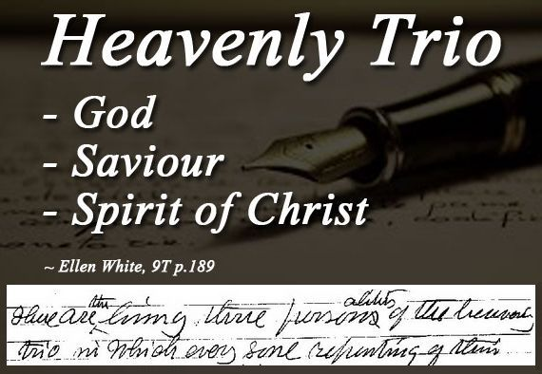

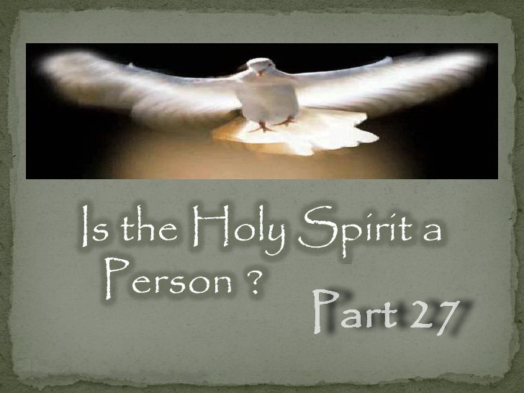

**IS THE HOLY SPIRIT A PERSON – PART 27**

**How many Holy Spirits are there?**

Below is something to consider very carefully. And please understand that I am not mocking. If you stop and consider what I am saying, you will realize this does in fact have to be true.

Trinitarians claim the phrase “Spirit of God” in Scripture refers to another being rather than God's own Spirit. But if the “Spirit of God” is not really the “Spirit OF God” but another being, then how can God Himself have His own Spirit if His Spirit is another being?

And if God does have a Spirit, what would His Spirit be called? The “Spirit of God” obviously which would also be a Holy Spirit! So that would mean we have the “Spirit of God” and the “Spirit of God.” One of them is another being and one is not, and both of course are Holy Spirits. So how many Holy Spirits would that make?

The only way around this problem is if God Himself does not have a Spirit and His Spirit is only another being separate from Himself. But the problem still does not end there. The Trinity doctrine teaches 3 co-equal beings, meaning equal in every single way.

So if the “Spirit of God” is another being, therefore, for Christ to be a co-equal divine being as the Trinity doctrine claims, then the “Spirit of Christ” must also be another being, which would also make another Holy Spirit!

How much easier it is if we accept that the Holy Spirit is not another being, and the “Spirit of God” is actually the “Spirit of God” which is shared by His Son. Then we have no problem!

A persons spirit is their mind, will and emotions. It is who you are. So a spirit is not and never can be a literal person in itself. If it were, it would cease to be a spirit. For instance, in order for a spirit to be another person, it would also have to have its own spirit. In other words, for the Holy Spirit to be a person, it would have to have its own spirit in order to have its own mind, will and emotions. So you would end up with the Spirit of the Holy Spirit. Along with this false theology introduced by Satan so he could achieve worship, man seems to have lost all touch with the reality of a what a spirit is. However, while our spirit is within us, God's Spirit can do what ours can't. He can send His Spirit anywhere and is how He and His Son represent “Themselves” where “They” are not personally present.

So when God gives you His Spirit, He gives you Himself, not another being. “*In giving us HIS SPIRIT, God gives us HIMSELF,*” — (E.G. White, 7T 273.1, 1902). Thus the Holy Spirit is the “Spirit of God” coming to us through His Son.

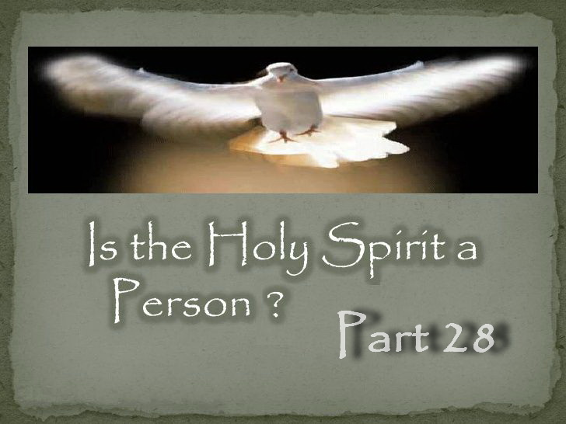

**IS THE HOLY SPIRIT A PERSON – PART 28**

**Did the Apostles Believe the Holy Spirit was a Literal Being?**

The Trinity doctrine is a manmade doctrine from the Catholic Church which was formed in two parts. The first part was created in 325 AD which states it is a 3 in 1 god. The second and final part was created in 381 AD where it was decided that the Holy Spirit was a third being, which was about 280 years *“after”* the death of the Apostles.

The noted Trinitarian historian Adolph Harnack observed that up to 325 AD the majority of Christians insisted the Holy Spirit was not a third being. So neither the Apostles nor their associates who survived them, nor their descendants believed the Holy Spirit was another being.

So who created the idea of the Holy Spirit as a literal being?

It was 44 years after Constantine's death in May 381 AD, Emperor Theodosius, baptized only a year earlier, convened the Council of Constantinople to resolve them. Theodosius favoured the Nicene Creed, and so after he arrived in Constantinople he expelled the bishop Demophilus, and surrendered the Churches there to Gregory of Nazianzus who was the leader of a small Nicene community there, and one of three men that became known as “the three Cappadocians.”

These three men had an agenda at this council which was for the first time to push the idea of the Holy Spirit being a literal being. Gregory was recently appointed as archbishop of Constantinople, but due to illness, Nectarius, an elderly city senator had to take over the role of archbishop and presided over the council. And so Nectarius was baptized for the job and the Trinitarian view on the Holy Spirit was governed by someone with little or no knowledge of theology!

What resulted became known as the Nicene-Constantinopolitan Creed where they had decided that the Holy Spirit was a literal being. Any who disagreed were in accordance with the edicts of the emperor and Church authorities branded heretics and dealt with accordingly. This final teaching on the nature of God is what became the Trinity as it is generally understood today. It was not decided so much from Scripture but from Greek philosophy, much bloodshed and whoever held the most power.

So did the Apostles believe the Holy Spirit was a literal being? How could they have. It is impossible for the Apostles to have believed or written about this manmade doctrine that did not exist for more than three lifetimes *“after”* their death. So if you think that Scripture reveals the Holy Spirit to be another being, think again. It is just a wrong idea you have been indoctrinated with as the Apostles could never have written about something that did not even exist in their time.

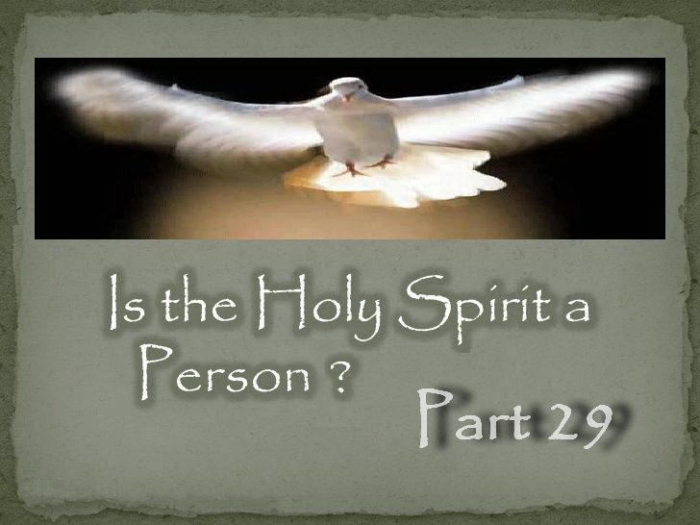

**IS THE HOLY SPIRIT A PERSON – PART 29**

**What is the Nature of the Holy Spirit?**

It is not uncommon when sharing what the Bible or SOP teaches on the Holy Spirit to have someone quote Ellen White where she says the “NATURE” of the Holy Spirit is a mystery.

This is typically quoted by Trinitarians when they are unable to defend their chosen belief. In other words, it is normally a ploy used by those who have been deceived to try and silence the truth.

So what is the “NATURE” that Ellen White says is a mystery?

“*The NATURE OF THE HOLY SPIRIT IS A MYSTERY not clearly revealed, and you will never be able to explain it to others because the Lord has not revealed it to you. You may gather together scriptures and put your construction upon them, but the application is not correct. The expositions by which you sustain your position are not sound. You may lead some to accept your explanations, but you do them no good, nor are they, through accepting your views, enabled to do others good. It is not essential for you to know and be able to define just WHAT the Holy Spirit is. Christ tells us that the Holy Spirit is the Comforter, and the Comforter is the Holy Ghost, “the Spirit of truth, which the Father shall send in My name.” “I will pray the Father, and He shall give you another Comforter, that He may abide with you for ever; even the Spirit of truth; whom the world cannot receive, because it seeth Him not, neither knoweth Him: but ye know Him, for He dwelleth with you, and shall be in you” [John 14:16, 17]. THIS REFERS TO THE OMNIPRESENCE OF THE SPIRIT OF CHRIST, CALLED THE COMFORTER.*” — (E.G. White, 14MR 179.2)

Notice that Ellen White states, “*It is not essential for you to know and be able to define just WHAT the Holy Spirit is.*” She said “WHAT” the Holy Spirit is, not “WHO!” Not only that, but after writing this quote, she concludes by stating “WHO” the Holy Spirit is.

Ellen White wrote that the “*Holy Spirit is the Comforter, and the Comforter is the Holy Ghost, “the Spirit of truth.*” And then concluded by telling us “WHO” the Holy Spirit is as she states, “*This refers to the omnipresence of the SPIRIT OF CHRIST, called the COMFORTER.*”

The “NATURE” of the Holy Spirit is “HOW” the Spirit of the Father and Son can function like “ANOTHER” and send their Spirit anywhere, something our spirit cannot do. It is also how They are ONE in Spirit.

The “NATURE” is “HOW” Jesus can be in the Heavenly sanctuary while still being with us as our Comforter and Spirit of truth by His Spirit. This is the “NATURE” that we do not understand, and we do not need to understand either. But “WHO” the Holy Spirit is we do know and need to know.

No one I know sharing truth is trying to explain “how” they are one in Spirit or “how” Christ is physically in the heavenly sanctuary while being present with us by His Spirit as our Comforter.

“While JESUS ministers in the sanctuary above, HE is still by HIS SPIRIT the minister of the church on earth. HE is withdrawn from the eye of sense, but HIS parting promise is fulfilled, “Lo, I am with you alway, even unto the end of the world.” Matthew 28:20. While HE delegates HIS power to inferior ministers, HIS energizing presence is still with HIS church.” — (E.G. White, DA, p. 166)

So it seems that many Trinitarians are seeing only what they want to see in this quote from SOP.

Trinitarians using this quote never say that the Holy Spirit is a third being, right? And they never declare that the Holy Spirit is god either, or do they? After all it is a mystery they say and we must remain silent. So do those using this quote follow their own faulty conclusion? No! Most are busy stating exactly “WHAT” they think the Holy Spirit is, while ignoring “WHO” the Holy Spirit is.

But even worse, teaching the Holy Spirit is another god turns the Spirit of the Father and Son into a separate god, which changes a lot more than the “nature.” This idea was manmade over 200 years AFTER the Bible was written and is really from Satan via the Catholic Church. It takes you away from the real Holy Spirit and turns it into a totally different entity so Satan could achieve worship from his creation!

Thus this quote is always brought out as a means of silencing the real truth on the Holy Spirit when they cannot defend their belief. And yet those who use it never follow their own advice or wrong conclusion.

Ellen White tells us “WHO” the Holy Spirit is in hundreds of different ways and over “20,000 Times.” She was not a hypocrite that never followed her own advice.

Thus the “NATURE” is “HOW,” not “WHO.”

Satan will also try and use a misunderstanding of this quote to silence those with truth so they do not share. What a tragic mistake for anyone falling for that deception.

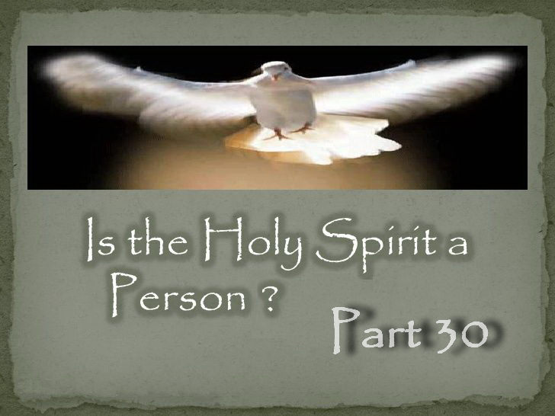

**IS THE HOLY SPIRIT A PERSON – PART 30**

## **Who is the Holy Spirit that Comforts and Guides your life?**

## The Holy Spirit is the mind, power and personal presence of the very life of God that the Father sends through His Son to us. Or to put it another way. The Holy Spirit is the presence and power of the Father manifested through Jesus Christ His only begotten son.

## This is not a separate person of the Godhead who is being sent, it is the very life of God coming to us through His Son.

“The impartation of the SPIRIT is the impartation of the LIFE OF CHRIST.” — (E.G. White, *DA*, 805.3)

“JESUS imbues the believer with his spiritual life, WHICH IS THE HOLY GHOST.” — (E.G. White, *3SP*, p. 242)

“CHRIST gives them the breath of HIS OWN SPIRIT, the life of His own life. The Holy Spirit [Christ] puts forth its highest energies to work in heart and mind.” — (E.G. White, *DA*, p. 827)

“The influence of THE HOLY SPIRIT IS THE LIFE OF CHRIST in the soul. We do not now see Christ and speak to Him, but HIS HOLY SPIRIT is just as near us in one place as another. It works in and through every one who receives Christ. Those who know the indwelling of the Spirit reveal the fruits of the Spirit,-love, joy, peace, longsuffering, gentleness, goodness, faith.” — (E.G. White, BEcho, June 17, 1901)

“WHAT WE WANT IS THE SPIRIT OF JESUS. When we have this, we shall love one another. Here are the credentials that we are to bear: “By this shall all men know that ye are my disciples, if ye have love one to another.” We need to pray more; and when we have Christ abiding in the soul, HIS SPIRIT IN ME will harmonize with HIS SPIRIT IN YOU; and he who controls our minds, controls also the heavenly intelligences, and they co-operate with us. Then in every council you will have the presence of One mighty in counsel. Jesus will be there.” — (Ellen G. White, GCDB, April 13, 1891)

When we grieve the Holy Spirit, whose Spirit do we grieve?

“O, how we grieve the pure, HOLY SPIRIT OF CHRIST with our defiling sins! We are not prepared for the appreciation of the holy communion with Christ and with one another unless we are cleansed by his efficacy.” — (E.G. White, *RH*, July 5, 1898)

“We can no more repent without the SPIRIT OF CHRIST to awaken the conscience than we can be pardoned without Christ.” — (Ellen G. White, *SC*, 26.2)

Our body is the temple of the Holy Spirit. So whose Spirit do we have abiding in us? “What? know you not that your body is the temple of the Holy Ghost which is in you,” 1 Corinthians 6:19

“When God’s people take the position that they are the temple of the Holy Ghost, CHRIST HIMSELF ABIDING WITHIN, they will so clearly reveal Him in spirit, words and actions, that there will be an unmistakable distinction between them and Satan’s followers.” — (E.G. White, *Ms100*, July 14, 1902)

Jesus told His disciples that after returning to His Father that He would come back to them by the Holy Spirit as their Comforter, “Do not let your hearts be troubled and do not be afraid. 28 You heard me say, 'I am going away and I am coming back to you.” John 14:27-28

Hence Jesus also said, “lo, I am with you alway, even unto the end of the world.” Matthew 28:20

How is Jesus going to be with us as our mediator, teacher as the Spirit of truth, Comforter etc. if He has returned to the Father? By coming back as another of the same kind. That is, through His Holy Spirit.

“While JESUS ministers in the sanctuary above, HE is still by HIS SPIRIT the minister of the church on earth. HE is withdrawn from the eye of sense, but HIS parting promise is fulfilled, “Lo, I am with you alway, even unto the end of the world.” Matthew 28:20. While HE delegates HIS power to inferior ministers, HIS energizing presence is still with HIS church.” — (E.G. White, *DA*, p. 166)

So who comforts and guides your life? The Spirit of God coming to us and manifested though His Son, hence the Spirit of Christ? Or some third being called “god the holy spirit?” The idea of a third being is a creation of Satan, brought into Christianity through the Catholic Church, so that he could be worshipped by unsuspecting deceived believers and steal their souls from the kingdom of heaven.



**Conclusion**

In summary, the Bible and Spirit of Prophecy clearly teach that the Holy Spirit is the Spirit of the Father and Son Themselves and is the means by which They live in us. Jesus said that “*If a man love me, he will keep my words: and my Father will love him, and we will come unto him, and make our abode with him.*” John 14:23. “*Truly our fellowship is with the Father, and with his Son Jesus Christ.*” 1 John 1:3

This message that we have been given through Scripture and Spirit of Prophecy that the Holy Spirit is the presence of Christ in us is a most beautiful thing. It is only Jesus who lived a sinless life as our Example and died on the cross as our Substitute; therefore, it is only Him that is qualified through His Spirit to be our Comforter and Guide. It is comforting to know that the One who conquered sin in His life and through His death is the same One who can overcome sin in us. Jesus is the Truth (John 14:6), and He has promised that we shall know the Truth, and the Truth shall make us free (John 8:32)

There is no beauty or truth in the lie. It is a counterfeit from Satan that dethrones Christ and so Satan can receive worship.