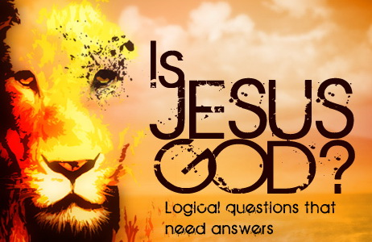

Please note: This page is designed so that individual parts can be copied and pasted into Facebook as posts, or responses to others. So you may find some duplicated passages in individual parts for this reason. CAPS have also been used in places since FB does not support any form of highlighting. Please feel free to copy and paste individual parts for sharing anywhere you choose or share the entire page. Thank you.

To download images or this document as a PDF. See <http://www.trinitytruth.org/isjesusgod.html>

[**Is Jesus God?**](http://www.trinitytruth.org/isjesusgod.html)

1) Does John 1:1 say Jesus is God?

2) Why Did the Father Call His Son God?

3) Did Jesus Say that He is the Father?

4) Does John 14:9 Mean Jesus is the Father?

5) Does Being the Alpha and the Omega Mean Jesus is God?

6) Is the Alpha and the Omega Christ or the Lord God almighty?

7) Do the Words “I AM” Mean Jesus is God?

8) Does Isaiah 9:6 Say Jesus is the Father?

9) Is Jesus God if He Can Forgive Sins?

10) Did Thomas Believe that Jesus was God?

11) How can Jesus be God if His Father is Greater Than Him?

12) Is Jesus God if He can be Worshipped?

13) How Can Jesus be God if there is Only One God?

14) Does Elohim Prove Jesus is God?

15) Is Jesus the Literal Son of God?

16) Is Jesus Divine if He is the Literal Son of God?

17) Did Jesus Have a Beginning if He is the Literal Son of God?

18) Was Jesus Created if He is Not God?

19) How Can Jesus be God Considering the Following?

20) Is Jesus God?

21) Does Romans 9:5 say Jesus is God?

22) Does Titus 2:13 say Jesus is God?

23) Does 1 Timothy 3:16 say Jesus is God?

24) Does 1 John 5:20 say Jesus is the one TRUE God?

25) Does Isaiah 43:11, Hosea 13:4 or Isaiah 44:6 Prove Jesus is God?

**Introduction**

The Trinity doctrine teaches three co-equal, co-eternal gods that are one god which proposes many serious problems. The first being that Scripture says many times that there is only one true God.

The second being that if the Father and Son are co-eternal and hence have supposedly always existed, how can Jesus be the Son of God and how can God be His Father? And if Jesus is God, then how could He have died on the cross since Scripture says God cannot die.

John 20:17 says, “*I ascend unto my Father, and your Father; and to my God, and your God.*” How can Jesus be God and have a God at the same time?

There are many complications associated with the Trinity doctrine as it is a manmade doctrine from Satan via the Catholic Church. The Trinity doctrine did not exist until over 200 years after the Bible was written. In this series you are going to learn the real truth about God and His Son.

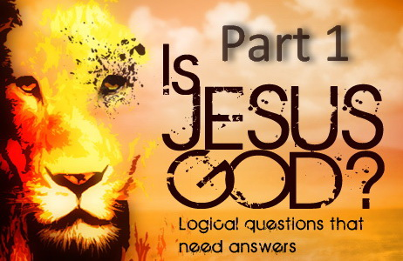

**IS JESUS GOD? – PART 1**

**Does John 1:1 say Jesus is God?**

John 1:1 says, “*(a) In the beginning was the Word, (b) and the Word was with [the] God, (c) and the Word was God.*”

That this Divine Word is none other than Jesus Christ is shown by verse 14, “*And the Word was made flesh, and dwelt among us, (and we beheld his glory, the glory as of the only begotten of the Father,) full of grace and truth.*”

John 1:1a says the Word was in the beginning, but the beginning of what? It has to be the beginning of something. Was it the beginning of this world? Was it the beginning of the creation of the angels? Whichever beginning you place it at, it has to be the beginning of something.

Many Trinitarians use this to say that Christ has always been, and had no beginning. But that is not what the verse says. God had no beginning and has always existed! Also the Word “with” has to mean something. The Word was “with” God. They cannot be the same being, or one could not be with the other. As John 1:2 NIV says, “*He [Jesus] was with God in the beginning.*” Ephesians 3:9 says who was with God and what this beginning was. In “*the beginning of the world ... God, ... created all things by Jesus Christ.*”

The proper rendering of John 1:1 into English from the original Koine Greek text continues to be a source of vigorous debate among Bible translators, and especially the phrase the Word was God (c). The first verse of John's Gospel says that God's Son Christ Jesus, being referred to as the Word here, was with God in the beginning, (a+b). John 1:1b does not say that the Messiah is God but was with “the” God. It is important to note that the word “the” exists in the Greek text and was left out by translators as they probably thought it read wrong, but it is correct and has purpose. Here is the original Greek text for (1b).

και and 2532 CONJ ο the 3588 T-NSM λογος Word 3056 N-NSM ην was 2258 V-IXI-3S προς with 4314 PREP τον the 3588 T-ASM θεον God 2316 N-ASM

The phrase “the God” identifies the one true God the Father in this verse and so the word “the” is important. While Jesus is called God in this verse, there is a clear distinction between Him and “the” God whom He was with. The God whom Jesus was with is “the” God the Father. Jesus was not the same God He was with but rather Jesus was God in the sense of being divine just like His Father, as being the Son, He inherits the characteristics of His Father. The Father is God and so His Son is God by nature just as any human by inheritance possesses the very nature and form of humanity.

One can better understand John 1:1 by using the same grammatical structure but with different subjects such as Adam and Eve for example. “*In the beginning was the woman, and the woman was with [the] human, and the woman was human.*” Adam is “*the human*” and the woman is Eve, but Eve is also human by nature but Eve is not “*the human*” in identity. They are two separate persons.

Look at this again with this perspective in mind. “*In the beginning was the Word, and the Word was with the Deity, and the Word was Deity.*” The Word, the Son was with the supreme Deity the Father, and the Word was Deity in nature. But the Son was not “the” Deity, the Son was not “the” Father, yet the Son has the Father's divine nature by inheritance. The Word has the same God quality, the same divine nature and the same God-ness as His Father.

Thus Jesus was with God in the beginning, but He is not “the” God the Father but God by inheritance and nature being the Son. He is God because He is the Son of God. It is that simple.

“*Jesus is the only begotten Son of God. He was begotten, not created. HE IS OF THE SUBSTANCE OF THE FATHER, SO THAT IN HIS VERY NATURE HE IS GOD; and since this is so “it pleased the Father that in him should all fullness dwell.” Col. 1:19 ... While both are of the same nature, the Father is first in point of time. He is also greater in that he had no beginning, while Christ's personality had a beginning.*” — (E.J. Waggoner, *ST*, April 8, 1889)

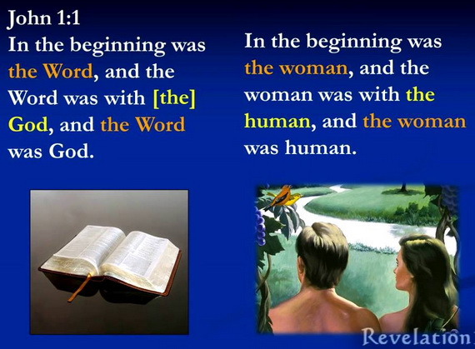

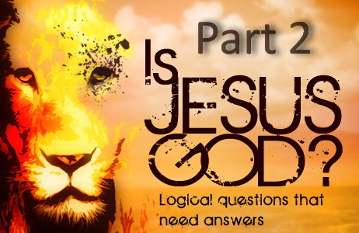

**IS JESUS GOD? – PART 2**

**Why Did the Father Call His Son God?**

In Hebrews 1:1-9 we note that the speaker is God the Father and that He is addressing His Son and calling Him “God.”

Verse 2 says that Christ was “appointed heir” of all things. An “HEIR” of course is someone who receives an “inheritance” from someone. In this case Christ the Son received an “INHERITANCE” from His Father.

But what did He receive?

His “NAME,” His authority and His power! In other words, Jesus being the one and only begotten Son of the living God received by virtue of His birth all of the attributes that His Father possessed.

Verse 4 says, “*Being made so much better than the angels, as he has by “INHERITANCE” obtained a more excellent “NAME” than they.*” Verse 8 says that this more excellent “*NAME*” is the name “*God,*” which was given by the Father to His Son. “*Unto the Son He [God] saith, Thy throne, O God, is forever and ever.*”

And so this name “*He has by “*INHERITANCE.” It is not a “NAME” that was bestowed but a “NAME” that was “INHERITED” from His Father.

Christ not only inherited His name but other things as well. Name means authority (Mark 11:9, John 5:43), and it also means character and nature (Exodus 33:18-19, Exodus 34:5-6). The name Adam means human for example. When people have children, they not only inherit the name of their parents but they also inherit the nature of the parents, which of course is human nature. In like manner, Jesus inherited the same name as His Father, just as a child inherits the name of the parents, and He also inherits the nature of His Father, which is His divine nature.

Christ also inherits His Father’s life. “For as the Father has life in himself; so has he given to the Son to have life in himself.” John 5:26. If Jesus had always existed alongside the Father as the Trinity doctrine claims, then God could not have given life to His Son as He would have always had life. But Scripture reveals this is impossible.

Thus there is only “ONE” true God. Jesus is “NOT” the God, He is the “Son of God.” He carries the “NAME” of God by virtue of His “INHERITANCE.” And because He is the Son of God, He is “EQUAL” with God.

Note that Ellen G. White endorsed what one of the Adventist pioneers wrote below who also explains in unmistakeable words.

“*This name [God] was not given to Christ in consequence of some great achievement, but it is His by right of inheritance.  
Speaking of the power and greatness of Christ, the writer to the Hebrews says that He is made so much better than the angels, because “He hath by inheritance obtained a more excellent name than they.” Heb. 1:4.  
A son always rightfully takes the name of the father; and Christ, as “the only begotten Son of God,” has rightfully the same name.  
A son, also, is, to a greater or less degree, a reproduction of the father; he has, to some extent, the features and personal characteristics of his father; not perfectly, because there is no perfect reproduction among mankind. But there is no imperfection in God, or in any of His works; and so Christ is the “express image” of the Father's person. Heb. 1:3.  
As the Son of the self-existent God, he has by nature all the attributes of Deity.*

*It is true that there are many sons of God; but Christ is the “only begotten Son of God,” and therefore the Son of God in a sense in which no other being ever was, or ever can be.  
The angels are sons of God, as was Adam (Job 38:7; Luke 3:38), by creation; Christians are the sons of God by adoption (Rom. 8:14,15);  
but CHRIST IS THE SON OF GOD BY BIRTH.  
The writer to the Hebrews further shows that the position of the Son of God is not one to which Christ has been elevated, but that it is one which He has by right.*” — (E.J. Waggoner, *CAHR*, p. 11-12)

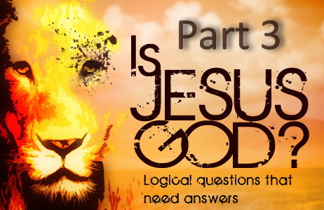

**IS JESUS GOD? – PART 3**

**Did Jesus Say that He is the Father?**

In John 10:30, Christ proclaimed, “*I and my Father are one.*”

This would have to be the most misquoted and misunderstood verse used by Trinitarians. Many conclude that this means Jesus and the Father are the same being as per the Trinity doctrine.

Some of the confusion regarding the number of beings comes from a misunderstanding of the word “one.” Simply put, “one” in the Bible does not always mean numerical quantity. Depending on the Scripture, “one” often means unity.

We see this principle established very early in Scripture. “*Therefore a man shall leave his father and mother and be joined to his wife, and they shall become one flesh.*” Genesis 2:24. “*One flesh*” here does not mean that a married couple melt into one human after their wedding, but rather they are to be united into one family. Romans 12:5 says, “*So we, being many, are one body in Christ, and every one members one of another.*”

So does that make us all one single Christian? You would have to say yes if you follow the Trinitarian formula!

We do not have to speculate what Jesus meant in John 10:30 when He said He and His Father are one, because the words of Christ further on in John reveal exactly what He meant.

Christ meant one in unity as He prayed that His disciples might be one in the same way He and His Father are one. This prayer did not contemplate one disciple with twelve heads, but twelve disciples working together in unity.

“*And the glory which You gave Me I have given them, that they may be one just as WE ARE ONE:*” John 17:22

“*Holy Father, keep through thine own name those whom you have given me, that THEY MAY BE ONE, AS WE ARE.*” John 17:11

“*Christ prayed that his followers might be one as he and the Father were one.*” — (E.G. White, *RH*, May 29, 1888)

Since the Trinity doctrine teaches 3 co-equal beings, then according to this doctrine, John 10:30 should have said, “*I and my Father and the Holy Spirit are one.*” But not so. There are three powers but only two literal beings.

“*HE [CHRIST] WAS NOT THE FATHER but in him dwelt all the fullness of the Godhead bodily,*” — (E.G. White, *Lt8a*, July 7, 1890)

“*The unity that exists between Christ and His disciples does not destroy the personality of either. They are one in purpose, in mind, in character, BUT NOT IN PERSON. It is thus that God and Christ are one.*” — (E.G. White, 8T 269.4, 1904)

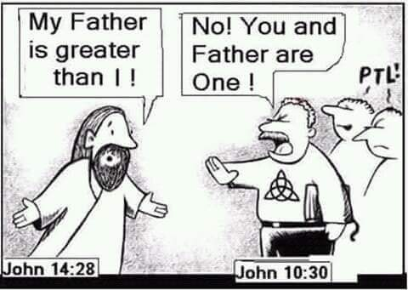

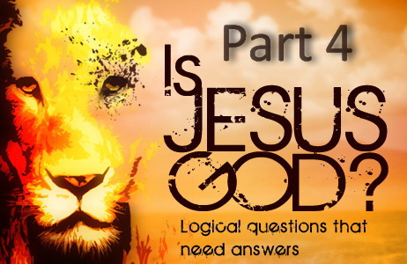

**IS JESUS GOD? – PART 4**

**Does John 14:9 Mean Jesus is the Father?**

In John 14:9 Jesus said “*He that has seen me has seen the Father.*” Did Christ mean He was the Father or that He was “*the express image of His Father,*” and so has the same nature, attributes and glory? In other words, he that sees one, sees the other: Below are comments from two theologians.

John Gill's Exposition of the Entire Bible on John 14:9 says:

“*He that hath seen me; not with the eyes of his body, but with the eyes of his understanding; he that has beheld the perfections of the Godhead in me:*

*Hath seen the Father; the perfections which are in him also; for the same that are in me are in him, and the same that are in him are in me: I am the very IMAGE of him, and am possessed of the same nature, attributes, and glory, that he is; so that he that sees the one, sees the other:*”

Christ is the express image of His Father. 2 Corinthians 4:4 “*In whom the god of this world hath blinded the minds of them which believe not, lest the light of the glorious gospel of Christ, who is the image of God, should shine unto them.*”

Albert Barnes' Notes on the Bible on 2 Corinthians 4:4 says:

“*Who is the image of God - Christ is called the image of God:*

*(1) In respect to his divine nature, his exact resemblance to God in his divine attributes and perfections; see Col_1:15; and Heb_1:3; and,*

*(2) In his moral attributes as Mediator, as showing forth the glory of the Father to people. He “resembles” God, and in him we see the divine glory and perfections embodied, and shine forth.*

*It is from his “resemblance” to God in all respects that he is called his image; and it is through him that the divine perfections are made known to people. It is an object of special dislike and hatred to Satan that the glory of Christ, who is the image of God, should shine on people, and fill their hearts. Satan hates that image; he hates that people should become like God; and he hates all that has a resemblance to the great and glorious Yahweh.*”

Colossians 1:15 “*Who is the image of the invisible God, the firstborn of every creature:*”

Hebrews 1:3 “*Who being the brightness of his glory, and the express image of his person, and upholding all things by the word of his power, when he had by himself purged our sins, sat down on the right hand of the Majesty on high;*”

A son is to a greater or less degree a reproduction of his father. He has to some extent the features and personal characteristics of his father. Not perfectly of course because there is no perfect reproduction among mankind. But there is no imperfection in God or in any of His works, and so Christ is the “express image” of the Father's person.

Thus Jesus was saying He is the express image of His Father and has the same nature, attributes and glory. Christ could not have meant literally of course as Scripture informs us that, “*No man has seen God at any time. If we love one another, God dwelleth in us, and his love is perfected in us.*” 1 John 4:12. Only Christ has seen the only true God the Father. “*Not that anyone has seen the Father, except He [Jesus] who is from God; He has seen the Father.*” John 6:46

“*Christ emphatically impressed on the disciples the fact that they could see the Father by faith only. GOD CANNOT BE SEEN IN EXTERNAL FORM BY ANY HUMAN BEING. Christ alone can represent the Father to humanity;* [John 14:9 quoted]” — (E.G. White, *RH*, October 19, 1897)

According to the trinity teaching, this verse should have said, “*He who has seen Me has seen the Father and the Holy Spirit.*” But not so. While there are three powers, there are only two literal beings. The third is their Spirit.

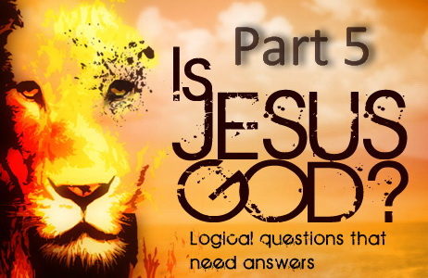

**IS JESUS GOD? – PART 5**

**Does Being the Alpha and the Omega Mean Jesus is God?**

Some claim that the words Alpha and Omega found in Revelation 1:8, 21:6 and 22:13 means that Christ is without beginning or end, but it does not say that. It says that Christ is the beginning and the end of something. Not only that, but a BEGINNING is the origin of something and an END is the termination of something. Since when does “always” have a beginning and what good is eternal life if it has an end?

Many Christians have the wrong concept of the word beginning in Scripture. Remember that God had no beginning and has always existed. The “Alpha” is the “first” letter of the Greek Alphabet and hence is the “beginning” of the Alphabet, and “Omega” is the “last” letter of the Greek Alphabet and hence is the “end” of the Alphabet. So these terms are simply referring to the beginning and to the end of something, but what?

Note that every single verse with a reference to the Alpha and Omega without fail follows a reference to the second coming of Christ and the “end” of this world. This is not a coincidence. Christ created this world and brought about its beginning, and He will be there in its end at His second coming and will bring about its destruction. Thus Christ is the Alpha and Omega, the beginning and the end.

Revelation 1:7-8 “*Behold, HE COMETH WITH CLOUDS; AND EVERY EYE SHALL SEE HIM, and they also which pierced him: and all kindreds of the earth shall wail because of him. Even so, Amen. 8 I AM ALPHA AND OMEGA, the beginning and the ending, saith the Lord, which is, and which was, and which is to come, the Almighty.*”

Revelation 21:1-6 “*And I SAW A NEW HEAVEN AND A NEW EARTH: for the first heaven and the first earth were passed away; and there was no more sea. ... 6 And he said unto me, It is done. I AM ALPHA AND OMEGA, the beginning and the end.*”

Revelation 22:12-13 “*And, BEHOLD, I COME QUICKLY; and my reward is with me, to give every man according as his work shall be. 13 I AM ALPHA AND OMEGA, the beginning and the end, the first and the last.*”

So we find a reference to the end of this world and the second coming of Christ before the words in question. That is too much evidence to be coincidental. And since we are at the end of the Bible and dealing with the end, then that is why these verses only refer to the “end.” So if the “end” is referring to the end of this world than the “beginning” obviously refers to be the beginning of this world, which we find in the beginning of the Bible such as Genesis 1:1 and references to the first chapter of Genesis. So everything we have looked at so far reveals that these verses are referring to the second coming of Christ and the end of this world.

Note Clarke's Commentary on Revelation 1:8 and how these words were used and understood by the Jews. Did they see these words to mean that Christ has always existed and is God? This of course would also contradict Proverbs 8 that says Christ was brought forth and so would not be possible anyway.

Adam Clarke's Commentary on the Bible. Adam Clarke, LL.D., F.S.A., (1715-1832)

*“*This mode of speech is borrowed from the Jews, who express the whole compass of things by א aleph and ת tau, the first and last letters of the Hebrew alphabet; but as St. John was writing in Greek, he accommodates the whole to the Greek alphabet, of which Α alpha and Ω omega are the first and last letters. With the rabbins מא ועד ת meeleph vead tau, “from aleph to tau,” expressed the whole of a matter, from the beginning to the end. So in Yalcut Rubeni, fol. 17, 4: Adam transgressed the whole law from aleph to tau; i.e., from the beginning to the end.

Ibid., fol. 48, 4: Abraham observed the law, from aleph to tau; i.e., he kept it entirely, from beginning to end.Ibid., fol. 128, 3: When the holy blessed God pronounced a blessing on the Israelites, he did it from aleph to tau; i.e., he did it perfectly.*”*

So as the Jews understood on the meaning of these words, from the beginning and first book of the Bible to the end and last book of the Bible, Jesus encompasses all things. Thus the Jews who actually knew the meaning of these words disagree with the claim made by Trinitarians. The beginning and the end referred to in these passages is the beginning of this created world, while the end is the second coming of Christ and the end of this world, when a New Heaven and Earth are created. Christ brought about the beginning of this world and He also brings about its end. Barnes Commentary on Revelation 22:13 also confirms what Scripture reveals in this respect.

Albert Barnes' Notes on the Bible. Albert Barnes (1798-1870)

“*The idea here is, that he will thus show that he is the first and the last - the beginning and the end. He originated the whole plan of salvation, and he will determine its close; he formed the world, and he will wind up its affairs.*”

“*Christ says, “I am the true witness. I am Alpha and Omega, the beginning and the end, the first and the last.*” — (E.G. White, *1SAT*, 231.3)

“*even FROM GENESIS TO REVELATION. Christ is the Alpha, the first link, and the Omega, the last link, of the gospel chain, which is welded in Revelation.*” — (E.G. White, 10MR 171.1)

“*And so the statement that He is the beginning or head of the creation of God means that IN HIM CREATION HAD ITS BEGINNING; that, as He Himself says, He is Alpha and Omega, the beginning and the end, the first and the last. Rev. 21:6; 22:13. He is the source whence all things have their origin.*” — (E.J. Waggoner, *CAHR*, p. 20, 1890)

Considering these verses in Revelation that state the beginning and the end are referring to the creating and beginning of this world, consider now Genesis 1:1, John 1:1-3 and Hebrews 1:10.

Genesis 1:1 “*In the BEGINNING God created the heavens and the earth.*” [The Beginning]

Compare with:

Revelation 21:1 “*I saw a new heaven and a new earth: for the first heaven and the first earth were passed away;*” [The End]

John 1:1-3 “*In the BEGINNING was the Word, and the Word was with God, and the Word was God. 2 He [Jesus] was with God in the BEGINNING. 3 Through him all things were made; without him nothing was made that has been made.*”

Hebrews 1:10 “*And, You, Lord, in the BEGINNING have laid the foundation of the earth; and the heavens are the works of thine hands:*”

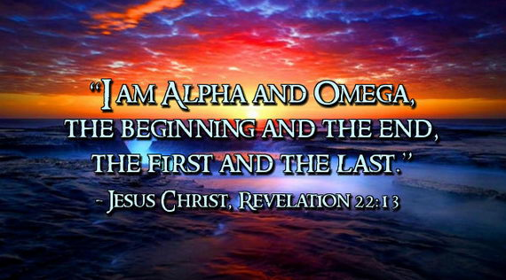

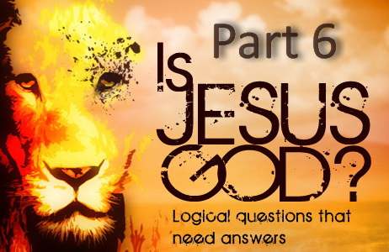

**IS JESUS GOD? – PART 6**

**Is the Alpha and the Omega Christ or the Lord God almighty?**

The confusion originates from Revelation 1:8 that even has theologians disagreeing with each other as they have missed something so simple. Please allow me to explain.

Note that the three phrases “*the Alpha and Omega, the beginning and the end, the first and the last*” in Revelation 22:13 all mean the same thing. And so from Revelation 1:17-18 we know that the “*first and the last*” (Alpha and Omega) is Christ. “*I am the first and the last: I am he that liveth, and was dead; and, behold, I am alive for evermore.*”

Ellen White is also clear, “*Christ says, “I am the true witness. I am Alpha and Omega, the beginning and the end, the first and the last.*” — (E.G. White, *1SAT*, 231.3)

Hence the phrase “*I am Alpha and Omega*” at the beginning of Revelation 1:8 refers to Christ, but the remainder of this verse refers to the Father. How do we know?

To begin with, Revelation 1:4-5 has the following salutation. “*Grace be unto you, and peace, from HIM WHICH IS, AND WHICH WAS, AND WHICH IS TO COME; … and from JESUS CHRIST,*”

So this salutation is from the Father (*which is, and which was, and which is to come*) and His Son (*and from Jesus Christ.*)

So we know that the latter part of Revelation 1:8 which says “*saith the Lord, which is, and which was, and which is to come, the Almighty*” is referring to the Father while the phrase “*I am the Alpha and the Omega,*” is referring to Christ.

This is where many get confused as they so easily read this verse incorrectly. They either apply the entire verse to the Lord God almighty or they apply it entirely to Christ.

Not that it really makes much difference to the meaning of this verse and what I am explaining, but those who do their research will find that the NIV for once actually has the most accurate rendering of this verse. We find the phrase “*the beginning and the ending*” was added in the KJV (which is not incorrect) and the word “*God*” was left out which would have made this verse a little clearer but it should still be obvious to any good Bible student.

Adam Clarke's Commentary in regards to the phrase “*the beginning and the ending” says “This clause is wanting [missing] in almost every MS. and version of importance. It appears to have been added first as an explanatory note, and in process of time crept into the text. Griesbach has left it out of the text.*”

And in regards to the phrase “*saith the Lord,*” Robert Jamieson, A. R. Fausset and David Brown Commentary says, “*The oldest manuscripts read “the Lord God.*”

And Albert Barnes' Notes on the Bible says, “*Or, saith God, according to what is now regarded as the correct reading.*”

Compare the KJV and the NIV.

Revelation 1:8 KJV “*I am Alpha and Omega, the beginning and the ending, saith the Lord, which is, and which was, and which is to come, the Almighty.*”

Revelation 1:8 NIV “*I am the Alpha and the Omega, says the Lord God, who is, and who was, and who is to come, the Almighty.*”

Comparing the following verses also reveals that the “*LORD GOD, WHO IS, AND WHO WAS, AND WHO IS TO COME, THE ALMIGHTY*” refers to the Father beyond any doubt.

Revelation 1:4-5 “*Grace be unto you, and peace, from HIM WHICH IS, AND WHICH WAS, AND WHICH IS TO COME [Father]; … and from JESUS CHRIST [Son],”*

Revelation 4:8 “*Holy, holy, holy, LORD GOD ALMIGHTY, WHICH WAS, AND IS, AND IS TO COME.*”

Revelation 11:17 “*We give you thanks, O LORD GOD ALMIGHTY, WHICH ARE, AND WERE, AND ARE TO COME;*”

The expression “*which is,*” “*which was,*” “*which is to come*” indicates that the last clause (which is to come) is a substitute for the future tense of the verb and is the same as saying “*which will be*” which would have been less misunderstood. Because some have assumed that this clause refers to the second coming of Christ. But it does not fit the context or the meaning of this phrase. This reference to the Father refers to His eternal nature and is saying that the same One who now continually exists has always existed and will always exist. The Twentieth Century New Testament more accurately reads, “*the Lord, the God who is, and who was, and who shall be,*” Revelation 1:8

Now Revelation 1:8 can be read one of two ways and most are inclined to read it the wrong way which creates a contradiction of Scripture. This is why people either apply the entire verse to the Lord God almighty or they apply it entirely to Christ. When you read it with the correct understanding there is no contradiction of Scripture anymore. Revelation 1:8 is just one of those verses that lost its clear meaning when it was translated from Greek to English. Please allow me to paraphrase this verse and you should then be able to see how it is supposed to be read and understood.

Note that Jesus is actually speaking the entire verse and He is saying, “*I am the Alpha and Omega, and my Father who is the Lord God, which is, and which was, and which is to come, the Almighty declares this.*”

With this correct understanding you should now be able to read Revelation 1:8 without seeing any apparent contradiction.

This three minute video also explains <https://www.youtube.com/watch?v=r5icSV-4gb0>

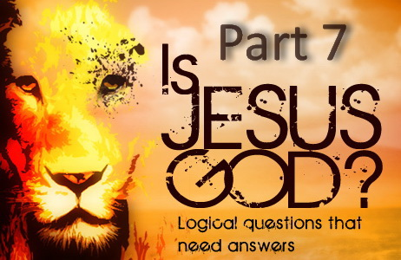

**IS JESUS GOD? – PART 7**

**Do the Words “I AM” Mean Jesus is God?**

This is based on John 8:58. But note that the words “I am” also mean “I exist.” Some claim that Christ was declaring Himself to be God in John 8:58 because He used the words “I am.” This is erroneously based on the words “I am” being a reference to Exodus 3:14. From this they draw the conclusion that Christ was alluding to the divine name and thereby telling the Jews that He was God. Trinitarians further try and support their claim by saying this is why the Jews picked up stones to kill Him. But this was due to many things Jesus just said that slowly brought them to anger. The final straw being Jesus claiming seniority over Abraham who they said was their father. So Jesus claimed greater authority than the patriarch and hence was also claiming to be greater than them.

The phrase “*I am*” in John 8:58 comes from two Greek words “*egō*” and “*eimi*.” The Strong's Definitions are:  
“***egō :*** *“I” (only expressed when emphatic): - I, me.*”  
“***eimi:*** *I exist (used only when emphatic): - am, have been, X it is I, was.*”

How would you expect Jesus to respond to this comment? “*Then said the Jews unto him, You are not yet fifty years old, and have you seen Abraham?*” John 8:57

Not knowing Jesus existed before Abraham, the Pharisees are saying how could you have seen Abraham because you are not yet 50 years old. Since the Greek words for “I am” also mean I exist or existed, what is the obvious translation and response from Christ who existed before Abraham?

“*Jesus said unto them, Verily, verily, I say unto you, Before Abraham was, I am.*” John 8:58

Or

“*Jesus said unto them, Verily, verily, I say unto you, Before Abraham was, I existed*.” John 8:58

Both are valid translations and the majority of Bible translations agree with the last one in fact with good reason!

So “*I exist*”, “*I have been*” and “*I was*” are other possible translations which have all been used by various Bible translators for John 8:58 as well as elsewhere in the KJV. For example: *ego eimi* has been translated to “*I was*” in Luke 19:22 “*You knewest that I WAS (ego eimi) an austere man,*”

These words formed a phrase that was in very common use by Jews and Christians and in New Testament Scriptures in the first century. It was not the name of any deity, be it the God of the Bible or any other god. It was never understood by Jews or Christians as declaring one to be God. If it were understood that way, you can be certain that the Jews would have never applied it to themselves as they did so frequently! In the following examples Peter, Paul, Gabriel and Zacharias all said, “I am” (ego eimi). But none of them were claiming to be God.

Luke 1:18 “*And Zacharias said unto the angel, Whereby shall I know this? for I AM (ego eimi) an old man,*” Luke 1:19 “*And the angel answering said unto him, I AM (ego eimi) Gabriel,*” John 1:27 “*He it is, who coming after me is preferred before me, whose shoe's latchet I AM (ego eimi) not worthy to unloose.*” Acts 10:21 “*Then Peter went down to the men which were sent unto him from Cornelius; and said, Behold, I AM (ego eimi) he whom you seek:*” Acts 21:39 “*Paul said, I AM (ego eimi) a man which am a Jew of Tarsus,*” And the blind man also identifies himself by saying, *I am*. John 9:9 “*Some said, This is he: others said, He is like him: but he said, I AM (ego eimi) he.*” None of the Jews saw this man as declaring himself to be God either.

Here are all the other verses where Jesus said *ego eimi* in the Gospels. Not one can be understood as Jesus claiming to be God.  Matthew 24:5, Mark 13:6, Luke 21:8 “*I am Christ*”, John 8:24, 28, 13:19, 18:5, 6, 8, “*I am he (Jesus)*,” Matthew 20:15 “*I am good*,” Matthew 28:20 “*I am with you always*,” Mark 14:62 “*Jesus said I am (the Son of God)*,” Luke 22:27 “*I am among you as one who serveth*,” Luke 22:70 “*You say that I am (the Son of God)*,” John 6:35, 48, 51 “*I am the bread of life*,” John 7:34, 12:26, 17:24, 14:3 “*Where I am*,” John 8:12 “*I am the light of the world*,” John 8:18 “*I am the one that bear witness*,” John 8:23 “*I am from above*,” and “*I am not of this world*,” John 10:7, 9 “*I am the door*,” John 10:11, 14 “*I am the good shepherd*,” John 11:25 “*I am the resurrection*,” John 14:6 “*I am the way*,” John 15:1, 5 “*I am the true vine*,” John 17:14, 16 “*I am not of the world*,” John 18:37 “*Thou sayest that I am a king*.”

At the end of Christ's ministry when news of Him had spread far and wide, who did the Jews understand Christ to be saying He was and what was the charge they brought against Him?

Matthew 26:63 “*the high priest answered and said unto him, I adjure you by the living God, that you tell us whether you be the Christ, the Son of God.*”  Matthew 27:40, 43 “*If you be the Son of God, come down from the cross. 43 He trusted in God; let him deliver him now, if he will have him: for he said, I am the Son of God.*” Mark 14:61 “*Again the high priest asked him, and said unto him, Are you the Christ, the Son of the Blessed? 62 And Jesus said, I am [ego eimi]:*” Mark 15:39 “*when the centurion, which stood over against him, saw that he so cried out, and gave up the ghost, he said, Truly this man was the Son of God.*” Luke 22:67, 70 “*Are you the Christ? tell us. ... 70 Then said they all, Are you then the Son of God? And he said unto them, You say that I am [ego eimi].*” John 19:7 “*The Jews answered him, We have a law, and by our law he ought to die, because he made himself the Son of God.*”

Twice in the verses above Jesus responded, “I am” (ego eimi) and yet He was not saying He was God but confirming that He was the Son of God. The Jews clearly never understood Jesus to be declaring Himself God. The outrage would have been heard far and wide if He had. There is no record anywhere in the entire New Testament of anyone even asking Him if He was God. So how could the Jews have seen Him to be saying He was God in John 8:58?

It is also notable that the words “*I AM THAT I AM*” in Exodus 3:14 have been variously understood for centuries. The Vulgate translates it as “*I am who am.*” The Septuagint to “*I am he who exists.*” The Targum of Jonathan and the Jerusalem Targum paraphrase the words as “*He who spake, and the world was; who spake, and all things existed.*” The original words literally signify, “*I will be what I will be.*”

A comparison of Exodus 3:14 and John 8:58 using the Greek Old Testament the Septuagint, reveals that God said, “*I am the being (ego eimi ho ohn*),” and Jesus said, “*Before Abraham was, I am (prin abraam genesthai ego eimi)*.” So the divine name is actually “*The being (ho ohn)*”, not “*I am (ego eimi*).” This is further proven by the end of Exodus 3:14 which says “*The being (ho ohn) has sent me to you.*” It does not say “*I am (ego eimi) has sent me to you.*” No matter how it is translated into English, “*ho ohn*” is not the same as “*ego eimi*.” So there is no connection between “I AM” in Exodus and “I am” in John. In no way does John 8:58 equate Jesus to God except by biased inference based on weak translation and bad grammar.

Below are a few examples of how John 8:58 should have been translated. There are in fact over forty translations that translated this correctly.

“*The absolute truth is that I was in existence before Abraham was ever born!*” — (The Living Bible)

“*Jesus answered, before Abraham existed, I existed.*” — (The Clarified New Testament)

“*In truth I tell you,” replied Jesus, “before Abraham existed I was.*” — (Twentieth Century New Testament)

“*Jesus answered, “The truth is, I existed before Abraham was even born!*” — (New Living Translation)

“*Jesus said to them, I am telling the truth: I was alive before Abraham was born!*” — (International Bible Translators)

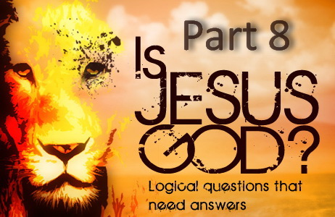

**IS JESUS GOD? – PART 8**

**Does Isaiah 9:6 Say Jesus is the Father?**

The answer lies in the correct Hebrew translation. Albert Barnes' Notes on the Bible explains, “*The Chaldee renders this expression, 'The man abiding forever.' The Vulgate, 'The Father of the future age.' Lowth, 'The Father of the everlasting age.' Literally, it is the Father of eternity.*”

Thus in the Hebrew text, the phrase is literally “*the Father of eternity,*” not “*the everlasting Father.*” And so Isaiah 9:6 is not saying Christ is the Father but He is the Father of all time to come. Young's Literal Translation and the Darby Bible are two of very few that translated it correctly.

“*For a Child hath been born to us, A Son hath been given to us, And the princely power is on his shoulder, And He doth call his name Wonderful, Counsellor, Mighty God, FATHER OF ETERNITY, Prince of Peace.*” Isaiah 9:6 YLT

“*For unto us a child is born, unto us a son is given; and the government shall be upon his shoulder; and his name is called Wonderful, Counsellor, Mighty God, FATHER OF ETERNITY, Prince of Peace.*” Isaiah 9:6 Darby

All things were created through Jesus and so in like manner He is also the Father of creation (Hebrews 1:2; John 1:3; Colossians 1:16-17)

It is also interesting to note that the Greek Septuagint that JESUS and the APOSTLES quoted from does NOT contain this phrase. PLEASE NOTE WHAT IT SAYS AND WHAT IT DOES NOT SAY! So how did this phrase that was wrongly translated find its way into the Hebrew Bible?

“*For a Child is born to us, and a Son is given to us, whose government is upon His shoulder; and His name is called the Messenger of great counsel; for I will bring peace upon the princes, and health to Him.*” Isaiah 9:6 Septuagint

The Greek Old Testament the Septuagint that Christ quoted from reveals what Isaiah 9:6 most likely originally said. It was translated by 70-72 Jewish scholars around 300-200 BC and hence came from the most ancient and reliable manuscripts available. The Hebrew Old Testament however was established by the Massoretes in the 6th century AD. It is known that many textual corruptions and additions crept into the Hebrew text between the 6th and 7th centuries. So where did this additional text in Isaiah 9:6 come from that was not even translated correctly by most modern translators?

The one thing that no one can deny is that only one of these translations can be correct. So which one? The Septuagint that came from the oldest manuscripts. Or the later that has known corruptions that crept in between the 6th and 7th centuries.

“THE MAN CHRIST JESUS WAS NOT THE LORD GOD ALMIGHTY,” — (E.G. White, *Ms140*, Sept 27, 1903)

“HE [CHRIST] WAS NOT THE FATHER but in him dwelt all the fullness of the Godhead bodily,” — (E.G. White, *Lt8a*, July 7, 1890)

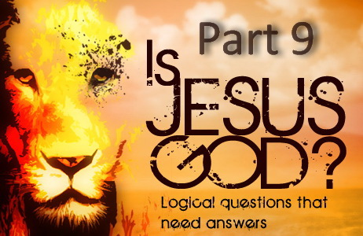

**IS JESUS GOD? – PART 9**

**Is Jesus God if He Can Forgive Sins?**

The deception of some Trinitarians is easily seen when their focus is on the words of a Pharisee while being blind to the words of Christ Himself. Some claim that Jesus is the Father because these Pharisees said that God only can forgive sins.

Mark 2:7 “*Why does this man thus speak blasphemies? WHO CAN FORGIVE SINS BUT GOD ONLY?*”

But these Pharisees whom Christ said will not enter the kingdom of heaven (Matthew 5:20; Matthew 23:13) did not know or accept that Jesus was the Son of God who had been given authority by His Father to do so. Three verses later Jesus tells us that He has been given authority to forgive sins.

Mark 2:10 “*But that you may know that THE SON OF MAN HAS POWER ON EARTH TO FORGIVE SINS.*”

And not just power to forgive sins. Jesus also said “*All power is given unto me in heaven and in earth.*” Matthew 28:18. And John wrote “*The Father loves the Son, and has given all things into his hand.*” John 3:35

Note that “all authority” and “all power” is “given” to the Son! If the Son is God as the Father is God, and the Son is almighty as the Father is, then how can the Son be “given” anything if He is God? How can God be “given” that which He has always possessed? God does not depend on anyone or anything so that it has to be “given” to Him. But we do see that Jesus had to be “given” all things into His hand just as Jesus was given authority to forgive sins by His Father.

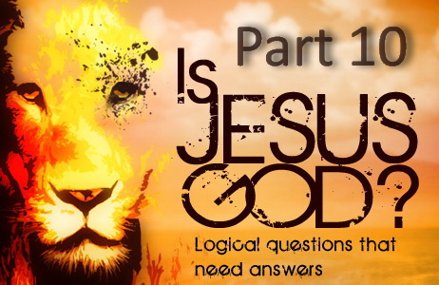

**IS JESUS GOD? – PART 10**

**Did Thomas Believe that Jesus was God?**

John 20:28 says, “*And Thomas answered and said unto him, My Lord and my God.*”

One can really only speculate as to why Thomas said what he did, but being dubbed “doubting” Thomas, it would be understandable if his statement was one made in a moment of shock and disbelief. Thomas was a Jew and may have been using a mode of expression common to the Old Testament in which accredited representatives of God are referred to as “God.” The Hebrew word for God is “elohim” and can refer to any of the following for example:

Brown-Driver-Briggs’ Hebrew Definitions

a) rulers, judges, either as divine representatives at sacred places or as reflecting divine majesty and power:

b) divine ones, superhuman beings including God and angels.

So Thomas was not calling Jesus God in the Trinitarian sense but was probably addressing Him as one who reflected divine power and majesty or a ruler. If this was not the case, then the following is the most probable reason for what Thomas said.

Staying within the bounds of proper grammar we find that two different individuals are being addressed in the expression “*οκυριοςμουκαιοθεοςμου - My Lord and my God.*” However, the expression “*ειπεναυτω - said unto him*” means only one person is being spoken to.

So while trusting the grammar, we need to find an interpretation which does not violate it. This can be done if we understand that while Thomas spoke these words to Jesus, he was addressing both Jesus and the Father who is in Jesus. The actual context supports this understanding which is found by looking at the last known conversation Jesus had with doubting Thomas and Phillip.

John 14:5-10 “*THOMAS saith unto him, Lord, we know not whither you goest; and how can we know the way? Jesus saith unto him, I am the way, the truth, and the life: no man cometh unto the Father, but by me. If you had known me, you should have known my Father also: and from henceforth you know him, and have seen him. Philip saith unto him, Lord, show us the Father, and it sufficeth us. Jesus saith unto him, Have I been so long time with you, and yet have you not known me, Philip? He that has seen me has seen the Father; and how sayest you then, SHOW US THE FATHER? BELIEVEST YOU NOT THAT I AM IN THE FATHER, AND THE FATHER IN ME? The words that I speak unto you I speak not of myself: BUT THE FATHER THAT DWELLETH IN ME, he doeth the works.*”

In the presence of Thomas, Phillip tells Jesus that seeing the Father is enough for him. Jesus responds to Thomas and Phillip saying that to see Him (Jesus) is to see the Father because the Father is in Him. But Thomas still did not understand.

The next known conversation Thomas had with Jesus is the passage of John 20:28. Thomas now understands that the Father works through Jesus, even raising Jesus from the dead, and thus to see Jesus is to see the Father, hence the exclamation cry from Thomas, “*my lord (i.e. Jesus) and my God (i.e. the Father).*” Thomas did not address Jesus as his “*Lord and God.*”

We also know that it is not possible for doubting Thomas to be declaring Jesus is the one God.

A few verses earlier John records that the risen Jesus appeared to Mary Magdalene and told her, “*I am not yet ascended to my Father: but go to my brethren, and say unto them, I ascend unto MY FATHER, AND YOUR FATHER; and TO MY GOD, AND YOUR GOD.*” John 20:17

Jesus said His God is His Father and that His God is also Mary’s God. Did Jesus tell Mary that He was her God? To the contrary, Jesus was very specific in stating that His God was also her God.

And since the risen Jesus called the Father “My God,” how can Jesus be God if He has a God? Indeed John could not have meant that Thomas was calling Jesus “my God” in the Trinitarian sense when John had just recorded that Jesus called the Father “My God.” Thomas could not be calling Jesus God because John just wrote that Jesus ascended to the same God Mary and Thomas both have.

And further, only one verse after the confession of Thomas, John concludes by writing, “*Many other signs therefore Jesus also performed … but these have been written that you may believe that Jesus is the Christ, the Son of God.*” John 20:30-31

John did not write “*that you may believe that Jesus was God.*” If that were so, it would have been far greater for John to proclaim that Jesus is God rather than that He is the Son of God.

“THE MAN CHRIST JESUS WAS NOT THE LORD GOD ALMIGHTY,” — (E.G. White, *Ms140*, Sept 27, 1903)

“HE [CHRIST] WAS NOT THE FATHER but in him dwelt all the fullness of the Godhead bodily,” — (E.G. White, *Lt8a*, July 7, 1890)

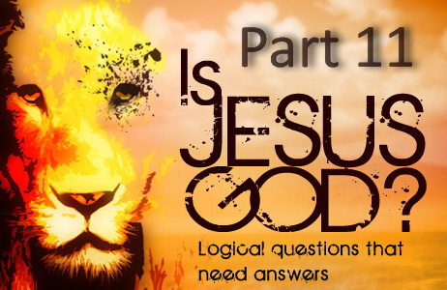

**IS JESUS GOD? – PART 11**

**How can Jesus be God if His Father is Greater Than Him?**

What did Jesus mean when He said “*my Father is greater than I*” considering Paul also said that Jesus is equal with God? There is no contradiction in Scripture, so how do we reconcile these verses below?

John 14:28 “*You have heard how I said unto you, I go away, and come again unto you. If you loved me, you would rejoice, because I said, I go unto the Father: for MY FATHER IS GREATER THAN I.*”

1 Corinthians 11:3 “*But I would have you know, that the head of every man is Christ; and the head of the woman is the man; and THE HEAD OF CHRIST IS GOD.*”

Philippians 2:6 “*Who, being in THE FORM OF GOD, thought it not robbery TO BE EQUAL WITH GOD:*”

The Greek word (theotes) for Godhead in Colossians 2:9 means the divine nature. Thus the fullness of the divine nature of God dwells in His Son Jesus Christ. And the word “form” in Philippians 2:6 means “shape/nature,” and so Paul is saying that the way Christ is equal with His Father is in “nature” which He inherited being His Son.

The word “greater” in John 14:28 refers to position in the same way it does with a human father and son as well as a husband and wife. 1 Corinthians 11:3 states that the head of the woman is man. But does this mean the husband is a superior being to his wife? The answer is an obvious no. She is a human being just as the man is and so they are equal in nature. The husband is greater than his wife only by position. The same applies to a father and son. The father is greater because he was first being the father, and the same applies to our Heavenly Father and His Son. The Father is greater in position in that He was first, but not greater in nature or form as Philippians 2:6 states.

“*The Father was greater than the Son in that he was first.*” — (James White, *RH*, Jan 4, 1881)

“*While both are of the same nature, the Father is first in point of time. He is also greater in that he had no beginning, while Christ's personality had a beginning.*” — (E.J. Waggoner, *ST*, April 8, 1889)

So we observe the same concept of being equal in nature, but Christ submitted Himself to the Father as He was greater in that He was first being His Father. We find in these verses the principle of headship and submission established by God as displayed in both marriage and the Godhead. These principles also reveal that God and Christ are a real Father and Son. As Waggoner, James White and Scripture reveals, Christ came after the Father being the Son.

However, we also find that the Father has “given” His Son all power and placed everything into His hands. Thus Christ has been given an “*exalted position*” and has been “*made equal*” by His Father in power and authority also. But while the Father has made His Son equal, His Father is still greater than Him, and He still submits to His Father.

“*All power is given unto me in heaven and in earth.*” Matthew 28:18. And John wrote “*The Father loves the Son, and has given all things into his hand.*” John 3:35

“God is the Father of Christ; Christ is the Son of God. To CHRIST HAS BEEN GIVEN AN EXALTED POSITION. HE HAS BEEN MADE EQUAL WITH THE FATHER.” — (E.G. White, 8T 268.3)

The Trinity doctrine claims the Father, Son and Holy Spirit are 3 co-equal, co-eternal God’s. But Ellen White says Christ was MADE EQUAL with His Father and by His Father as Scripture also reveals, again proving this doctrine from Satan a lie.



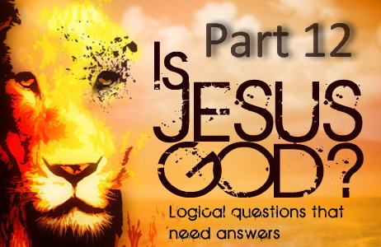

**IS JESUS GOD? – PART 12**

**Is Jesus God if He can be Worshipped?**

Some claim that Matthew 4:10 says that God alone should be worshipped, and since Jesus is worshipped, they say the Son must be the Father.

Matthew 4:10 “*Then saith Jesus unto him, Get you hence, Satan: FOR IT IS WRITTEN, You shall worship the Lord your God, and HIM ONLY SHALL YOU SERVE.*”

When Jesus said, “*for it is written,*” He was quoting Deuteronomy 6:13 from the Septuagint (LXX) which says, “*You shall fear the Lord your God, and HIM ONLY SHALL YOU SERVE;*” Deuteronomy 6:13 LXX

The first thing to note is that technically, these verses do not say to “*worship God alone.*” These verses say that *God only should you serve.* However, there is an element of worship to the word serve in this verse. In any case, since Jesus taught that we should serve others, this is obviously not what He was saying. And since the Father commanded worship of His Son, that cannot be what He was saying either. “*And again, when he bringeth in the firstbegotten into the world, he saith, And let all the angels of God worship him.*” Hebrews 1:6

And not forgetting that Philippians 2:5-6 states that Jesus is “equal” with His Father in nature and hence is fully divine, and so of course He is worthy of worship! Jesus also said, “*That all men should honour the Son, even as they honour the Father. He that honoureth not the Son honoureth not the Father which has sent him.*” John 5:23

So what then was Jesus saying to Satan that so many have misunderstood? It is not hard to work out. In Matthew 4:10 Jesus said, “*for it is written.*” So Jesus is referring to an example of something in the Old Testament Scriptures. To find the answer, all we have to do is look at what Jesus was referring to which will apply to what He was telling Satan. Note the reference.

Deuteronomy 6:13-15 “*You shall fear the Lord your God, and Him only shall you serve; and you shall cleave to Him, and by His name you shall swear. Go NOT AFTER OTHER GODS, of the gods of the nations round about you, for the Lord your God in the midst of you is a jealous God, lest the Lord your God be very angry with you, and destroy you from off the face of the earth.*”

The issue could not be more obvious. It was about “idolatry” which is false worship as in worshipping false gods. To worship Christ and serve Him is *not* idolatry. Isaiah 14:12-14 tells us that Satan wanted to be worshipped like the most high God. Satan wanted Jesus to fall down and worship him as a god and so Jesus quoted Old Testament Scripture to him that says you should not worship or “*go after other gods.*” So the words of Christ have to be taken in the *context* of what He was quoting. So often Christians neglect the context of a passage and apply specific words in a way that was never intended.

Thus we are to worship God, not false gods, and so this does not exclude the worship of His Son who is equal with His Father. And we are to serve God, not false gods, and so this does not exclude serving Christ.

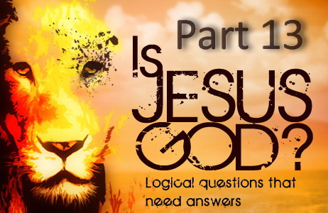

**IS JESUS GOD? – PART 13**

**How Can Jesus be God if there is Only One God?**

For more than 3,000 years, Jews have repeated Deuteronomy 6:4, “*Hear, O Israel: The Lord our God is one Lord.*” This sacred passage is called the Shema (*pronounced shaw-mah and is named after the Hebrew for its first word*) and has been held in high esteem and memorized by devout Jews for centuries. Trinitarians who believe there are 3 gods say, if the Bible says there is only one God then all three must be one, and yet others say if there is only one God, then how can God be composed of three beings? If Christians could only accept the simple words of Scripture instead of reading into it and trying to make Scripture say something it does not say.

When Moses said, “*The Lord our God is one,*” Israel was surrounded by polytheistic nations that worshiped many gods. In Deuteronomy chapter 6, Moses exhorts Israel to hear God and to keep His Commandments. And what Commandment was the most broken in Old Testament times? Idolatry! Polytheism is seen rampant all through the Old Testament and hence God constantly rebuking Israel for idolatry. They worshipped many false Gods including the sun and the moon as male and female deities. As a result, every devout Jew recites the Shema twice every day, and still do to this very day to keep up the great ancient national protest against the polytheisms and pantheisms of the heathen world. It is the great utterance of the national faith in One Jehovah!

What many fail to recognise is that to the Jews, there is only one God, and the Spirit of God is just that, not a separate being or god. The Jews were God's chosen people and God raised the Jewish nation as non-Trinitarian which has never changed. Trinitarians often try and use the language of the Jews to prove the Trinity doctrine and yet the people that this language belongs to were never Trinitarians! The Scriptures below also reveal there is but one God.

“*Have we not all one father? Has not ONE GOD created us? Why do we deal treacherously every man against his brother, by profaning the covenant of our fathers?*” Malachi 2:10

In the passage of Mark 12:28-34, “*one of the scribes came*” to Jesus and “*asked him, Which is the first commandment of all?*” (v. 28) “*Jesus answered, The first of all the commandments is, Hear, O Israel; THE LORD OUR GOD IS ONE LORD: And you shall love the Lord your God with all your heart*...” (v. 29, 30) Note Jesus quotes Deuteronomy 6:4. “*The scribe said unto him, Well, Master, you have said the truth: for THERE IS ONE GOD; and there is none other but he:*” (v. 32) How did Jesus respond to the Scribe? Did He tell Him that he was wrong? To the contrary, “*And when Jesus saw that he answered discreetly (wisely), he said unto him, You are not far from the kingdom of God.*” (v. 34)

“*Seeing IT IS ONE GOD, which shall justify the circumcision by faith, and uncircumcision through faith.*” Romans 3:30

“*You believest that THERE IS ONE GOD; you doest well: the devils also believe, and tremble.*” James 2:19.

These devils are fallen angels who knew God and His Son. So they know “*there is one God*” and they know that Jesus is the “*Son of God*,” and not the one true God. “*they cried out, saying, What have we to do with you, JESUS, YOU SON OF GOD?*” Matthew 8:29

“*Now unto the King eternal, immortal, invisible, THE ONLY WISE GOD, be honour and glory for ever and ever.*” 1 Timothy 1:17

**Note:** The following Scriptures also state that there is one God. But does the Bible include Jesus as the one God as the trinity doctrine claims, or is there one God “*and*” also one Lord Jesus Christ meaning they are two separate beings?

“*There is one body, and one Spirit, even as you are called in one hope of your calling; ONE LORD [JESUS], one faith, one baptism, ONE GOD AND FATHER OF ALL, who is above all, and through all, and in you all.*” Ephesians 4:4-6

“*For THERE IS ONE GOD, and ONE MEDIATOR between God and men, the man Christ Jesus.*” 1 Timothy 2:5

“*And this is life eternal, that they might know you THE ONLY TRUE GOD, and JESUS CHRIST, whom you have sent.*” John 17:3

“*For there are certain men crept in unawares, who were before of old ordained to this condemnation, ungodly men, turning the grace of our God into lasciviousness, and denying THE ONLY LORD GOD, and OUR LORD JESUS CHRIST.*” Jude 1:4

“*But to us THERE IS BUT ONE GOD, THE FATHER, of whom are all things, and we in him; and ONE LORD JESUS CHRIST, by whom are all things, and we by him.*” 1 Corinthians 8:6

So Paul, John and Jude state that the Father is the only true God while excluding Jesus Christ revealing that He is not the Father and separate from the one true God the Father. So the only contradiction would be a belief in the Trinity.

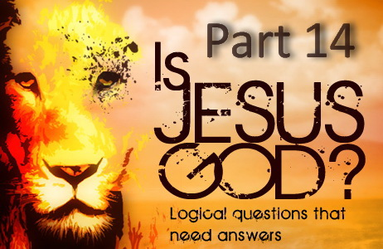

**IS JESUS GOD? – PART 14**

## **Does Elohim Prove Jesus is God?**

Some claim that because the word most often used for God in the Hebrew Bible is Elohim (plural for El), then God must be a trinity and hence Jesus must be God. But this is just another deception or ignorance. The fact is that the word Elohim is used for the true God, false gods, supernatural spirits (angels) and even human leaders such as kings and judges. Thus the word Elohim can and is used to refer to a single person, and when it does, linguists call it a “plural intensive” or “plural of majesty” which denotes greatness. The Hebrew people pluralized nouns when they desired to express greatness or majesty as they did with God. So when Elohim is used of the one true God, it is called a “plural of majesty” which denotes the greatness of God, not number.

This was “only” done by the Hebrew people so in the Greek translation of the Hebrew Bible (the Septuagint, which Jesus and the apostles quoted) where Elohim refers to the true God, the word Theos is used which is not plural but singular. The same applies to the New Testament where Theos is the Greek equivalent to Elohim and once again it is not plural but singular. For example. Jesus quotes Deuteronomy 6:4 in Mark 12:29. The word Theos for God in this verse is singular, not plural. If Elohim was really a plurality of the one true God, then the New Testament writers would have used the plural of Theos also when referring to God. Instead they used the singular form every single time. And yet the plural form is used eight times in the New Testament referring to men or false gods. (John 10:34-35; Acts 7:40, 14:11, 19:26; 1 Corinthians 8:5; Galatians 4:8). I trust that no one will say that God is a Trinity in the Hebrew language while being one God in the Greek language.

Below are some dictionary definitions from scholars concerning the usage of Elohim as a “plural intensive,” or as many prefer, “plural of majesty” (a pluralis excellentice) or “plentitude of might.”

“Elohim is a plural form which is often used in Hebrew to denote plentitude of might.” — (Hertz, The Pentateuch & Haftorahs)

“The form of the word, Elohim, is plural. The Hebrews pluralized nouns to express greatness or majesty.” — (Flanders, Cresson; Introduction to the Bible)

“The Hebrew noun Elohim is plural but the verb is singular, a normal usage in the OT when reference is to the one true God. This use of the plural expresses intensification rather than number and has been called the plural of majesty, or of potentiality.” — (New International Version Study Bible, Grand Rapids: Zondervan, 1985, p. 6)

“This word [elohim], which is generally viewed as the plural of eloah [Strong's #433], is found far more frequently in Scripture than either el or eloah for the true God. The plural ending is usually described as a plural of majesty and not intended as a true plural when used of God. This is seen in the fact that the noun elohim is consistently used with singular verb forms and with adjectives and pronouns in the singular.” — (Theological Wordbook of the Old Testament, Vol. 1, 1980, p. 44)

“The plural form of Elohim has given rise to much discussion. The fanciful idea that it referred to the trinity of persons in the Godhead hardly finds now a supporter among scholars. It is either what grammarians call the plural of majesty, or it denotes the fullness of divine strength, the sum of the powers displayed by God. Jehovah denotes specifically the one true God, whose people the Jews were, and who made them the guardians of his truth.” — (Smith's Bible Dictionary)

So why does the fanciful idea that Elohim refers to a trinity hardly find a supporter among scholars now? Because the truth is impossible to avoid and you would only end up looking very foolish and deceived if you use this to try and prove a lie. So when you hear the argument that Elohim means God must be a trinity, then understand that there is either deliberate deception or total ignorance and such a person cannot be trusted.

As for Genesis 1:26, the pronouns are plural in the Hebrew text so it is translated, “God said, let US make man in OUR image, after OUR likeness.” Trinitarians claim that since Elohim is plural, and the pronouns are plural, God must be more than one. But Elohim refers to the one true God which only leaves the question of who is “US” in this verse. Scripture does not leave us guessing.

Ephesians 3:9 says, “God, ... created all things by Jesus Christ:” God in this verse is obviously someone other than Jesus Christ, and Hebrews 1:2 and John 1:3 says God created all things by His Son. So who is speaking in Genesis 1:26 and who is He speaking to?

God the Father said to His Son, “let US make man in OUR image.” Christ is “the express image” of the Father, so anyone created in the Father's image is also created in His Son's image.

“The FATHER AND THE SON engaged in the mighty, wondrous work they had contemplated, of creating the world. ... And now GOD SAID TO HIS SON, “LET US MAKE MAN IN OUR IMAGE. [Genesis 1:26 quoted]” — (E.G. White, *1SP*, 24.1,2)

See <https://www.youtube.com/watch?v=_VZw6Dqczs8> for more on the true meaning of Elohim.

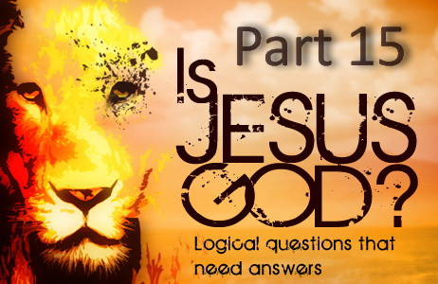

**IS JESUS GOD? – PART 15**

**Is Jesus the Literal Son of God?**

The Trinity doctrine states that there are three co-equal (equal in every respect), co-eternal (the same age), omniscient (all knowing), omnipotent (all powerful) gods, who are not three gods, but one god.

By the words of the Athanasian Creed it is, “*the Father is God, the Son is God, and the Holy Spirit is God, and yet there are not three gods but one God.*”

In other words. **1+1+1=1** !

So a 3 in 1 and 1 in 3 god which means the Father cannot really be a Father and the Son cannot really be a Son which denies the Father and Son which the apostle John called antichrist. And hence the Holy Spirit is supposedly a third god that makes up the one god rather than being the actual Spirit of the Father and Son just as we have a spirit.

However, John 5:26 tells us that the Father gave life to His Son. “*For as the Father has life in himself; so has he given to the Son to have life in himself.*” John 5:26

If Jesus had always existed alongside the Father as the Trinity doctrine claims, then God could not have given life to His Son as He would have always had life. But Scripture reveals this is impossible.

Jesus is the LITERAL Son of God and received LIFE from His Father in the days of eternity (*before time was/before creation*).

“*As the Son of the self-existent God, he has by nature all the attributes of Deity.* *It is true that there are many sons of God; but Christ is the “only begotten Son of God,” and therefore the Son of God in a sense in which no other being ever was, or ever can be. The angels are sons of God, as was Adam (Job 38:7; Luke 3:38), by creation; Christians are the sons of God by adoption (Rom. 8:14,15); but CHRIST IS THE SON OF GOD BY BIRTH.*” — (E.J. Waggoner, *CAHR*, p. 11-12)

“*If we take the liberty to say there is not a literal Ark, containing the ten commandments in heaven, we may go only a step further and deny the literal City, and the LITERAL SON OF GOD.*” — (James White, *RH*, June 9, 1851)

As a prolific Seventh day Adventist minister and evangelist said, “*Christ is the only LITERAL SON OF GOD. “The only begotten of the Father.” John 1:14. HE IS GOD BECAUSE HE IS THE SON OF GOD; not by virtue of his resurrection.*” — (J.G. Matteson, *RH*, Oct 12, 1869)

“*O what a gift God has made to our world! The Word was made flesh and dwelt among us. GOD SENT HIS OWN SON in the likeness of sinful flesh, liable to physical infirmities, tempted in all points like as we are. HE WAS THE SON OF THE LIVING GOD. His PERSONALITY did NOT begin with His INCARNATION in the flesh.*” — (E.G. White, *Lt77*, Aug 3, 1894)

“*The dedication of the FIRST-BORN had its origin in the earliest times. God had promised to give the FIRST-BORN OF HEAVEN to save the SINNER.*” — (E.G. White, *DA*, p. 51)

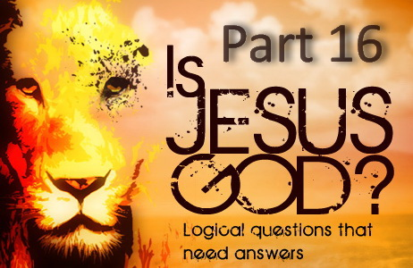

**IS JESUS GOD? – PART 16**

**Is Jesus Divine if He is the Literal Son of God?**

Some claim that Jesus cannot be divine if He was born of God. But this is just another tactic Satan uses to deter people from the truth. In any case, the problem is actually the other way around. Divinity is not based on how old you are but who you came from. Jesus inherited everything from His Father including his divinity. See Hebrews 1:4 for example.

Jesus is the literal Son of God, “*the firstborn over all creation*” (Colossians 1:15), and being brought forth from the Father, He has the same “*divine nature*” as His Father.

“*For it pleased the Father that in him should all fulness dwell;*” Colossians 1:19

We also find that the Greek word translated “Godhead” in Colossians 2:9 means “divine nature.” Thus Paul states that the fullness of the “*divine nature*” of God dwells in His Son.

“*For in him dwelleth all the fulness of the Godhead [divine nature] bodily.*” Colossians 2:9

Hence Jesus is fully divine because He “*is*” begotten of the Father, and hence came forth from the Father, and so He has the same “*divine nature*” as His Father. Thus the Father’s “*divine nature*” is in the Son because He is God’s Son.

Everything that Christ consists of had no beginning, His divinity, His makeup, His substance had no beginning as it all came from the Father. If you trace Christ back you will have to go through the Father and you will never get to a beginning. But His personality as the Son began when He was brought forth by His Father.

And if Jesus did not get His divine nature from His Father, then where did He get it from? That would mean that Jesus would have to be a God in His own right just like His Father and so we would have two gods. This would break the first Commandment where the one true God the Father says, “*You shall have no other gods before me.*” Exodus 20:3. It does not say BEFORE US. If Jesus does not have the same divine nature as His Father because He is His Son, then we have a very serious problem.

Why do some insist on trying to make Christ conform to the image they have of Him before they will accept Him? They expect Christ to be a second god identical to His Father in every way and thus reject Him as being a real Son. And yet the truth of Christ being God's Son is so precious. Just think about it for a moment. Christ is God's very own Son whom He loves very much! Why would anyone desire to destroy this precious Father and Son relationship?

Just imagine, the Father and Son in Heaven talking and Jesus says, “*Father, they say that I am not really your son. His father replies, I know son, it breaks my heart too.*” How many tears have the Father and Son shed over this lie that originated from Satan because he hates God’s Son?

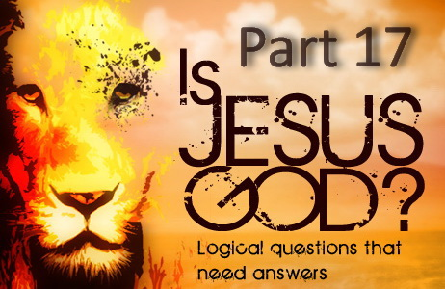

**IS JESUS GOD? – PART 17**

**Did Jesus Have a Beginning if He is the Literal Son of God?**

Consider the following. If we could travel at a septuagintacentillion (10513) times the speed of light in any one direction, would we ever find the end of the universe, like perhaps a wall with a sign saying this is the end? And if so, what would be on the other side of that wall? And what existed before God created all things through His Son? Was it nothing? And how long did nothing exist for if that was the case? It would have to be forever! And what about God, when did He begin to exist and who created Him? The answer is that there was never a time He did not exist and hence could never have been created. He is God and has always been and so is without beginning! And what about the Son of God who was born of the same substance of God? The same applies.

Since Christ is the same substance of His Father, then everything He consists of had no beginning. So His divinity had no beginning, His makeup; His nature had no beginning as it all came from the Father. So in principle, everything Christ is had no beginning. If you trace Christ back you will have to go through the Father and you will never get to a beginning. But His personality as the Son of God began when He was brought forth by His Father. So in effect it was only the personality of Christ that had a beginning. These are the mysteries of God and things our mind cannot possibly comprehend.

“The Lord Jesus Christ, the only begotten Son of the Father, is truly God in infinity, BUT NOT IN PERSONALITY.” — (E.G. White, MS116, December 19, 1905)

Waggoner explains in words that are easier to understand clarifying what Ellen White said above.

“Jesus is the only begotten Son of God. He was begotten, not created. He is of the substance of the Father, so that in his very nature he is God; and since this is so “it pleased the Father that in him should all fullness dwell.” Col. 1:19 ... While both are of the same nature, the Father is first in point of time. He is also greater in that he had no beginning, WHILE CHRIST'S PERSONALITY HAD A BEGINNING.” — (E.J. Waggoner, ST, April 8, 1889)

“*Angels of God looked with amazement upon Christ, who took upon Himself the form of man and humbly united His divinity with humanity in order that He might minister to fallen man. ... And although we may try to reason in regard to our Creator, HOW LONG HE [Christ] HAS HAD EXISTENCE, where evil first entered into our world, and all these things, we may reason about them until we fall down faint and exhausted with the research when there is yet an infinity beyond.*” — (Ellen G. White, 7BC 919.5)

Below Waggoner states that it was so far back in time that it was *practically* without beginning.

“*As to when He was begotten, it is not for us to inquire, nor could our minds grasp it if we were told. The prophet Micah tells us all that we can know about it in these words, “But thou, Bethlehem Ephratah, though thou be little among the thousands of Judah, yet out of thee shall He come forth unto Me that is to be ruler in Israel; whose goings forth have been from of old, from the days of eternity.” Micah 5:2, margin. THERE WAS A TIME WHEN CHRIST PROCEEDED FORTH AND CAME FROM GOD, FROM THE BOSOM OF THE FATHER (John 8:42; 1:18), but that time was so far back in the days of eternity that to finite comprehension it is practically without beginning.*” — (E.J. Waggoner *CAHR*, pp. 21, 22)

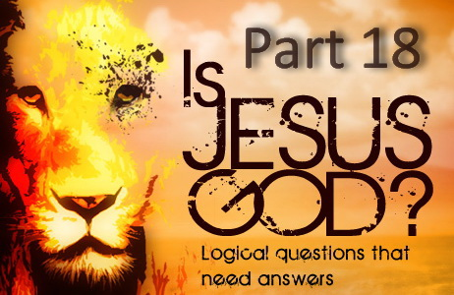

**IS JESUS GOD? – PART 18**

**Was Jesus Created if He is Not God?**

It is claimed that Arius who was a fourth century Alexandrian priest taught that prior to making anything else, God had a son who was begotten, or created or established. Some claim that back in the dawn of time, God the Father had some form of cosmic intimate relations with the Holy Spirit and Jesus was the product. They reason, “How else can you call Him the Son.” But these concepts are contrary to Scripture in which Jesus is revealed as the Creator and not a created being and has existed long before He created all things. (John 1:1-4)

The Bible states that Christ was not created but created all things. John 1:3 states, “*All things were made by him; and without him was not anything made that was made.*”

This verse has two direct statements being that Jesus pre-existed and created all things and that all things were made through Him, and without Him nothing was made that was made. Did you notice that John said that not only were all things made through Him but also that without Him nothing was made.

Paul also confirms what John wrote, “For by Him all things were created.” He continues with even greater clarity to make sure that we understand what he means by all things.

“*For by him were all things created, that are in heaven, and that are in earth, visible and invisible, whether they be thrones, or dominions, or principalities, or powers: all things were created by him, and for him:*” Colossians 1:16

If Jesus created all things then He could not have been one of the created things. Paul adds the following just so there can be no mistake about this fact.

“*And he is before all things, and by him all things consist.*” Colossians 1:17

If Christ created everything that was ever created, and existed before all created things, it is evident that Christ Himself is not among the created things. He is above all creation, not part of it. The idea that Christ is a created being denies His Divinity. No one who holds this view can possibly have any just conception of the exalted position which Christ truly occupies.

Note that the Spirit of Prophecy does not equate being born with being created as some imply.

“*God so loved the world, that he gave his only-begotten Son,”-- NOT A SON BY CREATION, as were the angels, nor a son by adoption, as is the forgiven sinner, BUT A SON BEGOTTEN IN THE EXPRESS IMAGE OF THE FATHER'S PERSON,*” — (E.G. White, *ST*, May 30, 1895)

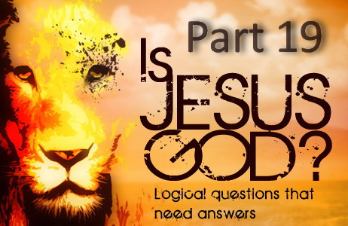

**IS JESUS GOD? – PART 19**

**How Can Jesus be God Considering the Following?**

If Jesus had “always” existed alongside the Father as the Trinity doctrine claims, then how could God have given life to His Son as He would have always had life. But Scripture reveals this is impossible. “*For as the Father has life in himself; so has he given to the Son to have life in himself.*” John 5:26

How could Jesus have died when Scripture says God cannot die (1 Timothy 6:15-16). The Bible does not say that only his “human nature” died, it says that Jesus died, which would include all of Him.

Jesus said “*All power is given unto me in heaven and in earth.*” Matthew 28:18. And John wrote “*The Father loves the Son, and has given all things into his hand.*” John 3:35. Note that “all authority” and “all power” is “given” to the Son! If the Son is God as the Father is God, and the Son is almighty as the Father is, then how can the Son be “given” anything if He is God? How can God be “given” that which He has always possessed? God does not depend on anyone or anything so that it has to be “given” to Him. But we do see that Jesus had to be “given” all things into His hand.

How can Jesus be “God” and have a “God” at the same time? “*I ascend to My Father and your Father, and My God and your God.*” John 20:17

God cannot be tempted by evil, yet Jesus was tempted in every way we are, so how can He be God? James 1:13 “*For God cannot be tempted by evil.*” And if Jesus is God and God cannot be tempted, why would Satan even try? We know Satan knows Scripture because he quoted it while trying to tempt Jesus. Satan is persistent, but he is not stupid. Why did Satan continue to ask Jesus “*if you are the Son of God…*” (Matthew 4:3, 6) when he was tempting him? Wouldn’t Satan know if he was speaking with the Almighty Himself? Satan knew that Jesus was a man, the Son of God, and that is why he did his best to try to get Him to sin. Satan knew that if he could get Jesus to sin one time, He could not be our perfect sacrifice that was necessary for the forgiveness of our sins.

If Jesus is God, then why does He pray to God and call Him “*THE ONLY TRUE GOD.*” John 17:3 “*Now this is eternal life: that they may know you, THE ONLY TRUE GOD, and JESUS CHRIST, whom you have sent.*” Jesus Christ makes a clear distinction between “*the only true God*” and Himself.

And if Jesus is God, why did He pray at all? Luke 6:12 “*One of those days Jesus went out to a mountainside to pray, and spent the night praying to God.*” He would have been praying to Himself. Was Jesus just acting when he was in the Garden of Gethsemane praying to God that there be another way, that “*if it is possible, that the cup be taken*” from Him? If Jesus is God, then all of his prayers “to God” make him look rather ludicrous.

Since the trinity doctrine claims Jesus is also the one God, an Adventist author from the 1800's wrote, “*To believe that doctrine, when reading the scripture we must believe that God sent Himself into the world, died to reconcile the world to Himself, raised Himself from the dead, ascended to Himself in heaven, pleads before Himself in heaven to reconcile the world to Himself, and is the only mediator between man and Himself… We must believe also that in the garden God prayed to Himself, if it were possible, to let the cup pass from Himself, and a thousand other such absurdities.*” — (J.N. Loughborough)

Some of those other absurdities it teaches is that Jesus is the immortal God but died, is the invisible God but was seen, is the omnipotent God but was strengthened by an angel, is the omniscient God but did not know the day of his return, is as great as His Father but His Father is greater than He, is equal with the Father and yet He is the Father, is the Son but the same age as the Father, is the Son who has a Father and the God who has no Father, is the begotten Son and the unbegotten God, is very God and very man, came out from Himself, prayed to Himself, gave power to Himself, thanked Himself, bore witness of Himself, went back to Himself, sits at the right hand of Himself, is His own Father and His own Son, left Heaven and yet was there all the time. There are many things which are hard to understand in the Bible, but you can be sure that God never expects us to believe impossibilities.

Over and over again you hear it said that the Gospel is so simple a child can understand it. And I agree. But how can that be the case with the teaching of the trinity? Not only do children not understand it, but our best theologians cannot even explain it. However, the thought that God sent His Son to this earth to die for you and me is easy to comprehend when we believe the simple Bible statement that Jesus is truly the Son of God! Not one of three mysterious beings making up “one God.” How can you possibly believe that Jesus is NOT the begotten Son of the eternal Father and then share John 3:16 with others in the hope of inviting them to take part in eternal salvation. Doesn't John 3:16 become a lie the moment you deny He is a Son? A metaphor did not send a metaphor to save us. A Father sent us His Son to save us.

John 3:16 “*For God so loved the world, that he gave his only begotten Son, that whosoever believeth in him should not perish, but have everlasting life.*”

2 John 1:3 “*Grace be with you, mercy, and peace, from God the Father, and from the Lord Jesus Christ, the Son of the Father, in truth and love.*”

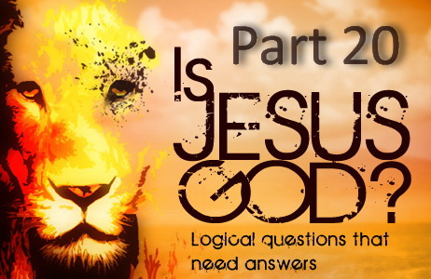

**IS JESUS GOD? – PART 20**

**Is Jesus God?**

The word God is used in two different ways in Scripture. Firstly, the word “God” is used to refer to the Supreme Being of the universe who is the ultimate source of all things. Every time the Bible refers to the one true God, it is referring to this supreme being who is the one that was before all else and from whom all life ultimately came. In this sense no one else is God. But the word God is also used to refer to someone who possesses the attributes of divinity, or the characteristics of God.

Many times the Bible teaches that Jesus Christ is the begotten Son of the one true God the Father, and being the Son, He possesses the same attributes and characteristics as His Father. It is an obvious fact that every son inherits the nature of his father. And since Christ came out of the Father, He is of the very substance of His Father and hence has the same God nature of His Father as He possesses by birth all the attributes and characteristics of His Father. In fact, Hebrews 1:3 says He is the “express image of His person.” A son also and always rightfully takes the name of the father and so Christ as the only begotten Son of God has rightfully the same name. Note that Hebrews 1:1-9 says that Jesus is an heir who has by inheritance obtained a more excellent name than the angels and that name is God! So Jesus inherited His Father's name, character and divine nature in the same way a human son inherits the human nature and name of his parents.

So Jesus is God because He is the Son of God. But He is not and cannot be “God the Father.” He is the “Son of God” just as the Bible so plainly states more than one hundred times. He is God's literal Son. To say that Jesus is God the Father is to say that the “Son is the Father” which means the Son is not really a Son and the Father is not really a Father. Or to put it another way, to say that Jesus is the Father because He has the same God nature as His Father is no different to saying that since my Father is Human and I am Human, therefore I must be my father! This is not good logic or theology and suddenly hundreds of Scriptures supposedly would no longer mean what they say at all. The truth is that Scripture means what it says and says what it means. God is the Father of Christ; Christ is the Son of God. The Bible never calls Jesus “God the Son” as Trinitarians do and with very good reason. It is always the “Son of God” because that is who He is.

Satan's plan is for us to deny the Father and Son as this is what John called antichrist. 1 John 2:22-23. He does not care if our belief is Trinitarian, Unitarian or other. As long as it denies Jesus is the literal Son of God which also denies God is a Father. Confessing Jesus is the Son of God is our only means to the Father and to deny this has eternal consequences.

In conclusion, Jesus is not “a” God or “the” God but God only by nature through inheritance being the Son. Jesus is a divine being but He is not the supreme being. The Father is the supreme being and the source of all things and the life of the Father flows through the Son and out to all. Jesus is the channel through which all things come and why the Father has given all things into His hands. Only the Father is described as the one “of whom are all things.” He is the great Source of all. Jesus is not another source “of whom are all things.” That would make Him another God. Rather Jesus is described as the one “by whom are all things.” The Father has given Christ authority to rule over all things but this does not include the Father Himself. The Father is greater in authority and always will be. God the Father is the source of all things including His Son. Thus all things proceed from the Father; including Christ Himself, but it has pleased the Father that in Him should all fullness dwell (Colossians 1:19). So when we say “Jesus is God,” we have to be careful to state exactly what we mean. Christ is a divine being, but not the supreme being. When we speak of the Supreme Being there is only one such person and it is not Jesus.

So there is but “one” God. Jesus is “not” God, He is the Son of God. He carries the “name” of God by virtue of His “inheritance.” And because He is the Son of God, He is “equal” with God.

“*But to us there is but one God, the Father, OF WHOM ARE ALL THINGS, and we in him; and one Lord Jesus Christ, BY WHOM ARE ALL THINGS, and we by him.*” 1 Corinthians 8:6

“*One God and Father of all, who is above all, and through all, and in you all.*” Ephesians 4:6

“*GOD IS THE FATHER OF CHRIST; CHRIST IS THE SON OF GOD. To Christ has been given an exalted position. HE HAS BEEN MADE EQUAL WITH THE FATHER.*” — (E.G. White, 8T 268.3)

“*HE [CHRIST] WAS NOT THE FATHER but in him dwelt all the fullness of the Godhead bodily,*” — (E.G. White, *Lt8a*, July 7, 1890)

“*The man Christ Jesus was not the Lord God Almighty,*” — (E.G. White, *Ms140*, Sept, 1903)

“*Only one being in the universe besides the Father bears the name of God, and that is His Son, Jesus Christ.*” — (J.E. White, *Coming King*, p. 33)

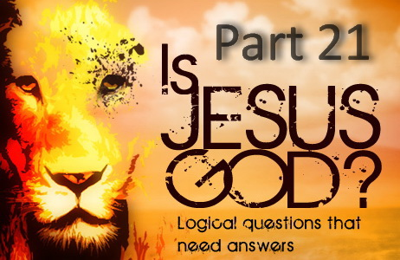

**IS JESUS GOD? – PART 21**

**Does Romans 9:5 say Jesus is God?**

The answer is No! It is just one of those verses that was difficult to translate and why we find such a huge variation in all the different translations.

The Seventh-day Adventist Bible Commentary explains:

“*Who is. The interpretation of the last half of v. 5 has been debated at great length. The discussions reached a climax after the appearance of the NT of the RV in 1881. Considerable space was devoted to the question in the religious journals of the day. The problem is one of punctuation, and since the original Greek manuscripts were written without any form of punctuation, the solution becomes a matter of interpretation (cf. on Luke 23:43).*

*With various changes of punctuation, four possible interpretations of this passage have been advanced (see RV text and margin). One is to place either no punctuation, or a comma, after “flesh” and refer the whole passage to Christ as an assertion of His divinity. This has been the traditional view and is the interpretation offered by the KJV and most other versions. A second possibility is to place a comma after “flesh” and a period after “all.” The passage would then read, “Of whom is Christ as concerning the flesh, who is over all. God be [is] blessed for ever.”*

*A third possibility is to place a period after “flesh” and translate the rest of the verse, “He who is God over all be blessed for ever,” or “God who is over all be blessed for ever.” This is the reading preferred by the RSV and a few other versions. A fourth possibility is to use the same punctuation as in the third solution and to translate, “He who is over all is God blessed for ever.” For a more detailed discussion of the problem see Sanday and Headlam, The International Critical Commentary, on Romans, pp. 233–238. ... For a further discussion of this text see The Ministry, Sept., 1954, pp. 19–21; Problems in Bible Translation, pp. 218–222.*”

Here are some other examples of how Romans 9:5 has been translated.

(RSV) “*to them belong the patriarchs, and of their race, according to the flesh, is the Christ. God who is over all be blessed for ever. Amen.*”

(GNB) “*they are descended from the famous Hebrew ancestors; and Christ, as a human being, belongs to their race. May God, who rules over all, be praised forever! Amen.*”

(NLV) “*The early preachers came from this family. Christ Himself was born of flesh from this family and He is over all things. May God be honored and thanked forever. Let it be so.*”

(UPDV) “*whose are the fathers, and of whom is Christ as concerning the flesh. May God, who is over all, be blessed forever. Amen.*”

(CEV) “*They have those famous ancestors, who were also the ancestors of Jesus Christ. I pray that God, who rules over all, will be praised forever! Amen.*”

The most common translation says that Jesus is blessed by God forever.”

(AKJV) “*Whose are the fathers, and of whom as concerning the flesh Christ came, who is over all, God blessed for ever. Amen.*”

(ASV) “*whose are the fathers, and of whom is Christ as concerning the flesh, who is over all, God blessed for ever. Amen.*”

(Darby) “*whose are the fathers; and of whom, as according to flesh, is the Christ, who is over all, God blessed for ever. Amen.*”

(DRB) “*Whose are the fathers and of whom is Christ, according to the flesh, who is over all things, God blessed for ever. Amen.*”

(KJV) “*Whose are the fathers, and of whom as concerning the flesh Christ came, who is over all, God blessed for ever. Amen.*”

(LONT) “*whose are the fathers; and from whom the Messiah descended, according to the flesh; who is over all, God blessed forever. Amen.*”

(MRC) “*whose are the fathers, and from whom is the Messiah according to the flesh, Who is over all, God blessed forever. Amein.*”

(NASB) “*whose are the fathers, and from whom is the Christ according to the flesh, who is over all, God blessed forever. Amen.*”

(NRSV) “*to them belong the patriarchs, and from them, according to the flesh, comes the Messiah, who is over all, God blessed forever. Amen.*”

(RV) “*whose are the fathers, and of whom is Christ as concerning the flesh, who is over all, God blessed for ever. Amen.*”

(TMB) “*of whom are the fathers, and from whom, according to the flesh, Christ came, who is over all, God blessed for ever. Amen.*”

(UKJV) “*Whose are the fathers, and of whom as concerning the flesh Christ came, who is over all, God blessed for ever. Amen.*”

(Webster) “*Whose are the fathers, and from whom according to the flesh, Christ came, who is over all, God blessed for ever. Amen.*”

(WNT) “*To them the Patriarchs belong, and from them in respect of His human lineage came the Christ, who is exalted above all, God blessed throughout the Ages. Amen.*”

(YLT) “*whose are the fathers, and of whom is the Christ, according to the flesh, who is over all, God blessed to the ages. Amen.*”

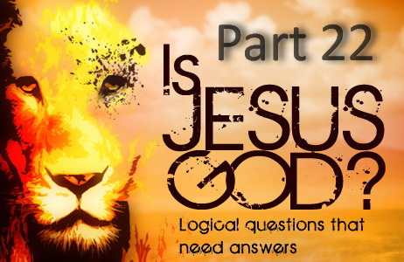

**IS JESUS GOD? – PART 22**

**Does Titus 2:13 say Jesus is God?**

Titus 2:13 KJV “*Looking for that blessed hope, and the glorious appearing of the great God and our Saviour Jesus Christ;*”

Sadly, it seems that the deceived read this verse with Trinitarian glasses and fail to see that this verse refers to BOTH God the Father and His Son. It says, “God ‘AND’ our Saviour!”

Titus 2:13 DOES NOT say, “*the glorious appearing of the great God Jesus Christ*” as Trinitarians seem to somehow imagine.

Titus 2:13 says, “*the glorious appearing of the great God “AND” our Saviour Jesus Christ.*”

Hence this verse does NOT say Jesus is God.

Adam Clarke's Commentary on the Bible, LL.D., F.S.A., (1715-1832)

“*Titus 2:13 - The glorious appearing - Και επιφανειαν της δοξης του μεγαλου Θεου και σωτηρος ἡμων Ιησου Χριστου. This clause, literally translated, is as follows: And the appearing of the glory of the great God, even our Savior Jesus Christ.*”

And so we also find the KJV is translated poorly on this verse, and the phrase “glorious appearing of the great God” should be “appearing of the glory of the great God.”

Also, note that no one has seen God at any time! His glory we can see, but not God Himself. “*NO MAN HAS SEEN GOD AT ANY TIME. If we love one another, God dwelleth in us, and his love is perfected in us.*” 1 John 4:12

Note the ASV and LONT for two clear examples of an accurate and literal translation.

Titus 2:13 ASV “*looking for the blessed hope and appearing of the glory of the great God and our Saviour Jesus Christ;*”

Titus 2:13 LONT “*expecting the blessed hope; namely, the appearing of the glory of the great God, and of our Saviour Jesus Christ;*”

Compare these two accurate translations above with Matthew 16:27 below.

Matthew 16:27 “*For the SON OF MAN [JESUS] SHALL COME in the GLORY OF HIS FATHER with his angels; and then he shall reward every man according to his works.*”

So what is the “appearing” spoken of in Titus 2:13?

It is Jesus Christ at His second coming who comes in the GLORY of His Father. Or to put it another way, it is the appearing of Jesus who appears in the glory of our great God.

Many translations accurately translated to “the appearing of the glory of our great God.”

(CENT) “*the appearing of the glory of our great God*”

(ESV) “*the appearing of the glory of our great God*”

(RSV) “*the appearing of the glory of our great God*”

(RV) “*and appearing of the glory of our great God*”

(Darby) “*and appearing of the glory of our great God*”

(HNV) “*and appearing of the glory of our great God*”

(ACV) “*and appearance of the glory of our great God*”

(ALT) “*and appearance of the glory of our great God*”

(LITV) “*and appearance of the glory of our great God*”

(MKJV) “*and the appearance of the glory of our great God*”

(NIV) “*the appearing of the glory of our great God*”

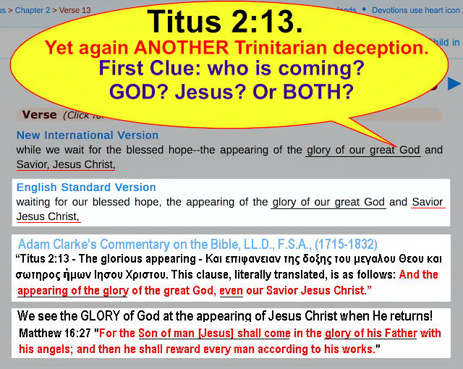

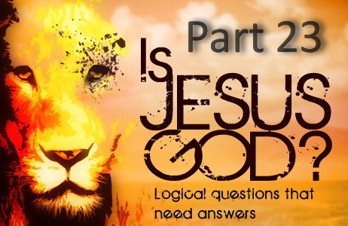

**IS JESUS GOD? – PART 23**

**Does 1 Timothy 3:16 say Jesus is God?**

Some claim 1 Timothy 3:16 identifies Jesus as “God” because the KJV translation says “*God was manifested in the flesh.*” However, modern Bible translations do not read “God” in this verse. Trinitarians make this claim by quoting from the KJV, despite the fact that Bible scholars agree this is a certain corruption. Yet some continue to cherry-pick this verse.

Below is the SDA Bible Commentary based on the incorrect KJV translation of the word “God.” The correct translation is “*he or who,*” not “*God.*” And that “*he*” is Jesus Christ.

“*God: Textual evidence favors the reading “he who.” The reference is clearly to Jesus, in and through whom the divine secret has been revealed.*” — (Seventh-day Adventist Bible Commentary)

Here is this verse from the KJV.

1 Timothy 3:16 KJV “*And without controversy great is the mystery of godliness: God was manifest in the flesh, justified in the Spirit, seen of angels, preached unto the Gentiles, believed on in the world, received up into glory.*”

And here it is from the NIV.

1 Timothy 3:16 NIV “*Beyond all question, the mystery of godliness is great: He appeared in a body, was vindicated by the Spirit, was seen by angels, was preached among the nations, was believed on in the world, was taken up in glory.*”

If the word “God” was correct, observe how the rest of the verse would read, which is clearly incorrect.

1 Timothy 3:16 KJV “*And without controversy great is the mystery of godliness: God was manifest in the flesh, [God was] justified in the Spirit, [God was] seen of angels, [God was] preached unto the Gentiles, [God was] believed on in the world, [God was] received up into glory.*”

Was God received up into glory? No! Jesus Christ was received up into glory. Trinitarians are going to have a hard time making all that fit. Now if the correct translation of “He” is used referring to Christ, we have no problem as we see below.

1 Timothy 3:16 “*And without controversy great is the mystery of godliness: [He] was manifest in the flesh, [He was] justified in the Spirit, [He was] seen of angels, [He was] preached unto the Gentiles, [He was] believed on in the world, [He was] received up into glory.*”

Note the “New International Reader's Version” for example.

1 Timothy 3:16 NIRV “*There is no doubt that godliness is a great mystery. Jesus appeared in a body. The Holy Spirit proved that he was the Son of God. He was seen by angels. He was preached among the nations. People in the world believed in him. He was taken up to heaven in glory.*”

There are many theologians who actually have a good idea how this corruption happened. Scribal copyists regularly used a contracted form of the Greek word for “God” called a “*nomina sacra*” that was used very early in Christian history for sacred names. The Greek word for “God” is theos which is written as “*Θεος.*” The abbreviation took the form “Θς” with a faint overscore stroke above the abbreviation, which often become quite faint in the copies.

Now the Greek word for “who” is the word “*hos*” which is written in Greek as “*Oς.*” Notice the similarity between these two words “*Θς*” and “*Oς*” and also remember they were hand written. With the exception of one pen stroke, the Omicron “*O*” and Theta “*Θ*” are nearly identical. So it would be very easy to make a mistake copying from one manuscript to another, which would be excusable if this is what happened.

But it would also be easy for an overzealous scribe to execute a forgery by changing the manuscript and the handwritten “*O*” (Omicron) into a “*Θ*” (Theta) with a single stroke of his pen which would completely change the meaning of the verse.

Albert Barnes' Notes on the Bible, (1798-1870) says:

“*To ascertain which of these is the true reading, has been the great question; and it is with reference to this that the microscope has been resorted to in the examination of the Alexandrian manuscript. It is now generally admitted that the faint line “over” the word has been added by some later hand,*”

So it has also been admitted by many that this could be a deliberate corruption to push the Trinity doctrine.

So below are the known facts:

**1)** Trinitarians are focused on a version of the text which is known to be a scribal error or a deliberate corruption.

**2)** Modern Trinitarian translations and their translators admit this is an error and do not translate this passage with the known error that seemed to support Trinity doctrine.

**3)** We know this error occurred by an additional stroke of a pen changing the Greek word from “who” to “God,” which was either accidental or a deliberate corruption.

**4)** The KJV version of this verse is NOT found anywhere in early Christian writings before the Trinity doctrine was created.

**5)** No early manuscripts contain this version of the verse. The corrupted version of this text appears only after the Trinity doctrine was developed in the fourth and fifth century.

**6)** The Greek grammar also indicates this rendering is wrong.

Besides the NIV and NIRV already given, below are a few more translations (there are many more) where the translators new it was error and have the correct reading of the manuscript. Most say “He” and some even say “Jesus” and “Christ” outright.

1Timothy 3:16

(ASV) “*And without controversy great is the mystery of godliness; He who was manifested in the flesh, Justified in the spirit, Seen of angels, Preached among the nations, Believed on in the world, Received up in glory.*”

(CEV) “*Here is the great mystery of our religion: Christ came as a human. The Spirit proved that he pleased God, and he was seen by angels. Christ was preached to the nations. People in this world put their faith in him, and he was taken up to glory.*”

(NASB) “*By common confession, great is the mystery of godliness: He who was revealed in the flesh, Was vindicated in the Spirit, Seen by angels, Proclaimed among the nations, Believed on in the world, Taken up in glory.*”

(NLT) “*Without question, this is the great mystery of our faith: Christ appeared in the flesh and was shown to be righteous by the Spirit. He was seen by angels and was announced to the nations. He was believed on in the world and was taken up into heaven.*”

(NLV) “*It is important to know the secret of Godlike living, which is: Christ came to earth as a Man. He was pure in His Spirit. He was seen by angels. The nations heard about Him. Men everywhere put their trust in Him. He was taken up into heaven.*”

(NRSV) “*Without any doubt, the mystery of our religion is great: He was revealed in flesh, vindicated in spirit, seen by angels, proclaimed among Gentiles, believed in throughout the world, taken up in glory.*”

(RSV) “*Great indeed, we confess, is the mystery of our religion: He was manifested in the flesh, vindicated in the Spirit, seen by angels, preached among the nations, believed on in the world, taken up in glory.*”

(WNT) “*And, beyond controversy, great is the mystery of our religion-- that Christ appeared in human form, and His claims justified by the Spirit, was seen by angels and proclaimed among Gentile nations, was believed on in the world, and received up again into glory.*”

Some Trinitarians will stop at nothing to try and prove this soul stealing lie from Satan that was brought into Christendom by the Roman Catholic Church long after the Bible was written. 1 Timothy 3:16 is a perfect example of just how far they will go.

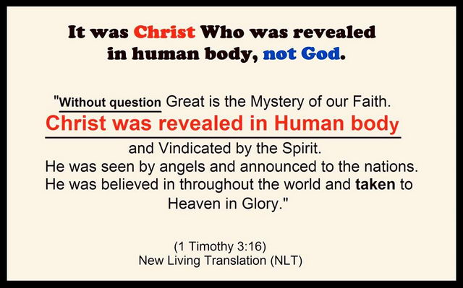

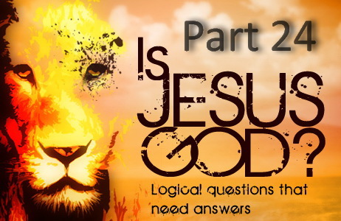

**IS JESUS GOD? – PART 24**

**Does 1 John 5:20 say Jesus is the one TRUE God?**

The answer is a definite NO! And easily seen unless wearing those Trinitarian blinders. Trinitarians often quote this verse as it can be misread. You will notice that the word “TRUE” all through this verse is referring to the one “TRUE” God, not Jesus.

If you read this verse carefully, you will note it is saying that “*the TRUE God*” is the one “*that is TRUE*” that has a “*Son Jesus Christ*” whom He sent to “*give us an understanding*” of this. I will use CAPS for clarity.

1 John 5:20 KJV “*And we know that the Son of God is come, and has given us an understanding, that we may know Him that is TRUE, and we are in Him that is TRUE, even in His Son Jesus Christ. This is the TRUE God, and eternal life.*”

How do we know that the one being called “TRUE” is the Father? Because His Son is Jesus Christ!

“*and we are in Him that is TRUE, even in His Son Jesus Christ*”

Thus who is it referring to in the final phrase of this verse when it says, “this is the TRUE God”? Many misread it to be Jesus as it follows a mention of the Son of the one who is “TRUE.” But no, it is referring to the Father as the one who is “TRUE.”

So what is this verse actually saying? It says that Jesus came to show us the one who is “TRUE” who is the Father and the one “TRUE” God. Let's break this verse down to see this even more clearly:

1 John 5:20 KJV “*And we know that the Son of God is come, and has given us an understanding*”

Who has come and why? The Son of God has come, and to give us understanding. An understanding of what?

“*that we may know Him that is TRUE, and we are in Him that is TRUE,*”

And who is the one that is “TRUE”? It is the “HIM” that has a Son called Jesus Christ. “*This is the TRUE God*” the Father!

“*even in His Son Jesus Christ.*”

The entire verse refers to the Father and is revealing that Jesus came to reveal the Father.

And so finally, the one that is “TRUE”, and the one that we are in, that this entire verse is describing, finishes by saying who this one that is “TRUE” is. So who is the one that is “TRUE” that has a Son called Jesus Christ that came to reveal Him? The final part of the verse now tells us!

“*This is the TRUE God, and eternal life.*”

Who do we need to know to have eternal life? The one “TRUE” God and His Son that was sent by the Father to reveal Him!

“*And this is life eternal, that they might know you the only TRUE God, AND Jesus Christ, whom you have sent.*” John 17:3

The (CEV) Contemporary English version leaves no room for error as it translates it very clearly so there can be no mistake!

1 John 5:20 CEV “*We know that Jesus Christ the Son of God has come and has shown us the true God. And because of Jesus, we now belong to the true God who gives eternal life.*”

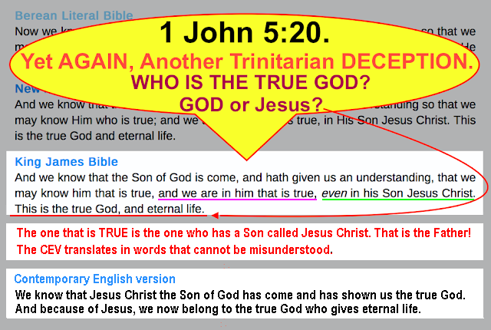

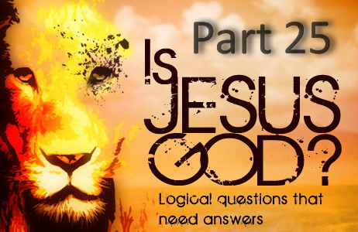

**IS JESUS GOD? – PART 25**

**Does Isaiah 43:11, Hosea 13:4 or Isaiah 44:6 Prove Jesus is God?**

Since the first two verses say that there is no saviour but God, and verses such as 1 John 4:14 say that Jesus is our Saviour, then the argument is that Jesus must be the one true God. But this is eisegesis and demonstrates a poor understanding of Scripture.

To begin with, God is the author of our salvation as it was God who sent His Son to die for us. Thus God is our Saviour in this respect also, and why Paul below says God is our Saviour AND Jesus is our Hope. Note Paul refers to the Father and Son separately here.

1 Timothy 1:1 “*Paul, an apostle of Jesus Christ by the commandment of God our Saviour, AND Lord Jesus Christ, which is our hope;*”

**Albert Barnes' Notes on the Bible** states:

“*1 Timothy 1:1 - Our Saviour - The name Saviour is as applicable to God the Father as to the Lord Jesus Christ, since God is the great Author of salvation;*”

Regardless of this fact, the two following verses are not referring to saving us from sin, but God saving His people from bondage and captivity.

Isaiah 43:11 “*I, even I, am the LORD, and apart from me there is no saviour.*”

Hosea 13:4 “*But I am the LORD your God, who brought you out of Egypt. You shall acknowledge no God but me, no Saviour except me.*”

The Hebrew word translated “saviour” in these verses is most commonly translated as “save,” “saved” and is also translated as “deliverer” and “delivered.” In Moses' day God saved His people from the power of Egypt, and in Isaiah's day He saved them from the power of Assyria. There was no one else who could save and deliverer them from these powers and so they had no other saviour but God as the context reveals.

Note the **Brown-Driver-Briggs’ Hebrew Definition** for the word translated as “saviour” in both of these verses for further clarity.

**H3467 BDB Definition:**

1) to save, be saved, be delivered

1a) (Niphal)

1a1) to be liberated, be saved, be delivered

1a2) to be saved (in battle), be victorious

1b) (Hiphil)

1b1) to save, deliver

1b2) to save from moral troubles

1b3) to give victory to

**Albert Barnes' Notes on the Bible** explains Isaiah 43, “*This chapter ... refers mainly to the promised deliverance from Babylon. The people of God are still contemplated by the prophet as suffering the evils of their long and painful captivity, and his object is to comfort them with the assurances of deliverance.”*

*Isaiah 43:11 - And beside me there is no Saviour - There is no one who can deliver from oppression, and captivity, and exile, such as the Jews suffered in Babylon;*”

And of course Hosea 13:4 refers to when God “saved” and “delivered” His people from the Egyptians. It says, “*I am the LORD your God, who brought you out of Egypt.*” The verse ends with, “*You shall acknowledge no God but me, no Saviour except me.*” So what is the author saying God saved or delivered them from? Is the word “saviour” applying to saving from sin as Christ did for us? Or God saving and delivering His people from Egyptian bondage?

Thus the context of God being the saviour of His people in these verses is about saving them from captivity from Babylon and Egypt. Not saving them from their sin as Christ has done for us.

The same applies to the following verse where some assume it is referring to Christ as our redeemer. But as already seen, God is also a redeemer.

Isaiah 44:6 “*Thus saith the LORD the King of Israel, and his redeemer the LORD of hosts; I am the first, and I am the last; and beside me there is no God.*”

Note that Isaiah is addressing idolatry here and states that God is the first and only God, and hence He is also the last and only God, and thus there is no other God than He! Not three gods as the Trinity and Tritheism claim.

**Nichol, F. D. (1978). The Seventh-day Adventist Bible Commentary says:**

“*The King of Israel. Here are set forth some of the most striking attributes of God: He is (1) the Lord, (2) Israel's King, (3) Israel's Redeemer, (4) Commander of the heavenly hosts, (5) the Eternal, the “first” and the “last,” and (6) the only true God. In vs. 9–20 Isaiah sets God forth in contrast with idols.*”

**And Albert Barnes' Notes on the Bible** says:

“*Thus saith the Lord - This commences, as I suppose, the argument to prove that Yahweh is the only true God, and that the idols were vanity. The object is, to show to the Jews, that he who had made to them such promises of protection and deliverance was able to perform what he had pledged himself to do.*”

The book of Revelation says Jesus is the “*Alpha and Omega,*” which is the “*beginning and the end,*” and the “*first and last*” letters of the Greek alphabet, but there is no relationship to the words “first” and “last” as used by Isaiah.

**Adam Clarke's Commentary on the Bible** says on the Alpha and Omega:

“*This mode of speech is borrowed from the Jews, who express the whole compass of things by א aleph and ת tau, the first and last letters of the Hebrew alphabet; but as St. John was writing in Greek, he accommodates the whole to the Greek alphabet, of which Α alpha and Ω omega are the first and last letters. With the rabbins מאועדת meeleph vead tau, “from aleph to tau,” expressed the whole of a matter, from the beginning to the end.*”

But Isaiah never speaks of the “*Alpha and Omega*” at all. In Isaiah, the sense is that God existed before all things and will exist forever, and so He is the “first” and He is “last” and only God, and that there is no other God. Isaiah is dealing with idolatry in this passage. The same applies to Isaiah 41:4 and 48:12. Many make the mistake of trying to relate these passages in Isaiah and Revelation, but they are referring to two different things and beings.

In Revelation, John called Jesus the “*Alpha and Omega,*” which is the “*first and last*” letters of the Greek alphabet. But Isaiah said God is the first, and God is the last, meaning that there is no other God than He. Isaiah clarified that here, “*I am the first, and I am the last; and beside me there is no God.*” Isaiah 44:6

Also, Revelation just says “*first and last,*” as in the first and last letters of the Greek alphabet. Isaiah however says “*I am the first, and I am the last;*” meaning I am first and only God, and I am the last and only God, and hence there is NO other God! Do you see the difference and what is being said?

Thus these verses in Isaiah deal with God only and are not referring to Christ or implying Christ is God as some Trinitarians try to claim in their abuse of these passages.