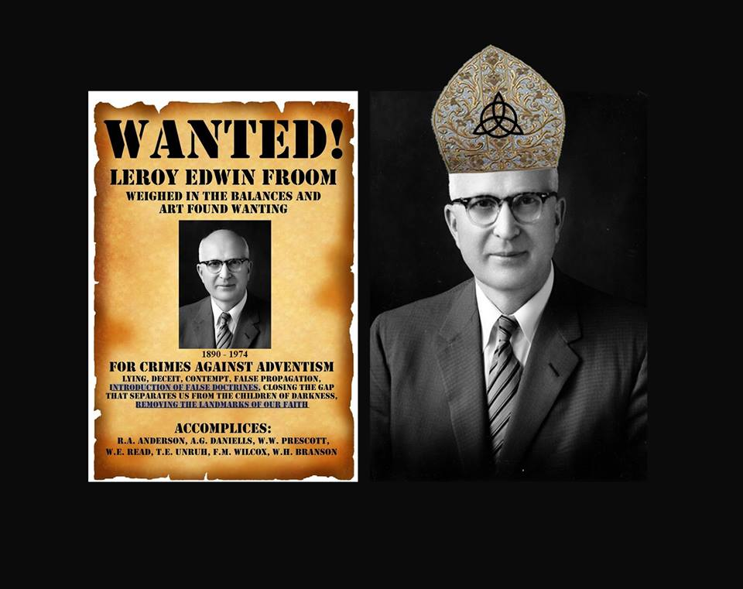

Please note: This page is designed so that individual parts can be copied and pasted into Facebook as posts, or responses to others. So you will find some duplicated passages in individual parts for this reason. CAPS have also been used in places since FB does not support any form of highlighting. Please feel free to copy and paste individual parts for sharing anywhere you choose or share the entire page. Thank you.

To download images or this document as a PDF.

See http://www.trinitytruth.org/exposingleroyfroomsbookevangelism.html

Index of Parts

1) Evangelism p. 615.1 – Heavenly Trio
2) Evangelism p. 615.2 – Pre-existent, Self-existent
3) Evangelism p. 615.3 – Equal, Eternal and Self-existent
4) Evangelism p. 616.1 – Not measured in figures
5) Evangelism p. 616.2 – Life, original, unborrowed, underived
6) Evangelism p. 616.4 – Eternal heavenly dignitaries
7) Evangelism p. 616.5 – Holy Spirit as much a person as God is a person
8) Evangelism p. 616.6 – Holy Spirit is a person
9) Evangelism p. 617.1 – Holy Spirit has a personality
10) Evangelism p. 617.2 – Third person
11) Evangelism p. 617.3 – Three great powers
12) Evangelism p. 615.1, 616.4, 616,6 617.1, 617.2, 617.3 – Holy Spirit

Introduction

It is claimed that Ellen White became a Trinitarian before completing the Desire of Ages which she finished in 1895. This claim is based on a handful of quotes that LeRoy Froom with deliberate intent set out to search for that he rightly figured would be misunderstood. Today many mistakenly believe these quotes say the Holy Spirit is a third being when in fact she actually taught the Holy Spirit is the Spirit of God coming to us through His Son.

It is notable that Froom and those who helped him had to search over 100,000 pages of her writings (25,000,000 words) just to find the handful of statements from her that on the surface appeared to fit the Trinitarian concept on the Holy Spirit. But only if you choose to read them as such, and at the expense of the thousands of non-Trinitarian statements she wrote. This would be a deceitful way to treat her writings if that was done, and certainly would be a dishonest way to determine what she believed. This should never be done with Scripture and neither should it be done with Ellen White.

It is alleged that Froom was a Catholic Priest before he entered the Adventist Church and some suspect him of being a Jesuit. He did and said things that an Adventist would never do. It is a known fact that Froom ordered plates for a new book that B.G. Wilkinson was writing on the Catholic Church to be destroyed. No true SDA would do such a thing.

On the 14 December 1955, Leroy Froom in a letter to Reuben Figuhr wrote, “I was publicly denounced in the chapel at the Washington Missionary College by Dr. B. G. Wilkinson as the most dangerous man in this denomination.” This took place in the mid 1940's. I believe Dr. B.G. Wilkinson had very good reason for saying this, much to the disgruntlement of Froom.

Froom put these quotes that he found in his book Evangelism. Most think that these quotes called “EV” or “Evangelism” are from a book written by Ellen White. But it was written by Froom in 1946 which was 30 years after the death of Ellen White. With the intent to deceive, Froom placed quotes from Ellen White in his book where she had said “third person”, “three great powers” and “Heavenly trio.” But the “third person”, “third great power” and the third entity in the “Heavenly trio” all refer to the Spirit of Christ and not another being. This is how Froom managed to lead the entire Adventist Church astray because people did not take the time to look at what else Ellen White wrote. She in fact wrote non-Trinitarian statements right through to her death which is very easy to confirm if people would only take the time to look.

In looking at what else she wrote we find the answer remains the same every time.
She said the Comforter is the Spirit of Christ,
the Spirit of truth is the Spirit of Christ,
the third person is the Spirit of Christ,
the third great power is the Spirit of Christ,
the Holy Spirit given at Pentecost was the Spirit of Christ,
the Holy Spirit Jesus breathed on His disciples was His own Spirit,
the Holy Spirit Christ sent to represent Himself was His own Spirit,
the Heavenly trio is the Father, Son and Spirit of Christ,
and she reveals over and over again that there are only two beings.

All you have to do is want the truth and to stop reading the quotes from LeRoy Froom with the mindset of a Trinitarian. The early pioneers had no problem with these few quotes that Froom searched for because they knew who the Holy Spirit is and would never read them the wrong way. But if your belief is that the Holy Spirit is another being, then that is what you will see when you read them.

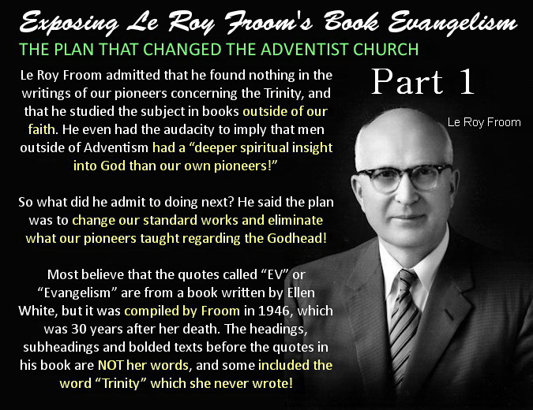

EXPOSING LEROY FROOM'S BOOK EVANGELISM – PART 1

Evangelism p. 615.1 - Heavenly Trio

“There are three living persons of the heavenly trio; in the name of these three great powers - the Father, the Son, and the Holy Spirit - those who receive Christ by living faith are baptised.” — (Special Testimonies, Series B, No. 7, pp. 62, 63, 1905) — Evangelism p. 615.1

The Trinitarian mindset assumes that a heavenly trio must be three beings. But says who? A Trinity is ALWAYS three beings, but a trio is NOT. So we need to let SOP explain SOP rather than assume.

Ellen White taught that the Father and Son are one in Spirit and that the SPIRIT OF GOD comes to us through His only begotten Son. Thus she called the HOLY SPIRIT the SPIRIT OF CHRIST.

“The HOLY SPIRIT is the SPIRIT of CHRIST, which is sent to all men to give them sufficiency,” — (E.G. White, 14MR 84.3)

“We want the HOLY SPIRIT, which is JESUS CHRIST.” — (E. G. White, Lt66, April 10, 1894)

“but it is the leaven of the SPIRIT of JESUS CHRIST, which is sent down from heaven, called the HOLY GHOST,” — (E.G. White, Ms36-1891)

Since Ellen White says the HOLY SPIRIT is the SPIRIT OF CHRIST, then she has to be saying the “Heavenly Trio” is the FATHER, SON and the SPIRIT OF CHRIST or she would be contradicting herself.

Hence she did in fact write those exact words proving beyond any doubt this is who she called the Trio. So letting SOP explain SOP, here is the “heavenly trio” according to Ellen White.

“They have ONE God and ONE Saviour; and ONE Spirit--the Spirit of Christ--is to bring unity into their ranks.” — (E.G. White, 9T 189.3, 1909)

The third in the Trio = ONE + ONE + ONE = “the Spirit of Christ.”

Many fail to realize that the “Spirit of Christ” can function like a person separate to Himself so it is like it is “another” person, though not a literal person of course. So we do have a heavenly trio, but not a heavenly Trinity.

Thus the “Holy Spirit” is the power and presence of God and of Christ which can function independently of themselves like a third (but not a literal third) and is how “They” represent “Themselves” where they are not personally present.

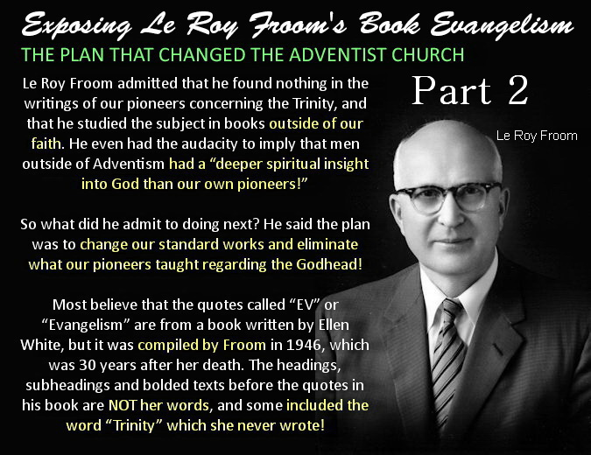

EXPOSING LEROY FROOM'S BOOK EVANGELISM – PART 2

Evangelism p. 615.2 - Pre-existent, self-existent

“Christ is the pre-existent, self-existent Son of God.... In speaking of his pre-existence, Christ carries the mind back through dateless ages. He assures us that there never was a time when He was not in close fellowship with the eternal God. He to whose voice the Jews were then listening had been with God as one brought up with Him.” — (Signs of the Times, August 29, 1900) — Evangelism p. 615.2)

PRE-EXISTENCE: Refers to the existence of Christ as the Son of God before His incarnation and the creation of all things. It does not mean to have always existed and implies a beginning. The Trinitarian view actually denies the pre-existence of Christ in the full sense, as it denies the personality of Christ as the literal Son of God before His birth in Bethlehem. Ellen White confirms this below where she refers to all the fallen Churches which are Trinitarian, as they all deny the pre-existence of Christ as the literal Son of God before His incarnation.

“The fallen denominational churches are Babylon. Babylon has been fostering poisonous doctrines, the wine of error. This wine of error is made up of false doctrines, such as the natural immortality of the soul, the eternal torment of the wicked, THE DENIAL OF THE PRE-EXISTENCE OF CHRIST PRIOR TO HIS BIRTH IN BETHLEHEM, and advocating and exalting the first day of the week above God's holy, sanctified day.” — (E.G. White, RH, Sept 12, 1893)

SELF-EXISTENT SON OF GOD: Self-existent means existing independently of other beings. This applies to the Father and the Son who are not reliant on other beings to exist. Since the Father gave His life to His Son, He has the same self-existent life as His Father. “For as the Father has life in Himself; so has He given to the Son to have life in Himself;” John 5:26. If Jesus had always existed alongside the Father as the Trinity doctrine claims, then God could not have given life to His Son as He would have always had life. But Scripture reveals this is impossible.

DATELESS AGES: Time as we know it is measured by the spheres in the heavens. For example: A year for the earth to revolve around the sun, a month for the moon to revolve around the earth and a day for one rotation of the earth. And it is from this that our “date” is derived. Hence the time before the creation of all things is called the “dateless ages” as there was nothing in the heavens to measure time by.

THERE NEVER WAS A TIME WHEN CHRIST WAS NOT IN CLOSE FELLOWSHIP WITH HIS FATHER: There never was a time when I was not in close fellowship with my father either. But there was a time when my father was not in close fellowship with me, which was before I was born. The same applies to the Father and Son obviously.

HAD BEEN WITH GOD AS ONE BROUGHT UP WITH HIM: Ellen White is quoting Proverbs 8:22-30 where she says that Jesus was brought forth from His Father and was brought up with Him, thus declaring Jesus is the literal Son of God.

“The Lord possessed Me in the beginning of His way, before His works of old. I was set up from everlasting.... When He appointed the foundations of the earth: then I was by Him, AS ONE BROUGHT UP WITH HIM: and I was daily His delight, rejoicing always before Him.” Proverbs 8:22-30.” — (E.G. White, PP, 34.1)

“Through Solomon CHRIST DECLARED: “The Lord possessed Me in the beginning of His way, before His works of old. I was set up from everlasting, from the beginning, or ever the earth was. WHEN THERE WERE NO DEPTHS, I WAS BROUGHT FORTH; when there were no fountains abounding with water. Before the mountains were settled, BEFORE THE HILLS WAS I BROUGHT FORTH.” — (E.G. White, ST, Aug 29, 1900)

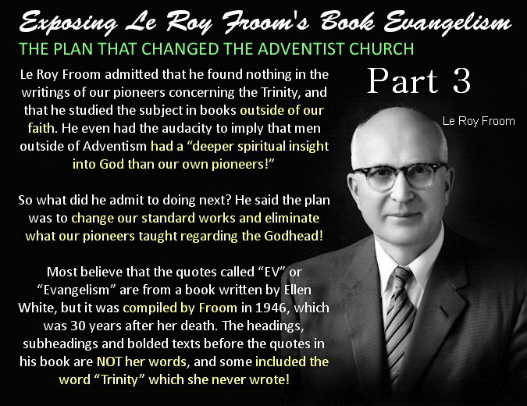

EXPOSING LEROY FROOM'S BOOK EVANGELISM – PART 3

Evangelism p. 615.3 – Equal, eternal, self-existent

“He was equal with God, infinite and omnipotent.... He is the eternal, self-existent Son.” — (12MR 395.3) — Evangelism p. 615.3)

HE WAS EQUAL WITH GOD: “God is the Father of Christ; Christ is the Son of God. To CHRIST HAS BEEN GIVEN AN EXALTED POSITION. HE HAS BEEN MADE EQUAL WITH THE FATHER.” — (E.G. White, 8T 268.3)

INFINITE: Christ is the same substance of His Father being brought forth from Him, which means everything Christ consists of has always existed as it came from the Father. And so Ellen White says that Christ “is truly God in infinity” as He came out of God. But the person of Christ had a beginning though what Christ consists of does not. “The Lord Jesus Christ, the only begotten Son of the Father, is truly God in infinity, BUT NOT IN PERSONALITY.” — (E.G. White, MS116, Dec 19, 1905)

ETERNAL: Ellen Whites use of the word “eternal” has confused many people such as used in the quote in question. For instance, what did she mean when she said Christ existed from eternity in the quote below?

“The Lord Jesus Christ, the divine Son of God, existed FROM ETERNITY, a distinct person, yet one with the Father. He was the surpassing glory of heaven. He was the commander of the heavenly intelligences, and the adoring homage of the angels was received by him as his right. This was no robbery of God. “The Lord possessed me in the beginning of his way,” he declares, “before his works of old. I was setup FROM EVERLASTING, FROM THE BEGINNING, OR EVER THE EARTH WAS. When there were no depths, I WAS BROUGHT FORTH; when there were no fountains abounding with water. Before the mountains were settled, before the hills WAS I BROUGHT FORTH; while as yet he had not made the earth, nor the fields, nor the highest part of the dust of the world.” — (E.G. White, RH, April 5, 1906)

Ellen White quotes Proverbs 8:23-26 above which equates “FROM ETERNITY”, “FROM EVERLASTING”, “FROM THE BEGINNING” and “BEFORE THE EARTH WAS” with the time before all things were created. So all these phrases mean the same thing. Quite simply, before the earth and all things were created. Not without beginning as many believe today. So when Ellen White said from eternity, she did not mean that Christ had always existed. She also confirms this when she twice says that Christ was “brought forth,” which means she is saying that the person of Christ had a beginning.

Christ cannot be the first-born of Heaven and have always existed. “The dedication of the FIRST-BORN had its origin in the earliest times. God had promised to give the FIRST-BORN OF HEAVEN to save the SINNER.” — (E.G. White, DA, p. 51)

SELF-EXISTENT SON: Self-existent means existing independently of other beings. This applies to the Father and the Son who are not reliant on other beings to exist. Since the Father gave His life to His Son, He has the same self-existent life as His Father. “For as the Father has life in Himself; so has He given to the Son to have life in Himself;” John 5:26. If Jesus had always existed alongside the Father as the Trinity doctrine claims, then God could not have given life to His Son as He would have always had life. But Scripture reveals that is impossible and that Christ is the literal Son of God.

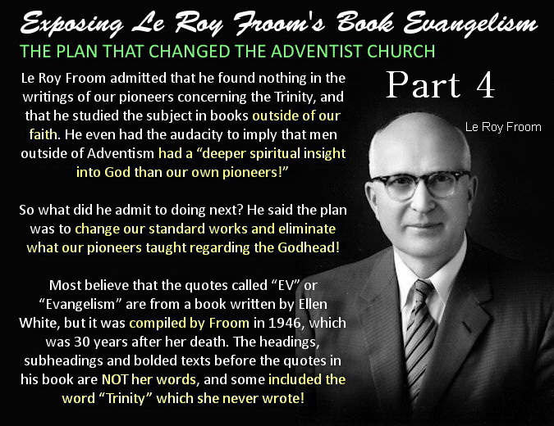

EXPOSING LEROY FROOM'S BOOK EVANGELISM – PART 4

Evangelism p. 616.1 - Not measured in figures

“Christ shows them that, although they might reckon His life to be less than fifty years, yet His divine life could not be reckoned by human computation. The existence of Christ before His incarnation is not measured by figures.” — (Signs of the Times, May 3, 1899) — Evangelism p. 616.1)

Time as we know it is measured by the spheres in the heavens. For example: A year for the earth to revolve around the sun, a month for the moon to revolve around the earth and a day for one rotation of the earth. And it is from this that our “date” is derived. Hence the time before the creation of all things there was nothing in the heavens to measure time by. So phrases such as “from eternity”, “from everlasting”, “before time was”, “the days of eternity”, “from the beginning” and “before the earth was” were used to describe the period where there was nothing to measure time by. So all these phrases mean the same thing. Quite simply, before the earth and all things were created.

And since Ellen White wrote that Christ was brought forth from the DAYS OF ETERNITY when there was nothing to measure time by, then the existence of Christ before His incarnation cannot be measured by figures.

“Out of Bethlehem, said the prophet, “shall He come forth ... that is to be ruler in Israel; whose goings forth have been from of old, from the DAYS OF ETERNITY.” — (E.G. White, DA, 44.2)

And below Ellen White explains further why His divine life could not be reckoned by human computation.

“And although we may try to reason in regard to our Creator, HOW LONG HE [CHRIST] HAS HAD EXISTENCE, where evil first entered into our world, and all these things, we may reason about them until we FALL DOWN FAINT AND EXHAUSTED WITH THE RESEARCH WHEN THERE IS YET AN INFINITY BEYOND.” — (E.G. White, 7BC 919.5)

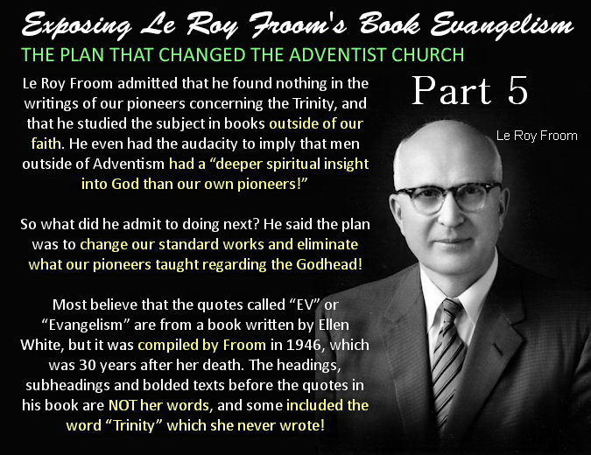

EXPOSING LEROY FROOM'S BOOK EVANGELISM – PART 5

Evangelism p. 616.2 - Life, original, unborrowed, underived

“Jesus declared, “I am the resurrection, and the life.” In Christ is life, original, unborrowed, underived. “He that hath the Son hath life.” The divinity of Christ is the believer's assurance of eternal life.” — (Desire of Ages, p. 530) — Evangelism p. 616.2

Trinitarians assume this means Christ has always existed, but in a later writing she reveals that is not what she was saying.

“He said. In Him was life, original, unborrowed, underived. This life is not inherent in man. He can POSSESS IT ONLY THROUGH CHRIST. He cannot earn it; IT IS GIVEN HIM as a free gift if he will believe in Christ as His personal Saviour.” — (E.G. White, ST, April 8, 1897)

Note that this original, unborrowed and underived life can also be GIVEN to man. The life of Christ was original, unborrowed and underived as it was given to Him by His Father.

“For as the Father has life in Himself; so has He given to the Son to have life in Himself;” John 5:26

If Jesus had always existed alongside the Father as the Trinity doctrine claims, then God could not have given life to His Son as He would have always had life. But Scripture reveals this is impossible and that Christ is the literal Son of God.

She also wrote, “ALL THINGS CHRIST RECEIVED FROM GOD, but He took to give.” — (E.G. White, DA, p. 21)

And since the life of the Father has been given to His Son, then that means Christ is also self-existent. So the Father gave this life to His Son and through Christ it can be given to us also.

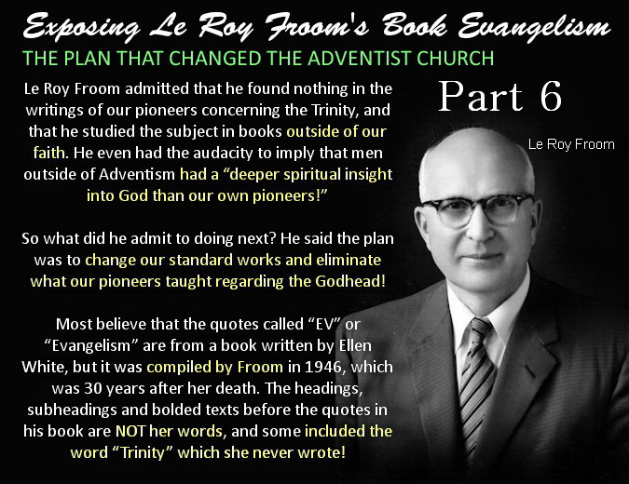

EXPOSING LEROY FROOM'S BOOK EVANGELISM – PART 6

Evangelism p. 616.4 - Eternal heavenly dignitaries

The Eternal Dignitaries of the Trinity—“The eternal heavenly dignitaries—God, and Christ, and the Holy Spirit—arming them [the disciples] with more than mortal energy, ... would advance with them to the work and convince the world of sin.” — (16MR 204.4) — Evangelism p. 616.4)

NOTE that the text “The Eternal Dignitaries of the Trinity” that is found in front of this quote in Froom's book was NOT written by Ellen White but was ADDED by Froom to aid his deception.

GOD, AND CHRIST, AND THE HOLY SPIRIT: Ellen White taught that the Father and Son are one in Spirit and that the SPIRIT OF GOD comes to us through His only begotten Son. Thus she called the HOLY SPIRIT the SPIRIT OF CHRIST.

“The HOLY SPIRIT is the SPIRIT of CHRIST, which is sent to all men to give them sufficiency,” — (E.G. White, 14MR 84.3)

“We want the HOLY SPIRIT, which is JESUS CHRIST.” — (E.G. White, Lt66, April 10, 1894)

Since she wrote that the Holy Spirit is the Spirit of Christ, then she has to be saying that the “heavenly dignitaries” are the FATHER, SON and the SPIRIT OF CHRIST or she would be contradicting herself.

Hence she did in fact write those exact words. So letting SOP explain SOP, here are the “heavenly dignitaries” according to Ellen White.

“They have ONE God and ONE Saviour; and ONE Spirit--the Spirit of Christ--is to bring unity into their ranks.” — (E.G. White, 9T 189.3, 1909)

Third heavenly dignitary = ONE + ONE + ONE = “the Spirit of Christ.”

ETERNAL: Ellen Whites use of the word “eternal” has confused many people such as used in the quote in question. For instance, what did she mean when she said Christ existed from eternity in the quote below?

“The Lord Jesus Christ, the divine Son of God, existed FROM ETERNITY, a distinct person, yet one with the Father. He was the surpassing glory of heaven. He was the commander of the heavenly intelligences, and the adoring homage of the angels was received by him as his right. This was no robbery of God. “The Lord possessed me in the beginning of his way,” he declares, “before his works of old. I was setup FROM EVERLASTING, FROM THE BEGINNING, OR EVER THE EARTH WAS. When there were no depths, I WAS BROUGHT FORTH; when there were no fountains abounding with water. Before the mountains were settled, before the hills WAS I BROUGHT FORTH; while as yet he had not made the earth, nor the fields, nor the highest part of the dust of the world.” — (E.G. White, RH, April 5, 1906)

Ellen White quotes Proverbs 8:23-26 above which equates “FROM ETERNITY”, “FROM EVERLASTING”, “FROM THE BEGINNING” and “BEFORE THE EARTH WAS” with the time before all things were created. So all these phrases mean the same thing. Quite simply, before the earth and all things were created. Not without beginning as many believe today. So when Ellen White said from eternity, she did not mean that Christ had always existed. She also confirms this when she twice says that Christ was “brought forth,” which means she is saying that the person of Christ had a beginning.

Christ cannot be the first-born of Heaven and have always existed. “The dedication of the FIRST-BORN had its origin in the earliest times. God had promised to give the FIRST-BORN OF HEAVEN to save the SINNER.” — (E.G. White, DA, p. 51) The Father literally gave life to His Son. “For as the Father has life in Himself; so has He given to the Son to have life in Himself;” John 5:26. If Jesus had always existed alongside the Father as the Trinity doctrine claims, then God could not have given life to His Son as He would have always had life. But Scripture reveals that Christ is the literal Son of God.

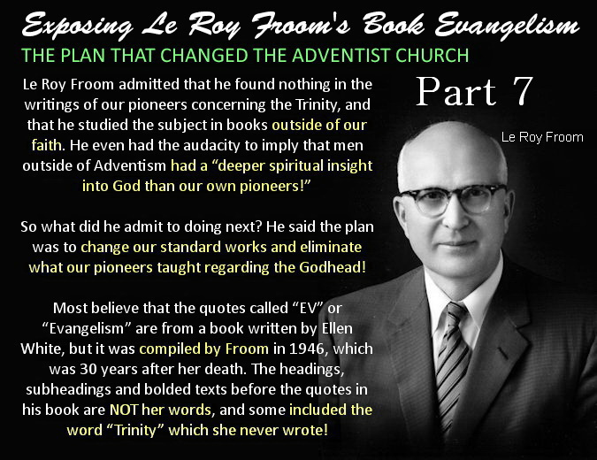

EXPOSING LEROY FROOM'S BOOK EVANGELISM – PART 7

Evangelism p. 616.5 - Holy Spirit as much a person as God is a person

“We need to realize that the Holy Spirit, who is as much a person as God is a person, is walking through these grounds.” — (Sermons and Talks Volume 2, pp. 136, 137, 1899) — Evangelism p. 616.5

The first thing to note is that this quote was not written by her hand but was taken down in shorthand from a sermon she preached, and was transcribed decades later. So it requires looking at the entire quote carefully to see who she is referring to. Because you will find the entire quote refers to Christ by His Holy Spirit which is easily seen if you let SOP explain SOP rather than assuming.

Here is more of the quote for context. “The Lord [Jesus] instructed us that this was the place in which we should locate, and we have had every reason to think that we are in the right place. We have been brought together as a school, and we need to realize that the HOLY SPIRIT, who is as much a person as God is a person, is WALKING THROUGH THESE GROUNDS, UNSEEN BY HUMAN EYES; ... HE HEARS EVERY WORD WE UTTER and knows every thought of the mind.”

So looking at the entire quote, who does Ellen White say is the Holy Spirit, was walking through those grounds, is unseen by human eyes, is the person of the Holy Spirit and who hears every word we utter?

QUESTION 1: Who does Ellen White say is the Holy Spirit?

“The HOLY SPIRIT is the SPIRIT of CHRIST, which is sent to all men to give them sufficiency,” — (E.G. White, 14MR 84.3)

“We want the HOLY SPIRIT, which is JESUS CHRIST.” — (E.G. White, Lt66, April 10, 1894)

“but it is the leaven of the SPIRIT of JESUS CHRIST, which is sent down from heaven, called the HOLY GHOST,” — (E.G. White, Ms36-1891)

QUESTION 2: Who was walking through those grounds, through our streets, and by our side and hears every word we utter?

“CHRIST WALKS UNSEEN THROUGH OUR STREETS. With messages of mercy He comes to our homes.” — (E.G. White, MH, p. 107)

“How few realize that JESUS, UNSEEN, IS WALKING BY THEIR SIDE! How ashamed many would be to hear His voice speaking to them, and to know that HE HEARD ALL THEIR FOOLISH, COMMON TALK!” — (E.G. White, 14MR 125.3)

“Remember that JESUS IS BESIDE YOU WHEREVER YOU GO, noting your actions and LISTENING TO YOUR WORDS.” — (E.G. White, YI, Feb 4, 1897)

QUESTION 3: Who is the person of the Holy Spirit who is unseen by human eyes?

“The human agent, the seen instrument, is to preach the Word, and the LORD JESUS, THE UNSEEN, AGENCY, BY HIS HOLY SPIRIT is to make the Word efficacious and powerful.—Letter 105, 1900.” — (E.G. White, 2SM 18.3)

“He [CHRIST] is an UNSEEN PRESENCE in the PERSON OF THE HOLY SPIRIT,” — (E.G. White, DG, 185.2, 1897)

The answer is Christ by His Spirit every time and this cannot be missed by any honest truth seeker. An honest person will reconcile all that she wrote, not cherry pick quotes that can be misunderstood on their own as Froom did.

So how does Christ walk unseen through our streets? By His Holy Spirit. Why is He unseen? Because He is doing so by His Holy Spirit. And how was Christ walking unseen through the Avondale school grounds? By His Holy Spirit. So this quote could be written as follows and would still mean the same thing without being misunderstood:

“We need to realize that Christ, by His Spirit, who is as much a person as God is a person, is walking through these grounds by His Holy Spirit, unseen by human eyes; He hears every word we utter and knows every thought of the mind.”

This or something very similar is no doubt the words she did preach. Remember someone else wrote down those words in shorthand. The statement below appears in the book Sermons and Talks, Book 1.

In the forward of the book we are told,

“All the messages reproduced in this volume were delivered in public and stenographically reported, or were prepared with that purpose in view. Many of Ellen White's sermons may be found in the Review and Herald and Signs of the Times, but nearly all of those included in this series have been drawn from previously unpublished manuscripts, as they appear in our files. So, although there were no tape recorders in Ellen White's day, a person may get the true “feel” of Ellen White as a speaker by reading this book.” — (Forward, Sermons and Talks, Vol. 1)

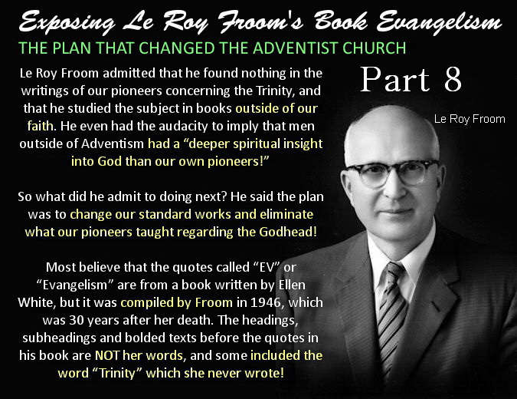

EXPOSING LEROY FROOM'S BOOK EVANGELISM – PART 8

Evangelism p. 616.6 - Holy Spirit is a person

“The Holy Spirit is a person, for He beareth witness with our spirits that we are the children of God. When this witness is borne, it carries with it its own evidence. At such times we believe and are sure that we are the children of God.” — (20MR 68.5, 1906) — Evangelism 616.6

Ellen White taught that the Father and Son are one in Spirit and that the SPIRIT OF GOD comes to us through His only begotten Son. Thus she called the HOLY SPIRIT the SPIRIT OF CHRIST. Letting SOP explain SOP, why did she call the Holy Spirit a person?

“but it is the leaven of the SPIRIT of JESUS CHRIST, which is sent down from heaven, called the HOLY GHOST,” — (E.G. White, Ms36-1891)

“We want the HOLY SPIRIT, which is JESUS CHRIST.” — (E.G. White, Lt66, April 10, 1894)

Answer: Because the Holy Spirit is a “person!” It is the person of Christ by His Spirit.

Ellen White calls the “unseen presence” of Christ the PERSON of the Holy Spirit. Speaking of the Comforter, she wrote, “When trials overshadow the soul, remember the words of CHRIST, remember that He is an UNSEEN PRESENCE in the PERSON of the Holy Spirit,” — (E.G. White, DG 185.2, 1897)

Why did she call the Holy Spirit a person? Because the Comforter is the Holy Spirit which is the PERSON of Christ. “This refers to the omnipresence of the SPIRIT OF CHRIST, called the COMFORTER.” — (E.G. White, 14MR 179.2)

Who does Ellen White call the Holy Spirit up above and below and whose Spirit represents Christ in the world? It is His very own Spirit! So what is another reason Ellen White calls the Holy Spirit a person?

“JESUS is present in the PERSON of HIS REPRESENTATIVE, the HOLY SPIRIT,” — (E.G. White, 12MR 145.2, 1898)

“The HOLY SPIRIT is HIMSELF, divested of the personality of humanity, and independent thereof. He would REPRESENT HIMSELF as present in all places by HIS Holy Spirit, as the Omnipresent.” — (E.G. White, 14MR 23.3, 1895)

Answer: Because His Spirit can represent Himself just like it is another person, though not a literal person of course. And so again Ellen White called Jesus by His Spirit a PERSON. So the Holy Spirit is indeed a person. Sadly, calling the Spirit of Christ a person has confused those with a Trinitarian mindset and has also allowed the abuse of her writings.
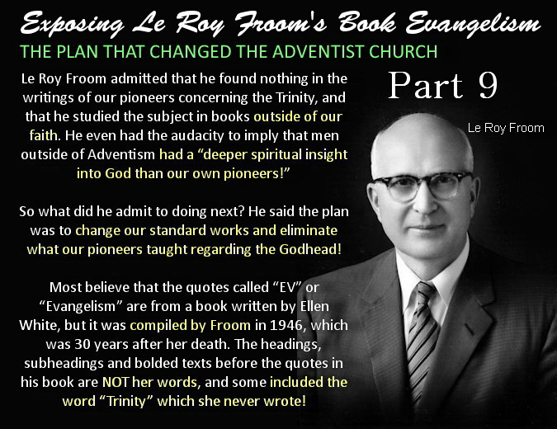

EXPOSING LEROY FROOM'S BOOK EVANGELISM – PART 9

Evangelism p. 617.1 - Holy Spirit has a personality

“The Holy Spirit has a personality, else He could not bear witness to our spirits and with our spirits that we are the children of God. He must also be a divine person, else He could not search out the secrets which lie hidden in the mind of God. “For what man knoweth the things of a man, save the spirit of man which is in him? even so the things of God knoweth no man, but the Spirit of God.” — (20MR 69.1, 1906) — Evangelism 617.1

Ellen White taught that the Father and Son are one in Spirit and that the SPIRIT OF GOD comes to us through His only begotten Son. Thus she called the HOLY SPIRIT the SPIRIT OF CHRIST. Letting SOP explain SOP, who did she call the Holy Spirit that has a personality?

“The HOLY SPIRIT is the SPIRIT of CHRIST, which is sent to all men to give them sufficiency,” — (E.G. White, 14MR 84.3)

“but it is the leaven of the SPIRIT of JESUS CHRIST, which is sent down from heaven, called the HOLY GHOST,” — (E.G. White, Ms36-1891)

“We want the HOLY SPIRIT, which is JESUS CHRIST.” — (E.G. White, Lt66, April 10, 1894)

Answer: It is the Spirit of Christ that has a “personality!” A person’s spirit is their mind, will and emotions and thus is their personality. And so the personality of the Holy Spirit is the personality of Christ.

Below Ellen White states that Christ has left HIS SPIRIT in the world to represent Him. Some respond, “How can His own Spirit represent Himself?” Quite easily as Christ's Spirit can function independently of Himself like it is “another” person.

“CHRIST has left HIS Holy Spirit to be HIS representative in the world, to give celestial aid to every hungering, thirsting soul.” — (E.G. White, Lt84, Oct 22, 1895)

And since the Holy Spirit is the Spirit of Christ which can function like a separate person, His Spirit person-fies Himself and has a distinct personality. It is essential to always let SOP explain SOP or you can easily come to the wrong conclusion.

“The HOLY SPIRIT is the COMFORTER, in Christ's name. He PERSONIFIES CHRIST, yet is a DISTINCT PERSONALITY.” — (E.G. White, 20MR 324.2)

Further confirming Ellen White is referring to Christ, the Holy Spirit is the Comforter which is the Spirit of Christ. “This refers to the omnipresence of the SPIRIT OF CHRIST, called the COMFORTER.” — (E.G. White, 14MR 179.2)

For clarification, Ellen White concludes by quoting 1 Corinthians 2:11 “For who among men knows the thoughts of a man except the man's spirit within him? IN THE SAME WAY no one knows the thoughts of God except the Spirit of God.”

Ellen White is revealing that both God and man have a spirit, and in like manner our SPIRIT is our THOUGHTS, or should I say, our mind will and emotions, which is our PERSONALITY! And so Paul reveals that the “Spirit of God” is no more a distinct person from God, than the “spirit of a man” is a distinct person from the man. God’s Spirit has God’s personality and our spirit has our personality. Note Paul says man’s spirit is “within him” but does not say that about God’s Spirit as He can send His Spirit anywhere.

Thus the “Holy Spirit” is the power and presence of God and of Christ which can function independently of themselves like a third (but not a literal third) and is how “They” represent “Themselves” where they are not personally present.

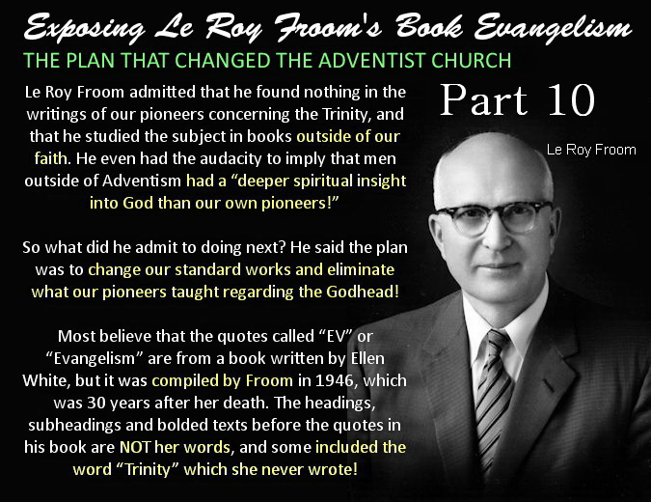

EXPOSING LEROY FROOM'S BOOK EVANGELISM – PART 10

Evangelism p. 617.2 - Third person

“The prince of the power of evil can only be held in check by the power of God in the third person of the Godhead, the Holy Spirit.” — (Special Testimonies, Series A, No. 10, p. 37, 1897) — Evangelism p. 617.2

Ellen White taught that the Father and Son are one in Spirit and that the SPIRIT OF GOD comes to us through His only begotten Son. Thus she called the HOLY SPIRIT the SPIRIT OF CHRIST.

“The HOLY SPIRIT is the SPIRIT of CHRIST, which is sent to all men to give them sufficiency,” — (E.G. White, 14MR 84.3)

“We want the HOLY SPIRIT, which is JESUS CHRIST.” — (E.G. White, Lt66, April 10, 1894)

Since she said the Holy Spirit is the Spirit of Christ, then she has to be saying the third person is the Spirit of Christ and that the three are the Father, Son and Spirit of Christ or she would be contradicting herself.

So she did in fact write those exact words. Thus she taught that the “third person” is the Spirit of Christ.

“They have ONE God and ONE Saviour; and ONE Spirit--the Spirit of Christ--is to bring unity into their ranks.” — (E.G. White, 9T 189.3, 1909)

Third Person = ONE + ONE + ONE = “the Spirit of Christ.”

She wrote that the POWER OF EVIL can ONLY be held in check by the Holy Spirit, which is the Spirit of Christ. So who ALONE can free us from the POWER OF EVIL? It is Christ of course!

“JESUS ALONE has power to SAVE FROM SIN, to free from the POWER OF EVIL; and to doubt him who has laid down his life for us, is to grieve and insult the Father,” — (E.G. White, RH, Feb 10, 1891)

She also wrote, “SIN could be resisted and overcome ONLY through the mighty agency of the third person of the Godhead,” — (E.G. White, DA, 671.2)

As already seen, the third person is the Spirit of Christ and is the ONLY one who can overcome sin in you. Why would we think it was anyone else other than the One who conquered and overcame sin on the cross? What many fail to realize is that Christ’s Spirit can function independently of Himself like “another” person, though not a literal person of course.

“There is no power in you apart from CHRIST, but it is your privilege to have Christ abiding in your heart by faith, and HE can OVERCOME SIN in you,” — (E.G. White, OHC, 76.5)
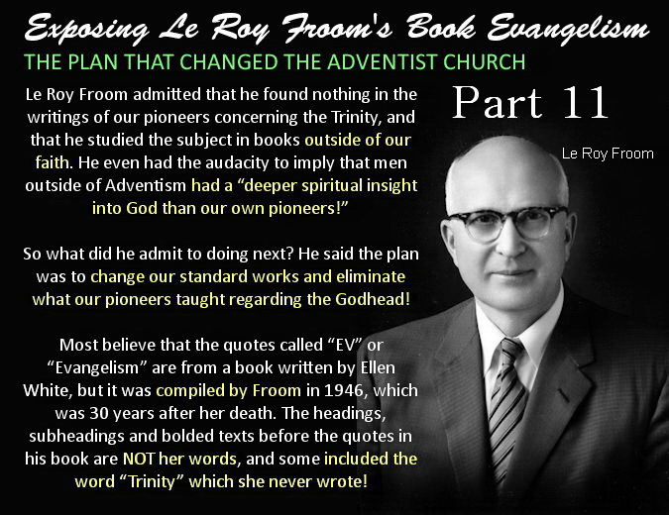

EXPOSING LEROY FROOM'S BOOK EVANGELISM – PART 11

Evangelism p. 617.3 - Three great powers

“We are to co-operate with the three highest powers in heaven,--the Father, the Son, and the Holy Ghost,--and these powers will work through us, making us workers together with God.” — (Ellen G. White, Special Testimonies, Series B, No. 7, p. 51) — Evangelism p. 617.3

Note Ellen White said POWERS, not BEINGS. The third power is the Holy Spirit which many think is another being. But Ellen White taught that the Father and Son are one in Spirit and that the SPIRIT OF GOD comes to us through His only begotten Son. Thus she called the HOLY SPIRIT the SPIRIT OF CHRIST.

“The HOLY SPIRIT is the SPIRIT of CHRIST, which is sent to all men to give them sufficiency,” — (E.G. White, 14MR 84.3)

“We want the HOLY SPIRIT, which is JESUS CHRIST.” — (E.G. White, Lt66, April 10, 1894)

Since she wrote that the Holy Spirit is the Spirit of Christ, then she has to be saying that the “three great powers” are the FATHER, SON and the SPIRIT OF CHRIST or she would be contradicting herself.

So she did in fact write those exact words. Letting SOP explain SOP, here are the “three great powers.”

“They have ONE God and ONE Saviour; and ONE Spirit--the Spirit of Christ--is to bring unity into their ranks.” — (E.G. White, 9T 189.3, 1909)

Third great power = ONE + ONE + ONE = “the Spirit of Christ.”

Thus we find Ellen White called the Spirit of Christ a “POWER.”

“CHRIST has given HIS SPIRIT as a divine POWER.” — (E.G. White, RH, Nov 19, 1908)

Trinitarians conclude that the third power is another being. But there is no other POWER in you apart from Christ.

“There is NO POWER in you APART from CHRIST, but it is your privilege to have CHRIST ABIDING IN YOUR HEART by faith, and He can overcome sin in you,” — (E.G. White, OHC, 76.5)

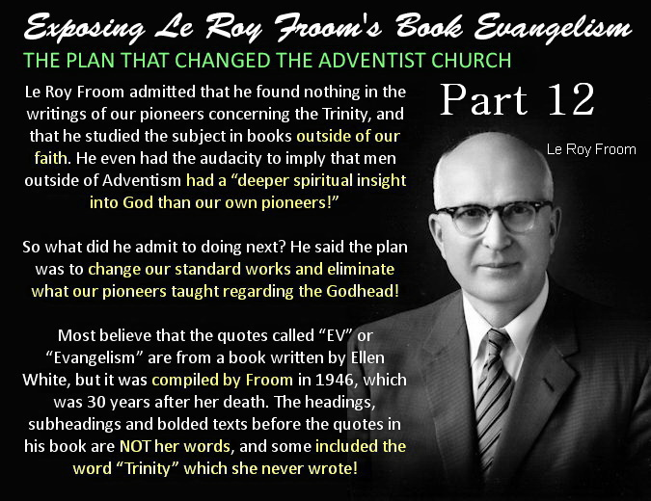

EXPOSING LEROY FROOM'S BOOK EVANGELISM – PART 12

Evangelism p. 615.1, 616.4, 616,6 617.1, 617.2, 617.3 - Holy Spirit

Ellen White taught that the Father and Son are one in Spirit and that the SPIRIT OF GOD comes to us through His only begotten Son. Thus she called the HOLY SPIRIT the SPIRIT OF CHRIST.

“The HOLY SPIRIT is the SPIRIT of CHRIST, which is sent to all men to give them sufficiency,” — (E.G. White, 14MR 84.3)

“We want the HOLY SPIRIT, which is JESUS CHRIST.” — (E.G. White, Lt66, April 10, 1894)

And since Ellen White wrote, “The Holy Spirit is the Spirit of Christ,” she also wrote:

The Comforter is the SPIRIT OF CHRIST,
the Spirit of truth is the SPIRIT OF CHRIST,
the third person is the SPIRIT OF CHRIST,
the third great power is the SPIRIT OF CHRIST,
the Holy Spirit given at Pentecost was the SPIRIT OF CHRIST,
the Holy Spirit Jesus breathed on His disciples was HIS own SPIRIT,
the Holy Spirit Christ sent to represent Himself was HIS own SPIRIT,
the heavenly dignitaries are the Father, Son and SPIRIT OF CHRIST,
the Heavenly trio is the Father, Son and SPIRIT OF CHRIST,
and she reveals over and over again that there are only two beings.

Below you will find one example proving each of the above statements.

“THIRD PERSON,” “THIRD GREAT POWER,” “HEAVENLY DIGNITARIES” and “HEAVENLY TRIO.” —— “They have ONE God and ONE Saviour; and ONE Spirit--the Spirit of Christ--is to bring unity into their ranks.” — (E.G. White, 9T 189.3, 1909)

The third person, power and dignitary of the trio = ONE + ONE + ONE = “the Spirit of Christ.”

THIRD GREAT POWER —— “CHRIST has given HIS SPIRIT as a divine POWER.” — (E.G. White, RH, Nov 19, 1908)

COMFORTER —— “This refers to the omnipresence of the SPIRIT OF CHRIST, called the COMFORTER.” — (E.G. White, 14MR 179.2)

SPIRIT OF TRUTH —— “JESUS comes to you as the SPIRIT of TRUTH; study the mind of the Spirit, consult your Lord, follow His way.” — (E.G. White, 2MR 337.1)

SPIRIT JESUS BREATHED ON HIS DISCIPLES —— “And when He had said this, He [Christ] breathed on them, and saith unto them, Receive ye the Holy Ghost: ... Before the disciples could fulfill their official duties in connection with the church, CHRIST breathed HIS Spirit upon them.” — (E.G. White, DA, p. 805)

SPIRIT GIVEN AT PENTECOST —— “The promise of the HOLY SPIRIT is not limited to any age or to any race. CHRIST declared that the divine influence of HIS SPIRIT was to be with His followers unto the end. From the Day of PENTECOST to the present time, the COMFORTER has been sent to all who have yielded themselves fully to the Lord and to His service.” — (E.G. White, AA, 49.2)

SPIRIT THAT REPRESENTS CHRIST —— “CHRIST came to our world, but the world could not endure His purity. He has gone to His Father, but HE has sent HIS Holy Spirit to represent HIM in the world till he shall come again.” — (E.G. White, Ms1, Jan 11, 1897)

TWO BEINGS ALONE —— “The Father and the Son ALONE are to be exalted.” — (E.G. White, YI, July 7, 1898)

And since Ellen White wrote that the Holy Spirit is the SPIRIT OF CHRIST, for any quote Froom used regarding the Holy Spirit that has been misunderstood, replace the words “HOLY SPIRIT” with “SPIRIT OF CHRIST” or “CHRIST BY HIS SPIRIT” and read it again. I quite assure you that it can no longer be mistaken as a Trinitarian quote!

Conclusion
Adventists today are putting things into Ellen White's references which are not there. When Ellen White says “persons,” they say it is “beings.” When Ellen White says that the Son was with the Father “FROM” all eternity, they say it was “FOR” all eternity. Trinitarians need to see that their mind is deceiving them. Their preconceived ideas are putting words into her writings that are not there because their old view is all they can see. That is why we so vitally need to allow the Holy Spirit to remove from us our preconceived ideas and lead us into truth.

Picking out statements from Ellen White's writings that would fit into a Trinitarian concept of God while ignoring her statements that do not fit the Trinitarian concept of God is a dishonest way to use her writings. To understand correctly what God has revealed through Ellen White, and find out what her beliefs were on this topic, it is necessary to quote all that she wrote on this subject, not just be selective in what we quote to suit our own agenda. That would be tantamount to deception.

